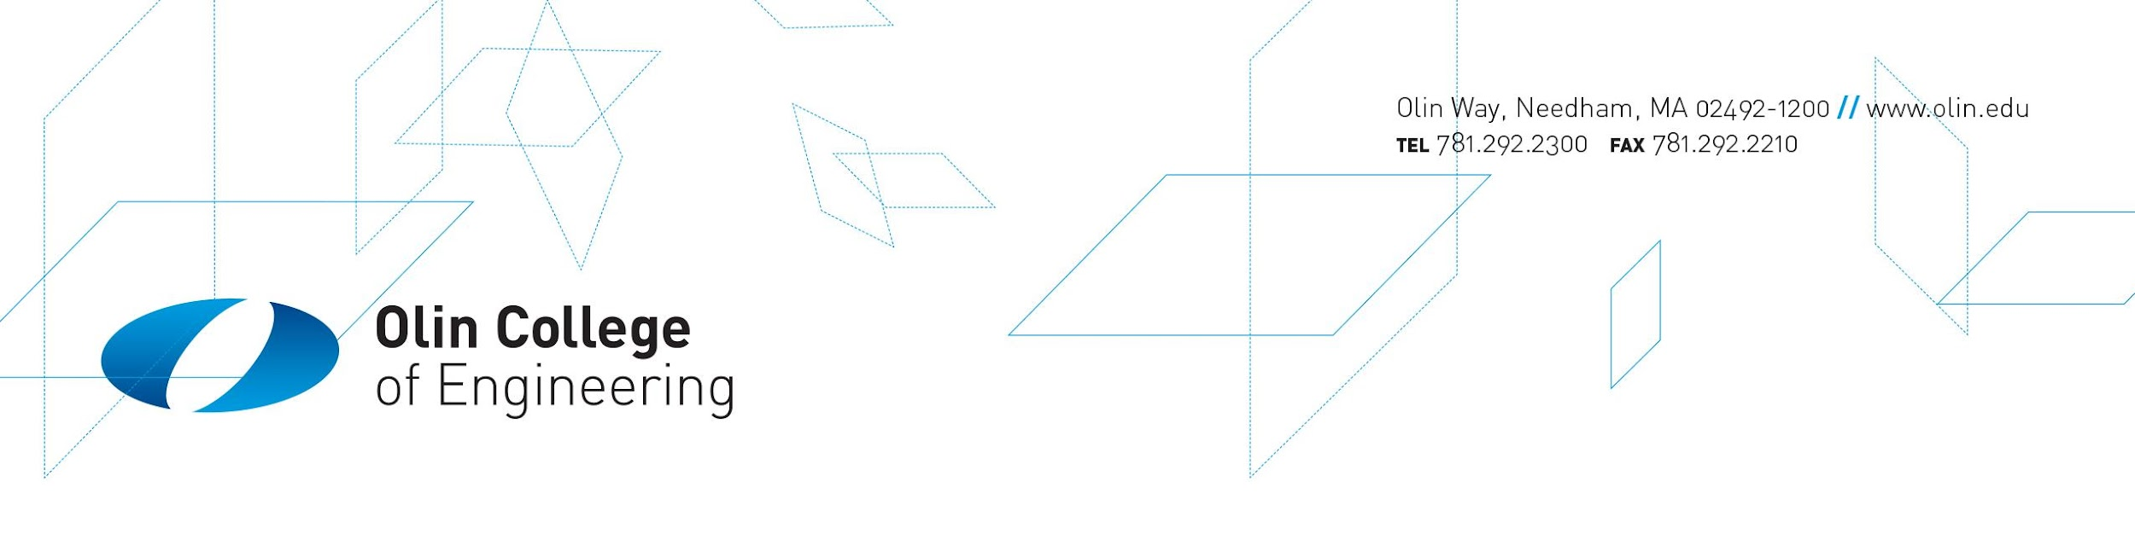
Informed Consent Document
For the research study:
EducateAI: Educating Responsible Technologists: Integrating Artificial Intelligence and Social Sciences via Immersive Learning Modules

This study is being conducted and overseen by Paul Ruvolo (Olin College Professor), Caitrin Lynch (Olin College Professor), and Chelsea Andrews (Tufts Professor)

Please read this form carefully – it tells you about your rights in this study. Ask questions if you want more information about this form or the study.

If you decide to participate in this study, you will sign this form – make sure you understand it completely before signing. Keep a copy of this form for your records – it has important information like whom to contact if you have questions later.

What is this study about?
How does experience with a project in applying AI to create technologies for and in collaboration with (people who are blind) lead to changes in student orientation towards their engineering identity and approach.

Who are we asking to participate?
Anyone who is enrolled in the course Machine Learning.

What will you be asked to do?
There are three components to this study:

- As part of the first assignment, you will be filling out a series of surveys. These surveys will take you about 30 minutes to complete.
- Later in the course, you will be filling out some additional surveys, which will take you about 30 minutes to complete.
- If you'd like, you can participate in a 30-minute interview or focus group session. Participation in the interview is optional.

Are there any possible risks to you?
Your information could be accidently leaked to people not connected with this study. We will do everything we can to make sure this doesn’t happen.

Will you benefit from participation?
No – you will not. But we hope to learn more about the educational effects of the Olin curriculum, which may be used at other institutions or with future Olin courses.

Will it cost you anything to participate?
If you do not do an interview, there is no cost to participate. This is because the surveys are part of normal course activities that you would do anyway. If you participate in an interview or focus-group, you will have a time commitment of 30-45 minutes.

How will we keep your information private?
We will not share any information that we collect that can identify you unless we legally have to.

We will use a random code to keep track of your answers. The code will link your answers to your name through a master list that will be stored separately from your answers.

If you participate in an interview, a recording of your interview will be transcribed into print and the audio will be erased. Any information that could directly identify you will be deleted. Your answers will be stored in a database protected by a password.

What will happen with your answers after this study?
We will store your answers – without information that can identify you – for a period of 3 years.

What if you don’t want to participate or change your mind partway through?
Participating in this study is completely voluntary. You can refuse to participate or quit at any time.

You may also refuse to answer specific questions– simply skip them on the questionnaire or ask the interviewer to move on to another topic.

Who can you call if you have more questions?
If you have any questions about the research or your participation in the study, feel free to contact Dr. Ruvolo at pruvolo@olin.edu (tel: 650-279-8868) or Dr. Lynch at clynch@olin.edu .

This research was approved by an office/committee that oversees the ethics of human subjects research at Brandeis University. If you have any questions about your rights – or if you have concerns about the study – you may contact them at 781-736-8133 or
hrpp@brandeis.edu

Subject Consent
I have read this consent form completely. I have been encouraged to ask questions and have received helpful answers. I understand that:

• My participation is voluntary
• I may quit at any time without penalty

Please Initial One Option
I am willing to participate in the study, but I am not willing to do an interview _______
I am willing to participate in the study, and I am open to doing an interview if asked by the research team _______

I voluntarily agree to participate in this study.

Participant’s Signature ____________________________ Date ________________________

Investigator’s Signature ___________________________ Date ________________________

