Smart Street Lighting System for Energy Efficiency, based on Microcontroller

Hasan Shakif Tushar | Alinoor Hossain Olip
Student  Faculty of Computer Science and Engineering, | Student  Faculty of Computer Science and Engineering,
East West University | East West University
Aftabnagar,Dhaka-1212 | Aftabnagar,Dhaka-1212
e-mail: hasanshakif8@gmail.com | e-mail: ontohinolip@gmail.com

Abdur Rahman | Dr. Md. Nawab Yousuf Ali
Student  Faculty of Computer Science and Engineering, | Associate Professor  Faculty of Computer Science and Engineering,
East West University | East West University
Aftabnagar,Dhaka-1212 | Aftabnagar,Dhaka-1212
e-mail: a.rahman.anup@gmail.com | e-mail: nawab@ewubd.edu

Abstract — nowadays energy has become a big issue for the world. There is a scarcity in every energy field. But electrical energy has the greater impact on human life. We can see that our roads in urban area using street light which are continuously giving us light but this is not efficient. This paper proposed a system where we will try to optimize that energy loss by automatic street lighting project. The prototype is designed with Arduino Uno microcontroller, LDR sensor, IR sensor and LED. We hope this kind of approach will help to establish energy efficient street lighting or any other lighting system.

Keywords - Energy efficient; Street Lighting; Low Power Consumption

- INTRODUCTION

Designing another framework for the streetlight that don't expend colossal measure of power and enlighten expansive zones with the most astounding force of light is concerning each architect working in this field. Giving road lighting is a standout amongst the most vital and costly duties of a city. Lighting can represent 10– 38% of the aggregate vitality charge in common urban communities overall [1]. Road lighting is an especially basic worry for open experts in creating nations due to its vital significance for financial and social strength. Wasteful lighting squanders noteworthy money related assets consistently, and poor lighting makes dangerous conditions. Vitality productive advances and plan component can lessen cost of the road lighting definitely. Manual control is inclined to blunders and prompts vitality wastages and physically diminishing amid mid night is impracticable. Likewise, progressively following the light level is physically impracticable. The present pattern is the presentation of computerization and remote administration answers for control road lighting.

II. PREVIOUS WORK

MUSTAFA SAAD et al proposed paper on” Automatic Street Light Control System Using Microcontroller “[2]. This paper aims at designing and executing the advanced development in embedded systems forenergy saving of street lights. Nowadays, human has become too busy, and is unable to find time even to switch the lights wherever not necessary. The present system is like, the street lights will be switched on in the evening before the sun sets and they are switched off the next day morning after there is sufficient light on the roads. This paper gives the best solution for electrical power wastage. Also the manual operation of the lighting system is completely eliminated. In this paper the two sensors are used which are Light Dependent Resistor LDR sensor to indicate a day/night time and the photoelectric sensors to detect the

movement on the street. The microcontroller PIC16F877A is used as brain to control the street light system, where the programming language used for developing the software to the microcontroller is C-language. Finally, the system has been successfully designed and implemented as prototype system.

B. K. Subramanyam et al proposed paper on “Design and Development of Intelligent Wireless Street Light Control and Monitoring System Along With GUI” [3] discussed that Now-a-days, it became essential for people work during nights and returning back to homes late nights; also increasing crime rate during night times. This can be best achieved by implementing proper solar based lighting system on Streets. The efficient monitoring and controlling of this lighting system must be taken into account. We will get more power consumption, saving money through solar panel. Also saving precious time, decrease the huge human power through from the LDR, IR Sensors. The Street lights are controlled through a specially designed Graphical User Interface.

III. RESEARCH METHODOLOGY

We took the help from various online literatures. Online sources gave us the proper idea of the hardware we used in this project. We also took help from various papers which describe some sort of smart lighting system.

IV. METHODOLOGY OF SMART STREET LIGHTING SYSTEM

Three parts have been included under this topic for completed this study. Design architecture is the main block function for the proposed design. While, the hardware specification will detail out the components involved in this design from the
sensor components until the controller selection. Software development based on the proposed design will be detail out in software part where the flow of the system operation will be detailed out elaborated.

A. Design Architrecture

We designed the project with the entire hardware component and cork sheet, papers and tape has been also used to design the physical out layer.

B. Hardware Specification

Hardware Used in the Project:

1. Arduino Uno
2. LDR Sensor
3. IR Sensor
4. Resistor 10k
5. LEDs
6. Connecting Wire
7. Breadboard

Arduino Uno:

The Arduino Uno is a microcontroller board based on the ATmega328 (datasheet). It has 14 digital input/output pins (of which 6 can be used as PWM outputs), 6 analog inputs, a 16 MHz ceramic resonator, a USB connection, a power jack, an ICSP header, and a reset button. It contains everything needed to support the microcontroller; simply connect it to a computer with a USB cable or power it with a AC-to-DC adapter or battery to get started. The Uno differs from all preceding boards in that it does not use the FTDI USB-to-serial driver chip. Instead, it features the Atmega16U2 (Atmega8U2 up to version R2) programmed as a USB-to-serial converter.

LDR:
A photoresistor (or light-dependent resistor, LDR, or photo-conductive cell) is a light-controlled variable resistor. The resistance of a photoresistor decreases with increasing incident light intensity; in other words, it exhibits photoconductivity. A photoresistor can be applied in light-sensitive detector circuits, and light-activated and dark-activated switching circuits.
A photoresistor is made of a high resistance semiconductor. In the dark, a photoresistor can have a resistance as high as several megohms (MΩ), while in the light, a photoresistor can have a resistance as low as a few hundred ohms. If incident light on a photoresistor exceeds a certain frequency, photons absorbed by the semiconductor give bound electrons enough energy to jump into the conduction band. The resulting free electrons (and their hole partners) conduct electricity, thereby lowering resistance. The resistance range and sensitivity of a photoresistor can substantially differ among dissimilar devices. Moreover, unique photoresistors may react substantially differently to photons within certain wavelength bands.
IR:
An infrared sensor is an electronic instrument which is used to sense certain characteristics of its surroundings by either emitting and/or detecting infrared radiation. Infrared sensors are also capable of measuring the heat being emitted by an object and detecting motion. Infrared waves are not visible to the human eye. In the electromagnetic spectrum, infrared radiation can be found between the visible and microwave regions. The infrared waves typically have wavelengths between 0.75 and 1000µm.
LED:
A light-emitting diode (LED) is a two-lead semiconductor light source. It is a p–n junction diode that emits light when activated. When a suitable current is applied to the leads, electrons are able to recombine with electron holes within the device, releasing energy in the form of photons. This effect is called electroluminescence, and the color of the light (corresponding to the energy of the photon) is determined by the energy band gap of the semiconductor. LEDs are typically small (less than 1 mm²) and integrated optical components may be used to shape the radiation pattern.
BREADBOARD:
A breadboard is a solderless device for temporary prototype with electronics and test circuit designs. Most electronic components in electronic circuits can be interconnected by inserting their leads or terminals into the holes and then making connections through wires where appropriate. The breadboard has strips of metal underneath the board and connect the holes on the top of the board. The metal strips are laid out as shown below. Note that the top and bottom rows of holes are connected horizontally and split in the middle while the remaining holes are connected vertically.

C. Software Specification
As we know Arduino is a programmable microcontroller so it must have software to run the codes. In the codes we can command Arduino how to work. We used Arduino Nova Sketch IDE to run our codes and test the result.

V. DESIGN PROCEDURE OF HARDWARE

We first connected the ground and voltage source from Arduino UNO to breadboard and made a common ground and voltage pin. We added the Vcc pin of all IR sensors, LDR to voltage source on the breadboard through connecting wires. We then connected the LDR’s, IR’s, Resistor’s ground pin and LED’s negative pin to common ground source. LDR’s negative pin is also connected to resistor. LDR sensor is connected at Arduino’s A0 pin. Four IR sensors are connected in Arduino’s A1, A2, A3 and A4 respectively. Four LEDs are connected to Arduino’s D6, D5, D4 and D3 respectively. Now our circuit is completed. Schematic diagram of the circuit is given bellow.
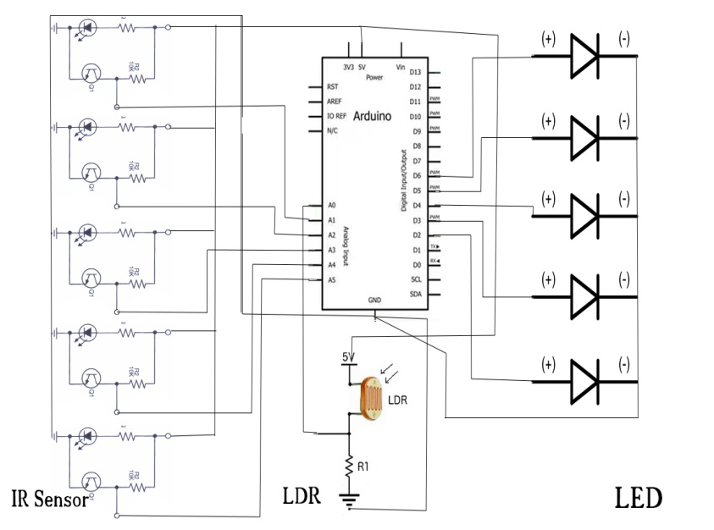
VI. WORKING PROCEDURE

When the Arduino is connected with laptop/PC’s USB source the circuit will be completed and get the ground and VCC source. With the logic described in code the circuit will work. The LDR sensor will sense the presence of light in environment. It doesn’t have to be completely dark as the sensor’s sensitivity can be controlled by Arduino. We set that value on code. If it’s day the circuit will not let the LED to on. LED will be off if there is proper light because we don’t need street light if it’s day. When dark, the sensor will sense it and automatically and will turn on the LEDs. But if there is no human, car or any object in the street the light will not be at full impedance state that means the light will remain faded. That’s how it will save the energy. When any object is on the road the IR sensors will sense it and the LEDs will be lighten up fully. The flow chart of work is given below.
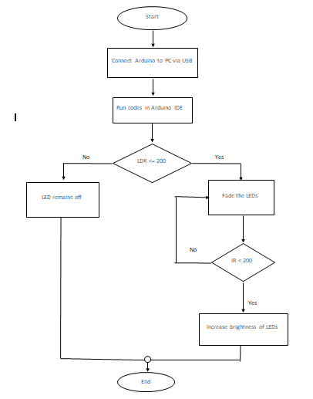

VII. EXPLANATION OF CODE
We took the integer variables of LEDs and assigned them to their pin number. Here 6,5,4,3 are the pin number where the LED pin is connected. We initialize LDR sensor at A0 as it’s connected to A0 pin and IR sensors at A1, A2, A3 and A4 pins.
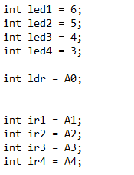
This part is for set up. Where we can see led will give outputs and LDR and IR will take input.
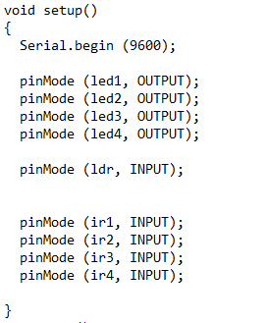
Our program starts here from the loop. Which reads value of A0 from pin and assign to ldrstatus variable. If ldrstatus value is less than 200 or equal to 200 if condition is satisfied. That means the environment is dark. All LEDs are dimmed initially. Note that 255 is the highest value for 8 bit LED. If we divide the max value we’ll get the value which is not max. That means LED will be dimmed.
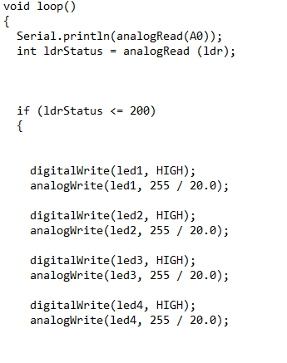
Here we are checking IR sensor Data if the value is less than 200 that means object is detected by the sensor. Then the LEDs are brighten up fully (max value 255). When the object is gone IR value will be greater than 200 that means it will go to the else condition and make the LED dim again.
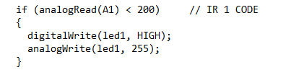

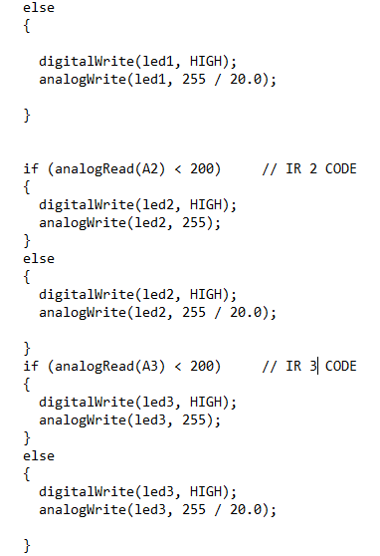
If ldrstatus value is greater than 200 then it will come to this else condition and turn off every LED for daylight condition.
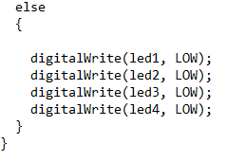

VIII. RESULTS AND ANALYSIS
We test our project and got the expected result. Our LDR sensor has been able to differentiate between the light and dark. Our IR sensor also sensed the presence of objects. We found that LEDs remains off at daylight when it’s dark. LEDs lighten up but not with the full power if there is no one on the street to save the energy. When IR sensor detects object it brighten up LEDs associate to them. When the object is gone it goes back to its initial state.

IX. LIMITATIONS
It’s a micro project so the project cannot be applied in real life. Arduino Uno has limited number of pins so by one Arduino it was not possible to make this project bigger. One IR is dedicated for one LED that makes the project inefficient though it is possible to have many lights for one sensor but again the pin number of Arduino restrain us from that efficiency. LEDs used in the project are not so good. With better LED the result would be more perfect and visible.

X. CONCLUSION
Though the project isn’t ideal for real life but its idea is sure applicable for real world. Energy efficiency is the need of time. Poorer countries need more electricity for many people but electric energy is wasted just because of analogue system. Our proposed system can bring this to an end and can make sure our electrical energy is not wasted for any reason.

REFERENCES

- D. A. Devi and A. Kumar, Design and Implementation of CPLD based Solar Power Saving System for Street Lights and Automatic Traffic Controller, International Journal of Scientific and Research Publications, Vol. 2, Issue11, November 2012. Available at: http://www.wseas.us/e-library/conferences/2013/Antalya/OTEMA/OTEMA-11.pdf [Accessed 30 March, 2018].
- Mustafa Saad, Abdalhalim Farij, Ahamed Salah And Abdalroof Abdaljalil “Automatic Street Light Control System Using Microcontroller”Department of Control Engineering College of Electronic Technology/ Baniwalid Baniwalid- Libya LIBYA, Mathematical Methods and Optimization Techniques in Engineering. Available at: http://www.ijera.com/papers/Vol5_issue6/Part%20-%201/Q560197100.pdf [Accessed 25 March, 2018].
- Valente, R. Morais, C. Serodio, P. Mestre, S. Pinto, and M. Cabral, “A zigbee sensor element for distributed monitoring of soil parame- ters in environmental monitoring,” Proc. IEEEE Sensors, pp. 135– 138, Oct. 2007. [3] Z. Rasin, H. Hamzah, and M. S. M. Aras, “Application and evaluation of high power zigbee based wireless sensor network in water irrigation control monitoring system,” in Proc. IEEE Symp.Ind. Electron. Appl., Oct. 4–6, 2009, vol. 2, pp. 548–551. Available at: http://ijssst.info/Vol-13/No-1/paper5.pdf [Accessed 01 April, 2018].

