Software Requirements Specification
for
WarriorJS
Version 1.0 approved
Prepared by George Sotiriou
Aristotle University of Thessaloniki
July 2022

Table of Contents
Table of Contents ii
Revision History iii
1. Introduction 1
1.1 Purpose 1
1.2 Document Conventions 1
1.3 Intended Audience and Reading Suggestions 1
1.4 Product Scope 2
1.5 References 2
2. Overall Description 3
2.1 Product Perspective 3
2.2 Product Functions 3
2.3 User Classes and Characteristics 8
2.4 Operating Environment 8
2.5 Design and Implementation Constraints 8
2.6 User Documentation 9
2.7 Assumptions and Dependencies 9
3. External Interface Requirements 10
3.1 User Interfaces 10
3.2 Hardware Interfaces 18
3.3 Software Interfaces 18
3.4 Communications Interfaces 19
4. System Features 19
4.1 Map 19
4.2 Units 20
4.3 Abilities 22
4.3 Command Line Interface - Loaders 24

5. Other Nonfunctional Requirements 24
5.1 Performance Requirements 24
5.2 Safety Requirements 24
5.3 Security Requirements 24
5.4 Software Quality Attributes 25

Revision History
Name | Date | Reason For Changes | Version
WarriorJS | 2018-05-03 | Initial Release of the game. | V0.1.0
WarriorJS | 2018-05-03 | Fixed missing bin directory in @warriorjs/cli package files | V0.1.1
WarriorJS | 2018-05-14 | Added:  - Reward property to unit class.  - Warrior score next to health in play log  - Support for Node 9 and 10  - --yes flag to CLI  Changed:  - Exclude abilities from play log except warrior’s  - Rescue ability awards unit’s reward  - CLI default answers  Removed –skip flag from CLI  Fixed path normalization in tests | V0.2.0
WarriorJS | 2018-05-16 | Added:  - Subtract reward points when killing a friendly unit  - Think ability (console.log replacement)  Changed:  - Distinguish between hostile and friendly units  - Move unit methods out of the Space API and to the unit API  Fixed enforce | V0.3.0
WarriorJS | 2018-05-19 | Added:  - Make warrior upset when losing points  - getRelativeOffset function (@warriorjs/geography)  - unit.release() method  changed:  - Rename unit.say() to unit.log()  - Improve profile directory detection  - Rename unit.isHostile() to unit.isEnemy()  - space.getLocation() returns the relative location of the space  - unit.isEnemy() returns whether the unit is considered an enemy by the unit that sensed it.  Removed unit.isFriendly() , unit.isWarrior() , unit.isPlayer()  Fixed:  - Line breaks on CLI output on Windows  - Diamond symbol on Windows | V0.4.0
WarriorJS | 2018-05-22 | Added --Silent flag to CLI  Changed:  - Print level independently of play log  - UI tweaks  - Improve think ability description  - Improve level tips | V0.4.1
WarriorJS | 2018-05-23 | Added warrior name suggestions | V0.4.2
WarriorJS | 2018-06-01 | Added:  - Load towers dynamically (support for external towers)  - Add tower description to README if available  Changed:  - Prevent seeing through walls with look ability  - Optimize profile file  - No longer ask confirmation before creating game directory | V0.5.0
WarriorJS | 2018-06-01 | Fixed external towers discovery | V0.5.1
WarriorJS | 2018-06-17 | Changed:  - Enhance CLI welcome message  - Sort actions and senses alphabetically in README  - Reference tower by ID in levels | V0.6.0
WarriorJS | 2018-07-06 | Changed:  - Reduce unit.log() calls by making reproduction ~50% faster  - Improve play log | V0.7.0
WarriorJS | 2018-07-06 | Added RGB colors to units  Optimize level and events payload | V0.8.0
WarriorJS | 2018-07-09 | Use less fragile method to check for player code errors | V0.9.0
WarriorJS | 2018-07-14 | Modularized codebase even more , adding new helper packages  Remove play score from play result | V0.10.0
WarriorJS | 2018-07-14 | Changed: Calling default after require(‘@warriorjs/helper-**) is no longer needed (nor supported) | V0.11.0
WarriorJS | 2018-07-14 | Force publish of helper packages | V0.11.1
WarriorJS | 2018-07-17 | Changed: Update superheroes dependency to version that doesn’t include a CLI | V0.11.2
WarriorJS | 2018-07-24 | Added warrior status to level JSON | V0.11.3
WarriorJS | 2018-07-30 | Changed official tower names and descriptions  Fixed think ability with complex thoughts | V0.12.0
WarriorJS | 2018-07-31 | Fix tick-tick-boom tower description | V0.12.1
WarriorJS | 2018-10-04 | Make getLevelConfig a pure function | V0.12.2
WarriorJS | 2018-10-04 | Fixed getLevelConfig | V0.12.3
WarriorJS | 2018-10-09 | - Add maxHealth ability  - Improve abilities descriptions | V0.13.0
WarriorJS | 2018-10-17 | - Simplify @warriorjs/helper-get-level-score  - Rename @warriorjs/helper-get-play-score to @warriorjs/helper-get-level-score | V0.14.0  (latest release)

Introduction

Purpose
The purpose of this document is to present a detailed description of the WarriorsJS v0.14.0, an open source game project. It contains basic information about the purpose, environment, features, interfaces, and tactics of the game, technical requirements, and user documentations. It will also explain to the reader how install the program via npm and start playing.
This document is intended for both users that want to develop their javascript skills and developers that want to contribute to this project. Game testers and documentation writers can also benefit from this document (more details about intended audience in paragraph 1.3).

Document Conventions
Document is build based on IEE template for System Requirement Specification Documents (SRS).
The document uses the following very common abbreviations.

JS | Javascript
API | Application Programming Interface
NPM | Node Package Manager
CLI | Command Line Interface
NPC | Non-Player Character
UI | User Interface
URL | Uniform Resource Location
HP | Hit Points

Intended Audience and Reading Suggestions
WarriorJS SRS document is intended for different types of readers. Those types are presented and described below.

- Users:
- New programmers/users with some or even close to zero programming experience that want to understand how the game works, how to start playing and what the game has to offer.
- Advanced programmers/veteran users can benefit by reading this document since they can study the core system functionalities of the game. Some Source code aspects of the game are explained in this document. This is possible because WarriorJS is an open source project. That’s pretty important since it gives advanced programmer the opportunity to interact with the code (contribute) besides playing the game itself.

- Game staff:
- Game Developers / contributors of WarriorJS can find solid and gathered information about the project and its modules. Future developers / contributors can also access this document in order to get familiar with the entirety of this project.
- Testers that need to observe patterns or different stages of the game in order to find bugs/issues (a lot of those stages are presented on this document).
- Documentation writers, to find accurate, organized and easy to find information about the game, for their documents.

.

Product Scope
WarriorJS is an open source project publicly accessible on GitHub for everyone. It can be launched offline through terminal (with npm installation) or via browser in the game’s website. It’s a game written in javascript and also played through javascript. This makes the game unique and innovative. Players need to use their coding skills in order to command their warrior to reach the top level of the tower. That’s right, the warrior only acts with commands written in javescript.
WarriorJS aims to entertain the player while expanding their computational thinking and knowledge by advancing the tower and facing more difficult coding challenges. This project invites both new programmers and veteran developers to have fun, hone their javascript skills and increase their muscle memory while coding.
Since this is an open source project people can also decide to interact with the source code themselves before playing and make the game even for interesting by implementing their own worlds / tower modules, defining levels, abilities and enemy units. Both makers and players have one thing in common, and that’s Javascript.

References
WarriorJS website:

https://warriorjs.com/

WarriorJS GitHub page:

https://github.com/olistic/warriorjs

WarriorJS Documentation page:

https://warrior.js.org/en/

IEEE Template for System Requirement Specification Documents:

https://goo.gl/nsUFwy

WarriorJS Community page:

https://spectrum.chat/warriorjs?tab=posts

WarriorJS unofficial tutorial on youtube:

https://www.youtube.com/watch?v=f1AQMOJu90s

Overall Description

Product Perspective
WarriorJS is an open source application focused on practicing and improving user’s software development skills. As mentioned before, it’s written in javascript and played with javascript. It’s a CLI game, meaning the game starts and played through terminal. A very brief explanation is the following. The player writes a script of javascript code inside a playerTurn method. The script defines how will the warrior move or act. When the player thinks the script is good enough, he can start the game with a command in terminal and the results are logged through an implemented terminal ui.
There are several components that come together in order for the game to function. Before the game is started, components such as profiles, towers game modes (normal profiles or epic profiles) are loaded. The game starts when the user runs the command warriorjs (after npm installation) in the terminal (offline play) or hit run in the browser (https://warriorjs.com/campaigns/new - Requires internet connection).

Product Functions
Major functionalities are going to be organized into packages and summarized without details below (details will be given in section 3). It’s a pretty brief explanation of what happens in the backstage (source code) for everyone to understand.

- Warriorjs-CLI (Command Line interface)
Contains the code about the basic environment of the game and how the game is fully loaded and displayed for the user in the CLI.

- CLI user interface
Since warriorjs is a CLI game, the UI folder contains every file necessary for a friendly user interface in command line. (Contains screen size, unit styles, printing floors, levels, messages etc.)

- Towers
Create a tower class (prototype model for towers) and finding internal or external towers (community towers) and loading them.

- Profiles:
Create a profile, return the path to the player code file and README file, enables epic mode, choose existing profile etc. In the end getting the targeted profile and loading it.

- GameErrors
Create a game error and an error message.

- GameStart:
Starts the game by loading the modules mentioned above. Loading towers, profiles, game mode, level and catching errors.

- Warriorjs-Core
Contains the core functionalities and characteristics of the game.

- Floor
Creates the floor of the given level. Returns the floor map, checks if the location in outside boundaries, checks stairs location, units location (confirms if units are alive), warrior location.

- Level
Creates a level. Plays until the level is passed or failed and reports it. Loads the level from a level configuration. Loads the warrior, unit, and unit abilities of the specific floor level.

- LoadLevel
Loads a specific level. More specifically load units, unit abilities, unit effects and warrior. Load level function used is used in the GameStart functionality as mentioned above.

- Position
Position Object has two core functionalities. First of all defines where an object is In reference to the floor (location). Secondly defines object orientation (Where the object is facing). Position can be moved or rotated.

- Space
Gives information about a sensed space. (Sense is one of the core warrior abilities). Returns a character that represents it. Needs to check if the sensed space is unit, walls, empty, or stairs. Provides a string representation of space.

- Unit
Contains information about a certain unit for example name, color, max health, position, abilities, turn. Also preparing and executing the actions that the unit is going to make the next turn. Also performing basic functionalities like heal, taking damage, doing damage, isAlive (Boolean), earn points, lose points, bind, get unit space information and the relative floor etc.

- Warrior extends Unit (child of unit)
Warrior is a unit itself, so it inherits every information of the unit class. In addition, warriors have a grouped collection of abilities and a status (includes current health and score values).

- Warriorjs-abilities
Contains functions with every ability and attribute of the warrior class.

- Attack
Attack function returns information about the attack direction and the amount of damage the unit does in the specific attack. Logs message if unit hits nothing.

- Bind
Binds in a given direction. Specifically the unit either succeeds to bind a target in a specific direction or fails if there is nothing there.

- Detonate
Detonate a bomb on a given direction, dealing damage to that space and also dealing damage to the surrounding four spaces (including yourself).

- Feel
Returns sensed space in the given direction

- Health
Return units health.

- Listen
Returns an array of all spaces which have units in them (excluding yourself).

- Look
Returns an array of spaces in the given direction. The number of spaces depends on the range parameter.

- maxHealth
Returns integer representing the warrior’s maximum health.

- Rotate (pivot)
Rotates in the given direction (default is backward).

- Rescue
Release a unit in the given direction (default is forward).

- Rest
Rests, restoring a portion of his health but does nothing more.

- Shoot
Shoots with the bow in a given direction with a specific power and range (parameters).

- Think
Console log replacement. Thinking loud with the message you want to display.

- Walk
Moves one space in the given direction .Either succeeds or bumps into something (wall, unit).

- Warriorjs-Units
Contains each unit as an object. Properties such as name, displayed character, max health, color, abilities (attack, shoot in specific range, feel and look) and methods such as npc threat manipulation are defined here. Every unit has all or some properties mentioned above with different values. Reference about the different types of units is made below.

- Warrior
- Archer
- Captive
- Sludge
- Thick Sludge
- Wizard

- Warriorjs-geography
Contains absolute (north, east, south, and west) and relative (forward, right, backward and left) direction functionalities. Also contains the interaction between the two.
- AbsoluteDirections
North, east, south, west variables as strings representation.

- RelativeDirections
Forward, right, backward, left variables as string representation.

- DirectionOfLocation
Returns the direction of a location based on another location. A location is defined by a coordinate set X, Y. The Euclidean distance between the two points is used to find and return the direction of a location based on another. (East, west, south and north).

- Absolute-Relative interactions
Returning relative or absolute offset for a given location with a reference to another location or direction. For example if the relative direction is RIGHT AND the reference direction (absolute) is NORTH it means that the returned value is EAST (‘‘is to the east when facing north’’).

- Warriorjs-helpers
Contains information about the grade letter, tower level information and scores.

- Grade-Letter
Returns a letter for the given grade (‘S’, ‘A’, ‘B’, ‘C’, ‘D’ or ‘F’).

- Level-Configuration
Return a configuration for the given level.

- Level-Score
Returns score based on clearing time and bonuses.

- Internal Towers
Contains the objects of the two internal towers (warrior-baby-steps, warrior-tick-tick-boom). Every tower object contains a name, description and a levels objects array. Every element of the levels array is an object with the following properties: description, tip, timeBonus, floor object. The object structure is presented ahead.

Internal towers Object Structure:

- Name
- Description
- Levels:
    - description
    - tip
    - timeBonus
    - aceScore
    - floor:
      - size (object)
      - stairs (object)
      - warrior (object)
      - units (object)

User Classes and Characteristics
- Users:
- New programmers/users can practice javascript coding by playing, reaching higher levels and most importantly, have fun. They can feel a sense of accomplishment as they reach higher difficulties that require harder computational thinking and get better at programming.
- Advanced programmers/veteran users can play the game, improve their muscle memory and practice javascript just like the typical users. They can also interact with the code, create their own tower, add levels to the tower, define abilities, units, optimize and test the source code. (Advanced programmers can be game contributors).
- Game staff:
- Game Developers / contributors /testers can further develop this project or fix existing bugs.

Operating Environment
- Windows XP
- Windows Vista
- Windows 7
- Windows 10
- Android
- iOS
- MacOS
- Linux

Design and Implementation Constraints
- Overview and limitations
The overall usage of WarriorJS depends on the user’s knowledge and correct script writing. Since it’s a game written and played through javascript WarriorJS users and developers require to understand the basic fundamentals of programming. The freedom of writing your own script to play the game/use the application has its own limitations and risks, since a script can do anything from freezing your computer (memory overflow) to create system exploits.

- Hardware Limitations
As mentioned hardware requirements of WarriorJS are proportional to the user’s script. The ‘’correct’’ scripts themselves in order to clear (beat) the game require minimum processing power and memory. Although, since the script is on the freedom of the user, time or space complexity issues can occur.

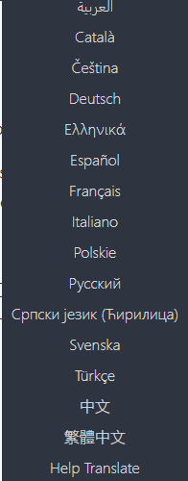
- Language Requirements
Many languages are available for the website (https://warrior.js.org/en/) but the game itself uses English exclusively.
On the right side the languages available on the website and documentation are presented. Contributors can help with translate, and new languages are added day by day.

User Documentation
WarriorJS offers rich documentation, from how to get started and install the game, to how the components works, play the game, create your own towers and even how to contribute. Everything you need to know is presented on the links below.

- Players Documentation
https://warrior.js.org/docs/en/player/overview

- Makers Documentation (Those that want to make their own tower)
https://warrior.js.org/docs/en/maker/introduction

- Contributing Guidelines
https://github.com/olistic/warriorjs/blob/master/CONTRIBUTING.md

- Overview (README)
https://github.com/olistic/warriorjs/blob/master/README.md

Assumptions and Dependencies

Online Play
WarriorJS is a free to play browser game. That means it can be compiled (JIT Compilation) and executed in the browser. The only third party program you need is a web browser such as Google Chrome, Mozilla, Microsoft Edge, etc. and an internet connection to launch the game from the website (https://warriorjs.com).

Offline Play
Internet connection in WarriorJS is optional since the game can be installed from npm. Node.js >= 8 needs to be installed in the computer before running the npm command.
Then open terminal and run the following:
npm install --global @warriorjs/cli
After installing the game, execute it by running the following command in terminal:
warriorjs
An IDE with integrated terminal such as Visual Studio Code is like the default option to go.

External Interface Requirements

User Interfaces
This section analyzes the basic UI components of warriorjs. The online and offline UI elements are both presented on this section with some sample screen images (Both online and offline UI are almost the same). Some snapshots of the game UI will be presented on this session.
Online Play (https://warriorjs.com)
GAME START:
User can press the ‘PLAY FOR FREE’ button for the game to start.
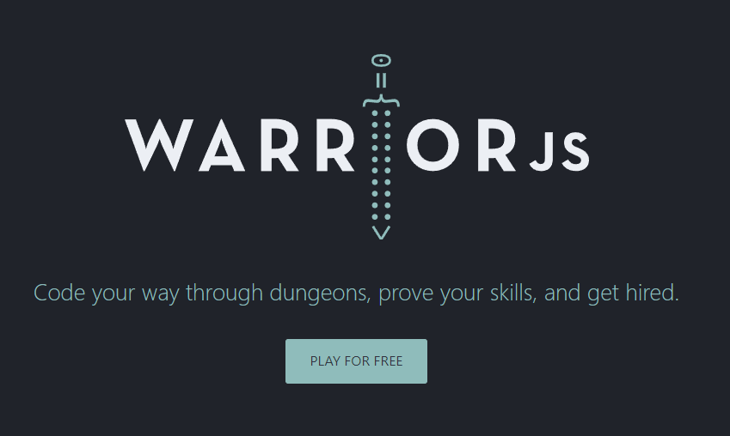

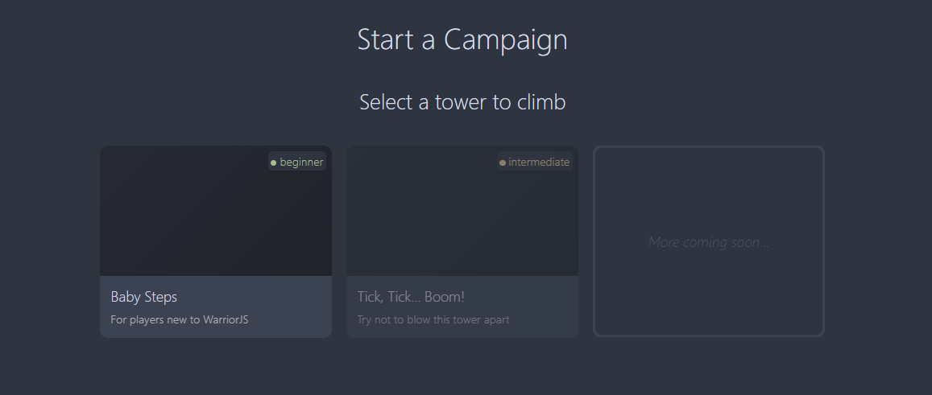
SELECTING DIFFICULTY:

CHOOSE A NAME:
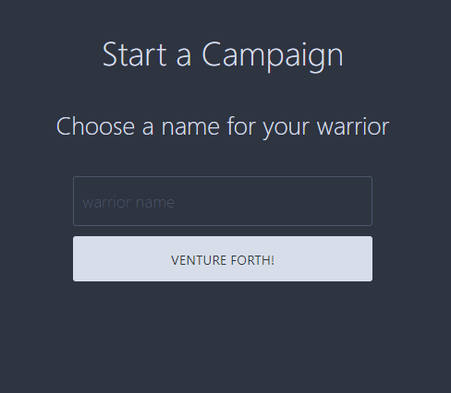

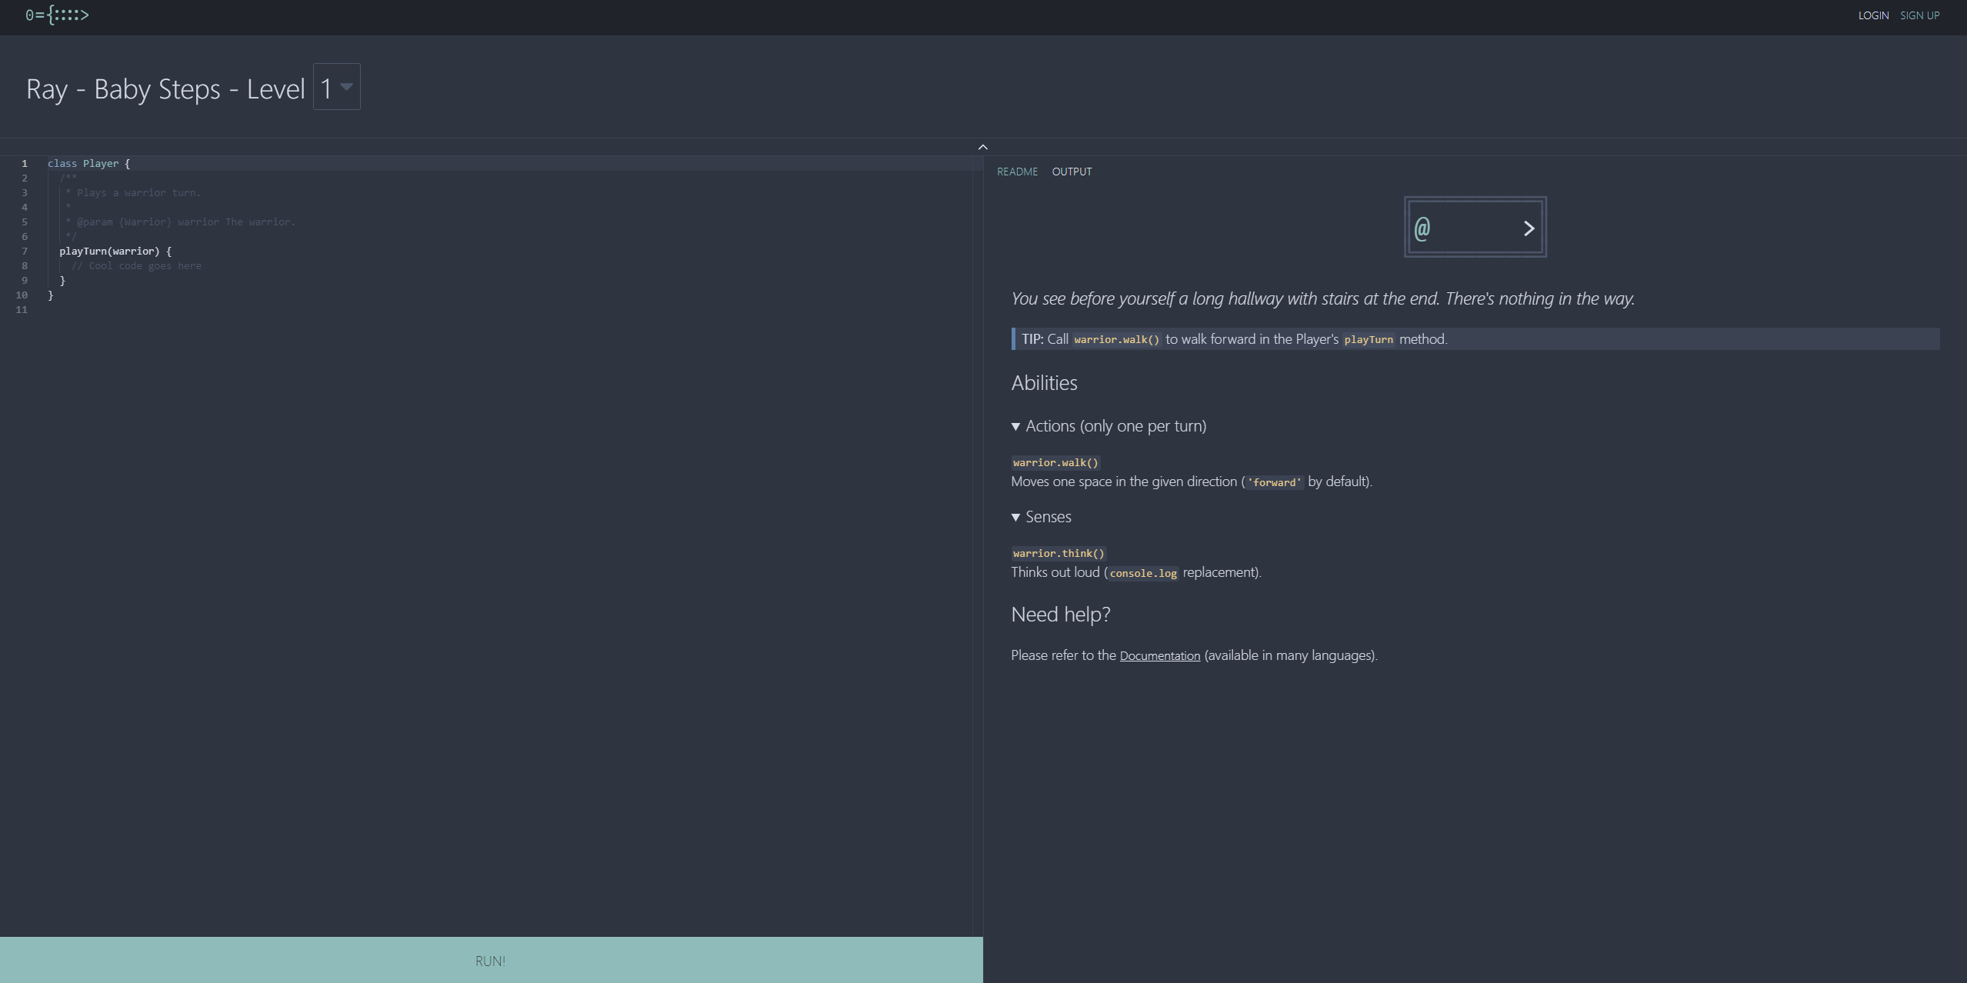
MAIN GAME UI: (Left and right side will be presented both ahead)

SCRIPT UI (TOP-LEFT SIDE):

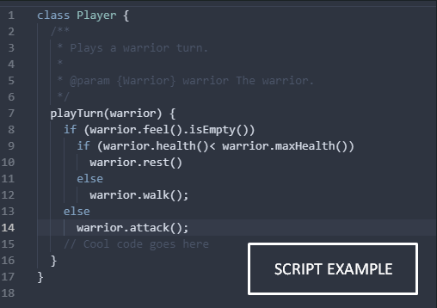

RUN BUTTON (BOTTOM-LEFT SIDE)
README UI: (RIGHT SIDE)
The white rectangles and text are presented only in those image samples not in the actual game in order to understand the UI better.
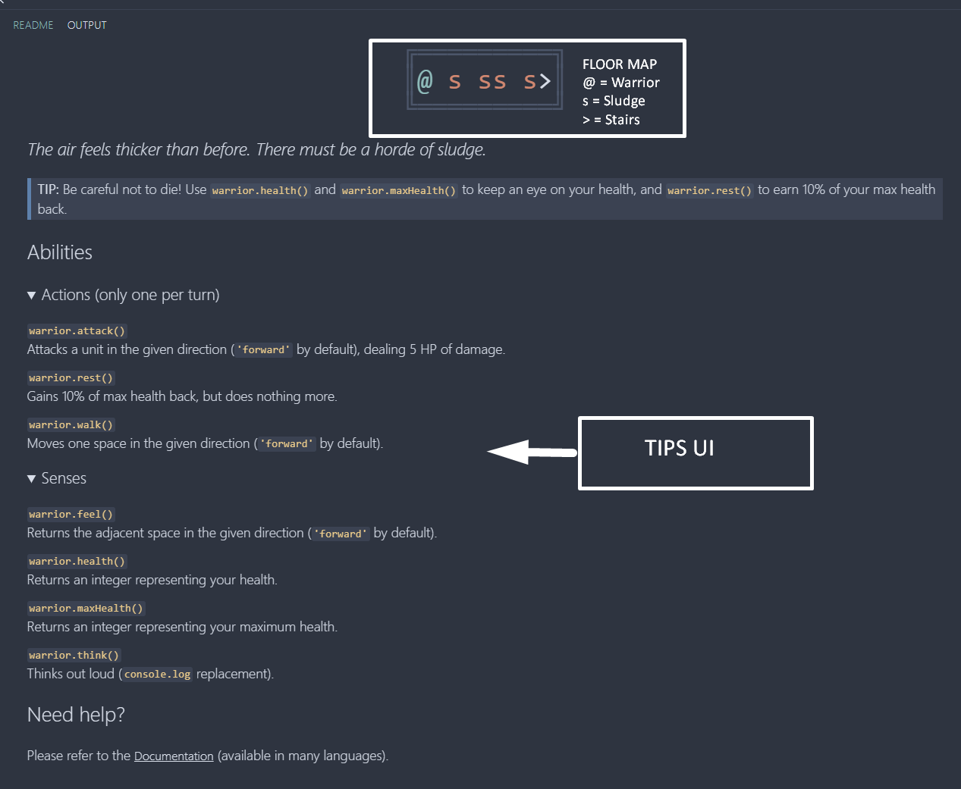

OUTPUT SNAPSHOTS: (Shows the actual gameplay snapshot after hitting the run button)
Two pictures are presented below in order to see the warrior’s movement and sludge clearing. The first picture shows the warrior in before the first sludge, while the second shows the warrior before the last sludge. When someone hits run the warrior starts executing the script. Every turn the commands in PlayTurn() function are executed again and again until:
- Warrior successfully clears the floor.
- Warrior dies. (Wrong movements. Script needs modification)
- Warrior is caught in an endless loop ( Script needs modification)
- Code Error (Script needs modification)
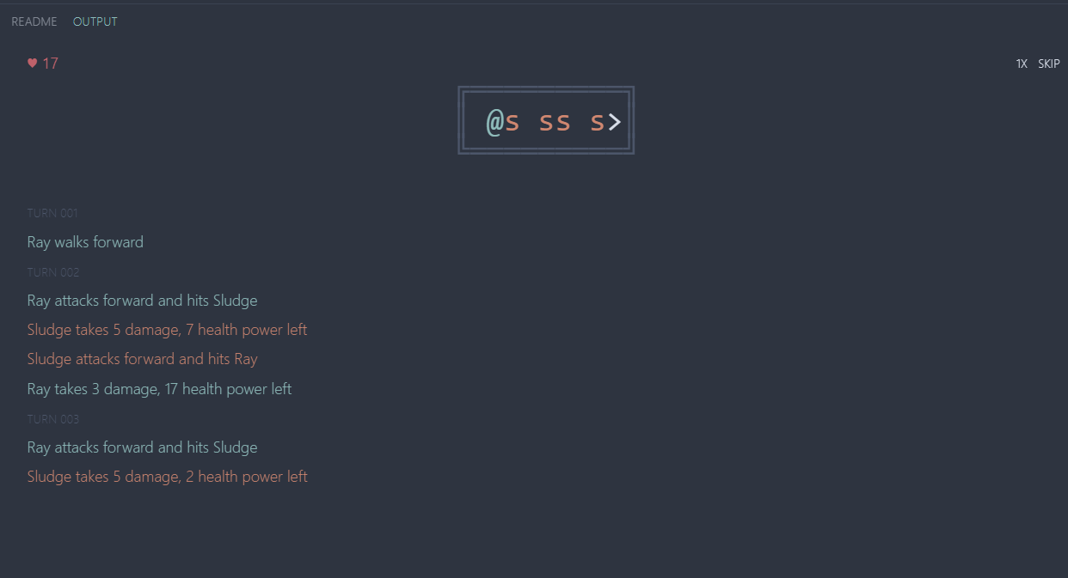
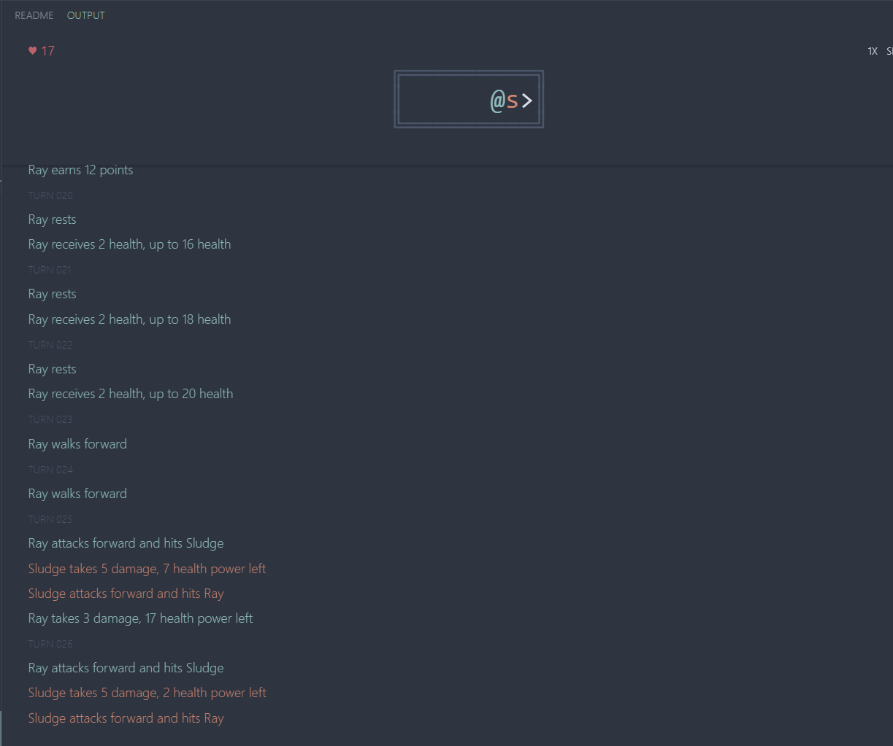
ERROR EXAMPLE: Example of a syntax error below
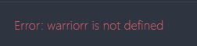

SUCCESS – SCORE UI:
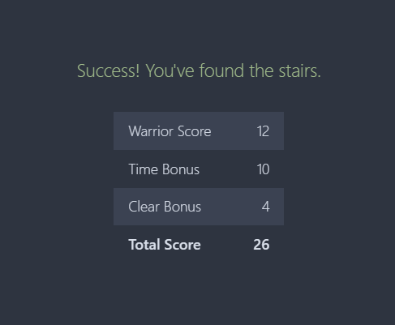

LEVEL FAIL – ADDITIONAL CLUES

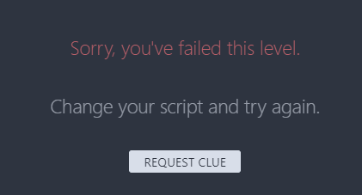

That concludes the online play interface. We move on to the offline play interface.

Offline Play
Pictures are taken in Visual Studio Code IDE and use the vs code integrated terminal

GAME START: (CLI)
Install game from npm as explained before. Then type ‘warriorjs’ in terminal to choose a profile and start playing.
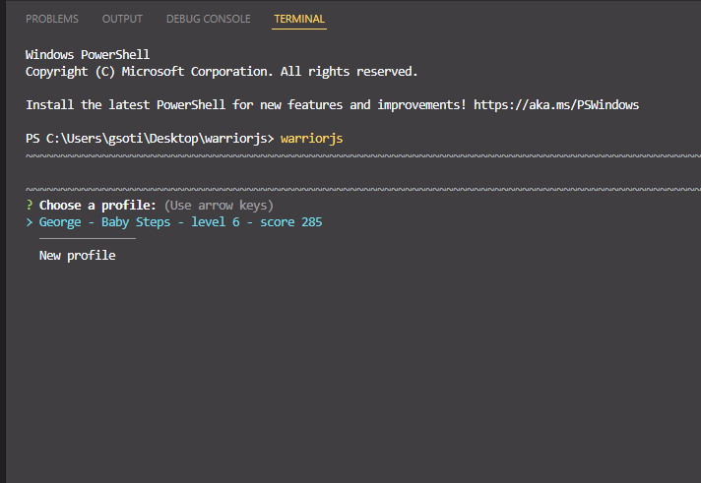

OFFLINE PLAY GENERAL IMAGE SAMPLE: Level 6 – code not tested. An overall image sample with the script file, the README file, and the terminal.
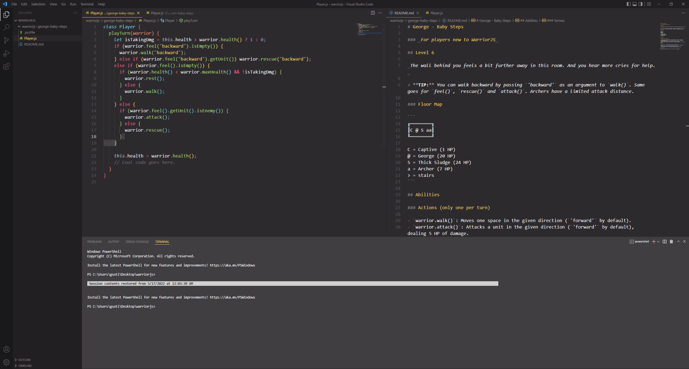

LEVEL 1 GAMEPLAY SNAPSHOTS: (Two images first one with the code-readme. Second one after we run ‘warriorjs’ in terminal for the game to start running.
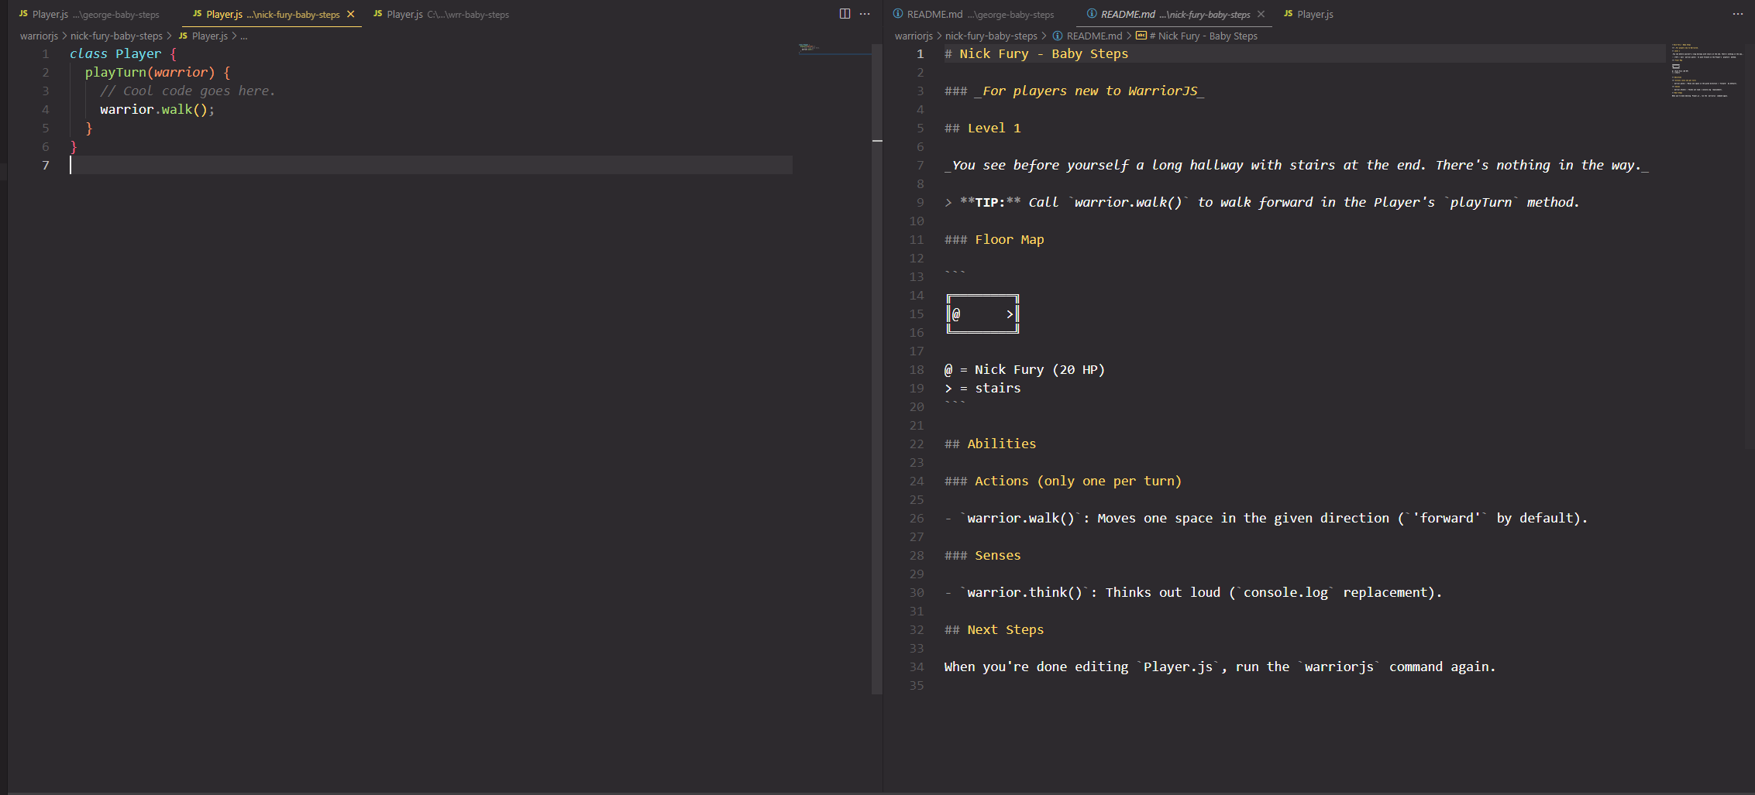

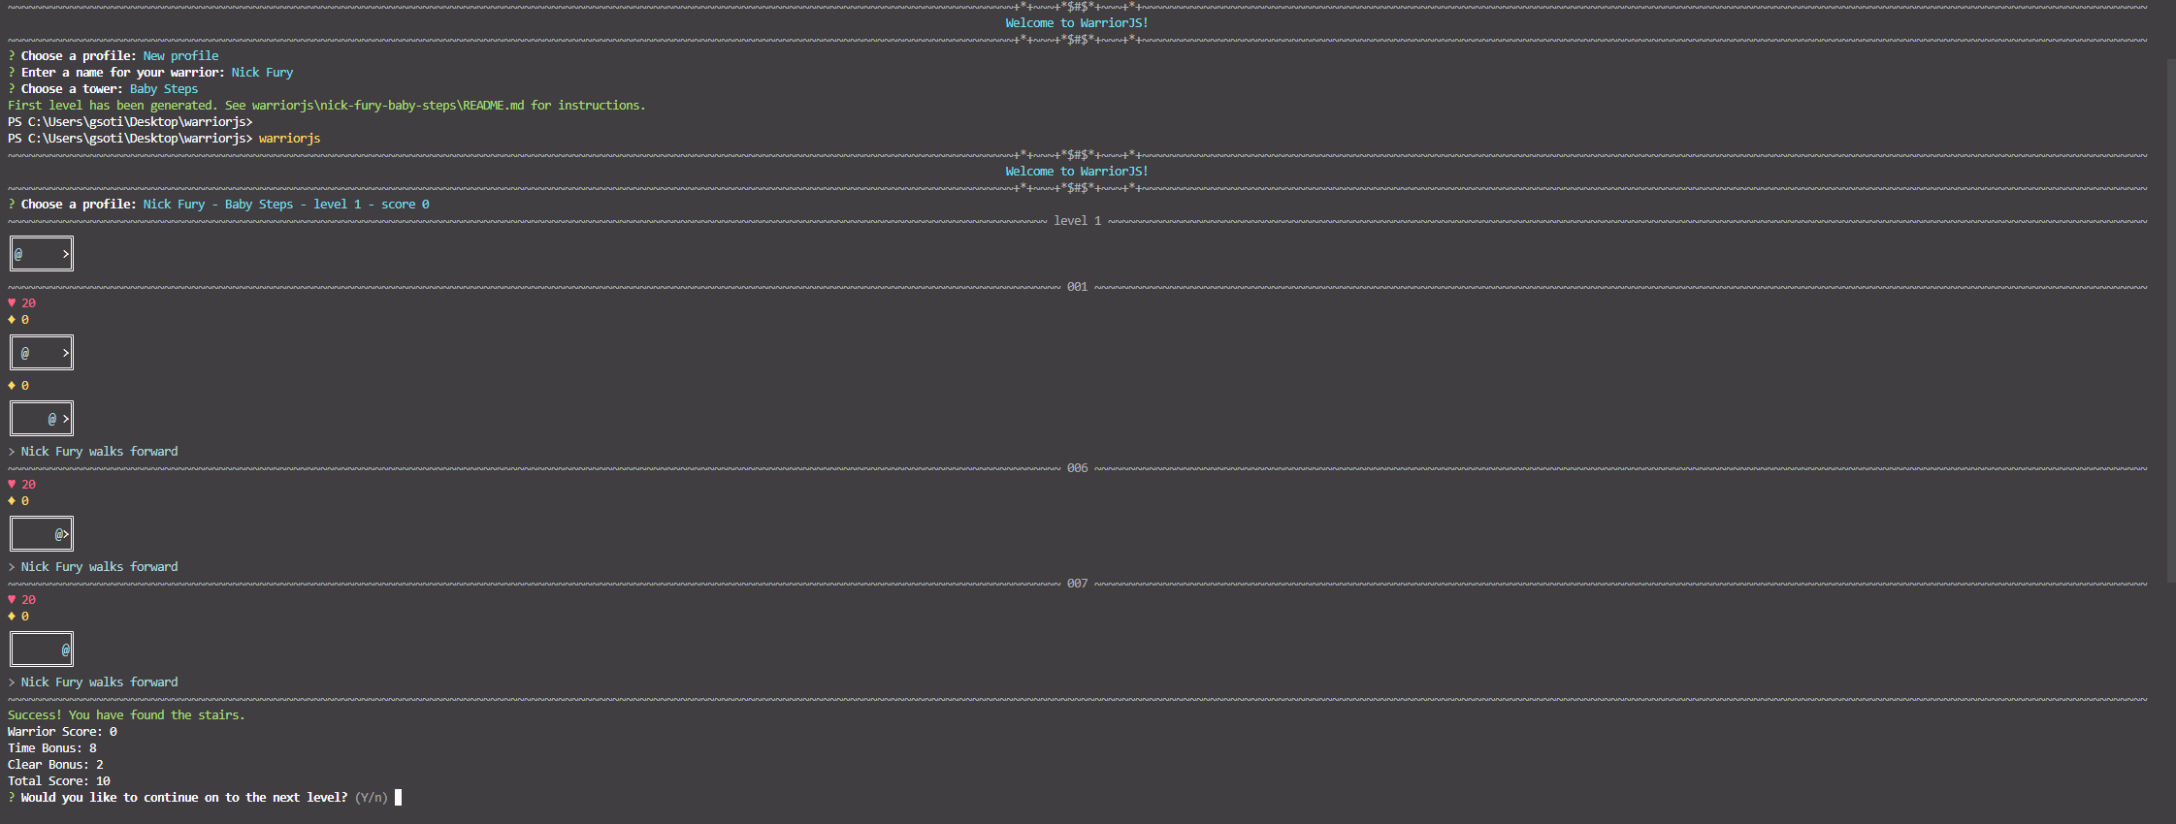
SUCCESS – SCORE UI: Score UI is integrated on the terminal as seen in the picture above. Here another picture of success UI is presented with warrior score, time bonus, clear bonus and total score. Need to type ‘Y’ or ‘y’ to proceed to the next level.

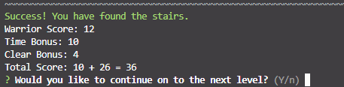

ERROR EXAMPLE: (Example of a syntax error shown in terminal)
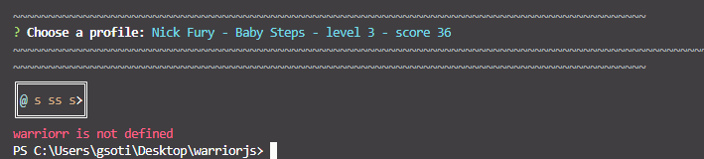

LEVEL FAIL – ADDITIONAL CLUES

That concludes the offline play interface.

Hardware Interfaces
Supported Browsers

WarriorJS supports all the latest stable releases of the major browsers and platforms. That includes, Internet explorer, Microsoft Edge, Firefox, Google Chrome, Safari, Opera etc. Overall, WarriorJS should function correctly in all major browsers. That includes mobile devices default browsers and desktop browsers.

Hardware Devices

WarriorJS supports both mobile and desktop devices. Hardware Requirements are minimum since it’s a CLI game with no graphical interface. Most modern platforms and devices are supported without issues.

Software Interfaces
WarriorJS online supports all the major operating systems including every recent window version (XP,Vista,7,8,8.1,10,11) most Linux distributions , and MacOS - iOS releases. For online play a major web browser is the only software required to play WarriorJS through the website (https://warriorjs.com/). For offline play Installation of warriorJS is available with npm. That means a windows terminal is required for windows or bash for Linux. As mentioned above warriorJS offline is a CLI game, meaning the user interface of the game is the command line.

Communications Interfaces
WarriorJS requires an internet connection and a browser to play online via https://warriorjs.com/). For offline play installation with npm is a one-time requirement. That means internet connection is required only for the installation. After that users can use WarriorJS offline without internet connection.

System Features

Map
Game map is a core feature of WarriorJS. Players are using the map to decide how they are going to write the script and check the quality of their code. Users interact with the map in every stage of the game in order to climb the tower. That makes it high priority feature. The map entity is updated in every turn of the game so users can see if their code functions as it should, or not, or it’s stuck in an endless loop.
Even before scripting, users can check the map of the current stage to determine a plan on how to approach this level. When this is done, the script is running and the map is updated each turn based on the script. One important feature of the map entity is that it can act as a debugger since the user can match the warrior actions in the map with their script.
An example on the map update process is given ahead for the Level 2 of ‘Baby Steps tower’.

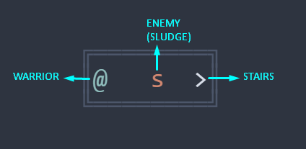
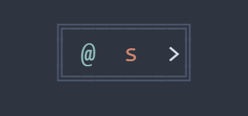
Starting State (Turn 1) Turn 2

Turn 3 Turn 4
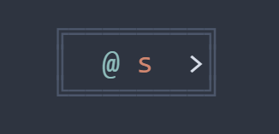
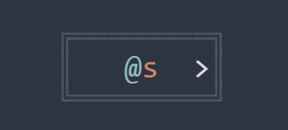

Turns 5, 6 Turn 7
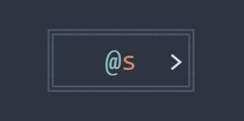
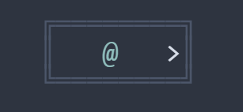
(Warrior attacking sludge until it’s defeated) (Sludge is defeated)

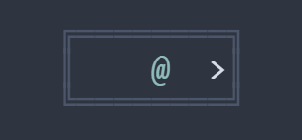

Turn 8 Turn 9

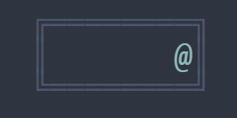
Turn 10 End (stairs reached- success)
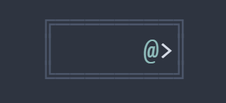

Units
WarriorJS contains a plethora of units. Units are a core system feature that defines the gameplay. They are either friendly or hostile. Warrior himself, is considered a unit since it contains and inherits the characteristics of the unit class. Units of a certain level have a given position on the map, and can be distinguished with their signature symbol and color. Every unit contains a different character as a map symbol, and warrior unit can change position each turn with the given function (warrior.walk()). A detailed description of each unit is given below.

- Archer
Type: Hostile
Symbol: ‘a’
Color: #ebcb8b
Max Health: 7
Abilities:
{
Look: Range 3
Shoot: Range 3, Power 3
}

- Sludge
Type: Hostile
Symbol: ‘s’
Color: #d08770
Max Health: 12
Abilities:
{
Feel
Attack: Power 3
}

- Thick Sludge
Type: Hostile
Symbol: ‘S’
Color: #bf616a
Max Health: 24
Abilities:
{
Feel
Attack: Power 3
}

- Wizard
Type: Hostile
Symbol: ‘w’
Color: #b48ead
Max Health: 3
Abilities:
{
Look: Range 3
Shoot: Range 3, Power 11
}

- Captive
Type: Friendly
Symbol: ‘C’
Color: #81a1c1
Max Health: 1
Reward: 20
- Warrior (User’s unit-Special unit)
Type: Friendly (in user’s control)
Character: ‘@’
Color: #8fbcbb
Max Health: 20
Abilities: Section 4.3 ahead presents detailed information about warrior abilities.

Abilities
WarriorJS contains unit abilities. This core feature make the units interact with each other or with the environment. Unit abilities have a number of utilities essential to the gameplay. Warrior (user) can use abilities to walk, defeat foes and save captives, thereafter proceeding the game. He can even display his health, heal, or type (think command). On the other hand hostile non-player characters are using abilities to attack the warrior thus making the game more challenging. Units are practically functions either players or npc’s use. A detailed description of each ability function is given below.

- Attack
Parameter: power
Description: Attacks a unit in the given direction, dealing $power HP of damage.
Direction: Default (Forward)

- Bind
Parameter: None
Description: Binds a unit in the given direction, to keep him from moving.
Direction: Default (Forward)

- Detonate
Parameter: targetPower, surroundingPower
Description: Detonates a bomb in a given direction dealing $targetPower HP of damage to that space and $surroundingPower HP of damage to surrounding 4 spaces.
Direction: Default (Forward)

- Direction Of
Parameter: None
Description: Returns the direction $FORWARD, $RIGHT, $BACKWARD, $LEFT to the given space.
Direction: Default (Forward)

- Distance of
Parameter: None
Description: Returns an integer representing the distance of the given space.
Direction: Default (Forward)

- Feel
Parameter: None
Description: Returns the adjacent space in the given direction.
Direction: Default (Forward)

- Health
Parameter: None
Description: Returns an integer representing your health.
Direction: None

- Listen
Parameter: None
Description: Returns an array of all spaces which have units in them (excluding yourself).
Direction: None

- Look
Parameter: Range
Description: Returns an array of up to $range spaces in the given direction.
Direction: Default (Forward)

- Max Health
Parameter: None
Description: Returns an integer representing your maximum health.
Direction: None

- Pivot
Parameter: None
Description: Rotates unit in the given direction (default – backward).
Direction: Default (Backward)

- Rescue
Parameter: None
Description: Releases a unit from his chains in the given direction.
Direction: Default (Forward)

- Rest
Parameter: healthGain
Description: Gains $healthGainPercentage ($healthgain * 100) of max health back but does nothing more.
Direction: None

- Shoot
Parameter: power, range
Description: Shoots in the given direction, dealing $power HP of damage to the first unit in a range of $range spaces.
Direction: Default (Forward)

- Think
Parameter: None
Description: Thinks out loud (Console.log replacement)
Direction: None

- Walk
Parameter: None
Description: Moves one space in the given direction.
Direction: Default (Forward)

Command Line Interface – Loaders
As mentioned, WarriorJS is a CLI game. A connection between user interface and command line is essential. WarriorJS uses loaders to get towers, levels, and profiles info from external files. Game class defines the directory under which the game will run and the asynchronous start method brings everything together and starts the game.

Other Nonfunctional Requirements

Performance Requirements
Performance requirements in WarriorJS are directly dependent on the code quality of the user. Since WarriorJS functions via code writing the user can affect the script runtime and system memory. In simple words the user can make the game slow. Endless Loops, nested repetitions, high memory usage can impact the quality of the game. Practicing in making code quality better can help the users not only play WarriorJS but more importantly becoming better programmers. Some handy tricks for writing good quality code are presented below.

    - Write visible clear code
    - Put comments in your code
    - Use variable naming conventions
    - Avoid unneeded nested repetitions
    - Organize your code in functions

Safety Requirements
To ensure that users don’t lose their profile data, score and levels, it’s a good practice to keep a backup of the save folder that system uses to continue the game.

Security Requirements
WarriorJS does not have any security requirements. Any type of user can use the program without additional or less privileges.

Software Quality Attributes
WarriorJS provide features for both beginners and expert programmers. As we mentioned every type of programmer can benefit by playing the game thus coding.
It’s important to clarify that users need to have at least a basic knowledge of javascript coding in order to play the game.

