GLA UNIVERSITY, GREATER NOIDA
Greater Noida – 201310, Uttar Pradesh, India

Production Line Quality Risk Advisor
SOFTWARE REQUIREMENT SPECIFICATION
Version 1.0
BACHELOR OF TECHNOLOGY
in
COMPUTER SCIENCE & ENGINEERING - AI
Submitted By
<FULL NAME OF STUDENT>
Roll No.: <ROLL NUMBER> | Section: <SECTION>
Under the Supervision of  <SUPERVISOR NAME>  GLA University, Greater Noida | Reviewed By  <REVIEWER NAME>  GLA University, Greater Noida

SCHOOL / DEPARTMENT OF COMPUTER SCIENCE & ENGINEERING / APPLICATIONS
GLA UNIVERSITY, GREATER NOIDA – 201310
<MONTH, YEAR OF SUBMISSION>

Revision History

Version | Date | Change | Reason
1.0 | <DD-MM-YYYY> | Initial version | First submission
<1.1> | <DD-MM-YYYY> | <e.g. FR-2.2 removed from MVP; FR-1.4 added to MVP> | <e.g. Weekly aggregation turned out to need no separate upload screen>

1. Introduction

1.1 Purpose

This document specifies the requirements of Production Line Quality Risk Advisor, a machine-learning-based quality risk assessment and decision-support application for manufacturing quality engineers. It defines the requirements for identifying elevated machine-failure risk, analyzing production conditions, prioritizing observations, and presenting understandable risk information.

1.2 Scope

The system will focus on manufacturing quality-risk assessment and machine-failure classification using structured production data. It will include data preprocessing, exploratory and statistical analysis, feature preparation and selection, machine-failure risk classification, model comparison and cross-validation, risk prioritization, model interpretation, interactive visualization, and a user-facing application for quality engineers. The system does not control machinery, automatically shut down production equipment, or guarantee real-world machine safety.

1.3 Definitions

Term | Definition
Production observation | A record of production and operating conditions used for quality-risk assessment.
Quality risk | The likelihood that a production observation is associated with machine failure or a quality problem.
Risk prioritization | The process of ranking potentially risky observations for further inspection.

2. Overall Description

2.1 User Classes

User class | Who they are | What they may do
Quality engineer | A manufacturing quality professional using the application for quality-risk assessment. | Examine risk, compare historical patterns, identify contributing factors, and prioritize observations for inspection.
Quality-control supervisor | A quality-control professional responsible for inspection decisions. | Review prioritized observations and use production and risk patterns to support inspection decisions.

2.2 Assumptions and Dependencies

- The system depends on the AI4I 2020 Predictive Maintenance Dataset from the UCI Machine Learning Repository; the dataset is synthetic and conclusions are limited to the available structured production data.
- The user-facing application depends on Streamlit and Plotly for interactive visualization and uses SHAP for model explanations.
- The analyst report depends on Power BI or Tableau for KPIs, drill-downs, heatmaps, and process-condition relationships.

2.3 Constraints

C1 The AI4I 2020 dataset is synthetic, so the system cannot claim that its results guarantee real-world machine safety.
C2 The machine-failure classes are highly imbalanced, so accuracy cannot be used as the primary performance measure.

3. Data Source and Baseline

Item | Value | Required now?
Dataset name | AI4I 2020 Predictive Maintenance Dataset | Yes
Source and URL | UCI Machine Learning Repository — https://archive.ics.uci.edu/dataset/601/ai4i+2020+predictive+maint | Yes
Licence / terms of use | Creative Commons Attribution 4.0 International (CC BY 4.0) | Yes
Number of rows and columns | 10,000 rows and 14 columns | Yes
Prediction target | Machine Failure | Yes
Task type | Binary classification — predict whether a production observation is associated with machine failure. | Yes
Class balance | 96.61% non-failure (0); 3.39% failure (1) | Yes
Primary evaluation metric | Precision@K | Yes
Why that metric | It measures how many of the K observations prioritized by the system are actual failure cases, matching limited inspection capacity. | Yes
Level 0 baseline and its score | Majority-class baseline: 96.61% accuracy; Precision@K is not meaningful because all observations receive the same score. | Yes
Known data quality problems | No missing values and no duplicate rows were found. The target is highly imbalanced, and failure-mode columns TWF, HDF, PWF, OSF and RNF can cause target leakage if used as ordinary inputs. | Yes
Level 1 baseline and its score | Majority class within each Product Type; score to be calculated during evaluation. | Later
Target for this release | The model must outperform the Level 1 baseline on Precision@K to justify the risk-prioritization feature. | Later

4. System Architecture

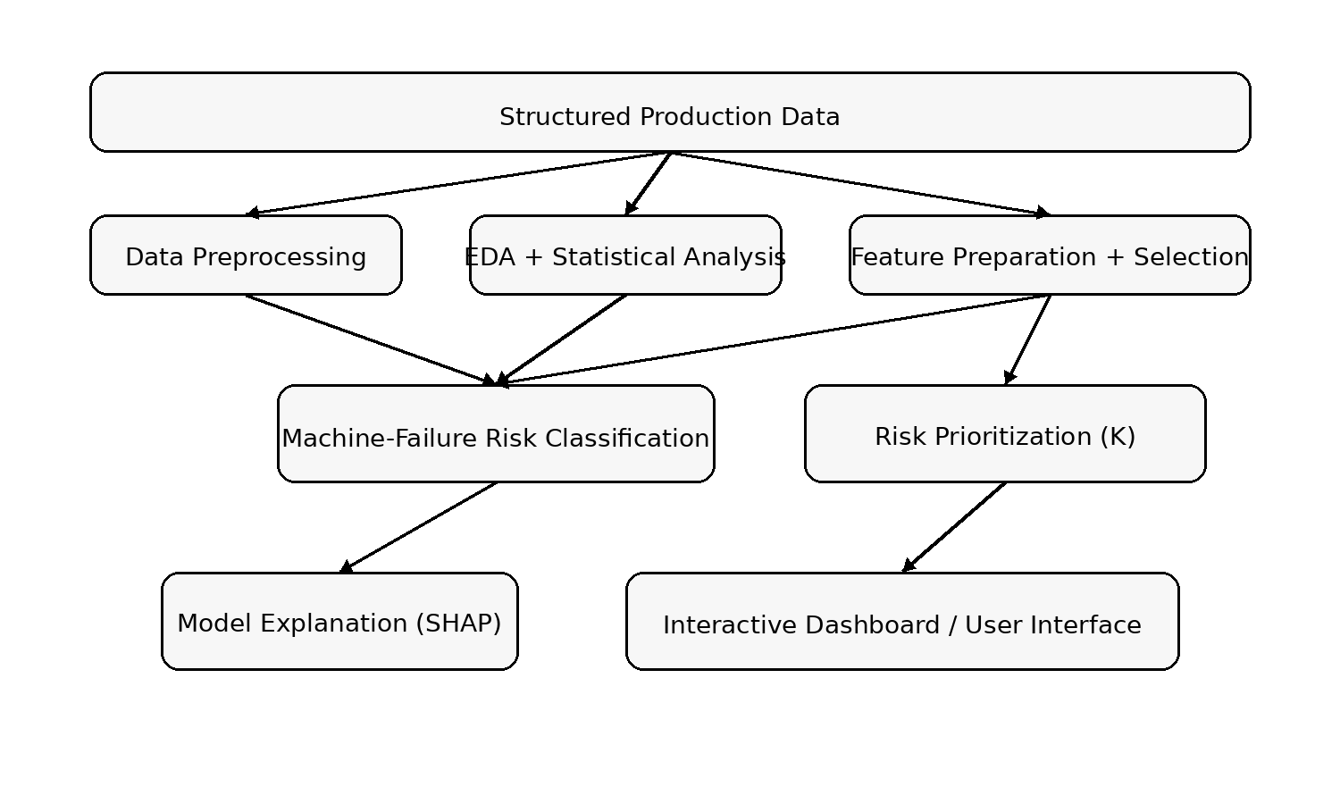
Figure 1: System architecture for production quality-risk assessment

Component | Responsibility
Data preprocessing | Loads structured production data, handles missing values and outliers, and prepares the data for analysis.
Statistical analysis | Explores distributions, correlations, failure patterns, and statistical relationships.
Classification model | Estimates machine-failure risk from selected production and operating-condition features.
Risk prioritization | Ranks potentially risky observations according to the inspection capacity K.

5. Functional Requirements

5.1 Quality Risk Assessment and Analysis
FR-1.1 The system shall preprocess structured production data, including handling missing values and outliers.
FR-1.2 The system shall identify and report missing required production-data fields before classification.
FR-1.3 The system shall perform exploratory data analysis and statistical analysis on production conditions.
FR-1.4 The system shall prepare and select features for machine-failure risk classification.

5.2 Model-backed Requirements

FR-2.1 The system shall accept production and operating-condition features as input for machine-failure risk classification and exclude identified failure-mode indicators from ordinary predictive inputs.
FR-2.2 The system shall return a machine-failure risk classification for a valid production observation.
FR-2.3 The system shall present the predicted risk together with information on factors contributing to the predicted risk.
FR-2.4 The system shall compare machine-learning classification results with the Level 0 and Level 1 baselines and report the comparison.
FR-2.5 The system shall allow the quality engineer to select K and view observations prioritized for further inspection.

6. Non-Functional Requirements

NFR-1 The system shall use cross-validation and Precision@K for model performance evaluation.
NFR-2 The system shall use SHAP-based model explanations to present factors contributing to predicted risk.
NFR-3 The system shall record model-comparison and performance-evaluation results for reporting.
NFR-4 The system shall provide an interactive visualization interface using Streamlit and Plotly.

7. Build Plan

7.1 Minimum Viable Product

FR / NFR ID | Requirement (short) | Why this one is in the MVP
FR-1.1 | Data preprocessing | Provides prepared production data for later analysis.
FR-1.3 | Exploratory and statistical analysis | Establishes production and failure patterns before classification.
FR-1.4 | Feature preparation and selection | Provides the inputs required for machine-failure risk classification.
FR-2.2 | Machine-failure risk classification | Provides the core risk-assessment capability.
FR-2.5 | Risk prioritization by K | Supports inspection prioritization when capacity is limited.
NFR-1 | Model performance evaluation | Ensures classification and decision-oriented performance are evaluated.
NFR-4 | Interactive visualization | Allows quality engineers to explore production and risk patterns.

Deliberately not in the MVP: FR-2.3 Model explanation. The project would first need validated model behavior and factor-contribution outputs before treating explanations as a completed MVP feature.

7.2 Build Order

For reference, the fixed project stages:
Stage | Deliverable | Date
Development Sprint I | Prototype / initial working model | 27 Sep 2026
Development Sprint II | 50% functional application | 17 Oct 2026
Development Sprint III | 75–80% functional application | 7 Nov 2026
Testing & Validation | Test report and bug log | 17 Nov 2026
Deployment & Documentation | Deployed application, user manual, technical documentation | 30 Nov 2026
Final Presentation | Final report, presentation and viva | 5–10 Dec 2026

Your plan:
Stage | What will be working by then | FR / NFR IDs | How I will know it is done
Sprint I27 Sep | Data preprocessing, EDA, and initial classification | FR-1.1, FR-1.3, FR-1.4, FR-2.2, NFR-1, NFR-4 | Demonstrate prepared data, initial analysis, risk classification, and interactive exploration.
Sprint II17 Oct | Risk prioritization and model comparison | FR-2.5, FR-2.4 | Demonstrate K-based prioritization and comparison with statistical baselines.
Sprint III7 Nov | Model explanations and complete user-facing application | FR-2.3, NFR-2, NFR-3 | Demonstrate contributing factors and recorded performance results.
Testing17 Nov | Testing and performance evaluation | FR-1.1, FR-1.2, FR-1.3, FR-1.4, FR-2.1, FR-2.2, FR-2.3, FR-2.4, FR-2.5 | Demonstrate test report, performance evaluation, and validation of the workflow.
Deployment30 Nov | Deployed application and documentation | FR-2.5, NFR-4 | Demonstrate the deployed user-facing application and documentation.

8. Data Requirements

8.1 Entities

Entity: Production Observation
Field | Type | Constraint / Notes
id | Integer | Unique observation identifier (UDI).
Product ID | String | Product identifier.
Type | Categorical | Product variant: L, M, or H.
Machine Failure | Integer | Target value: 0 = no failure, 1 = failure.

Other entities: Model result, risk priority, feature importance, visualization.

8.2 Entity Relationship Diagram

9. Design Decisions and Alternatives Considered

# | Decision | Alternative rejected | Reason
D1 | Combine machine learning, statistical analysis, and interactive visualization | Prediction-only model | The project is intended as a quality-risk assessment and decision-support application rather than only a prediction model.
D2 | Use machine-failure risk classification | Treat the task as regression | The stated objective is to identify production observations with elevated machine-failure risk, which is a binary classification task.
D3 | Include risk prioritization based on limited inspection capacity | Inspect all observations equally | The project specifically aims to prioritize potentially risky observations when inspection capacity is limited.

10. Acceptance Criteria

AC-1 A quality engineer examines production observations and the system displays the associated machine-failure risk for assessment.
AC-2 A quality engineer explores production conditions and failure patterns using the interactive visualization.
AC-3 Production data containing missing values or outliers is processed and the system reports the affected data during the quality-risk assessment workflow.
AC-4 A quality engineer selects an inspection capacity K and the system displays observations prioritized for further inspection.

11. Out of Scope for This Release

The system will not control machinery or automatically shut down production equipment. Its purpose is decision support for quality-control and inspection activities.
The system will not guarantee real-world machine safety. The AI4I dataset is synthetic and the application is intended to identify and prioritize production observations associated with machine-failure risk.
The system will not function only as a prediction model. Statistical analysis and interactive visualization remain part of the decision-support application.

