Motor power: performance measurement

All frequency measurements has been made without clamping the timer OCR value.

Frequency measurement

7.2 KHz +/- 1%

Minimum PWM

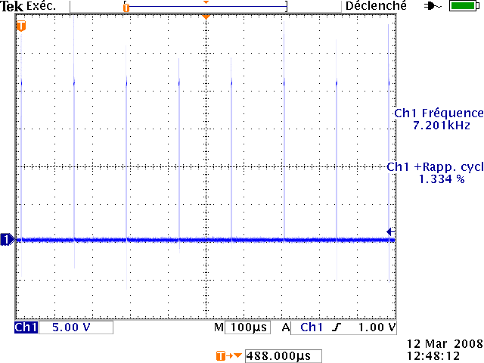

Minimum duty cycle: 1.4%
Minimum pulse width: 2µs

Maximum PWM

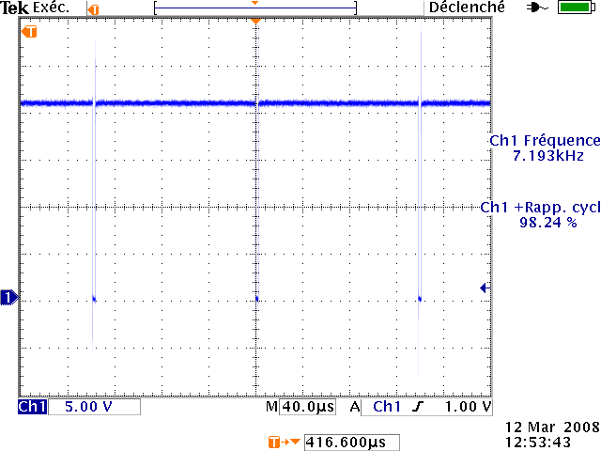
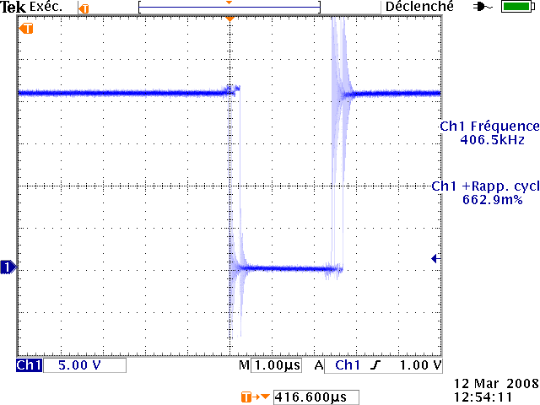
Maximum duty cycle: 98%
Minimum lower pulse width: 2.5µs

50% Duty Cycle

One output

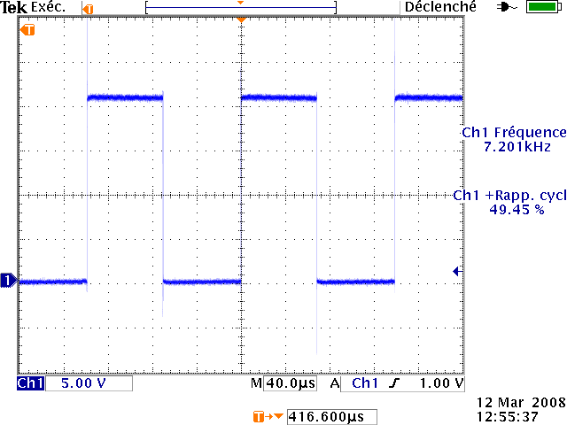

Both outputs
