

**Windows Engineering**

**CDKinit Program**

**Software Design Document**

1. **Introduction**

CDKinit is a program that aids in the user environment setup process through a programmer-specified configuration table. It is installed on Dealership PCs to ensure that each individual user will have their user environment set up probably to run CDK drive. It is intended to be a replacement to ADPinit, which was deprecated because it contained some obsolete functionalities that were no longer needed in the modern context.

1. **System Overview**
   1. **File Structure**

Upon installation, the CDKinit directory contains two components:

1. CDKinit.exe
2. Config.XML

|  |  |  |
| --- | --- | --- |
| File name | Description | Location |
| CDKinit.exe | The main program written in C#. Upon user login, it triggers events such as setting registry values, verifying existence of required files, setting .Ini file values, etc. | Installation Location |
| Config.XML | An XML file that contains the table-structures configuration of how the user environment should be set up. | Installation Location |

Table 2.1.0

* 1. **Software Architecture**

CDKinit.cs is composed of one namespace under which all classes derive their context from. The following enumerates the classes that are utilized in the program:

1. Iterator() – Class that, upon instantiation, iterators through all the nodes in the given Config.XML file and extracts all their respective attributes
2. ObjectFactory() – Takes a given XML node, determines its type(e.g. Registry, IniFile, File), and returns a BaseType child object based on that determined type.
3. File() – A child of the BaseType class. It contains functionality that ensures that a file exists in the given location. If the file doesn’t exist, it copies a backup file from the Installation Directory to the location in the user’s machine.
4. Registry() – A child of the BaseType class. It contains functionality that sets Registry key-values where they are declared
5. IniFile() – A child of the BaseType class. It contains functionality that modifies an IniFile’s key-values at a given section/
6. BaseType() – Parent class from which all “node” classes derive from. Requires its children to have create(), update(), delete(), and log() methods.

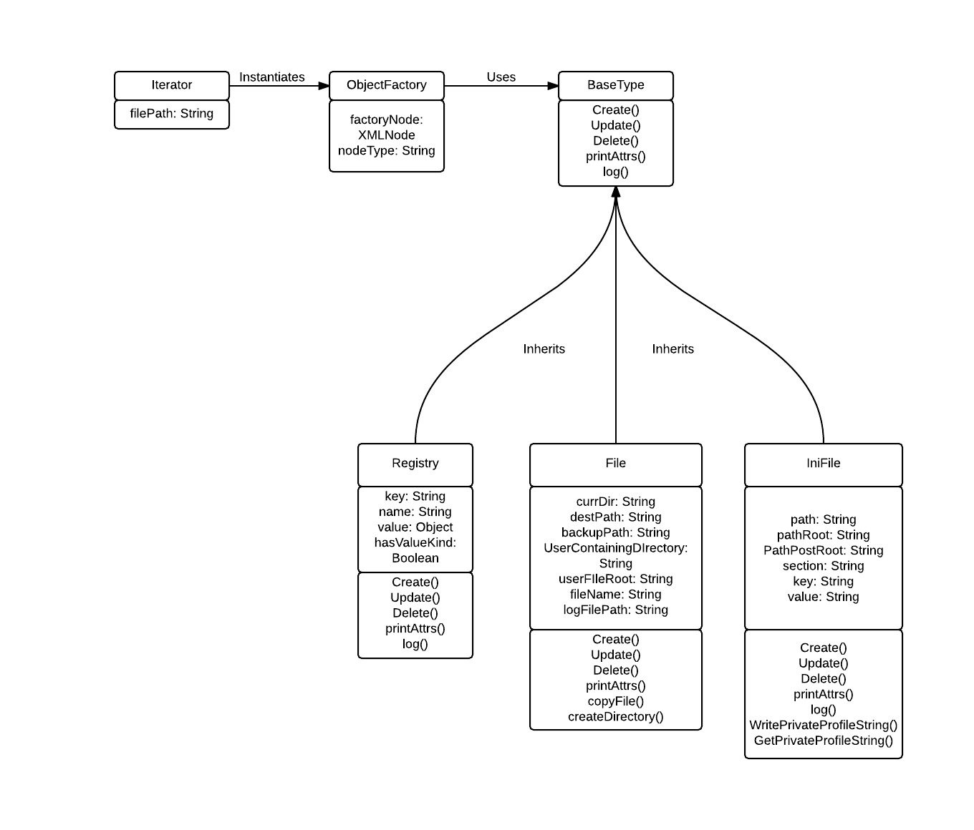

Diagram 2.2.0CDKinit class diagram

Config.XML is a table-structured file where each node represents the type that needs to be modified in the user environment setup process. Each child node attribute is configurable to any desired value. Some attributes may have dependencies on each other. The reason for this is so that CDKinit, would have all the individual pieces of information it needs to modify the environment. The following is a description of each node:

**Registry** – Represents a Registry setting

Attributes:

Key: The Registry Key where value will be modified

Name: The name in the key-value Registry pair

Value: The value that needs to be changed in the specified name

valueKind: The type of the given Registry value.

**File** – Represents a system file

Attributes:

FullPath: The full path in the user system to where the file must exist. There is no need to specify the full root directory. CDKinit will determine it based on the given “shortcut” keyword and create a path in the context of the local user environment. For example, if user “olivarp” is running CDKinit, specifying "Documents\Bluezone\config.docx" would be interpreted by CDKinit as “C:\Users\olivarp\Documents\bluezone\config.docx”

Name: The name of the target file in the file path (ex: “config.docx”)

rootLocation: The top directory location in FullPath (ex: “Documents”)

UserContainingDirectory: The Directory that contains the file in FullPath (ex: “Bluezone”)

BackupContainingDirectory: The Directory in the Installation location where a backup file will be found just in case the file isn’t found in the user’s system (ex: “Bluezone”)

**Ini –** Represents the Ini file to be modified.

FullPath: The full path to the .Ini document (ex:”Documents\IniDocuments\IniFoldersIni.Ini").

PathRoot: The top directory of the FullPath (ex:”Documents”).

PathPostRoot – The part of the path after the root (ex: “"IniDocuments\IniFoldersIni.Ini").

Section: The .Ini File section where value will be modified

Key: The key component of the key-value pair within the .Ini file section.

Value: The value that will be set.

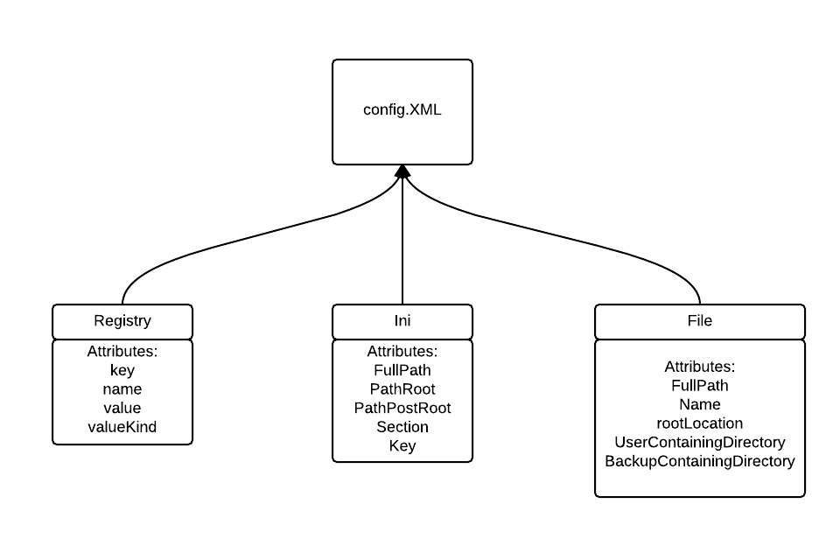Diagram 2.2.1 XML node structure

* 1. **Program Execution**

Any event could trigger the execution of CDKinit such as user PC reboot or modifying config.XML. The following are currently accepted argument flags for the program:

1. –config <configFilePath> : A required argument in which the file path for the .XML configuration file must be specified
2. –log <logFilePath> : An optional argument in which the file path for the .txt log file must be specified. If the flag is not declared as an argument, logging functionality will be turned off by default.

Once CDKinit.exe gets called with the appropriate arguments, Main will execute the follow processes:

1. Instantiate an Iterator Object with the XML file path passed in.
2. Iterator parses through the XML file.
3. For each node, Iterator will instantiate a new ObjectFactory object, with the XML node passed in as a parameter.
4. ObjectFactory uses a switch statement to determine the type of that node and returns an Object that is a child class of the BaseType class.
5. The create() method is then called on that ObjectFactory object. Certain tasks will be performed based on what was implemented in the create() of the child class. For example, Registry’s create() method sets Registry values, File’s create method() checks for file’s existence, IniFile’s create() method sets a value in the specified section of an ini file.

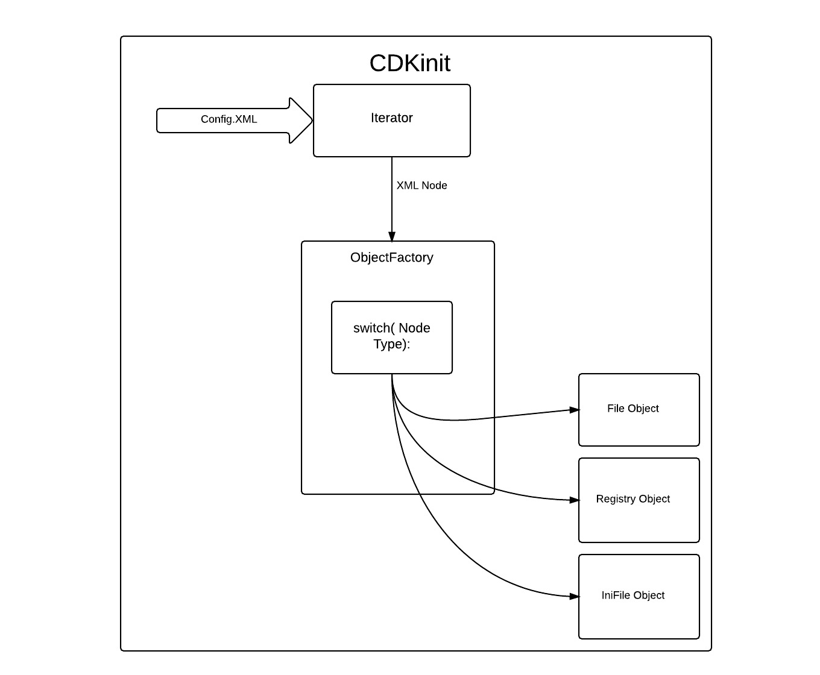

Diagram 2.3.0 CDKinit execution process