Pork Rub

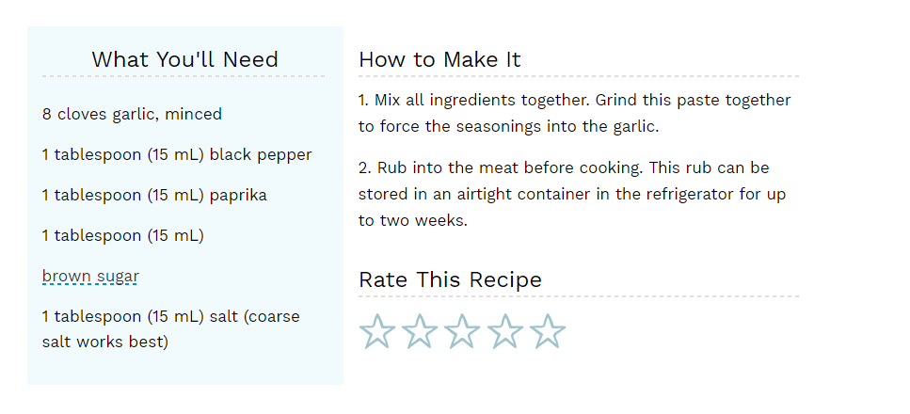

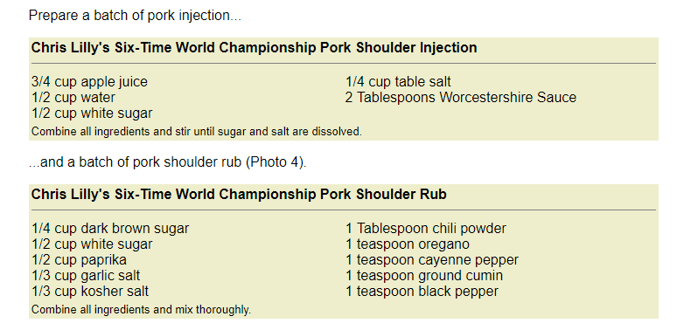

CHICKEN INJECTION RECIPE

HOMEMADE CREOLE BUTTER INJECTION MARINADE

INGREDIENTS:

* 1 stick of butter, melted
* 1-2 tablespoons of Cajun seasoning (depending on how much seasoning you want)
* 1 tablespoon garlic powder

DIRECTIONS:

1. Combine all ingredients together in a small bowl; whisk to combine. Put the mixture into your injector, and inject your poultry or pork all over, and at different angles. Roast as normal.
2. \*Double this recipe for injecting a turkey!

<http://www.mrshappyhomemaker.com/homemade-cajun-garlic-butter-injection/>