**Feedback:**

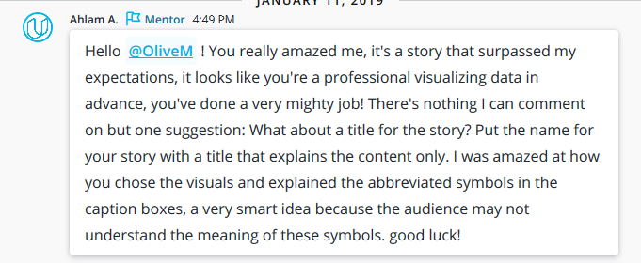

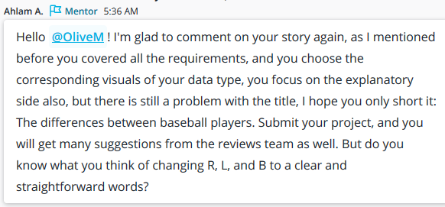

<https://study-hall.udacity.com/sg-346183-2559/rooms/community:nd002:346183-cohort-2559-project-948/community:thread-u40021535-428130?contextType=room>

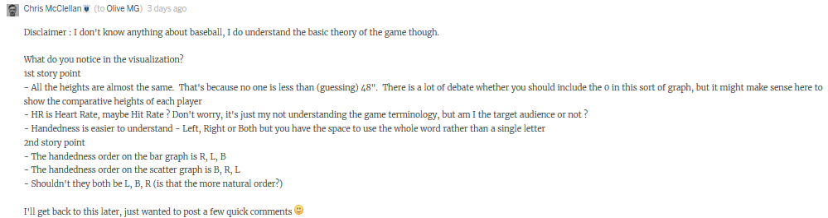

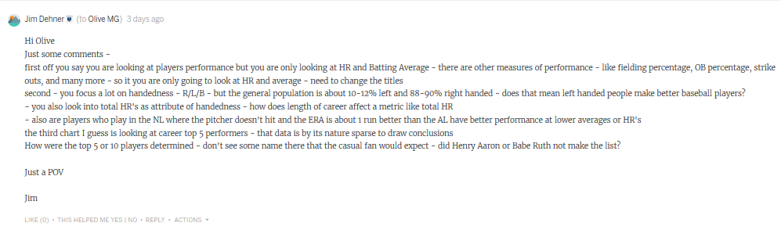

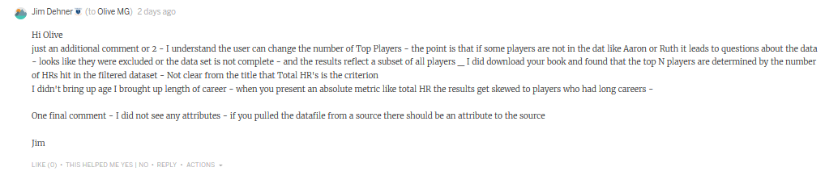

Source : https://community.tableau.com/inbox

Last comment :

