James:revature bridges client needsGenAI is the best technology out there, we are on best trackEssaki Perumal:

Trainers- maria & krishna gopiLots of challanges and bugsreach out to peerstalk to mentors very promptlybe open to learn and ask questions  
  
Maria:  
  
Focus on assignments and challenges  
  
Gopika:  
  
Gen AI is interesting topic and you’ll enjoy 9 week session.

Praveen:

Client expects you to be project ready from day 1

Learn latest tech skills

Communicate well with clients

You will do team and individual projects as well

Adhira:  
  
RRP (Revature Readiness Program)

* 8 to 9 week programming
* Tech, soft skills, role based learning
* Individual and team based projects
* Enterprise level projs

Quality checks:

* 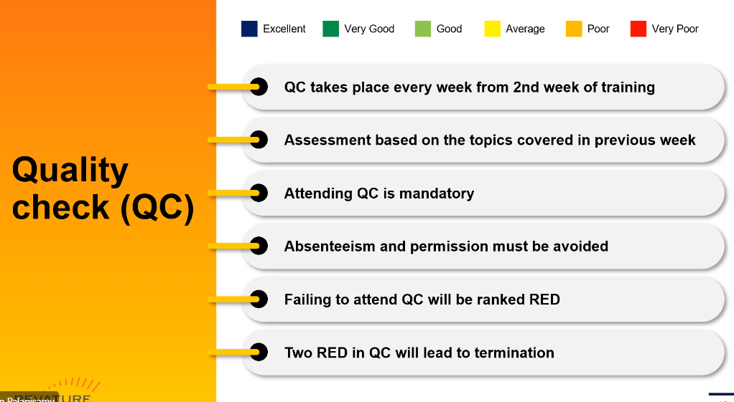

Mentain attendance in regular sessions

* Qc is mandatory
* Your profile is made on basis of QC for clients
* In case you are not able to crack the client interview, you will be in staging phase,

Leave policy: none during trainee

Documents:  
- aadhasr

Pan

Passport

10th, 12th , UG

We will make portfolio for ourself to showcase to clients

First Stipend cleared after 6th week,

Next stipend after 15th or 30th depending on date of joining

Refined Minutes:

Training Program Overview:

Revature Readiness Program (RRP) is an 8-9 week training.

Focus on technical, soft skills, and role-based learning.

Involves individual and team-based projects, including enterprise-level projects.

Trainers and Guidance:

Trainers include Maria and Krishna Gopi.

Emphasis on facing challenges and bugs.

Encouragement to reach out to peers and mentors promptly.

Expectations and Skills:

Clients expect trainees to be project-ready from day 1.

Emphasis on learning the latest tech skills.

Effective communication with clients is crucial.

Involvement in both team and individual projects.

Revature Readiness Program Details:

Quality checks (QC) are mandatory.

Trainee profiles for clients are based on QC results.

Staging phase if unable to crack client interview post-training.

Documentation and Portfolio:

Required documents: Aadhar, PAN, Passport, 10th, 12th, and UG certificates.

Creation of a portfolio to showcase to clients.

Stipend and Leave Policy:

First stipend cleared after 6th week, subsequent stipends on 15th or 30th based on joining date.

No leave during the training period.