# ASTM D3039 Test report

### Montreal 2022-03-27

D30 Committee. (2017). Test Method for Tensile Properties of Polymer Matrix Composite Materials. ASTM International. https://doi.org/10.1520/D3039_D3039M-17

Test done by: Your name

Comment on anomalies or problems encountered during testing: Write here

## Material Identification

* Material name: Flax
* Material type:
* Material source:
* Material code number:
* Date of material certification:
* Date of expiration for material certification:
* Filament diameter:
* Tow or yarn filament count and twist:
* Form or weave:
* Fibre areal weight:
* Matrix type:
* Prepreg matrix content:
* Prepreg volatile content:
* Composite material ply stacking sequence:

## Specimen preparation

* Fabrication start date:
* Fabrication end date:
* Process specification:
* Cure cycle:
* Consolidation method:
* Description of the equipement used:
* Average ply thickness (mm):
* Specimen coupon cutting method:
* identification of tab geometry, tab material, and tab adhesive used:
* Direction of cutting and loading of the specimens:
* Conditioning procedure:

**Dimensions of each test specimen**

|  |  |  |  |
| --- | --- | --- | --- |
| Specimen number | Width (mm) | Thickness (mm) | Length (mm) |
| 1 | 15.05 | 1.01 | 250.5 |
| 2 | 14.95 | 1.02 | 249.5 |
| 3 | 14.97 | 0.99 | 250.3 |
| 4 | 15.02 | 0.98 | 249.8 |

## Testing procedure

* Type of test machine, grips, jaws, grip pressure:
* Relative humidity and temperature of the testing laboratory:
* Environment of the test machine environmental chamber (if used):
* Number of specimens tested: 3
* Rate of loading head displacement: 0.033251404432128824 mm/min

## Flexural stress-strain curves

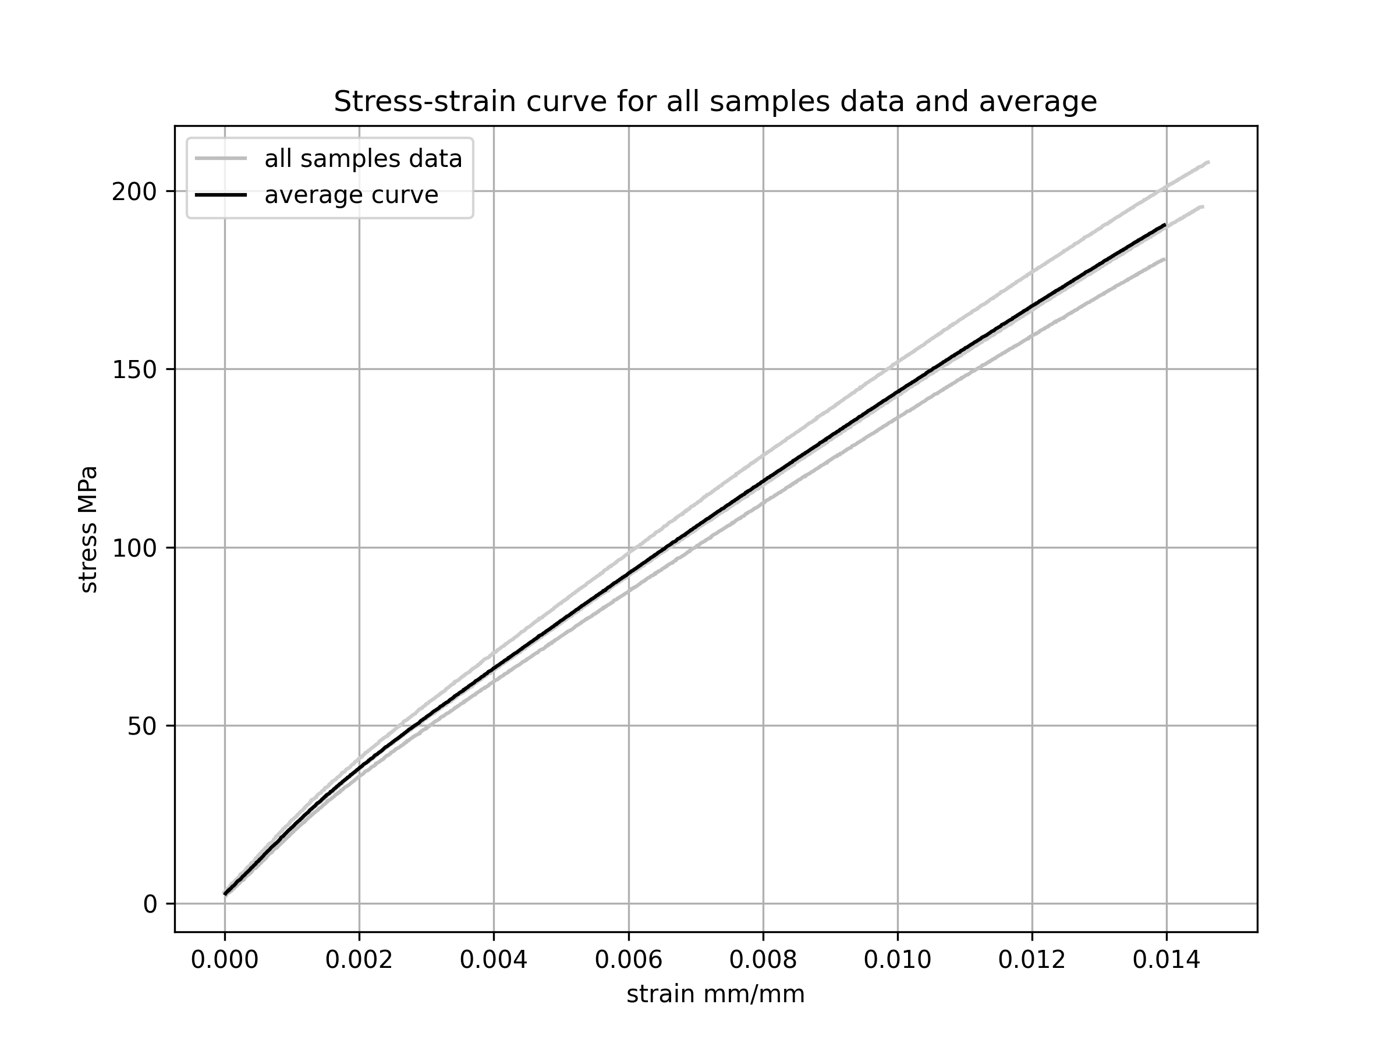

## Test results

* Was a speciment rejected after testing: Yes, No, why ?

**Average properties test results**

|  |  |  |
| --- | --- | --- |
| Property | Mean value | CV % |
| Tangent bending modulus (MPa) | 15431 | 4 |
| Flexural strength (MPa) | 195 | 6 |
| Strain at break (MPa) | 0.014 | 2 |

* Strain range used for chord modulus determination : 0.001, 0.003

**Samples properties test results**

|  |  |  |  |  |
| --- | --- | --- | --- | --- |
| Sample number | Strength (MPa) | Failure strain (mm/mm) | Modulus (MPa) | Rupture behaviour |
| 1 | 181 | 0.014 | 14656 | Ruptutre mode codes are shown on figure 4 ASTM D3039 |
| 2 | 208 | 0.015 | 16267 |  |
| 3 | 196 | 0.015 | 15371 |  |