# ASTM D5868 Test report

### 2022-03-27

D14 Committee. (2001). Test Method for Lap Shear Adhesion for Fiber Reinforced Plastic (FRP)   
 Bonding. ASTM International. https://doi.org/10.1520/D5868-01R14

## Adhesive Identification

* Adhesive name: flax and wood glue
* Adhesive type:
* Adhesive source:
* Adhesive code number:

## Substrate Identification

* Substrate name: flax and wood glue
* Substrate type:
* Substrate source:
* Substrate code number:
* Substrate ply stacking sequence:

## Specimen preparation

* Adhesive cure time:
* Adhesive cure temperature:
* Other adhesive bonding conditions:

**Specimens dimensions**

|  |  |
| --- | --- |
| Specimen number | Area (mm^2) |
| 1 | 643.0 |
| 2 | 648.0 |

## Testing procedure

* Test temperature:
* Other testing conditions:

## Flexural stress-strain curves

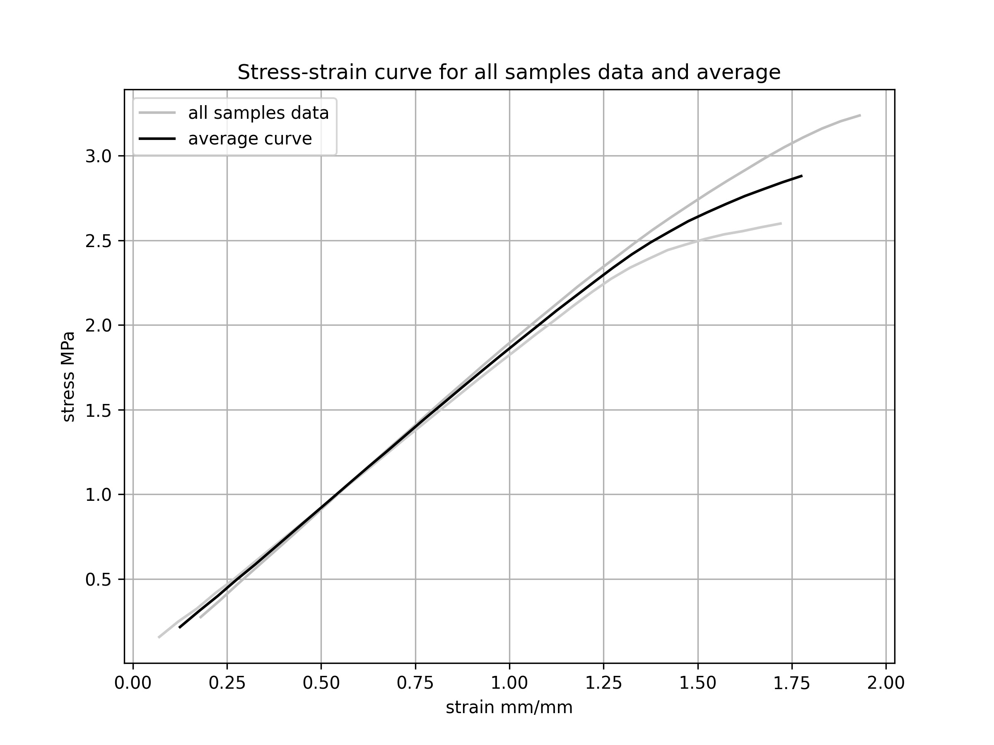

## Test results

* Was a speciment rejected after testing: Yes, No, why ?

**Average properties test results**

|  |  |  |  |  |
| --- | --- | --- | --- | --- |
| Property | Mean value | Standard deviation | Min value | Max value |
| Peak load values (MPa) | 2.9 | 0.3 | 2.6 | 3.2 |

**Samples properties test results**

|  |  |  |
| --- | --- | --- |
| Sample number | Peak load (MPa) | Rupture behaviour |
| 1 | 3 | Describe rupture behaviour here |
| 2 | 3 |  |