# ASTM D790 Test report

### 2022-03-27

ASTM International. (2017). Standard Test Methods for Flexural Properties of Unreinforced and Reinforced Plastics and Electrical Insulating Materials.

## Material Identification

* Material name: carbon
* Material type:
* Material source:
* Material code number:
* Composite material ply stacking sequence:

## Specimen preparation

* How the specimens where prepared:
* Direction of cutting and loading of the specimens:
* Conditioning procedure:

**Specimens dimensions**

|  |  |  |
| --- | --- | --- |
| Specimen number | Width (mm) | Depth (mm) |
| 1 | 10 | 1.05 |
| 2 | 10.1 | 1.03 |
| 3 | 9.9 | 0.97 |
| 4 | 10 | 0.98 |
| 5 | 10.1 | 1.02 |
| 6 | 9.9 | 0.99 |

## Testing procedure

**Remove the procedure/type you have not used**

* Procedure A: Rate of cross head motion was computed using Eq. (1) section 10.1.3
* Procedure B: Rate of cross head motion was determined so that the rate of straining of the outer surface of the test specimen is 0.10 mm/mm
* Type I: Deflexion was measured using cross head motion
* Type II: Deflexion was measured using a deflectometer
* Support span length: 100 mm
* Large span was used: No
* Support span-to-depth ratio: 99:1
* Radius of loading nose and supports: 5 mm (change value if not 5 mm)
* Rate of cross head motion: 5 mm/min

## Flexural stress-strain curves

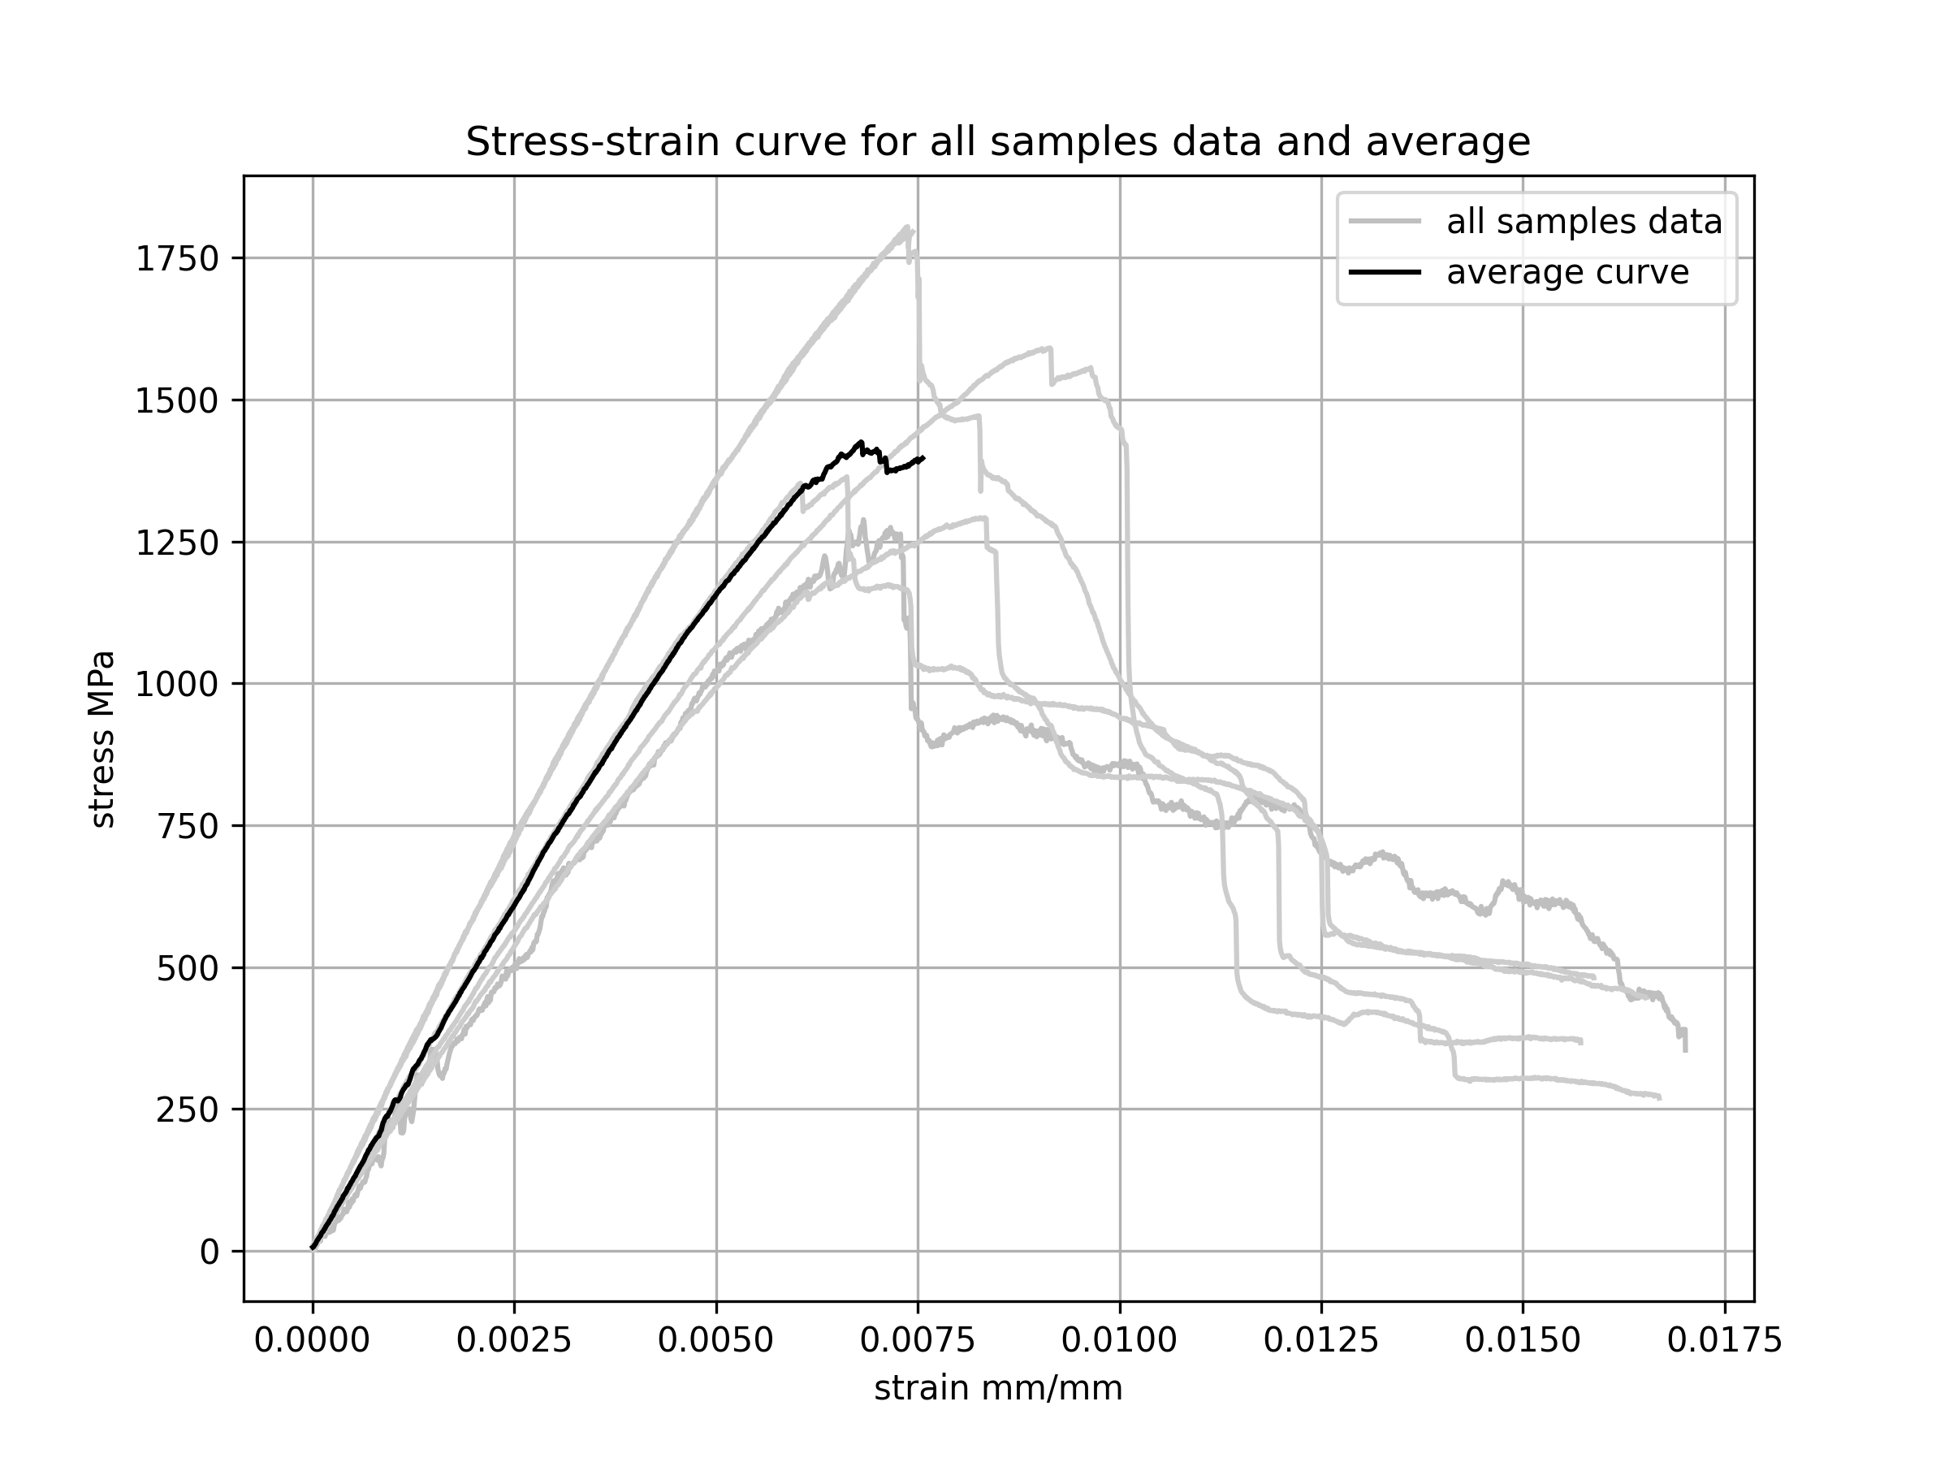

## Test results

* Was a speciment rejected after testing: Yes, No, why ?

**Average properties test results**

|  |  |  |
| --- | --- | --- |
| Property | Mean value | Standard deviation |
| Tangent bending modulus (MPa) | 304618 | 73928 |
| Flexural strength (MPa) | 1522 | 220 |
| Flexural stress at break (MPa) | 619 | 531 |

**Samples properties test results**

|  |  |  |
| --- | --- | --- |
| Sample number | Rupture below 5% strain | Rupture behaviour |
| 1 | yes | Describe rupture behaviour here |
| 2 | yes |  |
| 3 | yes |  |
| 4 | yes |  |
| 5 | yes |  |
| 6 | yes |  |