-- 1. Create database
CREATE DATABASE IF NOT EXISTS studentdb;

-- 2. Use the database
USE studentdb;

-- 3. Create the students table
CREATE TABLE IF NOT EXISTS students (
id INT PRIMARY KEY AUTO_INCREMENT,
first_name VARCHAR(50) NOT NULL,
last_name VARCHAR(50) NOT NULL,
email VARCHAR(100) NOT NULL,
phone VARCHAR(15) NOT NULL
);

Student_form
CREATE TABLE IF NOT EXISTS student_form (
student_id VARCHAR(10) PRIMARY KEY,
name VARCHAR(50) NOT NULL,
email VARCHAR(100) NOT NULL
);

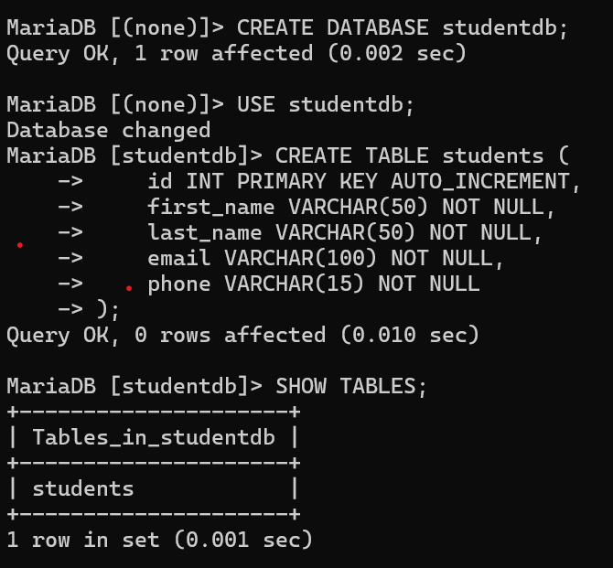

Table of student form
