**Method 1:**

To fix this problem, simply remove the file**/etc/udev/rules.d/70-persistent-net.rules** and reboot your system.

# rm /etc/udev/rules.d/70-persistent-net.rules

Now, you will see the network card is up.

**Method 2:**

If the problem is still not solved, open up the **eth0** config file:

# vi /etc/sysconfig/network-scripts/ifcfg-eth0

Note down the MAC id (HWADDR).

[...]

HWADDR=**08:00:27:DC:33:3F**

[...]

[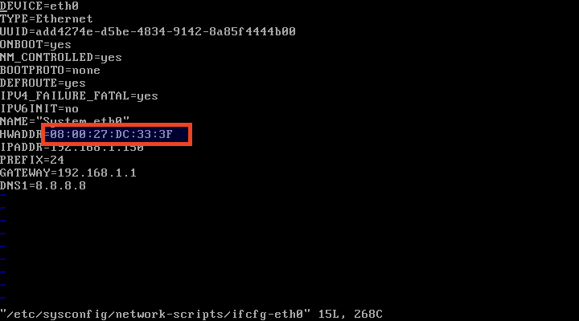](http://www.ostechnix.com/wp-content/uploads/2016/09/CentOS-6.8-Minimal-Running-Oracle-VM-VirtualBox_017.png)

Close the file. Then, power off the CentOS guest and go to **Settings –> Network–> Adapter 1 –> Advanced** from VirtualBox menu bar.

Replace the old MAC id and update it with new one.

[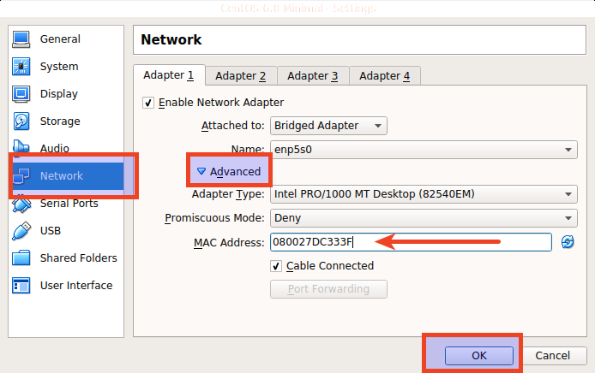](http://www.ostechnix.com/wp-content/uploads/2016/09/CentOS-6.8-Minimal-Settings_018.png)

After changing the MAC address, Click OK to save it. and power on your guest.

Now, Check if the network card is up using command:

# ifconfig

[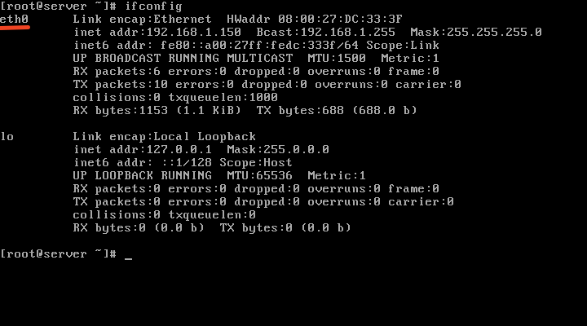](http://www.ostechnix.com/wp-content/uploads/2016/09/CentOS-6.8-Minimal-Running-Oracle-VM-VirtualBox_019.png)

That’s it. It works.

Cheers!