THEMES
Frappe UI Theme Editor

User Manual
A step-by-step guide to building and applying a theme
Frappe v15 / v16 · The Desk Theme Editor is covered in a separate manual

Opening the editor
- Open Desk → Themes → Theme Editor, or go straight to /themes/theme-settings.
- The toolbar runs along the top, the five tabs sit below it,
Nothing is applied to the site until you press Save Changes.
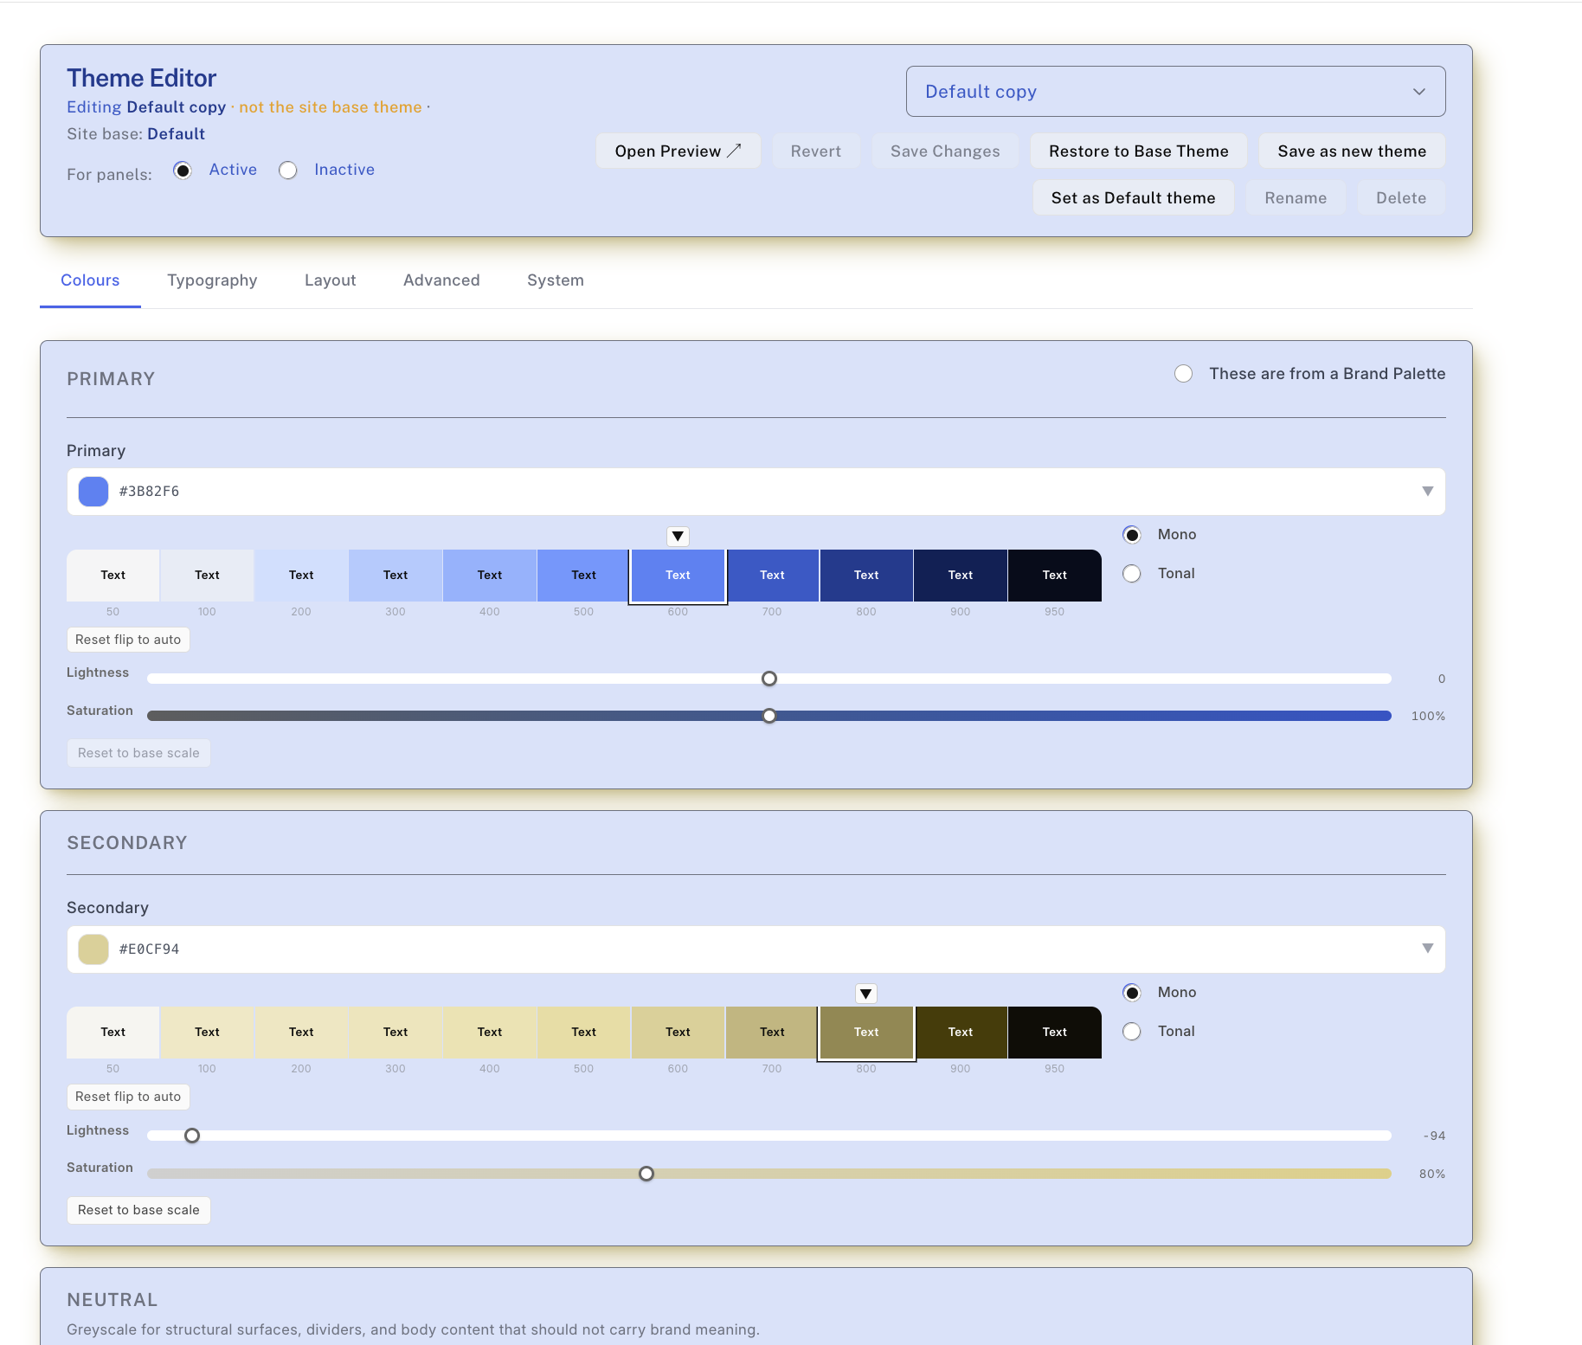

Brand colours
Primary and Secondary are your main brand colours.
- Click the colour to set a base — choose a hue, or grab any colour with the eyedropper.
- Use the lightness and saturation sliders to fine-tune the whole range at once (Not available if “These are form a Brand Pallette is selected – so th exact hex values for a a corprtatye palate are preserved).
- The editor builds an 11-shade scale and a readable text colour for you automatically.

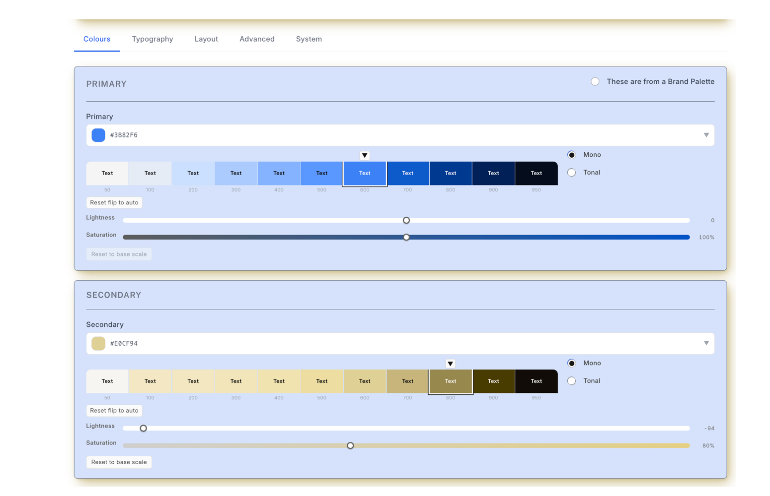

Neutral
The neutral greys are controlled by a single Warmth slider. Slide it cooler or warmer, or press Reset for a pure grey.
These greys are available for surfaces, borders and body text .
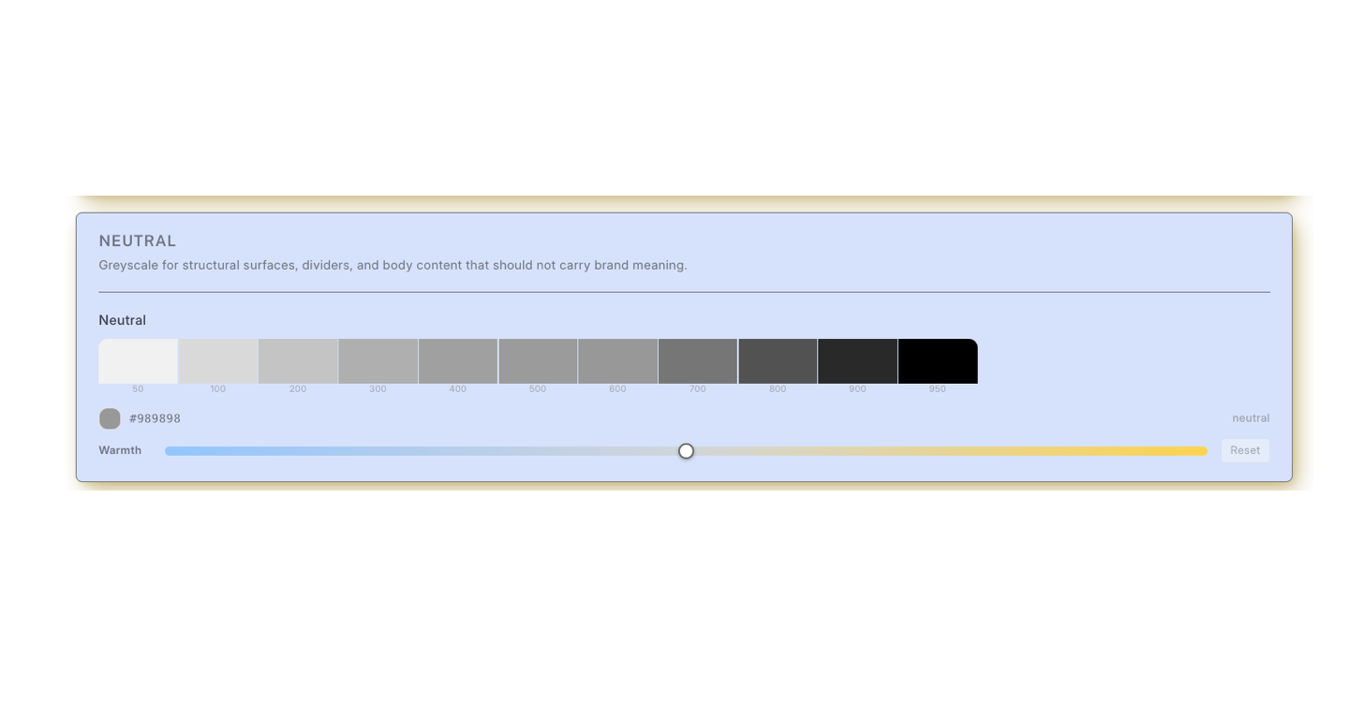

Status & surface colours
The status colours — Accent, Success, Info, Warning and Danger — carry meaning across the interface.
The surfaces set the page background, cards and panels, borders, and the alternate row colour in tables.
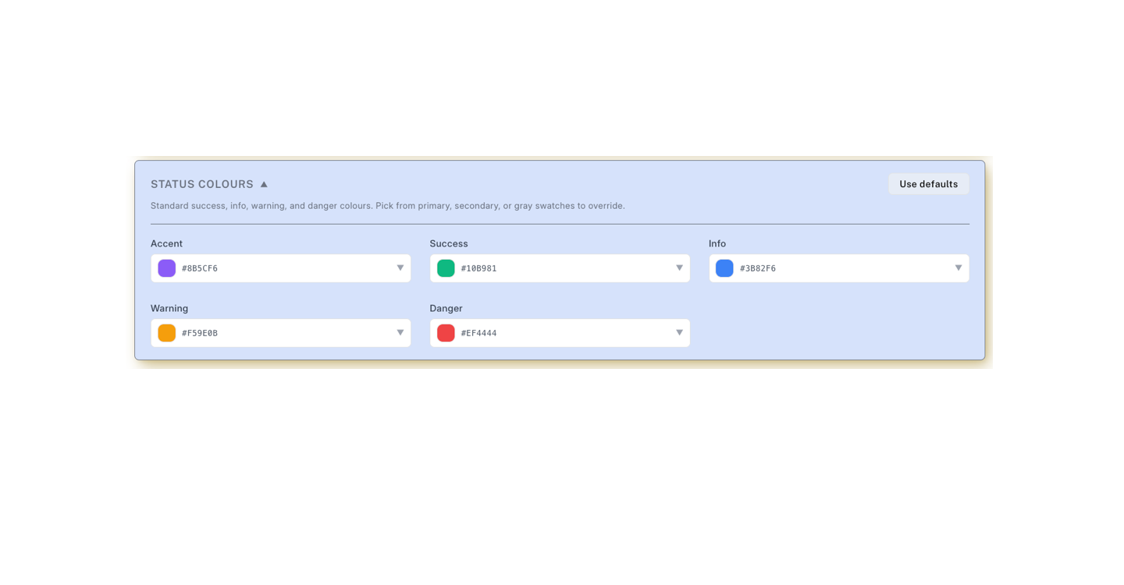

Typography
Choose separate body and heading fonts and watch the live sample update.
Then set the text colours — body, heading, muted, links and the focus ring — and the base font size, font weight and line height.
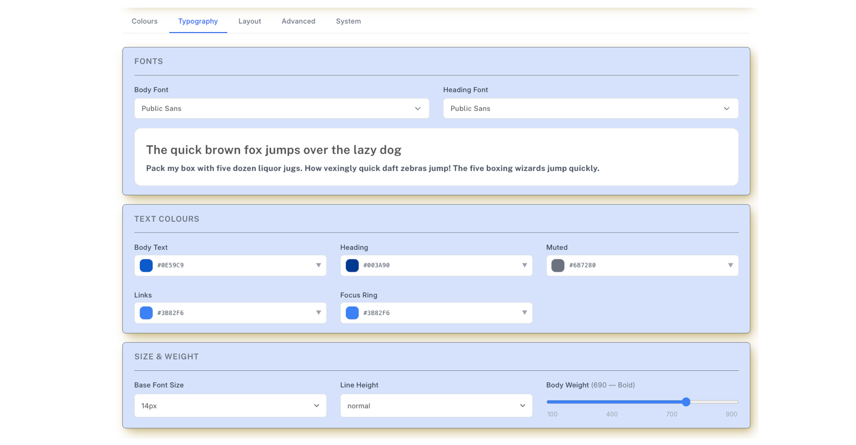

Layout — Corners, Line Widths and Tables
Set the corner radius, the three line widths (thin, normal and strong) These apply consistently to cards, inputs, buttons and dividers across every page.
Table styles can also be set.
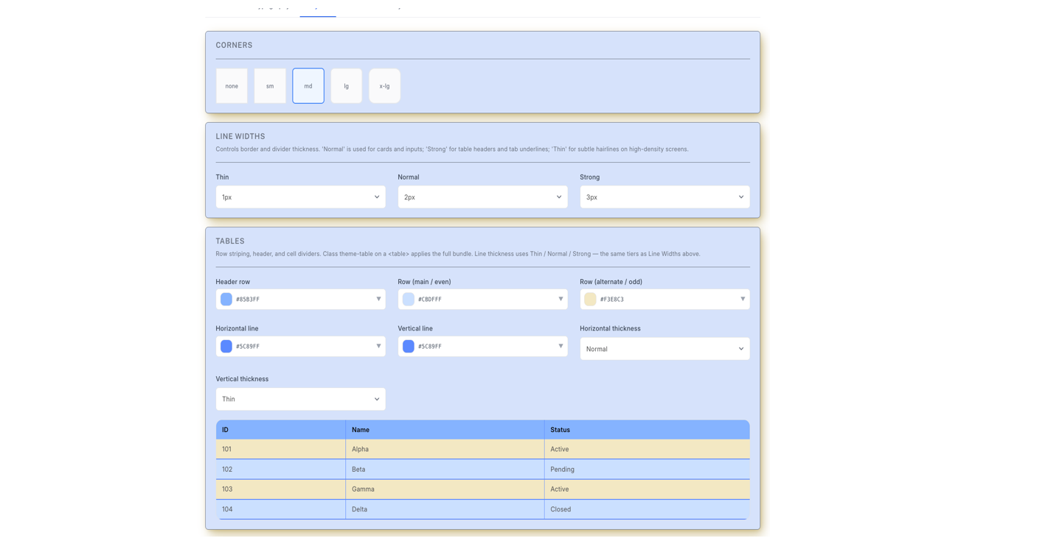

Layout — shadows & dimensions
Adjust the shadow depth, colour and direction, the sidebar and container widths, and how fast interactions animate.
A dark-mode option is also set here.
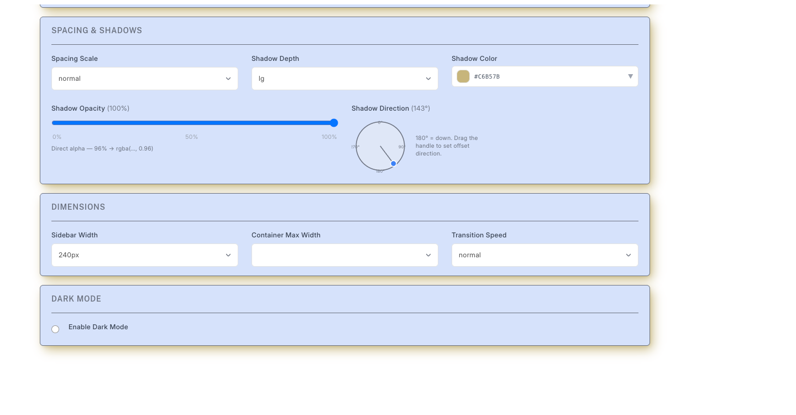

Managing your themes
From the toolbar you can save the current settings as a new theme, switch the active theme, set the site default, and rename or delete a theme.
If something goes wrong, Restore to Base returns the theme to its known-good starting point.
Press Save to publish the active theme across the whole site. If a browser shows old colours, hard-refresh with Cmd/Ctrl + Shift + R.

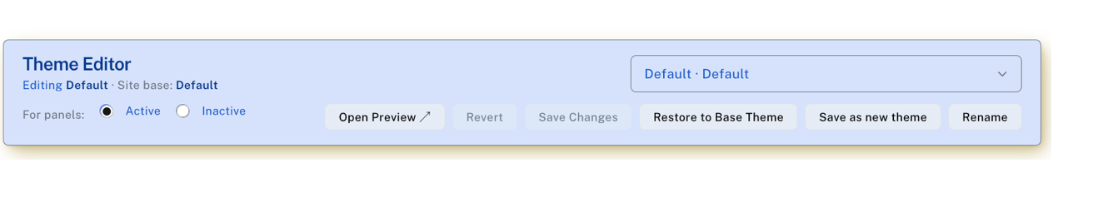
Preview your theme
The “Open Preview” button opens a preview of your theme. It rins isn an I-franem and immedilat rspons to changes – so you can see the effects without saving them:
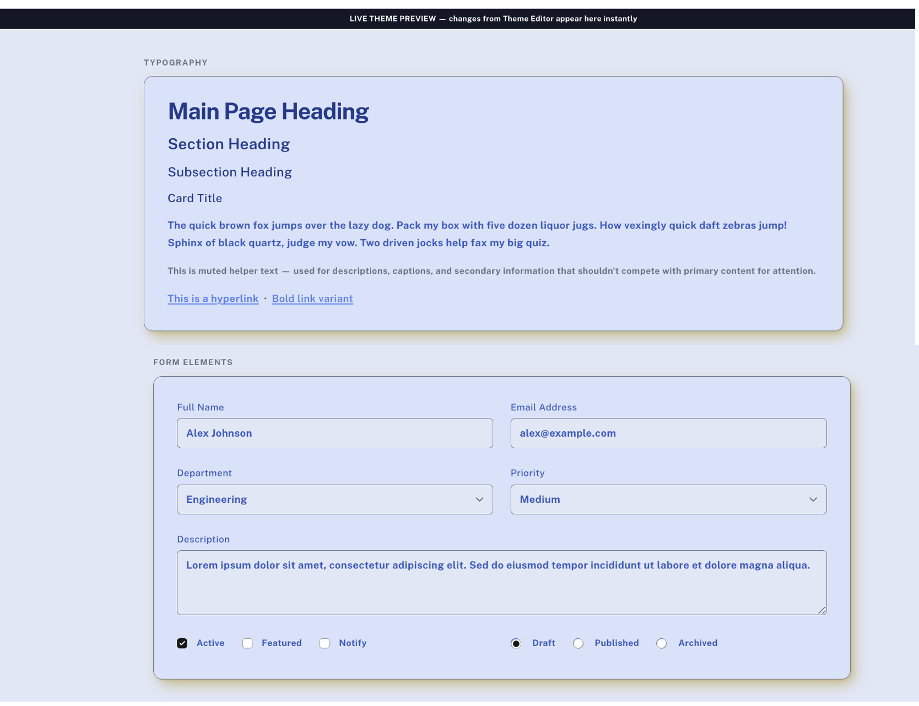

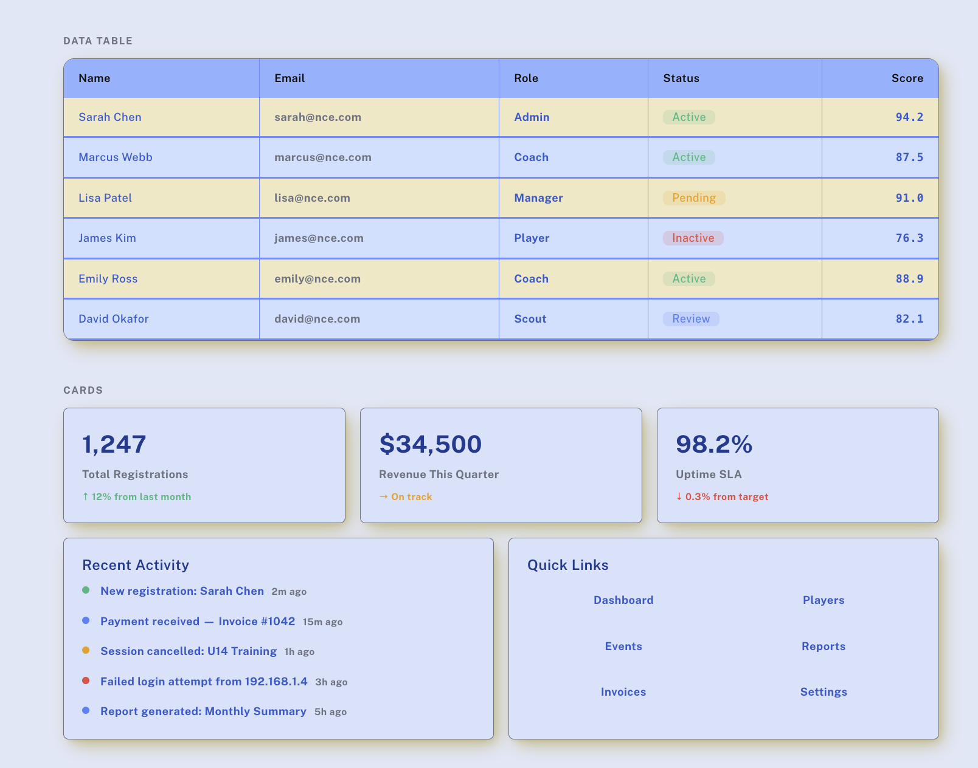

Putting it to work: Applying to a site app
With two themes saved, the effect of a theme is easy to see. The next pages show the same NCE Events screen under 2 different Themes.
Only the palette changes — the screens themselves are not recoded.
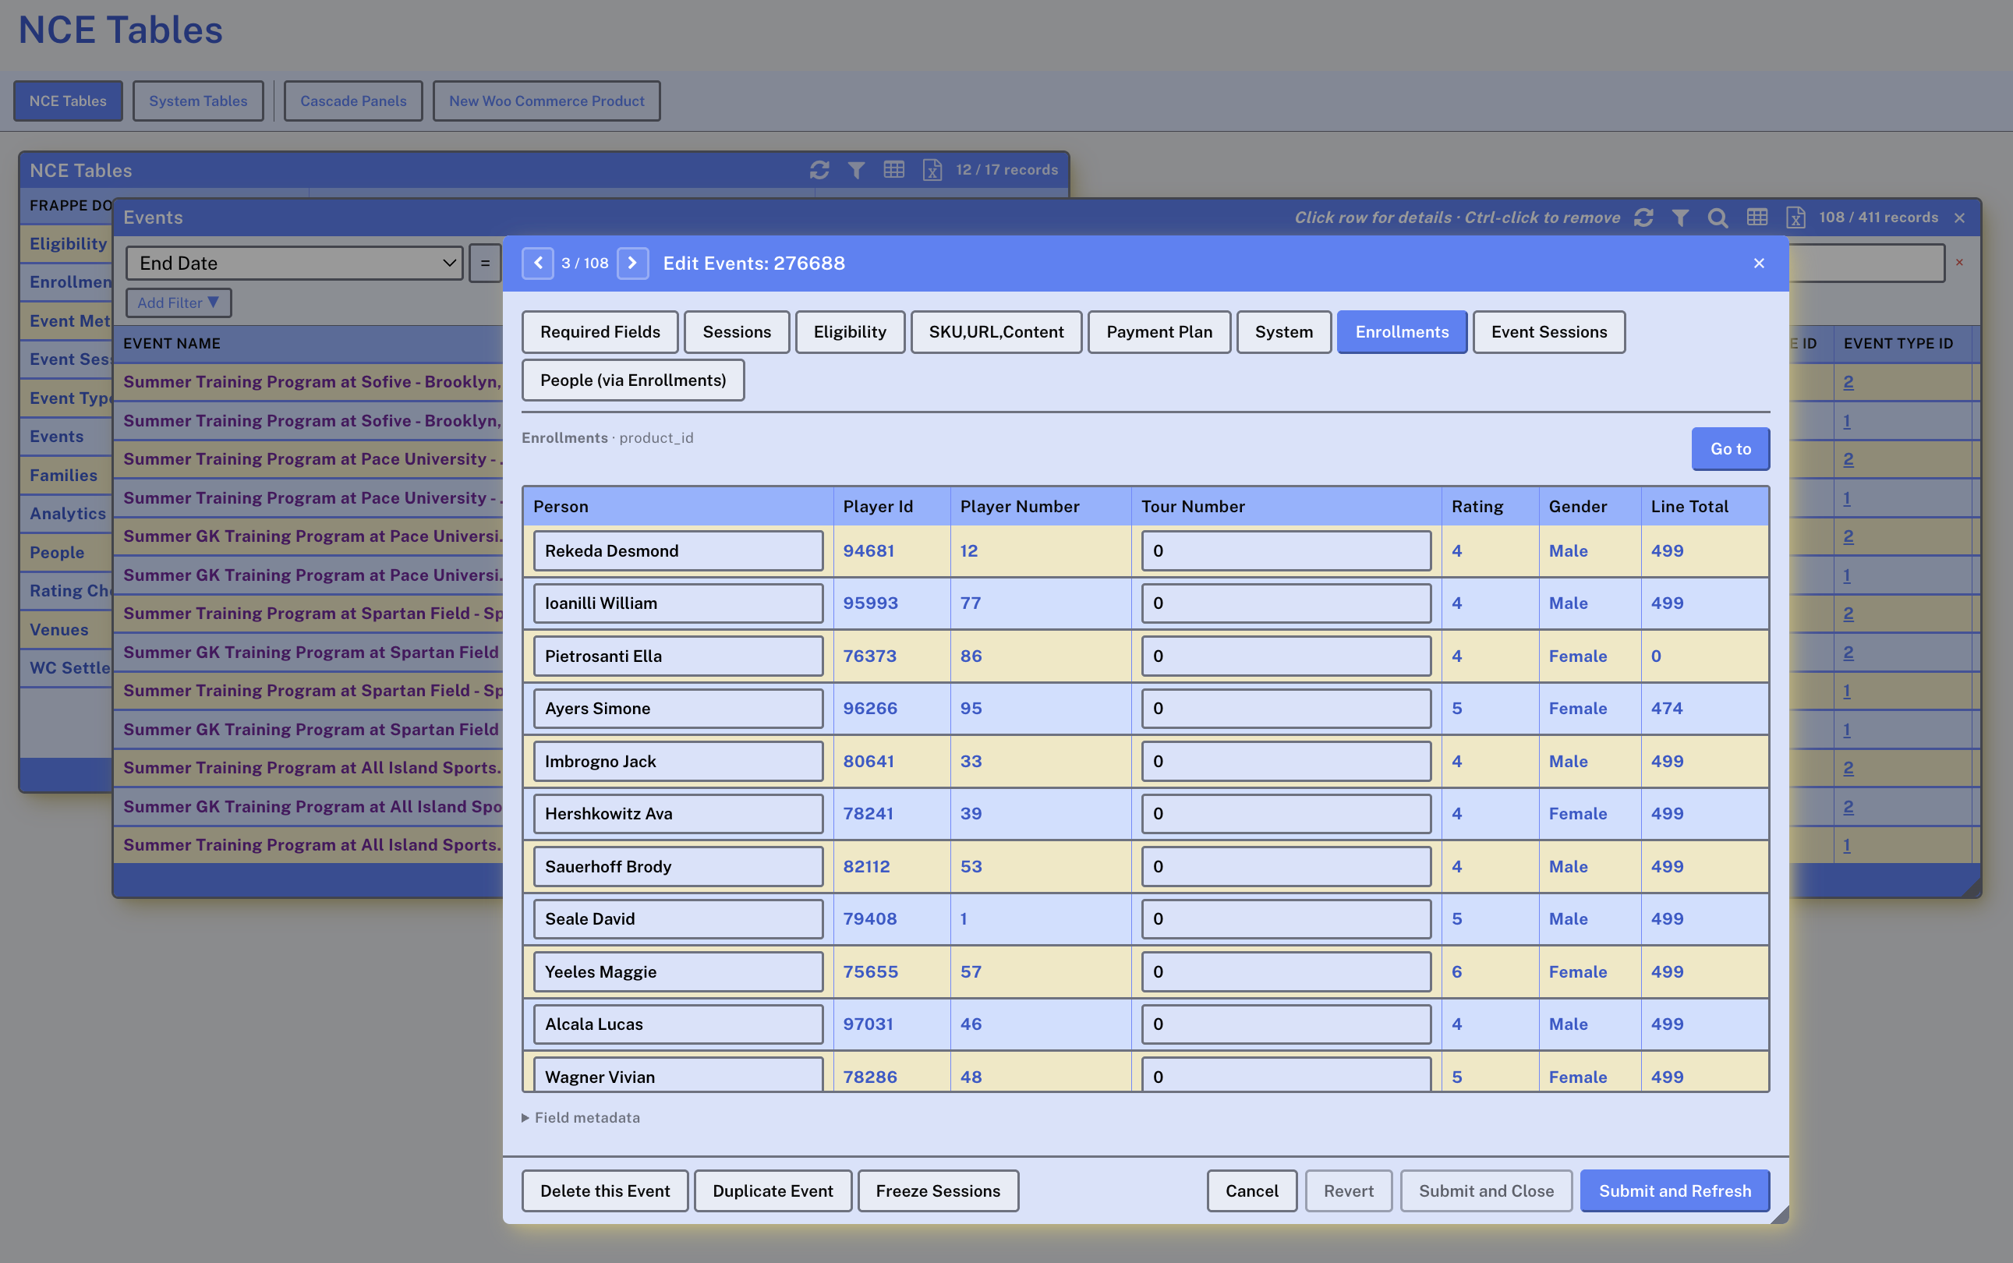

The same screen — the second theme
Here is the NCE Events screen rendered under the second saved theme. Compare it with the previous page — only the palette has changed.


