York St John University

2CB102

Yorkshire Aircraft Museum Specification - Assignment 1
Name：Oliver Whitehead

Student ID： 189115982
Module Tutor：Mike O’Dea

[Due Date]

Table of Contents

Table of Contents 1
0. Summary 2
0.1 Objective 2
0.2 MySQL 2
0.3 Design Process 2
1. Conceptual Design 3
1.1 Building Conceptual Data 3
1.2 Conceptual Relationships 3
1.3 Entity Attributes 4
1.3 Conceptual Data Model 5
2. Logical Design 6
2.1 Building Logical Data Model 6
2.2 Normalization 7
2.3 Validating Relationships for Transactions 7
3. Physical Design 8
3.1 Data Dictionary 8
3.2 Critical Transactions 9
3.3 Transaction Flow 9
3.4 Peak Times and Performance 10

Summary
0.1 Objective

The objective of this specification is to continue on from where the Yorkshire Aircraft Museum Case Study document finished. This specification will specify the full range of the system functionality that is to be implemented.

0.2 MySQL

It has already been specified in the case study that the client would like the system to be implemented using MySQL, so this document has been created with that assumption throughout. This does mean that some stages of database design are only covered minimally as knowing the target DBMS makes it much easier to plan ahead and avoid unnecessary work, especially when it comes to translating the logical data model to fit the physical database design.

0.3 Design Process

The design process in this specification covers three parts: Conceptual, Logical and Physical. It includes transaction analysis, the documented normalization process and a data dictionary.

Due to the nature of this assignment, this document cannot be used solely on its own. The document continues on from where the case study finished and therefore, both documents are needed to begin implementation.

Elements that were present in the case study document are not repeated in this document. Elements that this document does not cover are:

- Executive Summary
- Product/Service Description
- Requirements (Including User Interface Requirements)
- User Scenarios/Use Cases

Conceptual Design
1.1 Building Conceptual Data

The entities required to start the conceptual design process are taken from the forms and reports in the case study document. The required entities, seen below, form the basis of the conceptual design for the database.

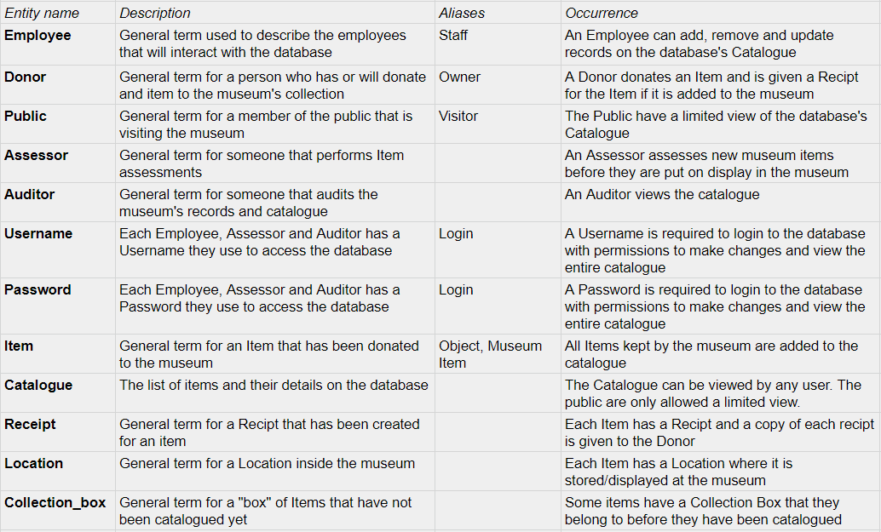

An additional entity called “Catalogue” has been created for the list of items and their details. The distinction between a generic item and the catalogue of items is required so that the entity relationships can be modeled accurately.

For example, when a member of the public views an item on the database, they are viewing the item through the catalogue on the database, not the physical item itself.

Another example is a donor. Donors do not donate items directly to the database; they donate them to the museum. Once the item has been assessed, the item will be listed on the catalogue by an employee.

1.2 Conceptual Relationships

The relationships of the entities can be seen in the ER diagram below. This is the first version of the entity relationship model and it will be updated further down the document.

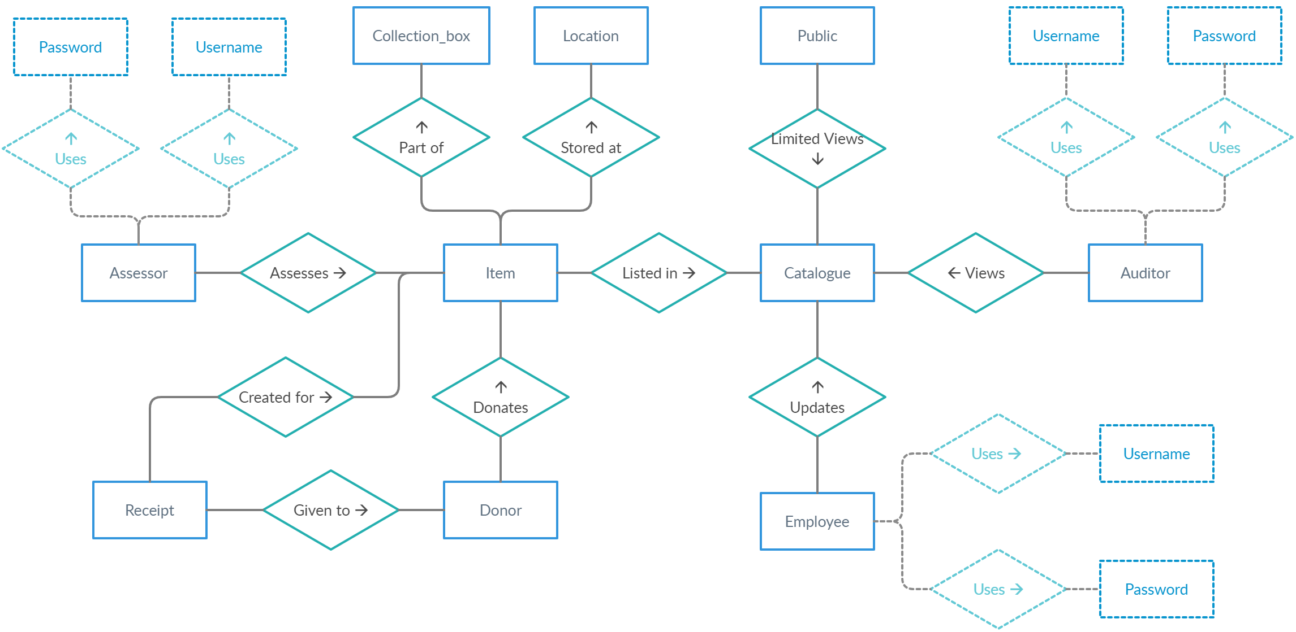

A more specific description of the individual relationships that these entities have can be found in the table below.

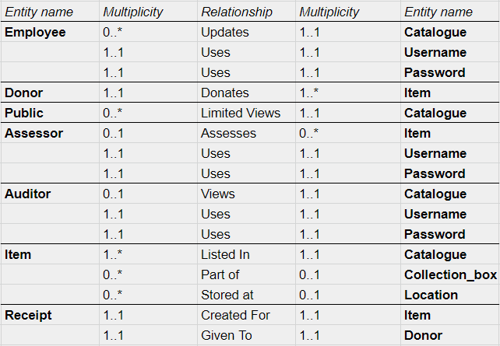

1.3 Entity Attributes

The attributes of the entities are also required to complete the conceptual design. You can find the important attributes of the entities in the table below.

(Note: The table does not contain every possible attribute of each entity, it only contains enough so that the conceptual design process can be demonstrated. Additional attributes can be added at this step or included later when the system is being implemented.)
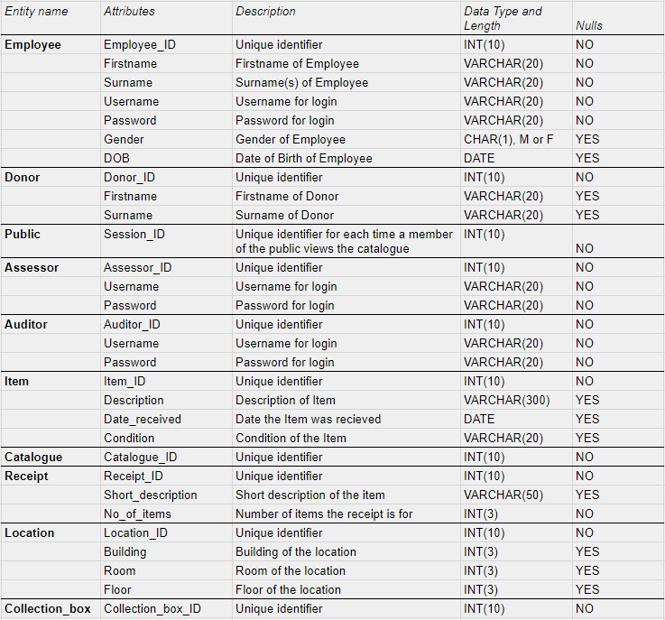

The entities “Username” and “Password” that were redundant have been removed and are now stored as attributes of the entities that require them.

Each entity has been given a unique identifying attribute that will act as the primary key of the entity.

For the entity “Public”, the primary key will be a unique ID that is assigned to each session that a member of the public opens when they view the catalogue on the database. This method allows differentiating between multiple instances of the public interacting with the database.

The entity “Catalogue” is also given a unique identifying attribute. It is assumed that there will be only one catalogue on the database. However, this does allow for additional catalogues to be used should the client decide to split up the data further.

1.4 Conceptual Data Model

The conceptual data model can now be completed with an updated ER diagram using the relationships, attributes and updated entities from the previous section.

The multiplicity of the entity relationships and the primary keys are also included in the diagram.

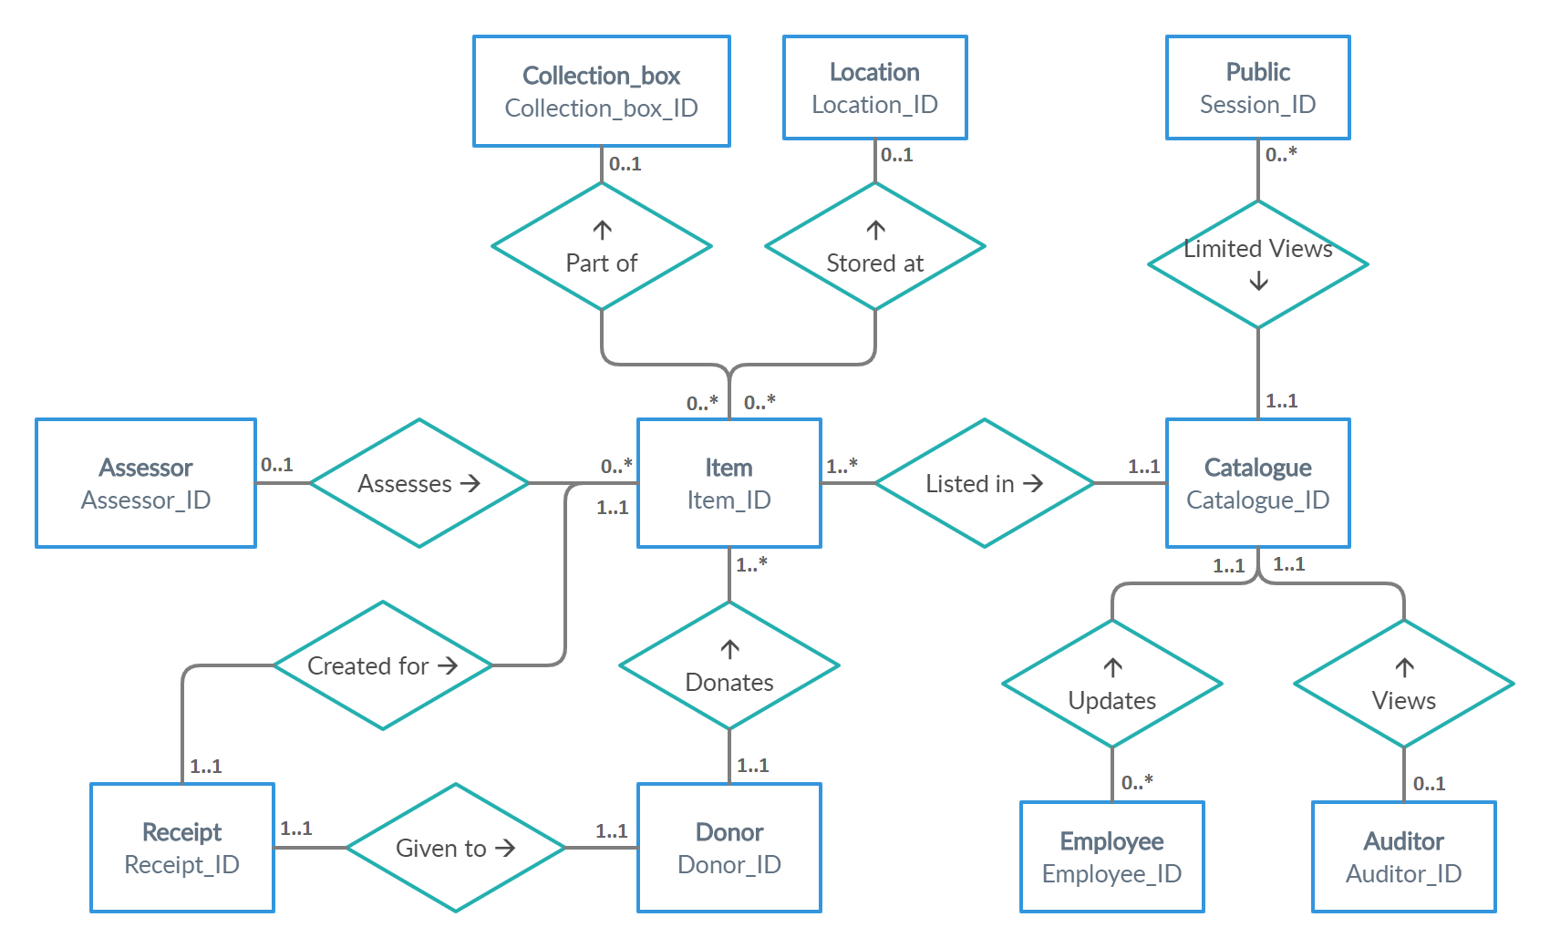

Logical Design
  - Building Logical Data Model

A more detailed ER diagram that includes the attributes of all the entities can be seen below. It contains everything from the previous diagrams as well as the foreign keys of the entities.

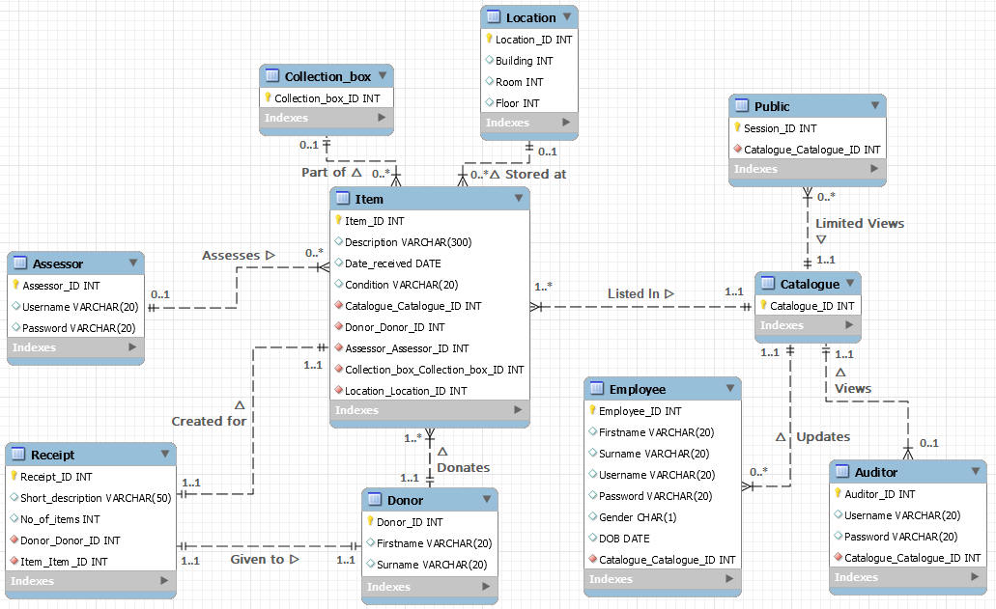

2.2 Normalization

The majority of the data model is already in 3rd normal form (3NF). However, there is one entity that requires fixing; the “Receipt” entity works for a single type of item but breaks 3NF when you consider that a single receipt is often created for multiple different items.

As can be seen in the above example, “Receipt” does not have atomic values and requires fixing.

First, the values are all made atomic:

The entity is then split into four entities and repeating columns are taken out:

The data model is now complete as there are no repeating groups, all values are atomic, there are no partial or transitive dependencies, and they each have a unique name and primary key. Now that each entity and its relationships has been checked against this list of requirements, the data model is in 3NF.

2.3 Validating Relationships for Transactions

The most common transactions are listed below with the four basic functions they require. The four functions are Create, Read, Update and Delete (CRUD) and they show the type of transactions that the relationships need to support.

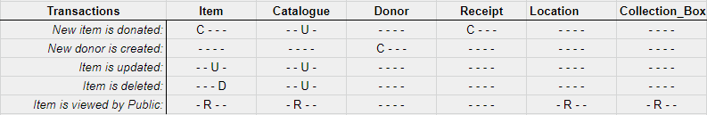

This also shows the level of access that different users will require. Members of the public should only have the permissions to Read entities on the database, where as employees will need to have permissions to Create, Update and Delete depending on the operation they are carrying out.

Physical Design
As stated in the summary of this document, it has already been specified that the target DBMS for this task will be MySQL. The logical data model from the previous section was created in MySQL and the base relations, primary keys, foreign keys and integrity constraints are all completed.

Before it can be implemented however, a full data dictionary and further analysis of the more complicated transactions is required.

  - Data Dictionary

Here is the completed data dictionary that shows the specifics of each attribute that has been created in MySQL.

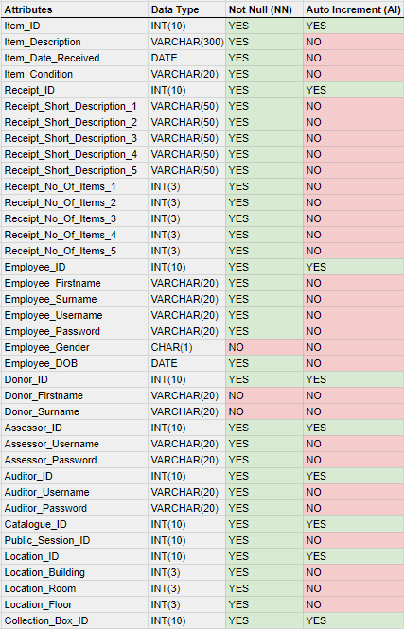
  - Critical Transactions

Data integrity and reliability is required for all transactions on the database. Private information about donors and employees will be stored on the database so security in critical transactions that handle this information must be a high priority.

Ensuring that the public only have a limited view of the catalogue and do not have the permissions or access level to create, update or delete items on the database is critical. The reliability and speed of the public’s limited view is also very important as it could be a major factor for visitors to the museum enjoying their visit.

  - Transaction Flow

Here is a flow diagram that depicts the full transaction of a donor donating an item to the museum and it being added to the database catalogue.

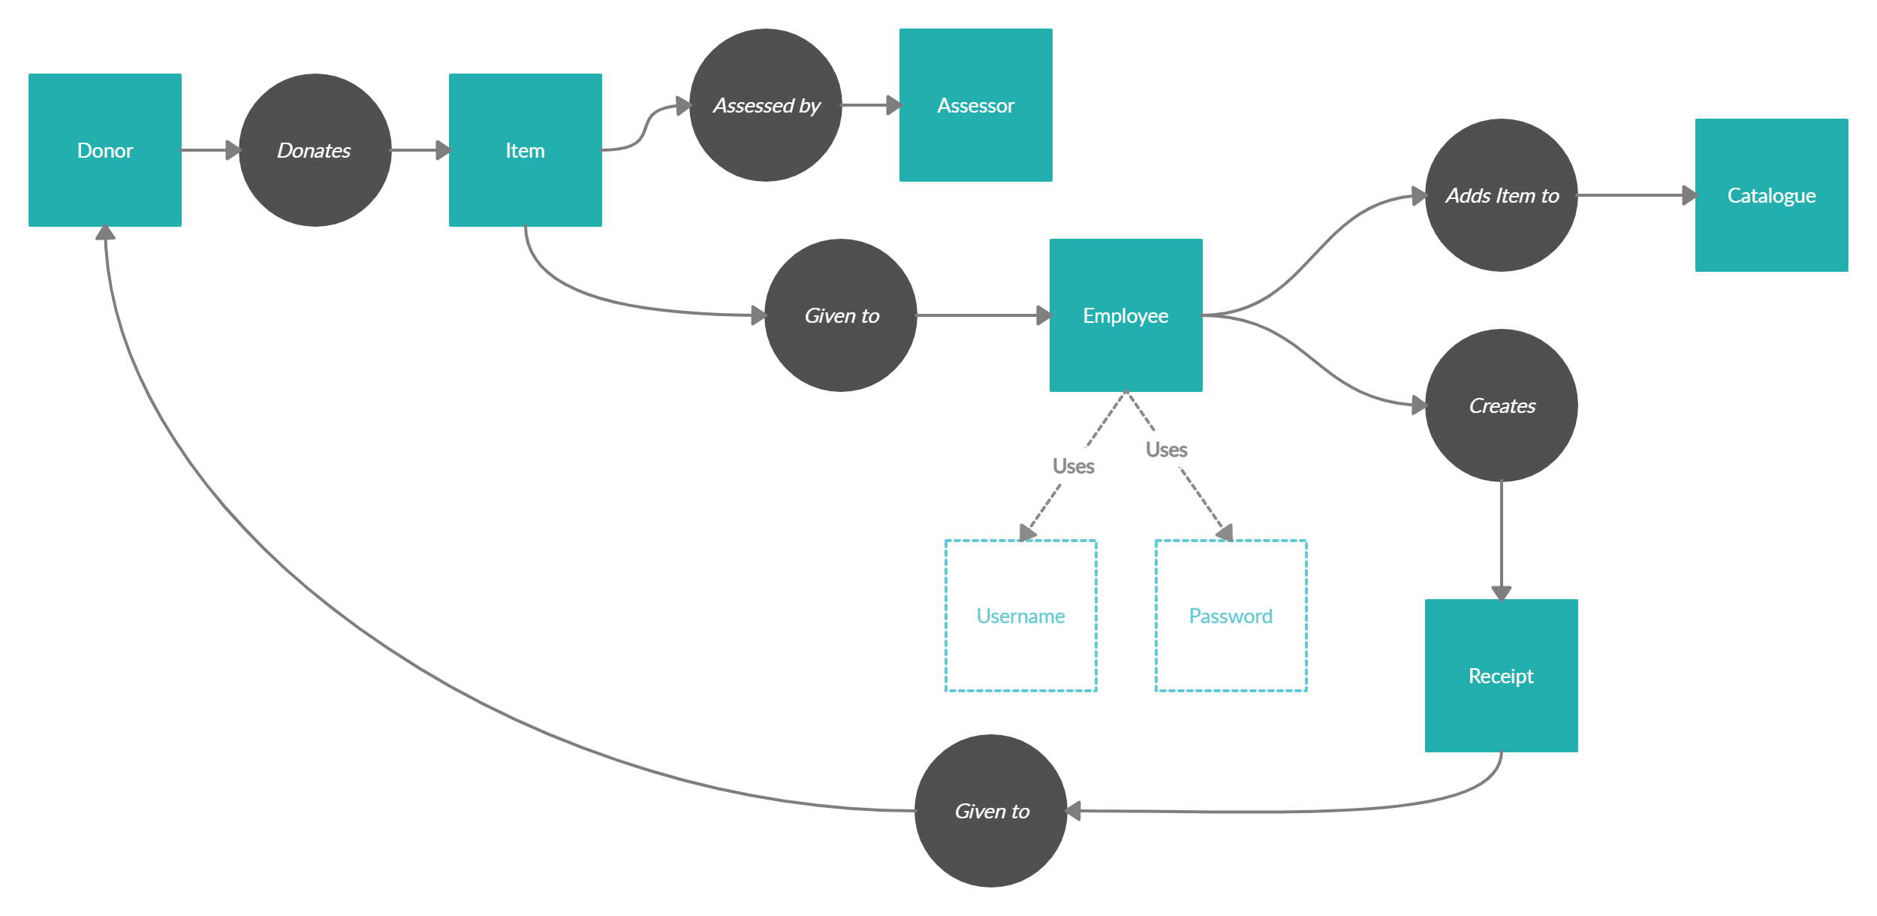

From this diagram we can see how the transaction will interact with the entities in the database. Before implementation begins, it is imperative that the client is consulted about the flow of these central transactions to make sure that they are modeled accurately.

Here is a flow diagram that depicts the full transaction of an item having its details updated after it has been moved to a new room in the museum.

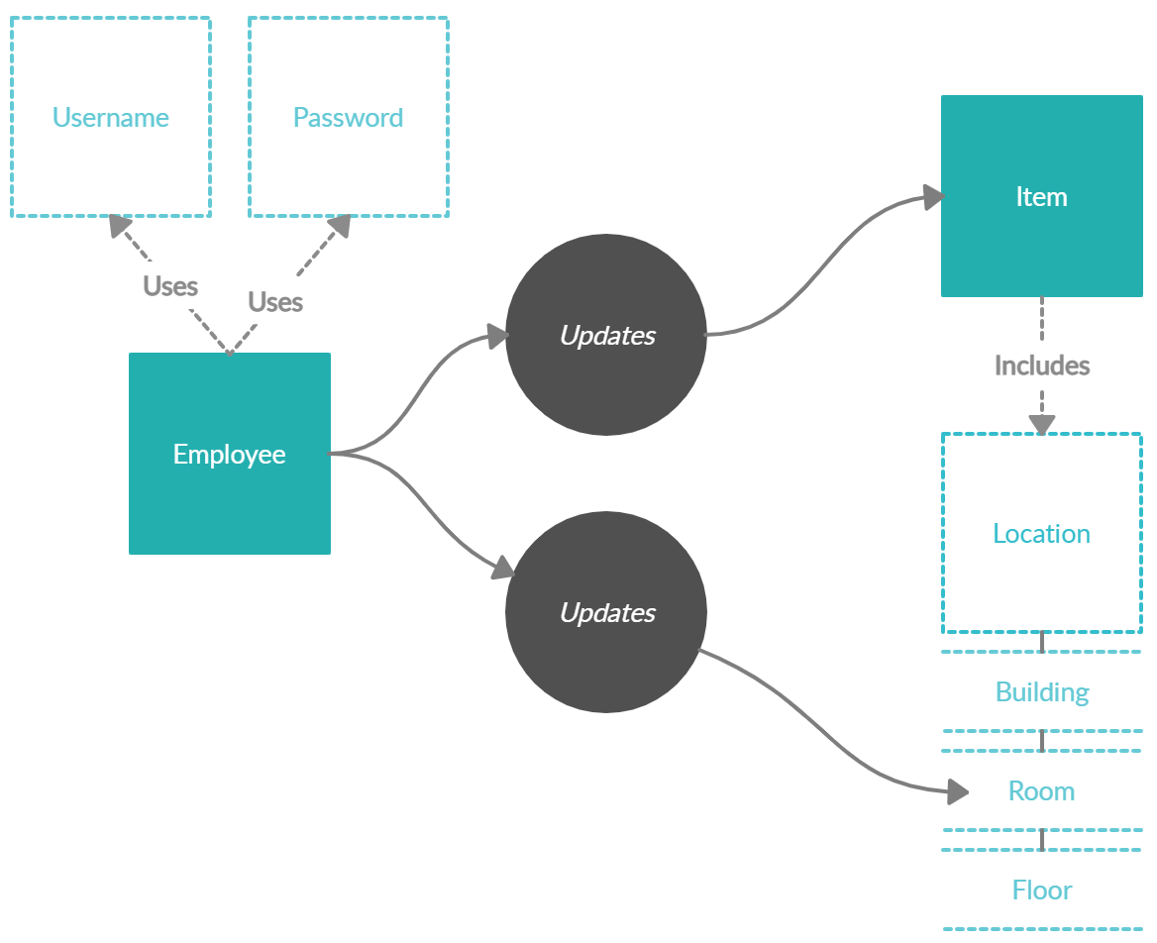

  - Peak Times and Performance

High traffic could cause performance issues for the system. Peak times are assumed to be during opening hours on days when the museum has the most visitors. Weekends, holidays and any day that a popular new exhibit is put on display could cause much higher traffic than usual.

Frequent or scheduled transactions could also increase traffic on the system. Consulting the client about how many transactions are expected to be carried out at any one time is recommended.

The simple design of the system, created using MySQL, should be able to handle constant traffic without a noticeable drop in performance. Doing a stress test during implementation to be safe is also recommended.

