This research will be conducted in conjunction with the MSU ICT4D Tanzania Study Abroad. The purpose of the ICT4D study abroad is to set up and maintain computer systems in primary and secondary schools, and to teach students and teachers how to use technology.

This project is in response to the large quantity of people with a desire to learn how to use a computer, and the limited time and availability of people able to teach. The project is a guided interface which explains how to use a computer from the most basic principles (clicking, typing) in a tutorial fashion.

I propose a study of the efficacy of the guided interface to educate people on how to use computers. The study will consist of a before and after test to measure any improvement found in using the interface, and a short survey to obtain feedback on potential improvement.

Any person learning to use a computer will be invited to participate in the study. It will be made clear through speech and writing that participation in any and all parts of the study is voluntary. Subjects will be free to use the guided interface and computers regardless of study participation. Consent will be given verbally.

Subjects will first be given a written survey (attached). The survey will be translated into Swahili and approved by a native speaker. The survey will ask about age, education level, English fluency, and computer literacy to build persona information. It will not ask for participants’ names. The survey will ask what makes computers difficult, their comfort level, what they use computers for, and what they would improve about the interface.

Then, subjects will take a computer abilities test. The test will cover computer literacy questions of increasing difficulty, many participants will be unable to complete the test. The abilities test scores will be recorded on the survey. After the pre-test, participants will learn more about computers through the guided interface. Their approximate time learning with the interface will be recorded on the survey. Once they are done, they will retake the same abilities test and record their post-lesson scores on the survey as well.

The following pages detail the computer abilities test.

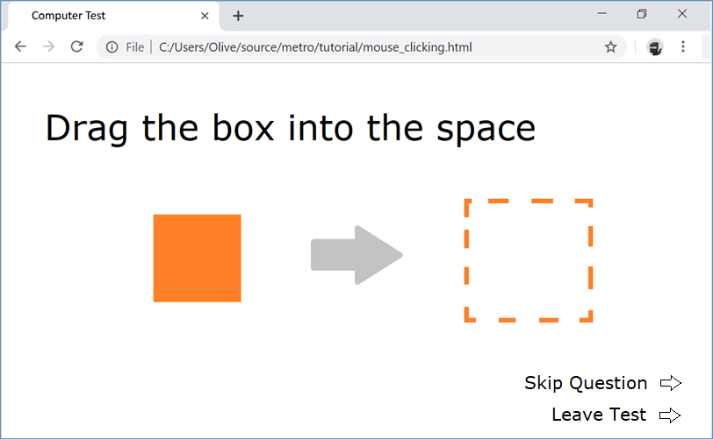

Click the box

Double click the box

Right click the box

Drag the box into the space

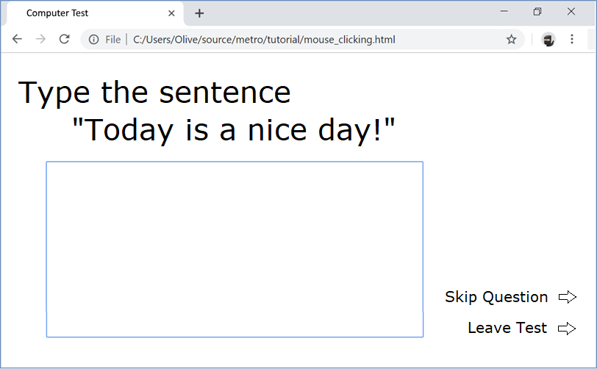

Type the sentence

Replace the ‘.’ with ‘!’

Highlight the sentence

Copy and paste the sentence

Delete the sentence

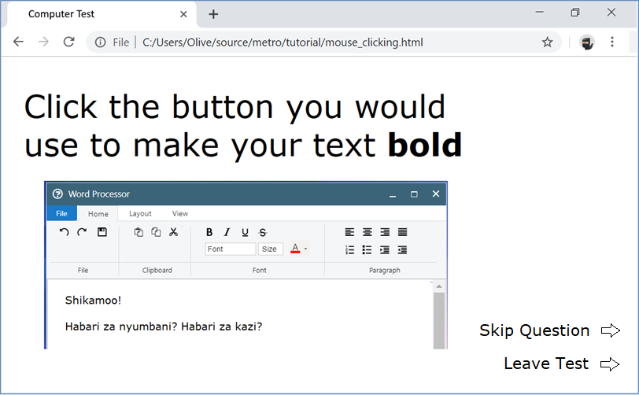

Click the button that would

… make your text bold

… close the window

… make the window bigger

… change the size of the text

… make text centered

… undo an action

… save the file

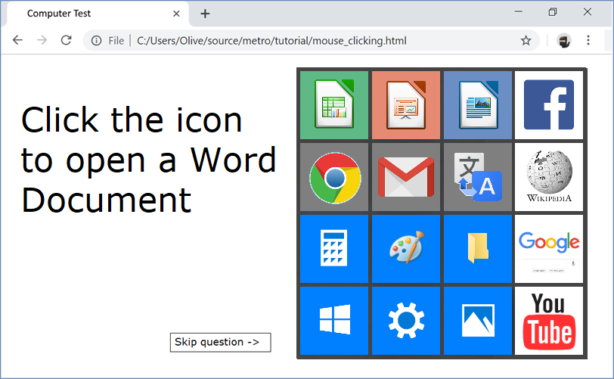Click the icon to…

… open a word document

… open an excel spreadsheet

… open a list of programs

… open a program to draw a picture

… open computer settings

… a website for emailing people

… a website for watching videos

… a website for searching the internet

