Computer Abilities Test

administered before and after training how to use a computer

scores are recorded on survey sheet, separated into categories

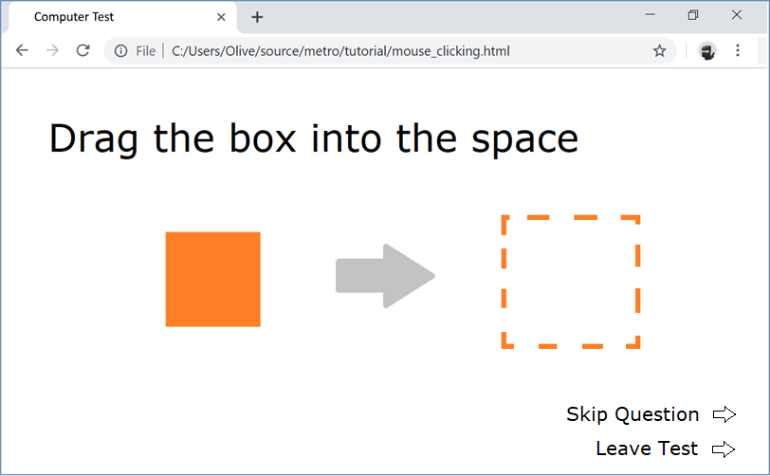

Click the box

Double click the box

Right click the box

Drag the box into the space

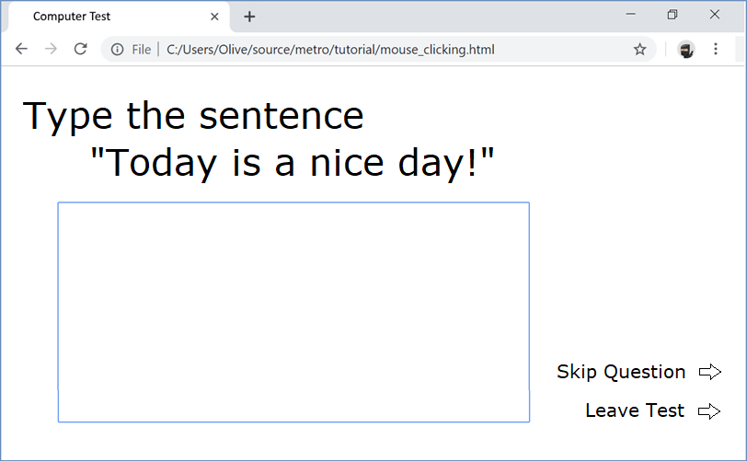

Type the sentence

Replace the ‘.’ with ‘!’

Highlight the sentence

Copy and paste the sentence

Delete the sentence

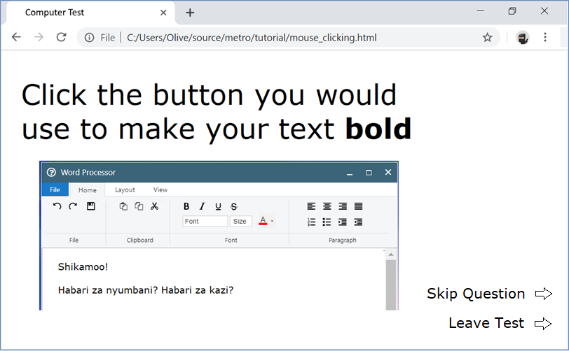

Click the button that would

… make your text bold

… close the window

… make the window bigger

… change the size of the text

… make text centered

… undo an action

… save the file

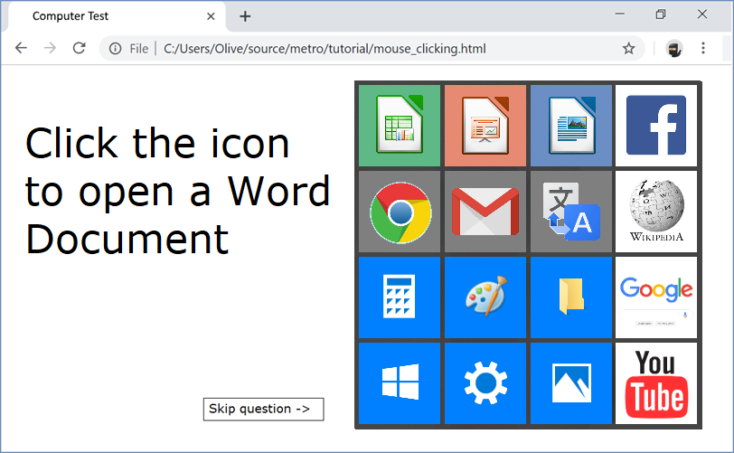Click the icon to…

… open a word document

… open an excel spreadsheet

… open a list of programs

… open a program to draw a picture

… open computer settings

… a website for emailing people

… a website for watching videos

… a website for searching the internet

