Managing Property Details

Guestroom Genie | 900 Circle 75 Parkway, Suite 900, Atlanta, GA 3006

Managing property details, A How-To Guide

v1.0 – Published on 11/03/2023

2023

This Guestroom Genie how-to guide offers readers a brief overview of managing property details. For more information on managing property details, relevant use cases, and Property Management Systems in general do not hesitate to get in touch with the GRG Team.

Starting from the Dashboard, click the Property tab in the top right corner.

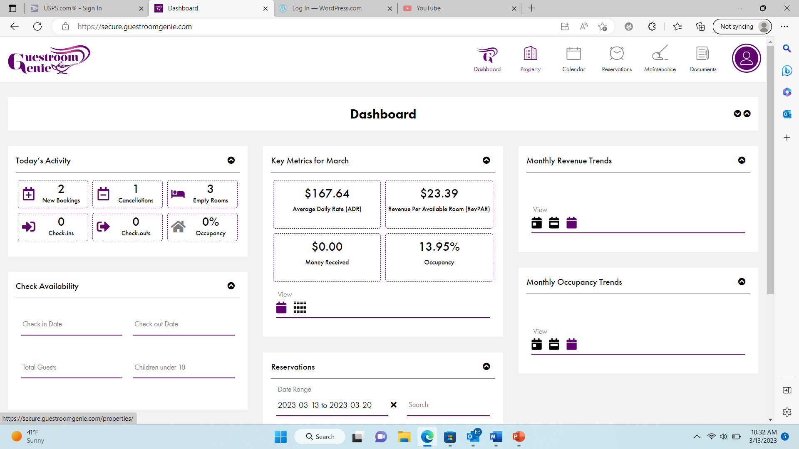

Next, click Update Property Details under the Property Details section.

Under the Property Logo section, you can add a photo or logo.

By clicking the Manage Tax Rates button (under Tax Rates), you can manage all tax rates associated with the property.

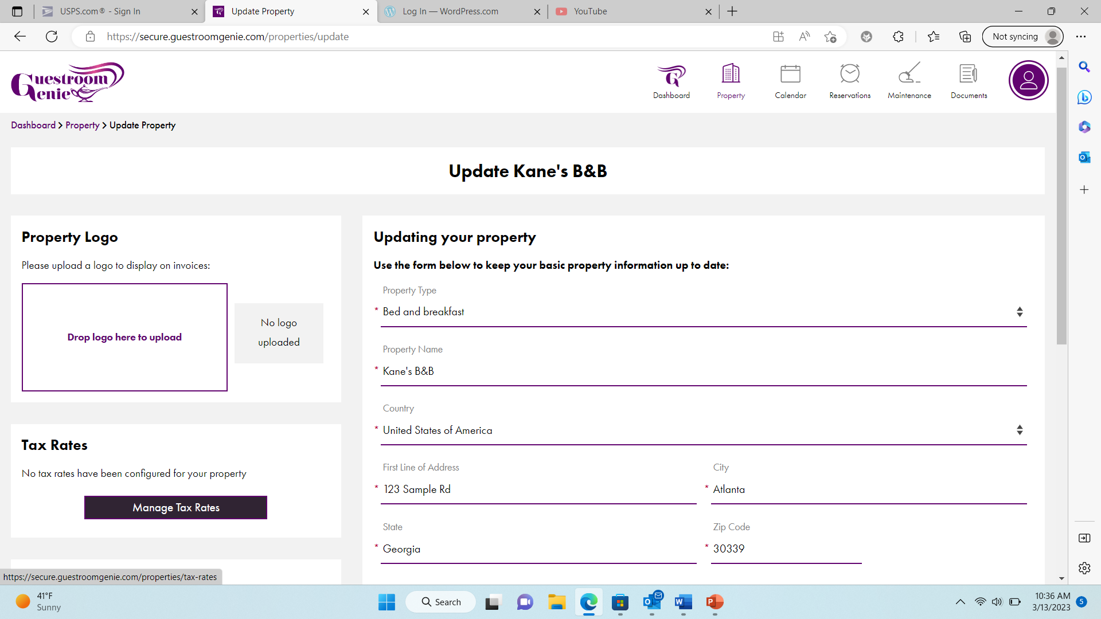

Under the Holding Reservations section, you can specify how long a reservation should be kept. For example, if you are missing some of a guest’s information, you can specify how long to wait before the system removes that booking.

The Cleaning Schedule section allows you to choose the maximum number of days before a room must be cleaned.

Under the Updating Your Property section, you can add or edit information about the property. This includes Property Type, Property Name, Country, Address, City, County, and the Postal Code.

The Child Guest section allows you to determine whether children are allowed. It also lets you set the maximum age for a guest to be classified as a child.

Granting Wishes to Hoteliers