Documentation for the UDP client server communication

Olivér Izsák

Slovenská technická univerzita v Bratislave

Fakulta informatiky a informačných technológií

xizsak@stuba.sk

20. oct. 2022

1.Assignment plan

Description:

The task of this assignment is to design and implement a program using a custom protocol on top of the UDP of the transport layer of the TCP/IP network model. Furthermore, the program should contain a client and server side, which are able to communicate with each other using the custom protocol. Additionally, the program should be able to deal with fragmentation of the message, corrupted or lost packets, keep up the connection with a keep alive, and be able to transfer any message and files with the size of atleast 2MB.

Header :
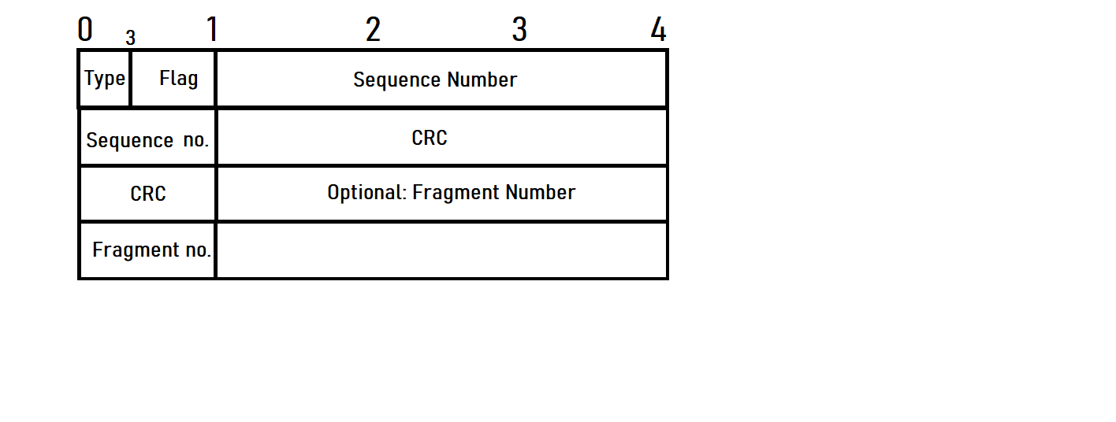
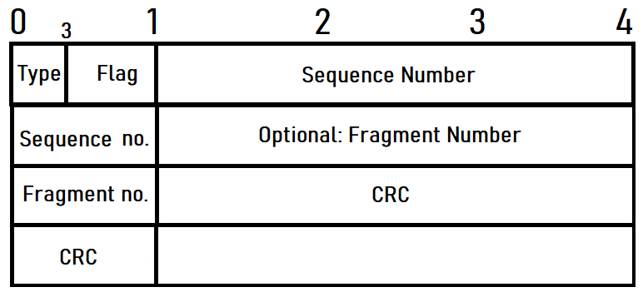

This is the design of the header with a maximum header size of 13 and minimum header size of 9 bytes. It starts with the 3-bit Type field containing a number from 0 to 4 in binary. Each symbolizing a different type of packet.
Type field interpretation:
-0 being a flag packet which contains no data except flags. This is used for creating connection and for keep alive. (There are 4 types of packets that have 0 type in their flag field: syn,syn-ack,keepalive,keepalive-ack packets)
-1 which is the non-fragmented message packet, that will also contain an end flag.
-2 is the non-fragmented file packet, which signalizes the beginning of a file transfer, this packet also contains the path of where the file should be transferred to and also the name of the file and also contains an end flag.
-3 is the fragmented message packet which contains messages that have been fragmented which means the overall message size is above 555 bytes.
-4 which is the fragmented file packet, same as fragmented message, except for files.

Next up is the flag field of the header which has a bit size of 5. There are 5 possible values, and they can be used in combination:
- S -synchronization
- A – acknowledgment
- R – resend
- K – keep alive
- E – end
Sequence number will be generated at the start of the synchronization process. Both the client and the server will use that sequence number to increment it with their data length. This means they will be able to figure out the data length of a packet from the sequence number.
The goal of sequence number was originally to be used for keeping track of bytes sent and received and for reordering packets, however later in implementation I realized it was not important to keep track of bytes sent and received, and also that fragment number take care of reordering the packets. So I left it in to later implement a some kind of method to prevent or detect session hijacking. Basically someone sending a fake packet in the name of the server or client. However I didn’t have to implement this.

Fragment number is an optional part of the header. Which means that in some cases, when a flag packet Is being sent, which contains no data or when a non fragmented message is sent then that will not contain a fragment number. However when a fragmented packet is being sent it will contain a fragment number.

Lastly the cyclic redundancy check will be calculated using the header parts such as type,flag ,sequence number, fragment number and the actual data. It will be checked before sending the packet and after receiving the packet.

Fragmentation
The maximum safe udp size that can be sent without IP fragmentation happening is 576 bytes. According to these calculations the maximum fragment size of my protocol is 555. Which was calculated by subtracting the 13 bytes of the header of my custom protocol and then substracting 8 bytes for the UDP header.
576-13-5=555 bytes. This means any data that will be above 555 bytes might get fragmented.
However it is also possible to sometimes send a 559 byte data if the header does not contain a fragment number flag. Which only should happen in non-fragmented communication.

Fragment reassembly
Packets can be lost due to connection issues, interference or packet corruption, thus there is a possibility that some fragments will not arrive at the receiving end. To avoid this problem fragment reconstruction is necessary. The method which I will use is that both the client and server will keep track of all the fragments sent and received. After that every 100th fragment will serve as reconstruction check. When the client gets to the 100th fragment, it will keep sending it until the server starts resending the missing fragment numbers. When that happens, the client will start resending each fragment that the server was missing, until the server replies with the resend acknowledgment packet, signaling that he got the packets.
This reconstruction check is also good for not overloading the RAM, in case large file size. Since after every 100th packet the heap containing the all the fragments sent so far will be wiped.

Error detection
Error detection is needed on both client and server side when receiving packets to avoid corrupted packets.
For this reason I will be using a library called zlib.crc32, which computes a crc checksum of the packets using the following polynomial : x^32+x^26+x^23+x^22+x^16+x^12+x^11+x^10+x^8+x^7+x^5+x^4+x^2+x+1.
The result is an unsigned 32 bit integer.
The crc calculation will happen after creating the packet and when receiving a packet, and they will use each flag of the header and the data to calculate the overall crc of the packet.

Communication types
My implementation will have 4 main communication types a 2 way-handshake for starting a connection and synchronization. Keep alive algorithm to make sure connection is does not get disconnected if the there are no packets received on either side. Fragmented communication with a memory free up process and a simple non-fragmented communication.

1. 2-way-handshake

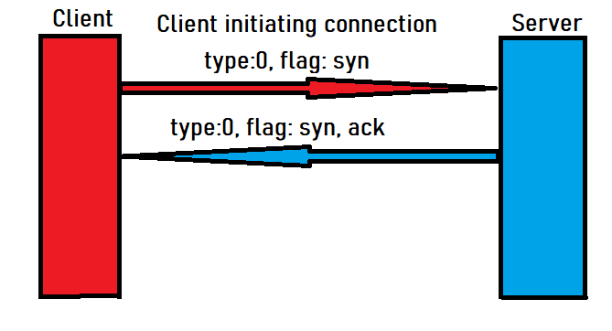
This communication happens when the client initiates a connection to the server.
It will begin with the client sending a flag packet that only contains the starting sequence number which is a random number + the data length of the packet, and the packet also contains the syn flag.
This synchronization packet will be sent until the server replies with a syn ack flag packet. After that the connection is initiated between them.

2.Keep alive

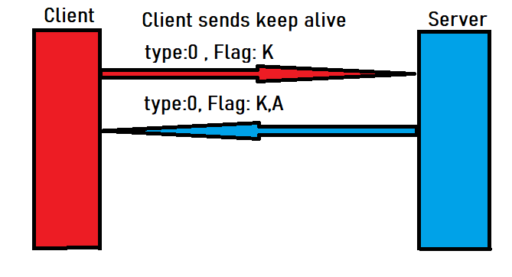
The keep alive communication is required to make sure the connection is still up. Both the client and the server can initiate a keep alive check. In this case, the client sends the keep alive flag packet. After the packet is sent, the client will wait 5 seconds then it will send another keep alive packet. This will be repeated 5 times, if until that time, there was no response received from the server,the connection will be terminated. On server side if it receives the keep alive, it will respond with a keep alive acknowledgment flag packet. After that received both the client and the server will wait 5 seconds and if in that 5 second no new packet is received on either side then a new keep alive packet will be sent.
Every packet received or sent will reset the 5 second wait time for keep alive. Which means if the user does not send or receive anything in 5 second, then keep alive packets will be sent on both sides.

3.Fragmented communication

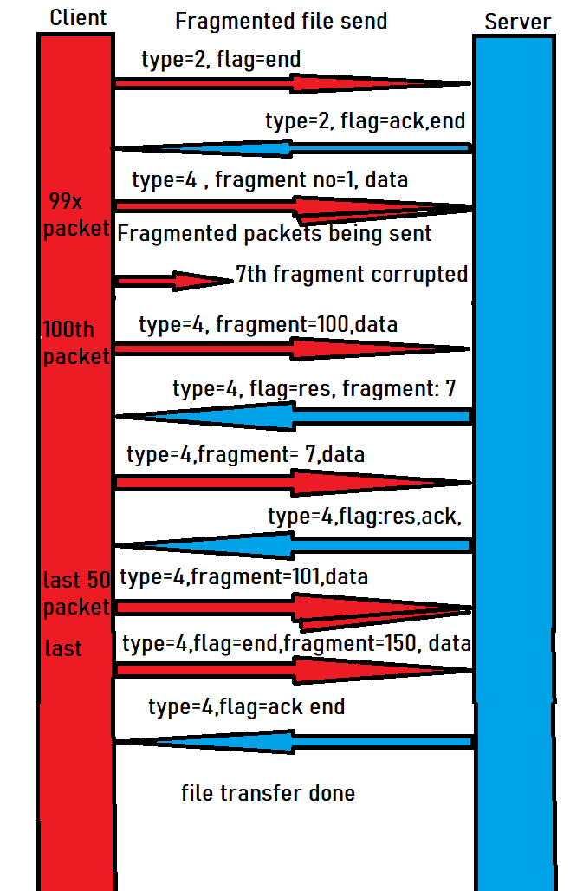

In the case of a fragmented communication there are 2 types, fragmented file and fragmented message.
The illustration shows fragmented file communication, since that is bit more complicated than the fragmented message communication, the reason being that in fragmented file communication the first packet sent is just a message packet containing the name and the path where the file should be stored on the server, this packet also contains and end flag. After that the server responds with ack end flag packet, that he is ready to receive the fragmented file data.
Then the client starts sending them one by one, until it reaches the 100th packet, this one will be sent in a loop, until the server answers with either and resend acknowledgment packet or with a resend packet that contains the fragment that the server is missing (In case of packet corruption or connection error).
When client receives the res ack flag packet, it will start sending the next 100 packets. Every 100th packet there will be a resend initiated so that both the server and client can free up the memory of the unnecessary data (data that has already been transferred without error). When the last packet is sent from the client side, this packet will contain an end flag and it will be sent over and over again until the server responds with an ack end flag packet.

As it was mentioned before, fragmented message communication is the same as this one, however there is no filename initialization part. Simply the client sends the fragmented messages to the server, where it gets reassembled by the server.

4.Non-fragmented communication

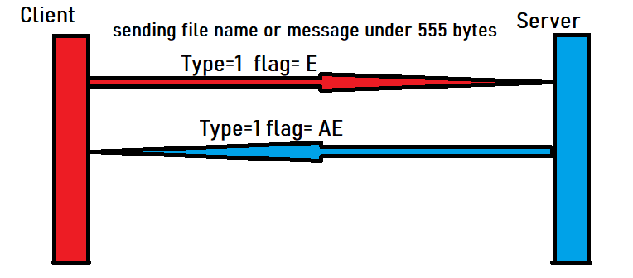
Non-fragmented is the simplest communication, it is used in 2 situations. One is when a message is being sent which is under 555 bytes or when a file transfer is starting and the client sends a message packet containing the path and name of the file, and the server uses this first non-fragmented packet to create and empty file with the name sent in the message.
Non-fragmented files will be sent over and over again until the receiver replies with an end acknowledgment packet.

Implementation

I decided to implement the server-client side communication in python.
For this implementation I created 4 python files.(Server.py,Client.py,Constants.py,Myheader.py)
Server.py and Client.py contain the server and client side code, since both can act as a server and client, this means both contain each other’s methods, variables and functionalities.
Furthermore I created a MyHeader.py, which is a class responsible for creating, checking and organizing the packets that are being sent between client and server.
Finally, I have a Constants.py file, which simply contains some global variables such as header size, fragment size,memory_reconstruction_size etc...
I will further describe MyHeader.py and the Server/Client implementation:
MyHeader.py
It also contains an initialize method which functions for creating packets and organizing the packets when they are recieved on the other side in bytes.
When the packet is created the protocol header will take up 9 or 13 bytes, depending whether these is a fragment number in the given header.
Firstly the init method will create a packet when the type field argument is between 0 and 4 (both included).
Then we take the the type field and will assign to it 3 bits, for the flag we assign 5 bits.
Following that comes, the sequence number for that we assign 32 bits. Next we check if the fragment number is bigger than -1, if it is we assign the 4 byte fragment number too.
If it is -1, then we know that this packet will not have a fragment number, so later we will not add it to the crc calculation.
After that we take the length of the data and the prev_sequence number and calculate if adding them create an integer overflow, if it does we deal with it by substracting the max integer value which is 2147483647 from the data+ sequence number, and we add it as a new sequence number.
Lastly, we create crc for each header field and the data and assign it to the crc field.

The other function of the init is organizing an array of bytes into a packet when the data is recieved, this will happen when the type argument is -1. This follows a similiar process when creating a packet, we go by byte boundaries and assin them to their corresponding fields.

Additional functionalities of this class include:
1. The set_Corrupted method which corrupts a packet, by changing a bit in the crc field.
2. Getter and setter methods for the fields of the header.

3. Print out method , crc_check method

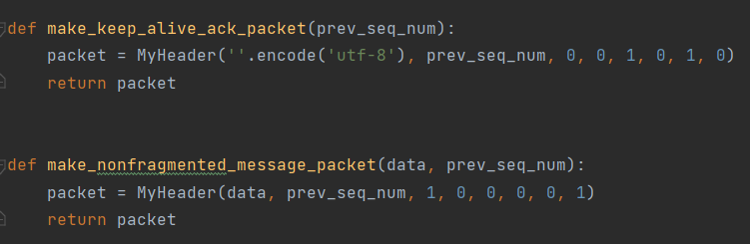
4. Methods for creating different type of packets, that look like this:

Server.py/Client.py

Both the server and client consist of the similiar functions.
Such as send_to_server/send_to_client
Which are responsible for sending out the packet to the other side, however it also includes the corrupted packet feature, which corrupts one packet that is specified in the self.problem_send variable.Which takes a number, and the number of the packet that corresponds to the problem_send number (given by the user) will be corrupted.

Some other smaller methods include write,read and open file methods, setClient/setServer,recieve_packet.
These 2 classes also offer a menu option, where the user can choose to change the max fragment size, of which the minimum value is 14. Simply because 13 is the header size. This means if the user inputs 15 as choosen max_Fragment size, then in reality the for the program that will be 15+13 , which means the actual max fragment size will be 28. However the recommended max_fragment_size to use is 555.

The most important methods implemented are the send_file, send_message,resend_file and resend_message.
Send_message/Send_file
These methods work very similiarly, there are only slight differences.
Which is at the start in send_file it checks the name and path of the given file, and the client sends out a non-fragmented file packet, which will be recieved by the server and will choose its file path based on the filepath in the file. If the file doesn’t contain a file path, then it will just be saved to the path that the server side user has configured to be his default path.
In case of the fragment size being smaller than the name of the file or path of the file. Then it will give it an automatic name.
However it is advised to not put the max_fragment_size below 200 bytes, so the server always recieves the file with the same name and format.
Next the method will take out the configured amount of bytes from the file which was turned into an array of bites.
It will put these smaller chunks (max fragment size) and will send it to the server. It will keep sending until it sends the 100th packet. After that it will go into resend_in_progress mode 1. Which means in this mode the client will be constantly sending the 100th packet, until it gets a reply from the server. This is done to avoid even the slightest chance of the packet not going through, or being corrupted.
So when the server replies with a packet containing an ’R’ flag, the client will go into resend_in_progress mode 2, which means it will keep listening to incoming resend requests from the server and send back the packet which the server was requesting. This goes on until, the server recieves all the missing packets, when this happens, the server will immidiately send a ’AR’ flag packet, which signalized that it got all the missing packets to the client and that it can go back to resend_in_progress mode 1 and start counting again from 0 to 100.
Finally when the server client through all the fragments, it will start sending the last packet in a loop until the server answers with an ’R’ flag, which will initiate the final resending of the missing fragments.
When the server got all the fragments back from the client it will send a final ack end flag packet, which symbolizes the end of the communication for both sides.

Resend_file/Resend_message

These methods are responsible for requesting missing fragments from the client.
It uses a heap to keep track of missing fragments. Once the server reaches the 100th packet, it will send back a reply for accepting the 100th packet and will start removing fragments from the heap one by one and requesting them from the client until it gets all of the missing packets.
User Manual and User interface

The client and the server parts have to be run separately, and each of them will ask for the server’s IP address and port.
After that it will display a short menu.

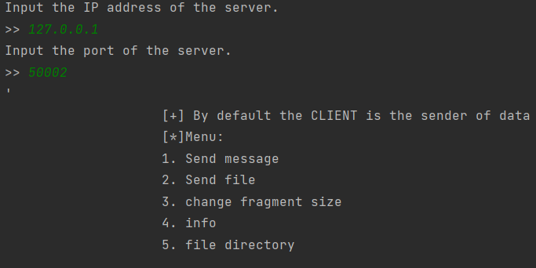

For sending a message the user has to input 1, followed by the message they want to send.
To send a file the user has to input 2, followed by the location of the file that needs to be sent.
Then it will ask the user to input the location of the directory where the file should be uploaded to on server side. This is an optional, it can be left blank, by pressing enter.
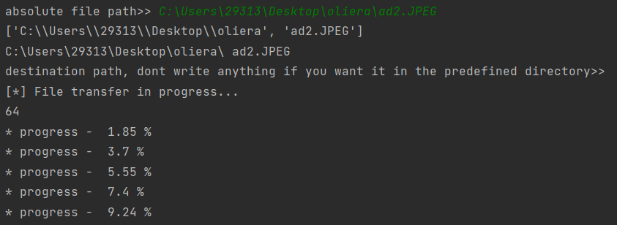
After that on server-side it will show the amount of fragments it took to send, and the amount of overall bytes
and the directory where it was uploaded to and the name of the file.
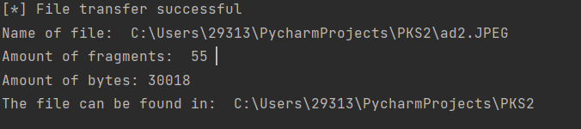

Option 3 will change the max fragment size to a desired value.
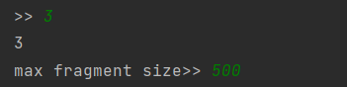

Option 4 can be pressed to see the current directory and the amount of bytes:
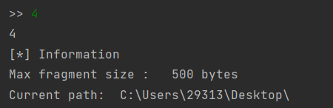

Option 5 can be pressed to change the directory where the files will be downloaded to:
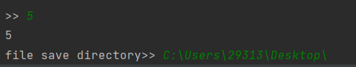

Libraries
zlib
random
os
socket
threading
time
heapq
copy
bitarray
socket
shutil

Sources:
https://www.pico.net/kb/what-is-the-largest-safe-udp-packet-size-on-the-internet/
https://www.cs.wmich.edu/~alfuqaha/cs595/lectures/lecture5-B.pdf
https://www.ibm.com/docs/en/zos-basic-skills?topic=layer-transmission-control-protocol-tcp

