January 2026
Over a month, I 3d modelled, printed and built an autonomous robot that integrates software coded in python with hardware such as motors and sensors.

The robot includes 2 motors, ultrasonic sensor, motor driver and a Raspberry Pi 0 W.
Below you can see the robot virtually before it was 3d printed.
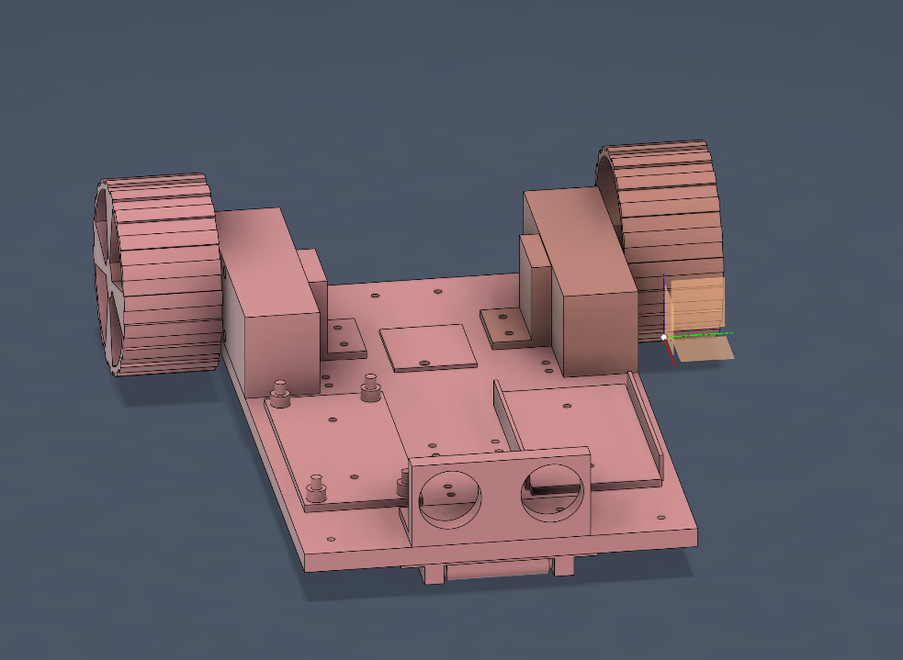

Below you can see the robot assembled.
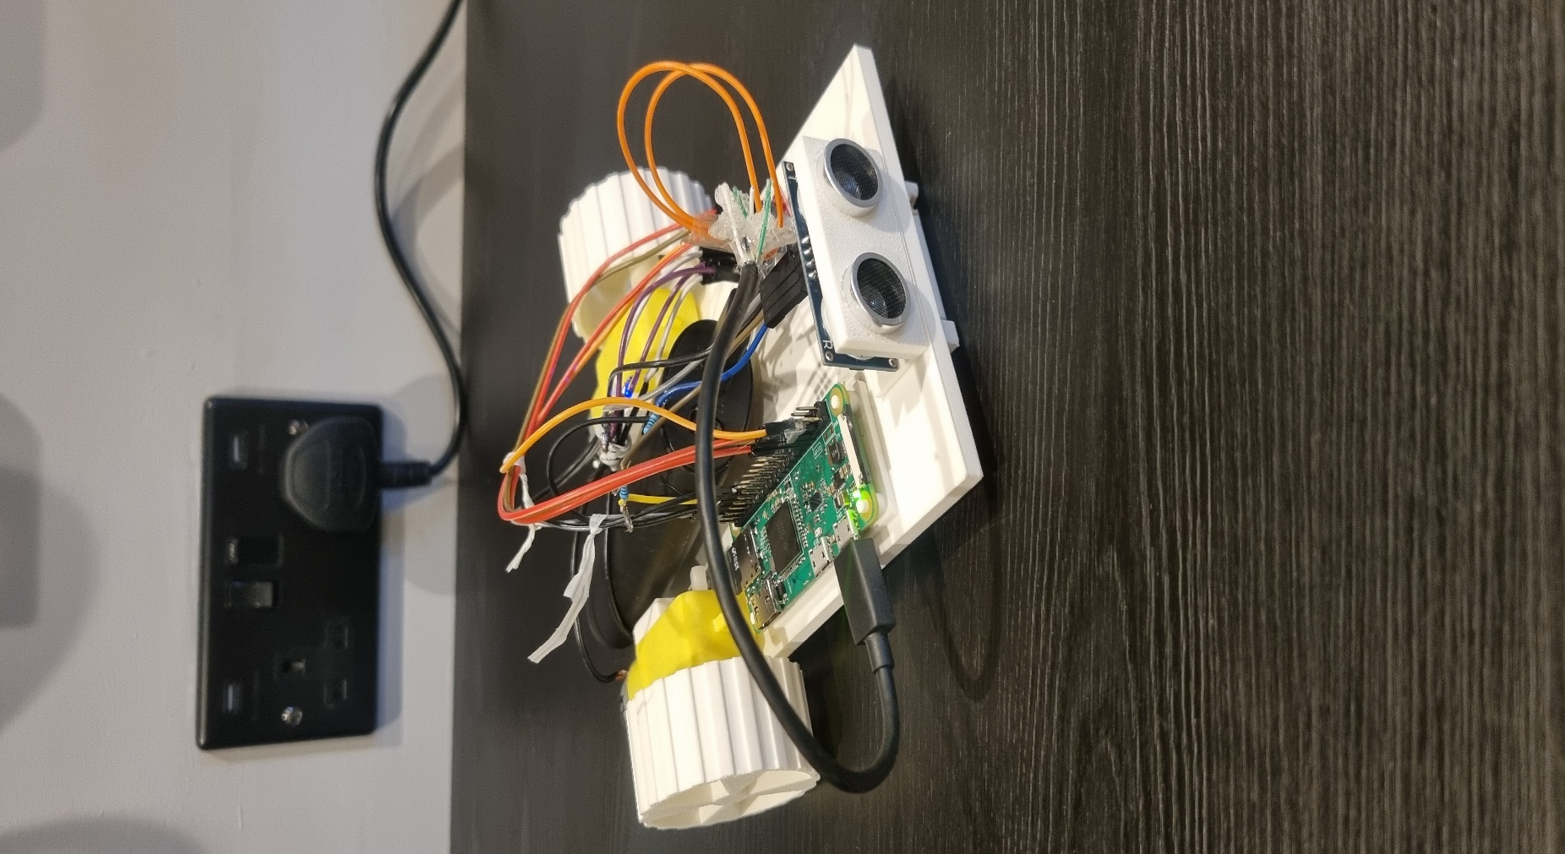

The robot works by getting distance readings from the ultrasonic sensor and relaying them to the microcontroller. If the distance to the next object is greater than 30cm both motors drive forward as usual. If the distance is smaller than 30cm one motor drives forward and the other backwards causing a turning effect until the distance is bigger than 30cm again. Turning is helped by the roller wheel at the front of the robot.

Below you can see the robot functioning.
https://drive.google.com/file/d/18xM7VtVJAlWMKPxZIxT-rLIJP85dPTxe/view?usp=sharing

I chose the Raspberry Pi 0 W for this project because it supports python and provides easily accessible wireless code changing. An ultra sonic sensor was used due to its straightforward distance readings and reliability. Finally high torque motors were used to power the robot due to its moderate weight.

Overall, the code for this project was 84 lines long and if desired could be easily altered due to the use of subprograms for controlling the motors.

Made by Oliver Ron Andreasen.

