# What happens 20. July to 20. August?

11. - 14. August appears different than other “normal” periods according to Figure 1. The wind speed reaches 18 m/s in this period and the wind direction stays somewhat constant. The rotor operates at around 15 rpm somewhat constant.

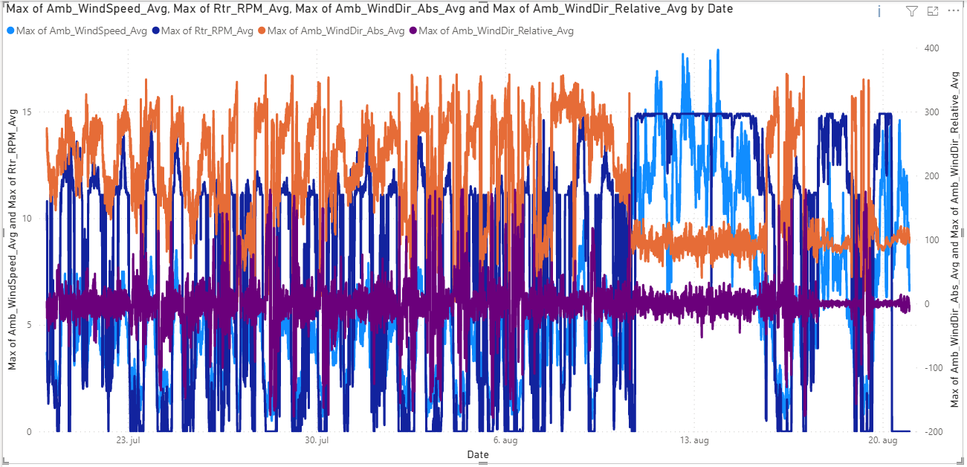

Figure 1: Wind direction and wind speed

Pitch angle remains low while wind speeds are higher according to Figure 2. Wind speed of ca. 14 m/s gives a pitch angle of ca. 10 degrees.

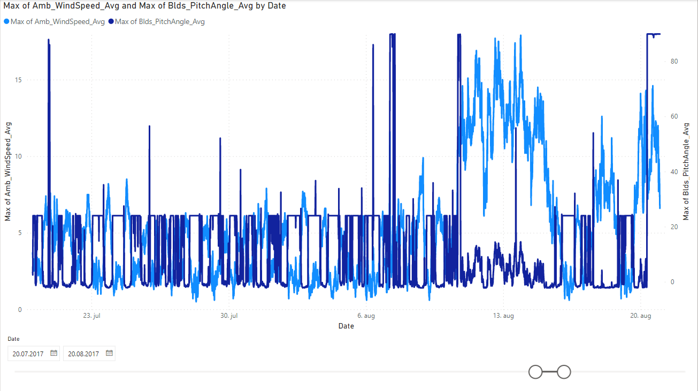

Figure 2: Wind speed and blade pitch angle

It is difficult to conclude that the pitch system is failing when comparing to other periods with similar wind speed, such as in Figure 3.

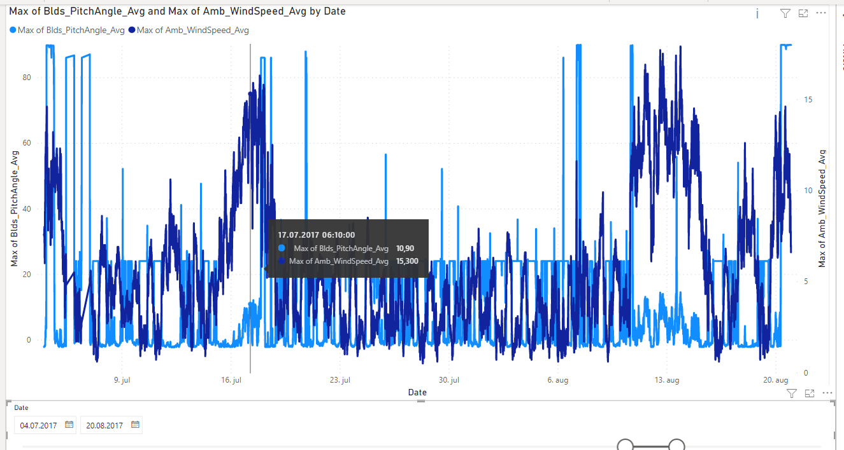

Figure 3: Blade pitch angle and wind speed at different time

Figure 3 shows temperature of gearbox bearing and bearing 1 and bearing 2 in generator.

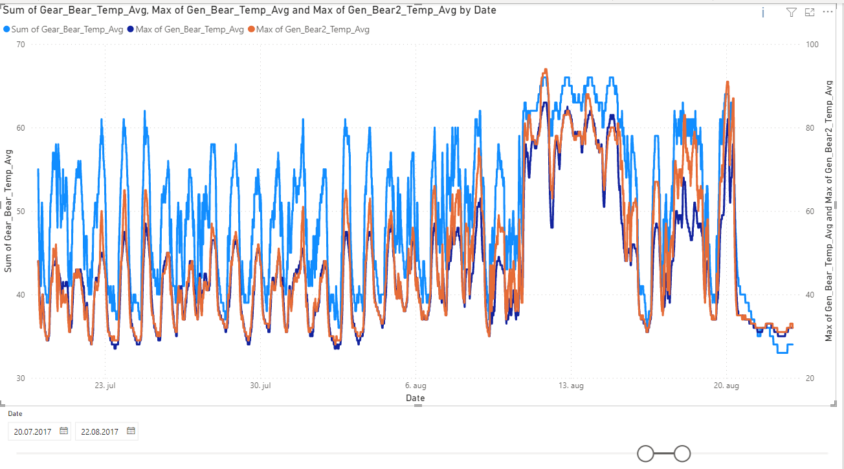

Figure 4: Bearing temperatures

Max generator rpm over the 10 min intervals shoots up before reaching the constant level in the 13. Aug period, and again right before the turbine shuts down.

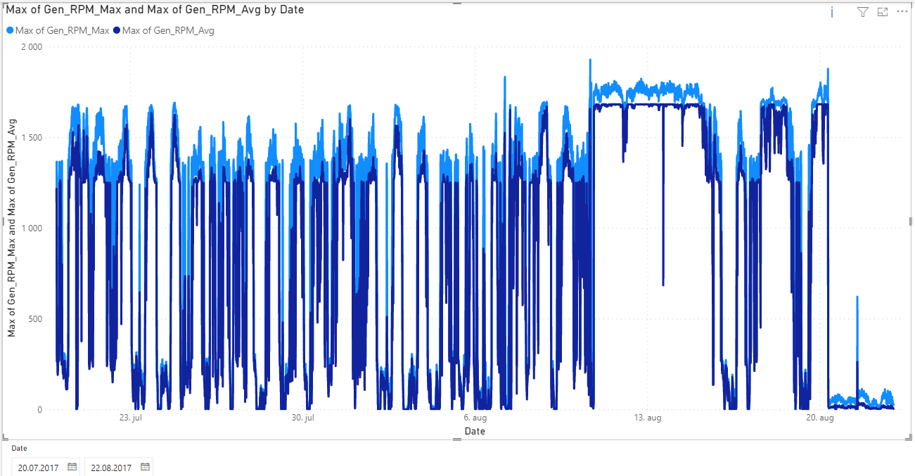

Figure 5: Avg and max generator rpm

Nacelle direction stays constant in the period mentioned, which seems right according to the wind direction. The nacelle temperature is also displayed in Figure 5

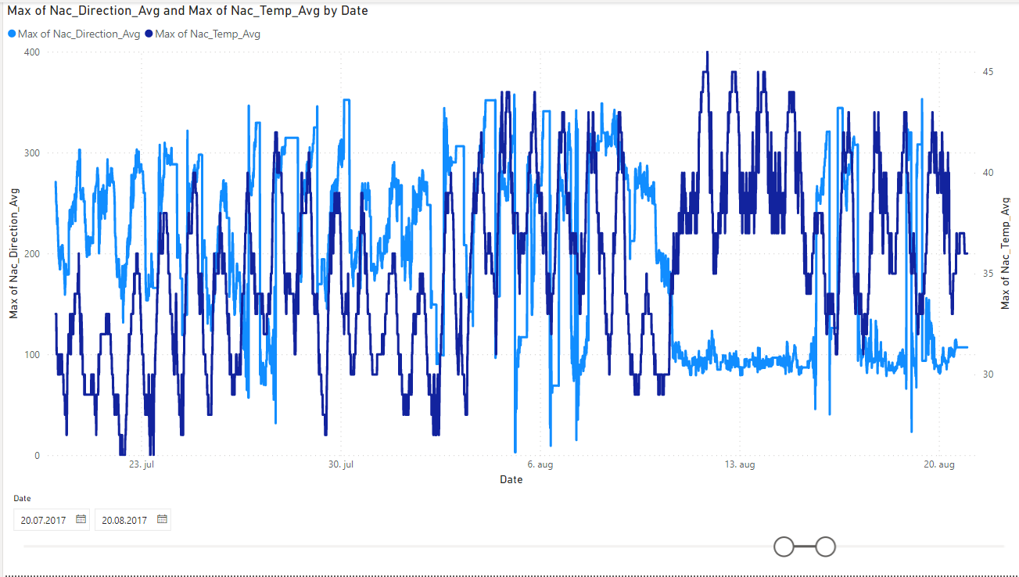

Figure 6: Nacelle direction and temperature

Rotor rpm and generator rpm are highly correlated according to Figure 7.

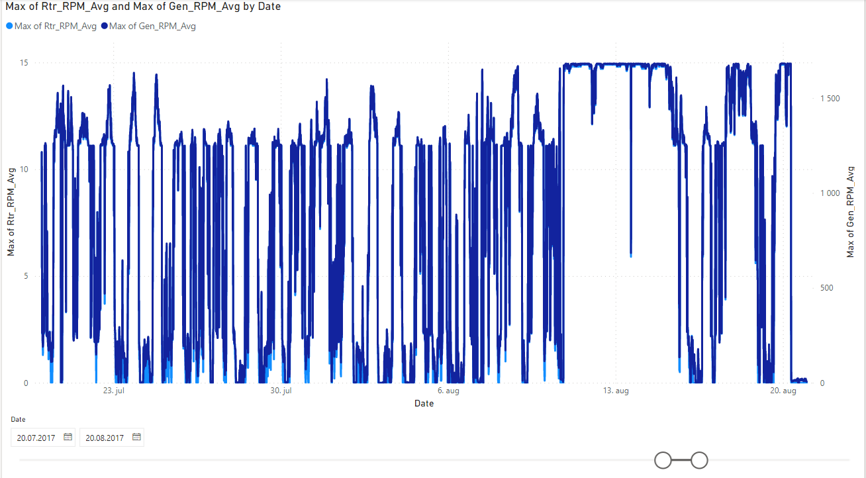

Figure 7: Rotor rpm and generator rpm

Generator bearing 2 temperature tends to be higher than generator bearing 1 temperature as displayed in Figure 8.

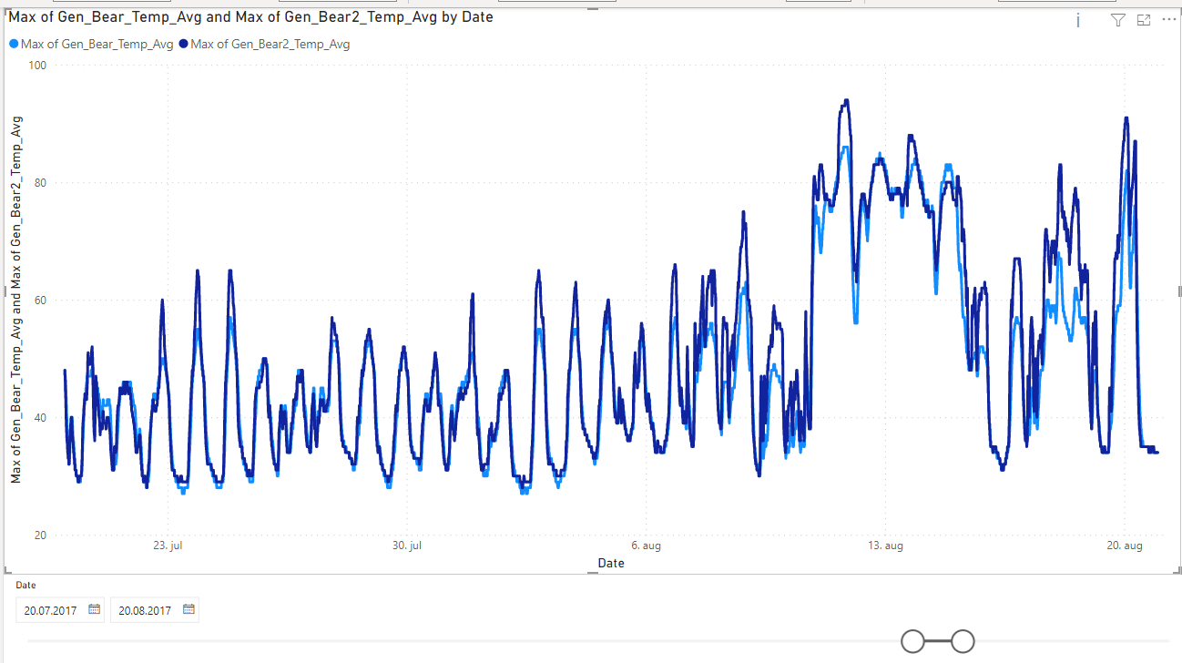

Figure 8: Gen bearing 1 and 2 temperatures

## Correlation matrix

Findings in Figure 9 involve a negative correlation of -0,71 between pitch angle and difference in theoretical power and actual power produced.

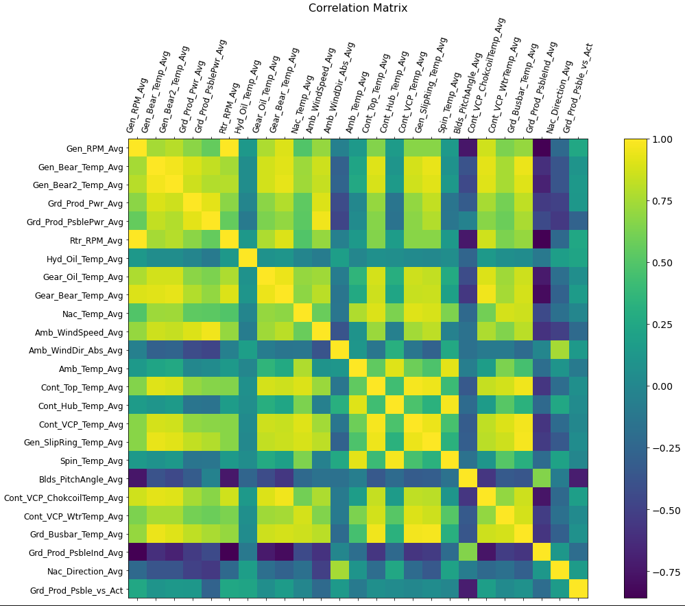

Figure 9: Correlation matrix 20.07.2017-20.08.2017

A comparison of correlation matrixes below in Figure 10 and Figure 11 show a stronger correlation in the hydraulic oil temperature row for the former and a stronger correlation in the gear oil temperature in the latter.

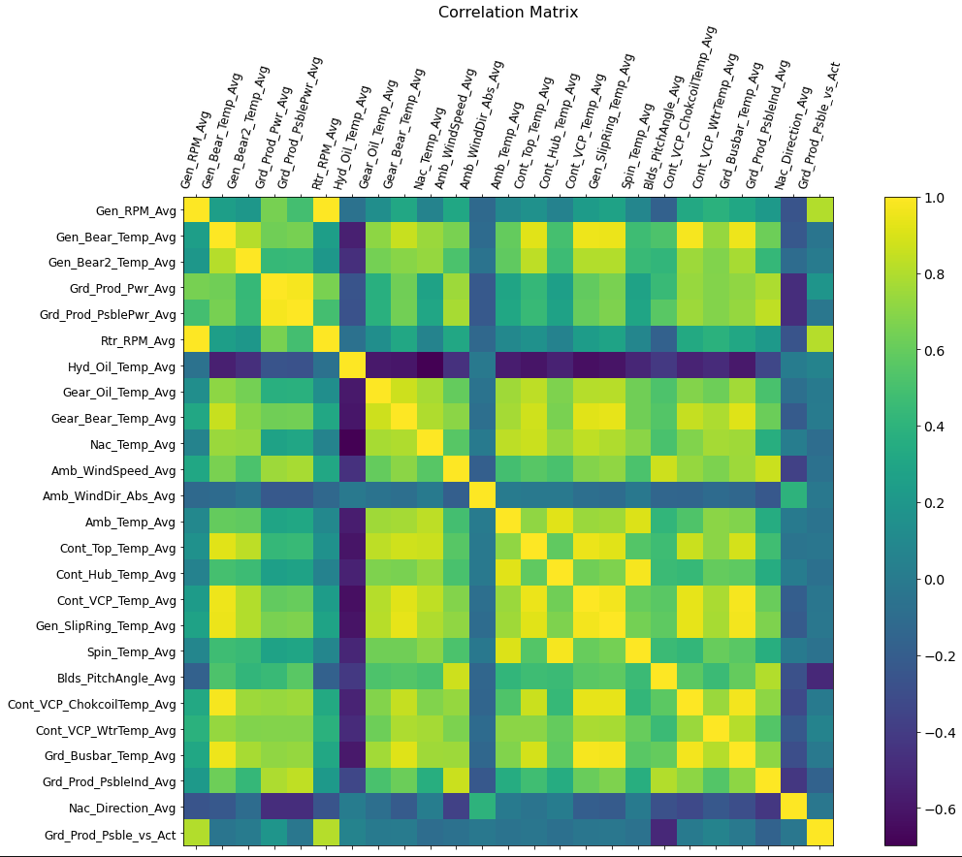

Figure 10: Correlation matrix 11.08.2017-14.08.2017

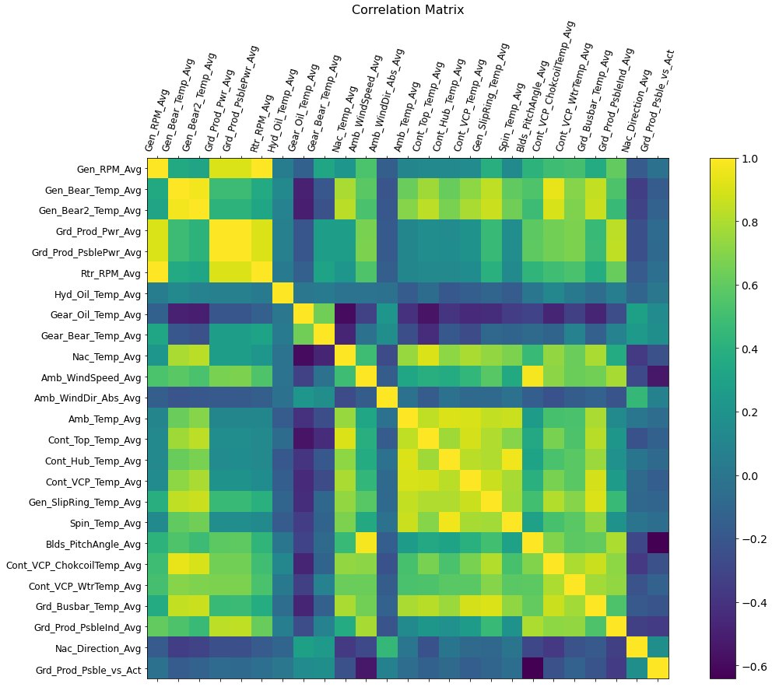

Figure 11: Correlation matrix 07.04.2017-10.04.2017

# Table of strong correlations

Table 1: Strongly correlated variables

|  |  |  |
| --- | --- | --- |
| Variable 1 | Variable 2 | Correlation |
|  |  |  |
|  |  |  |
|  |  |  |
|  |  |  |

## Blade pitch angle vs wind speed

When wind speed is below cut-in speed the blade pitch angle is at a set value of around 24 degrees according to Figure 12. As the wind speed increases above the cut-in speed, the blade pitch angle drops to near 0 degrees and from there on seems to increase with increased wind speed but still remain below 24 degrees, as seen in Figure 13 and Figure 14.

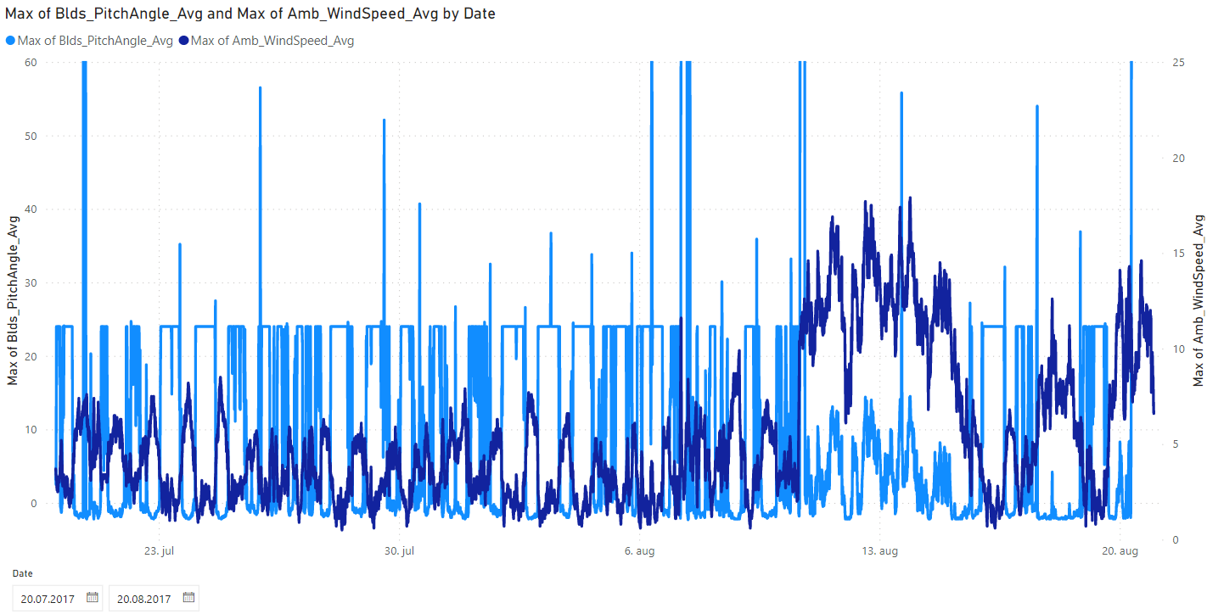

Figure 12: Blade pitch angle vs wind speed 20.07.2017-20.08.2017

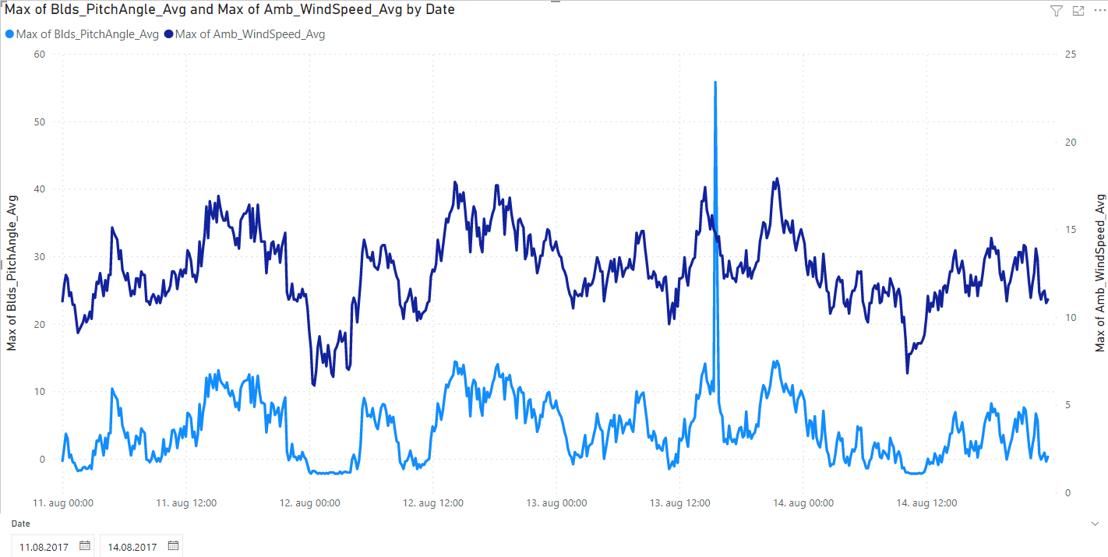

Figure 13: Blade pitch angle vs wind speed 11.08.2017-14.08.2017

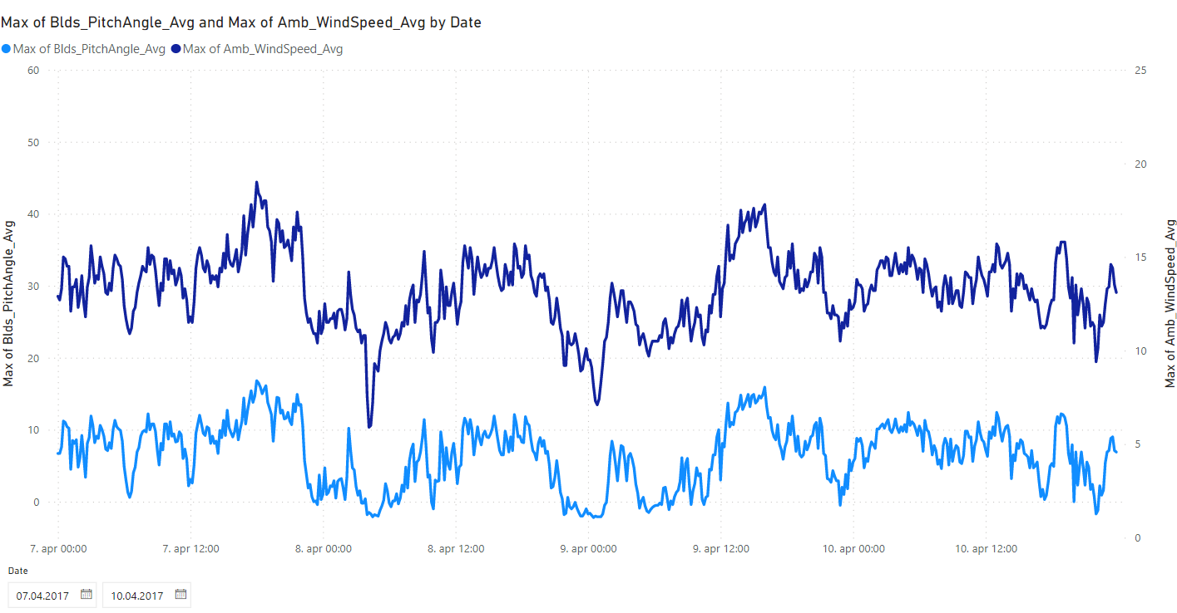

Figure 14: blade pitch angle vs wind speed 07.04.2017-10.04.2017

# Investigation of spike 13. August

Figure 15 shows a sudden drop in generator rpm 13. August at 15.30. The drop also occurs in the rotor rpm in Figure 16 and power production in Figure 17 and it is therefore not likely an error in the data.

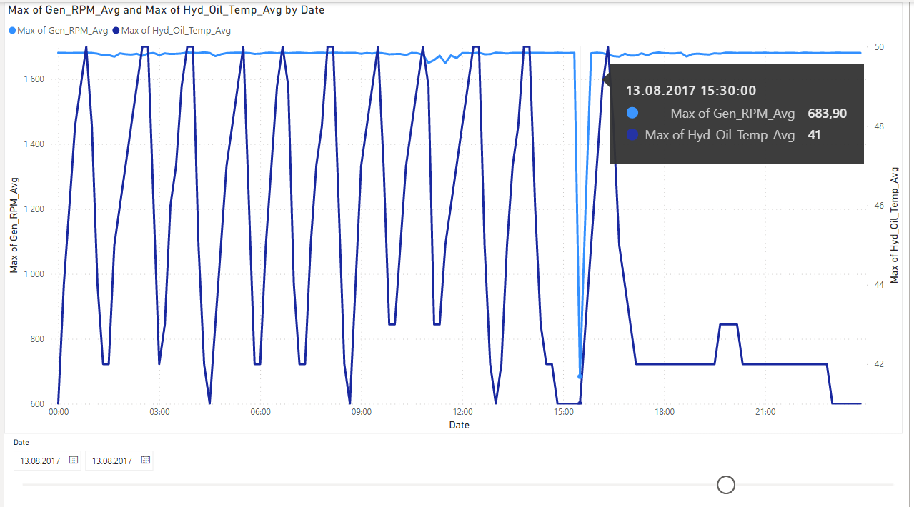

Figure 15: Generator speed 13. Aug

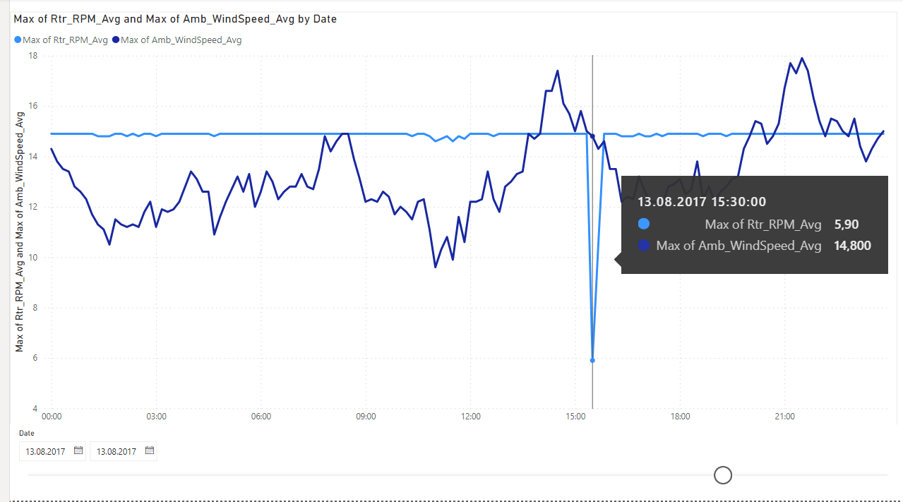

Figure 16: Rotor speed 13. Aug

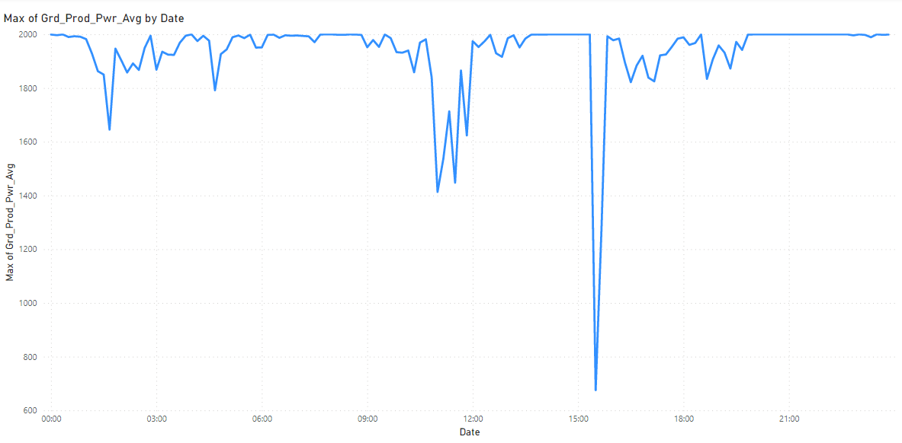

Figure 17: Power production 13. Aug

# Grouping of temperature and rpm

In Figure 17 only temperatures are correlated in the heat map in order to identify one single temperature which acts as a good measure of all temperatures for further research.

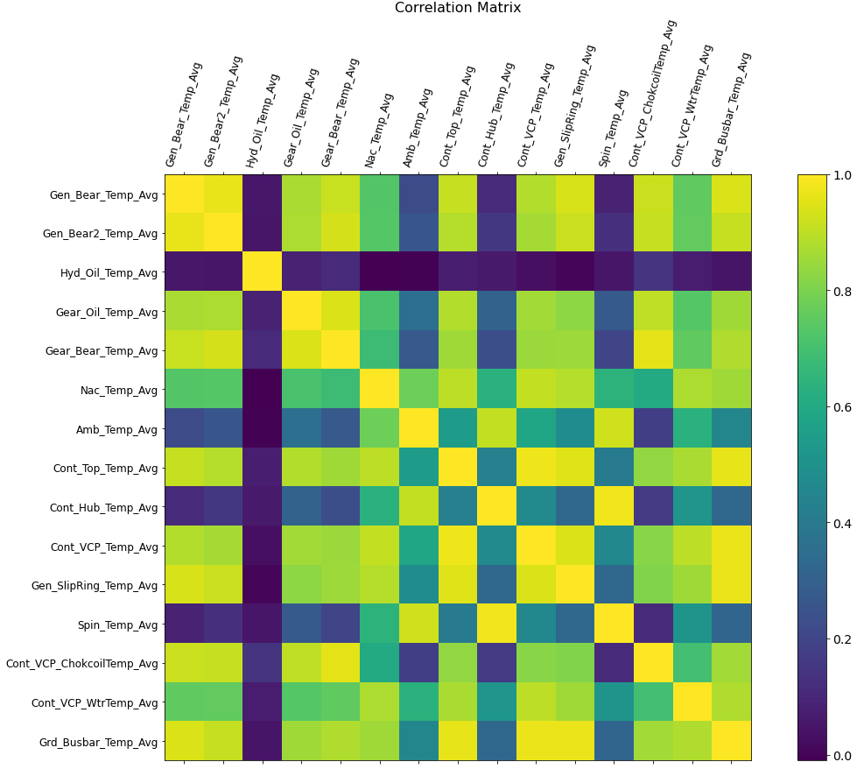

Figure 18: Correlation of temperatures 20.07.2017-20.08.2017

Figure 18 shows that generator rpm and rotor rpm are very highly correlated and can therefore grouped together in further work.

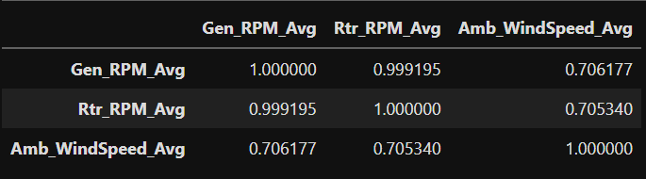

Figure 19: Correlation of rpm and wind speed 20.07.2017-20.08.2017

# Temperature trend

A 12-hour rolling average of bearing 2 temperature and generator rpm is shown in Figure 20. The light blue color is the generator rpm and a seasonal variation can be identified with a higher temperature during summer months and a lower temperature during winter months.

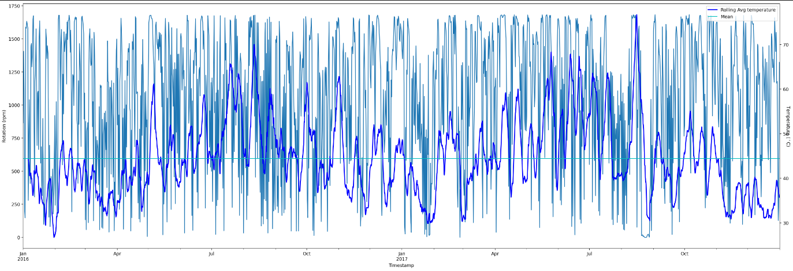

Figure 20: Bearing temperature trend vs gen rpm