General notes:
Should ‘simulation’ be ‘Simulation’ as it’s a product name/ for consistency with Virtual Work Experience?
Remove em dashes as not a US client and makes it look more AI.
First screen
Join Terence at art'otel Hoxton to prepare tonight’s product launch for one hundred guests. Check the food, make decisions and get the evening team ready.
CHANGE TO
Join Terence at art'otel Hoxton to prepare the kitchen for tonight’s product launch for one hundred guests. Check the food, make decisions, and get the evening team ready.

Use a mouse, touch or keyboard. Sound is optional.
CHANGE TO

Use a mouse, touchpad or keyboard. Sound is optional.
Compare ingredients with your allergen chart, propose changes and identify checks still needed.
CHANGE TO
Compare ingredients with your allergen chart, propose changes and identify what checks are still needed.
Weigh the waste and explain what the evening team needs to know and follow up.
CHANGE TO
Weigh the waste and explain what the evening team needs to know and follow up on.

Task 1 of 5, step 1 of 3

Night team to morning
CHANGE TO

Completed by the night team
Step 2 of 3 Walk-in fridge — 1 of 7
Unable to review all of the hotspot copy as the image is overlapping the text.
Step 2 of 3 Larder fridge 2 — 3 of 7
Use what you find inside to explain the discrepancy and what you did.
CHANGE TO
Use what you find inside to explain the issue and what you did to fix it.
‘Write it in my notebook’ doesn’t prompt anything - should it?
Step 3 of 3
Food Temperature Log Book
to Record Fridge Freezer Temperature
Change the case type of this wording and remove the ‘to record…’
Food temperature log book
Task 2 of 5
Check the delivery in
CHANGE TO
Task 2 of 5
Check the new delivery
General note: decapitalise Salmon, e.g. Check Salmon fillet, skin on

Job card
Who you're working with: In person with the driver, who is in a hurry, and on the kitchen radio to Terence when the salmon count does not match the sheet.
This is giving a hint for the activity, so change to
Who you're working with: In person with the driver, who is in a hurry, and on the kitchen radio to Terence when support is needed.
Amend the ‘DONE WHEN’ copy to…
Done when
Every line on the order sheet is marked as arrived, short or refused; every chilled line is marked with a temperature, and you’ve signed for what you accepted.

Every line is marked as arrived, short or refused
Every chilled item is marked with a temperature
The fish is looked at and smelled
Delivery note signed for what you actually accepted
All 10 items inspected
6 chilled items have temperatures measured
Inspected and explained sea bass findings
Status and acceptance chosen for every item
Calculated missing quantity
Sent shortage report to Terence
Corrected note and signed for goods received
Change copy on the radio hotspot to:
Head to the back door: Where the delivery van is waiting

Step 1 of 13
Inspect the goods, measure what arrived and enter it beside the order. Decide whether to accept the checked quantity.

CHANGE TO
Inspect the goods, measure what has arrived and enter your findings beside the order. Decide whether to accept the checked quantity.

21/09 notes

General rule: To match our style guide, use Oxford comma consistently throughout the copy.

General rule: Quite a lot of scrolling which makes it hard to complete activities, type in answers, press temperature dials etc as a lot of back and forth required.

General rule: Copy is quite choppy and unnatural; mix sentences between punchy phrasing for art’otel branding, with longer-flowing bits of narrative to make it more authentic and conversational, especially when copy is supposed to come from Terance.
If giving an instruction to click something, put the button name/label in single quotes, e.g. ‘Tap a tray to choose it, then press and hold ‘Add beef’ to pour, or use the 0.5 kg buttons,’
General rule: After a colon, capitalise the first letter of the first word to match our style guide.
Some em-dashes in here still, e.g. task 5 of 5: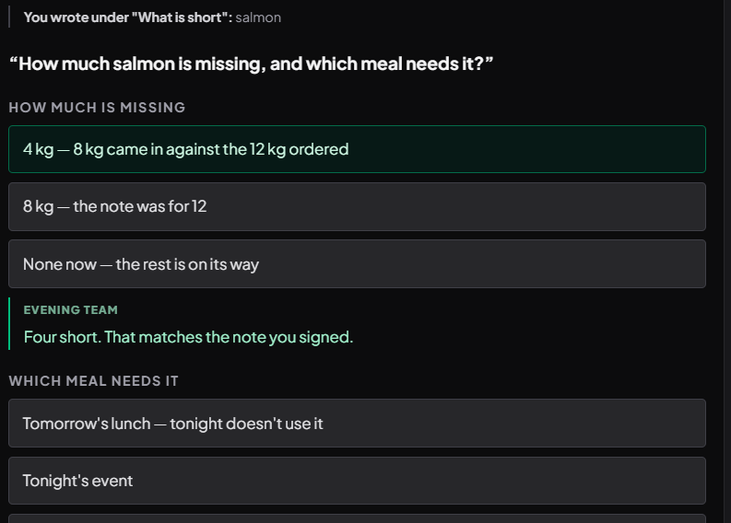

Generally, the tone and copy style within the ‘Evening team’ feedback in green is really good, casual and conversational: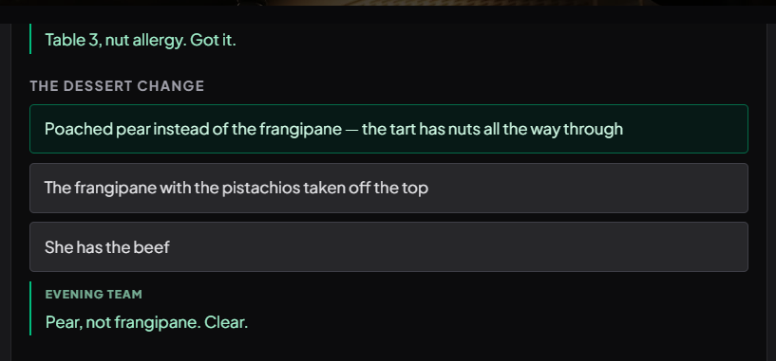

Url is https://marriott-sous-chef-try-day-fable-test.replit.app/?testMode=1 rather than art’otel

On first page i would maybe remove the second ‘ART’OTEL’ as the logo is probably enough 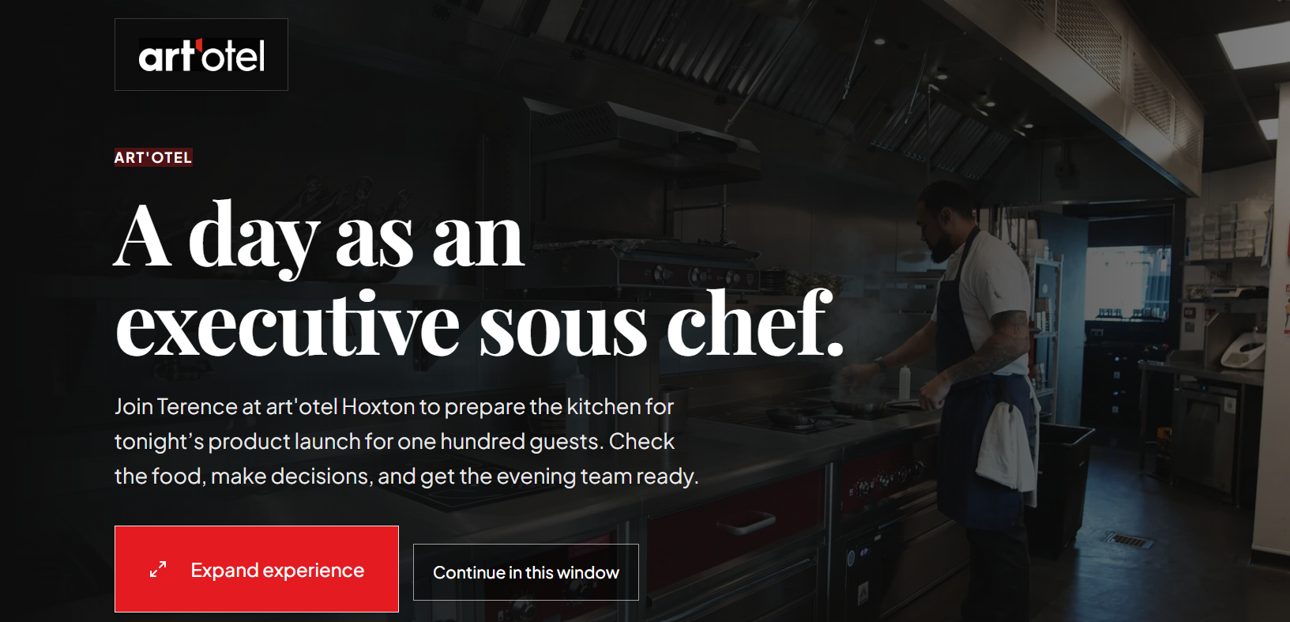
Before your shift:
Change ‘Follow the step guide through five tasks. Check your work before signing it off.’ to:
‘Follow the step-by-step guide through five tasks. Check your work before signing it off.’
Change ‘Tap one and it highlights’ to ‘Tap one to highlight it’.
Change ‘Press on a tray, probe or ruler and drag it where it goes. The places it can go light up.’ to ‘Press on a tray, probe, or ruler and drag to where it belongs. The places it can go will light up.’
Change ‘Press and hold a thermometer or probe for a couple of seconds until it settles, then read it yourself.’ to ‘Press and hold a thermometer or probe for a couple of seconds until it settles, then take the reading.
Change ‘Three things to know before you start. You can see them again at any point from "How do I do this?" beside the step guide.’ to ‘Three things to know before you start. You can read them again at any point by clicking "How do I do this?" beside the step guide.’

Add Oxford comma here: ‘Use a mouse, touchpad, or keyboard. Sound is optional.’
Add one in ‘Choose how you work’ after ‘comparing…’
Add Oxford commas throughout device advice.
Your briefing from Terance
Change briefing text to: Everything Terence says in the video, for reading instead of watching.

At top of Experience, change ‘Interactive Try Day’ to ‘‘Try’ Activity’

Task ⅕ was hard to review as the instructions were confined to a small box 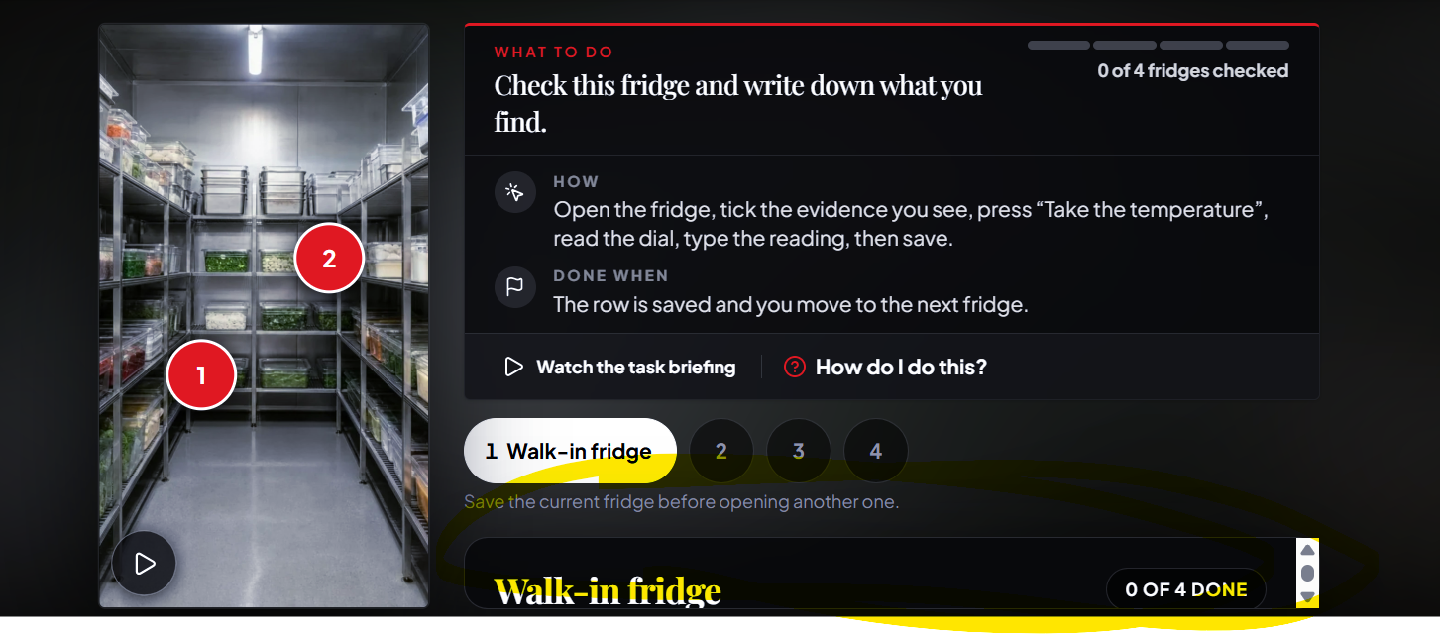

Task ⅗, Terrance box, change: ‘You have half of the twenty-seven-kilo batch. Keep the beef no deeper than fifty millimetres. If the trays on the bench will not hold your share at that depth, ask for a clean spare. Then we will work through a recorded cooling comparison.’ to ‘You have half of the twenty-seven-kilo batch. Portion the beef no deeper than fifty millimetres per tray. If you don’t have enough trays, ask for a clean spare. Then we’ll work through a recorded cooling comparison.’

In job card ‘Who you’re working with’ change ‘Alongside Terance’ to start with just ‘Terance, who…’

This popped up on task 3 and then i couldnt minimise it to see the rest of the progression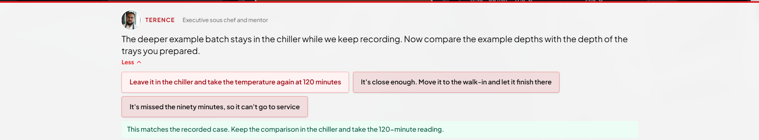

On task 4 of 5, give all menu items sentence case for consistency: Wellington has it already but all others are written lowercase: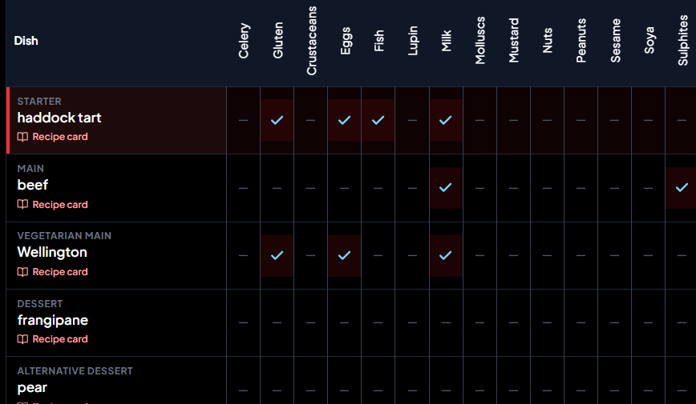
Change ‘Five dishes down the side, the fourteen declarable allergens across the top. Mark what the recipe card shows, review each row, and note anything you cannot tell from the card.’ to ‘Compare the five dishes down the side to the fourteen declarable allergens across the top. Mark what the recipe card shows each dish includes, review what Terance has noted, and jot down any additional checks needed’

In ‘What counts as what’, add a question mark on that initial question ‘What counts as what?’
Once expanded, display this copy: ‘This is a general reference sheet, not an answer key. Pick a category for a simple description.’

Change ‘Nothing here confirms a dish as safe.’ to ‘Nothing here confirms that a dish is safe.’
Tidy up the close of day copy slightly, so it reads:
‘That's you finished with your tasks. You checked the fridge properly, did not sign off on salmon that had not arrived, kept the beef in the chiller until it was ready, checked allergens before serving a nut-allergic guest, and left the evening team a handover they can use to serve our guests. Anyone can learn to cook; what matters is checking properly, explaining decisions, and leaving records people can trust.’

