Title

An analysis by Oliver Foster

# Inspiration

As a young professional in the age of the internet I find myself drowning in unsolicited advice regarding how I should be managing my personal finances. On one hand there are the more senior know-it-alls urging me to invest into the Canadian real-estate market, while on the other hand there are a sea of futurists arrogantly stating that Millennials have created a world where homeownership is no longer of upmost importance. When asked to defend their advice I often find the two groups citing anecdotal evidence about their cousin Jim who got in early in the Toronto real-estate boom, or their college roommate Connor mining Bitcoin before Blockchain was at the top of everyone’s minds. While these stories make for interesting conversations at happy hour this type of advice isn’t rooted in exact science. I decided I wanted to investigate the alternatives to purchasing real-estate by the numbers.

Let’s assume you have a pot of money that each year you can put towards a combination of your property expenses and savings. If you decide you’re going to rent for the next 30 years, this pot would contribute to your cost of rent, and the remaining available funds would be put towards an investment in the stock market. If you decide on purchasing a condo, this pot would be put towards your mortgage payment, condo fees, property taxes, and the remainder towards the stock market (provided you still have money to spend).

Which of these portfolios would yield a better return on investment? Intuitively a large investment into the stock market seems like a more risky play but you stand to have more upside potential. The downside to this strategy is you’re throwing away your money to rent every month. Purchasing a condo seems like a safer strategy – the returns on real-estate in Canada are less volatile and you lose no money to rent. You do however have the downside of paying condo fees and property taxes while limiting your upside potential with a smaller investment into the stock market. How can one effectively weigh their options with so much uncertainty?

# Monte Carlo to the Rescue

Monte Carlo simulation is a technique used by analysts to simulate possible outcomes to strategies containing considerable uncertainty. It starts by defining a returns distribution for your investment strategies and then simulating year-by-year performance by randomly pulling the current-year returns from this distribution. After simulating 1000 times you are left with 1000 likely outcomes for your return on investment given its historical uncertainty. If you decide to rent and invest all remaining funds into the stock market your portfolio’s returns depends solely on the returns of the stock market. Alternatively if you purchase a condo your portfolio’s returns depends on a combination of capital gains returns in the real-estate market and a lesser share investment into the stock market.

# Assumptions

Considering I currently reside in Montreal I will take it’s composite housing price index as a proxy for real-estate capital gains returns, while using the returns of the S&P 500 as a proxy for market returns. Additionally we must assume:

* You have $27,000 annually to invest into a combination of property expenses and stock market investments
* Rent & salary increase 3% annually
* Existing investment in the stock market of $20,000 (irrespective of the investment strategy taken)
* You can purchase a 10-year fixed term mortgage with a 3.2% interest rate
* Property taxes are 1% of the market value of the condo & school taxes are 0.15%
* There is a 20% down payment required for any real-estate investment to avoid penalties
* Real-estate broker fee of 5% of market value at the end of the investment horizon (assuming the property will be sold at that point)
* Start-up cost of purchasing a condo of $6,000 to account for inspection & administrative fees
* 100 dollars annual transaction fees for purchasing stocks
* 30Y investment horizon for all simulations

# Case Study 1: Testing Length of Amortization Period

Let us assume that you’ve decided to purchase a condo. You are left to decide how long your amortization period should be. As humans we are naturally debt adverse so you may want to pay off your mortgage as quick as possible (pick say a 20-year amortization period). Thinking by the numbers we must ignore that bias and consider the results of the analysis:

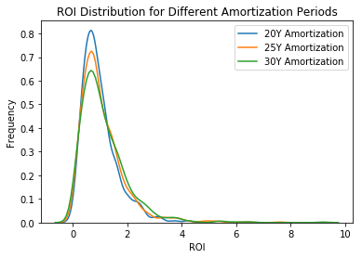

Consider the results of the Monte Carlo Simulation above. If you had decided to go with the 20Y amortization period your investment would be slightly safer – but you would be foregoing considerable upside potential when comparing to the 30Y period. Intuitively this makes sense – if you stretch out your amortization period you have more money now to invest into the stock market. While the stock market has a more risky return profile there is considerable reward opportunity on the right side of the histogram tail.

The preliminary conclusion is to maximize the amortization period of any real-estate investment with the assumption that you can get a 10Y fixed mortgage of 3.2%.

# Case Study 2: Renting vs. Buying

Given the results of the amortization study let’s compare the purchase of a $300,000 condo with a 30Y amortization period to renting and investing all your money into the stock market:

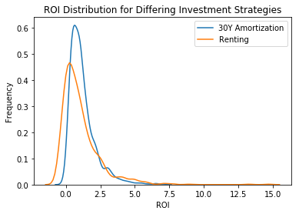

As anticipated - renting and putting all investment in the stock market is a riskier profile (wider distribution). This time however the majority of the risk is on the downside of the distribution when comparing the renting investment strategy to the 30Y mortgage. It seems that the risk associated with putting all that money into the stock market might not be worth the potential downside.

Given the resultant distribution one can conclude that renting & investing all funds into the stock market poses too much downside risk to view as a viable alternative to buying. A limitation of this simulation is the assumption that you would put all money on the S&P: a savvy investor would likely diversify their portfolio & include financial instruments with lower risk than the S&P. For the sake of this analysis however - buying seems to be the smarter strategy.

# Case Study 3: Cost of Condo

Building off the previous analyses you have decided to purchase a condo with a 30Y amortization period. You are now left with the decision: how much money should I spend on this condo? We can simulate the anticipated ROI distribution for a $300K, $350K, and $400K purchase:

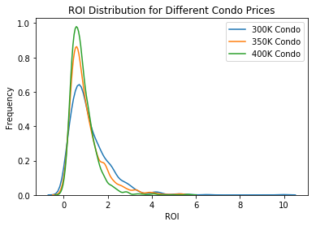

The cost of your condo seems to affect your potential ROI significantly. While there is negligible downside risk to all 3 purchases there is considerably more upside potential if you purchase a cheaper property. By overspending on your real-estate purchase you can miss out on potential returns from the stock-market considering the more you spend on your condo the less you have for stocks. Given these distributions a more affordable unit is recommended to maximize your ROI.

# Conclusion

Given the results of the case studies outlined in this article I would recommend the following:

1. If you can afford the down payment and start-up costs - purchasing real-estate is a good investment in Montreal if the assumed alternative is to put all your savings into the stock market
2. Select the longest amortization period you can while the interest rate of a 10Y fixed mortgage is hovering around 3.2%
3. Don't overspend on your real-estate purchase - if you don't allow yourself to put some of your yearly savings into the stock market you miss out on the potential upside of stock returns.

The prevailing theory stands: if you can afford it, purchasing real-estate is a wise investment. Millenials haven’t shifted the paradigm just yet.