Project: Signing I/O System Advanced
Jacob-L
https://github.com/oliverinhalo/CS-NEA/tree/development
#a862ea
#6545a4
#6545a4
#6545a4
#465ca4
Table of contents
Analysis 4
Introduction 5
The Initial Problem 6
Prospective users 7
Client objectives/User Feedback 8
Success criteria 9
Possible Solutions 12
Chosen Solution 13
Limitations 14
Research 15
Website 15
What languages? 15
How to make accessible? 15
Documented Design 16
Critical Path 17
High level overview 18
Database 19
Normalization 19
My input data 19
DB planning 20
Mock DB 22
SQL table design 23
ER diagram 23
SQL code 24
Joining tables (algorithm) 25
Location 26
Using HTML Geolocation API 26
General IP API 26
How the Program Will Work 27
How the webpage will function 28
Login 30
Data Structure 31
File Structure 34
Visuals 35
Teacher Tiles page 35
Login Page 35
Technical Solution 36
Testing 37
Evaluation 38
Appendix 39
Client 40
Bibliography 42

Analysis

Introduction
My client is a boarding school with 150 pupils. School staff and students need to be able to keep track of pupils’ locations for safety reasons. Students need to follow their lesson timetable and go to the right classrooms at the right time. Students are responsible for logging their whereabouts and seeking permission if they are doing something off their predefined timetable e.g. going to study in the library during a free period or to the music school after lessons to practice).
The school currently relies on paper sign in. They want a more accurate, efficient and easy to use system of logging students’ locations.
I plan to make a new improved online software system with automated sign in/out features (using GPS?). This will let teachers know where students are and where they should be according to their timetable. The software will also allow students to view their timetables so they know where they are supposed to be, and electronically sign in/out to log their location.
This software will run simultaneously on multiple devices on different OS with multiple display views (e.g. admin rights for teachers)

The Initial Problem
At boarding schools, teachers need to know where peoples are to make sure pupils are safe, such as if there is a fire. The current system uses paper sign-in forms within boarding houses, and a register is taken three times a day, and a register is taken at each lesson. These forms/registers are needed because most pupils have different schedules (free periods), music lessons, sports, other events going on.
The current system is outdated and vulnerable to inaccuracies.
Problems with the current system:
- Paper forms can be lost, damaged, or illegible
- They can be inaccurate e.g. someone can sign in on behalf of someone else
- Relies on students remembering to sign in and out
- The sign in book/forms are heavy
- It needs to be physically accessed to check e.g. if there is a fire alarm
- It can be time consuming e.g. it takes time for pupils to walk back to house to sign in/out; sometimes there is no pen so causes delay while you look for one
Advantages with the current system:
- Just works for the basic task
- Younger pupils have less access to their phones or are not on their laptop in lessons.

Prospective users
- My main client is my house matron, but the program would also be used by other school staff/teachers, and all the students as well.
- This type of system could also be useful for any organisation that requires clocking in and out.
- This program need to be simple for users that only want to sign in and know where they need to go. But have the ability to see more data and communicate information with it.

Client objectives/User Feedback
Client link | Client requirement | Summary
m-10-a | Fast | Responsive, not waiting for data to load
m-10-c | Reliable | No down time
m-10-e | Easy to use | Simple UI for less techy people
m-10-g | Compatible/universal | Works on a phone and laptop
m-10-i | Secure/safe | Data protection
m-10-j | Data analysis | Data review page
p-6-a | Remote access | Not local network specific
M-10-d | Seamless | Integration with school network/devices
 | Save time?

Success criteria
  - Account access and security
    - User login
      - Input School or personal email + password
        - Password hash with key (email)
      - First time login requires MFA device specific
        - Email MFA
        - Remember password
          - Cookies
    - Change password
      - Password strength checker
      - Change home email
    - Encrypted data (no raw data stored or sent)
  - Database
    - Secure Access when needed
    - Secure queries
    - Limited direct SQL access
      - SQL injection protection
    - Database in highest normal form
    - Contains images in text type
    - Archiving access
  - GUI (graphical user interface)
    - Easy to use interface (key information only)
      - No extra buttons
    - Fast to use
      - Less than 15s to update location
      - No need to login once logged in on the device
    - Regular visuals across all pages
      - Regular colour scheme
      - Regular font + font size
      - Regular padding
  - Pupil display (over 100 students)
    - (Webpage – computer) + (Webpage – mobile) + Computer app (stretch objective)
      - How to set/get location
        - Timetable
        - WAP MAC (where the wifi router is)
        - Drop down (normal possibilities at current time)
        - Geolocation
      - Display timetable
        - List view
        - Day view
        - Weekly view
        - Monthly view
        - Quick view
  - Teacher display
    - Public-Display
      - Easily readable
        - Large text
        - Colour coded
        - Symbols
        - Animations
      - Only shows public/non-sensitive data
        - Only simplified name
        - Current location
        - Expected/Next location
        - Pupil photo
      - Different ways of displaying data
        - Grid view
        - List view
    - Sensitive data display
      - Current location of all class pupils
        - Manually update pupils’ location (when no pupil phone access)
      - Data analysis page
        - Per student
          - Arrival and departure time (daily/weekly average)
          - Time spent in
            - Town
            - House
            - Library
            - Sports hall
            - Music school
      - Functional operations
        - Email notification if pupil absent from expected location (i.e. actual location differs from expected location) past a certain time

Possible Solutions
Application itself
One solution is to create an application. However this would be time-consuming to implement as it would require different code for each different device which would be very labour intensive and would require learning many new coding languages.
Another solution is to create a website. This would work with python using flask to control the website.
Encryption
One solution is to use a pre-built library that hashes the data that I give it.
Another solution is to make my own module library which will hash the data as given to encrypt the data.
Database
Using MySQL which is a professional database management system would be the optimal way to have access to a database online. However, the cost and complexity of using MySQL is high. SQLite is well suited for small and lightweight local programmes. SQLite is simpler, portable and easier to set up.

Chosen Solution
The most universal way to improve this pupil tracker problem is to create a website rather than native applications for various devices that exist. This will the best option for users due to it running in the browser. This will mean it is easy to access using a range of different devices.
For the encryption I will make my own algorithm to demonstrate my ability.
Using SQLite is an obvious choice as it is more than adequate for this browser-based project.
Creating a browser app will be easy to access and read by users.

Limitations

Research

Website

What languages?
To help this project using python (I already know) with flask to build my backed
This would be used with a HTML UI and a CSS styling

How to make accessible?
(Dyouri & Walia, 2025) shows a step-by-step approach on making and host a website
Front end?
Database?

Documented Design
/*
Brief (how I want it to work)
‘instructions’
*\

Critical Path
I worked out a critical path for sequencing and planning my project to produce an efficient solution and enable ongoing maintenance of the system.
ID | Link to success criteria | Description | Initial Ideas
0 | 2 | Make the database | SQLite, dbever
1 | 3 | Build Flask template to run the Website | Use w3schools
2 | 1 | Login System | HTML, JS, Python, DB connection
3 | 4 | Make login system graphical | CSS
4 | 4-5 | Repeat for the following pages  - Teacher page  - Teacher list  - Teacher tiles  - Student page  - Simplified timetable  - Complex timetable  - Admin page  - Add account  - Remove account  - View account  - SQL query  - Password reset  - 404 page (404 error message page) | *

High level overview
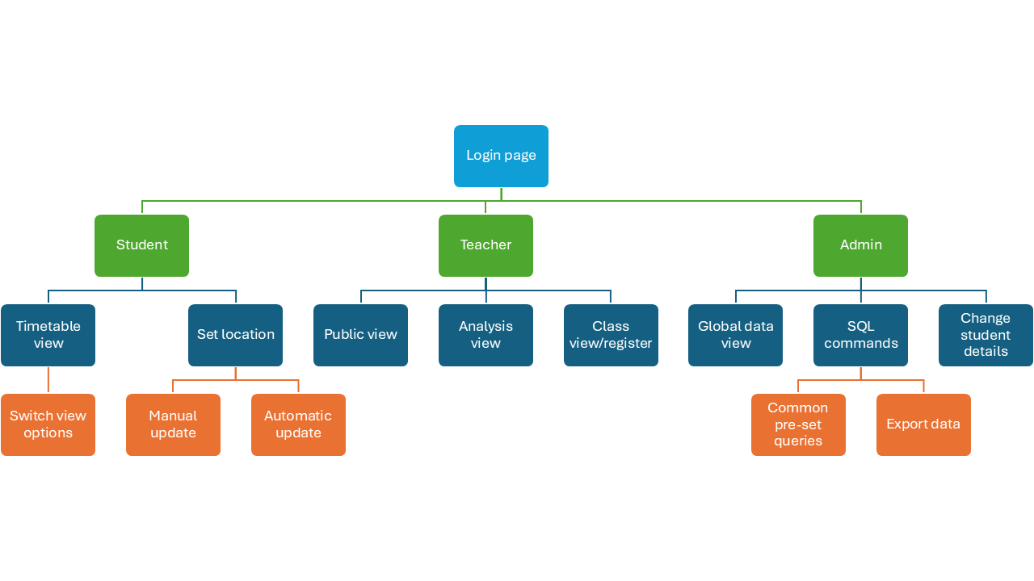

Database
I will use SQLite due to simplicity interacting with python.

Normalization
Using 3rd normal form minimizes the duplication of data between tables.
Using primary and secondary keys keeps the data normalised
For example, splitting the Accounts and Student info is important due to teachers being stored in accounts but not have all the attributes that a pupil has such as house and form meaning they would be null.
A non-normalised db would look like this.
UserID | FirstName | LastName | SchoolEmail | HomeEmail | Password | Gender | Image | RoleName | Form | House | Year | Alteration | Subject Name | Teacher | Lesson Type | LocationName | Start | End | Day | Week | Token | ExpiraryDate

It would mean that every person’s email password and all the data will be duplicated for every lesson they have in timetable. The duplication of data would be very large making the db much larger in file size.

My input data
My school provided me with old data which was anonymised.
There were about 1850 + 3000 + 150 = 5000 lines of data that I put into my database
Pupil Data
Pupil ID | Form | Bording house | Gender
random | A tru G | 1 tru 7 | M/F

Pupil Timetable Data
Pupil ID | Set Code | Subject | Teacher
random | random | Subject name | teacherID

Set timetable data
Set Code | Teacher | Period ID | Classroom
random | TeacherID | 1 tru 81 (7 lessons for 12 days) | Room name

I need to generate data for the DB. I generated a first name, last name, image, random password, gender.

DB planning
Table | Field | Type | Key | NOT NULL | UNIQU
ACCOUNTS | UserID | INT | PK | TRUE | TRUE
ACCOUNTS | FirstName | TEXT |  | TRUE
ACCOUNTS | LastName | TEXT |  | TRUE
ACCOUNTS | SchoolEmail | TEXT |  | TRUE | TRUE
ACCOUNTS | HomeEmail | TEXT |  | FALSE | TRUE
ACCOUNTS | Password | TEXT |  | TRUE
ACCOUNTS | Gender | TEXT |  | TRUE
ACCOUNTS | Image | TEXT |  | FALSE
ACCOUNTS | RoleID | INT | FK | TRUE
ROLES | RoleID | INT | PK | TRUE
ROLES | RoleName | TEXT |  | TRUE
STUDENT_INFO | UserID | INT | FK | TRUE | TRUE
STUDENT_INFO | Form | TEXT |  | TRUE
STUDENT_INFO | House | TEXT |  | TRUE
STUDENT_INFO | Year | INT |  | FALSE
STUDENT_INFO | TimeTableID | INT | FK | TRUE | TRUE
STUDENT_INFO | Alteration | INT |  | FALSE | TRUE
SUBJECTS | SubjectID | INT | PK | TRUE
SUBJECTS | Name | TEXT |  | TRUE
SUBJECTS | UserID "teachers" | INT | FK | TRUE | TRUE
SUBJECTS | EventID | INT | FK | TRUE
EVENTS | EventID | INT | PK | TRUE
EVENTS | Type | TEXT |  | TRUE
LOCATIONS | LocationID | INT | PK | TRUE | TRUE
LOCATIONS | LocationName | TEXT |  | TRUE
MACS | LocationID | INT | FK | TRUE
MACS | WAP_MAC | TEXT |  | TRUE | TRUE
TIMETABLE | TimeTableID | INT | PK | TRUE | TRUE
TIMETABLE | LocationID | INT | FK | TRUE
TIMETABLE | SubjectID | INT | FK | TRUE
TIMETABLE | Start | TIME |  | TRUE
TIMETABLE | End | TIME |  | TRUE
TIMETABLE | Day | INT |  | TRUE
TIMETABLE | Week | INT |  | TRUE
Remember_Me | UserID | INT | FK | TRUE | TRUE
Remember_Me | Token | TEXT | PK | TRUE | TRUE
Remember_Me | ExpiraryDate | DATETIME |  | TRUE

Mock DB
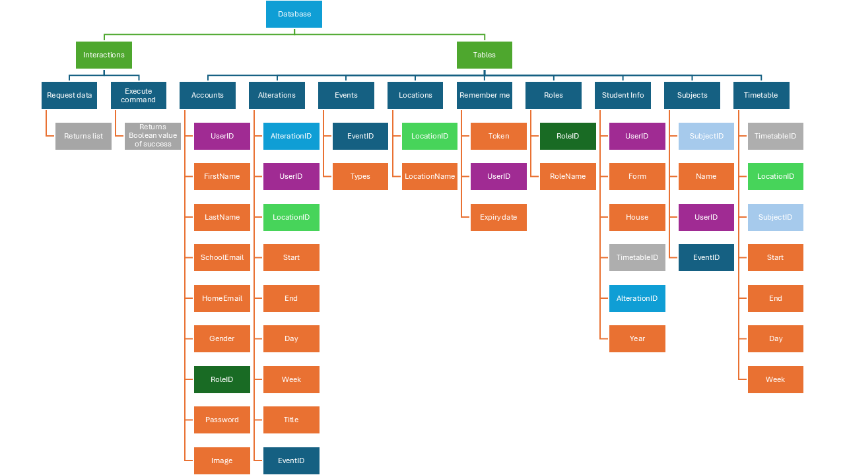

SQL table design

ER diagram
This is how the data will link with primary keys and foreign keys.
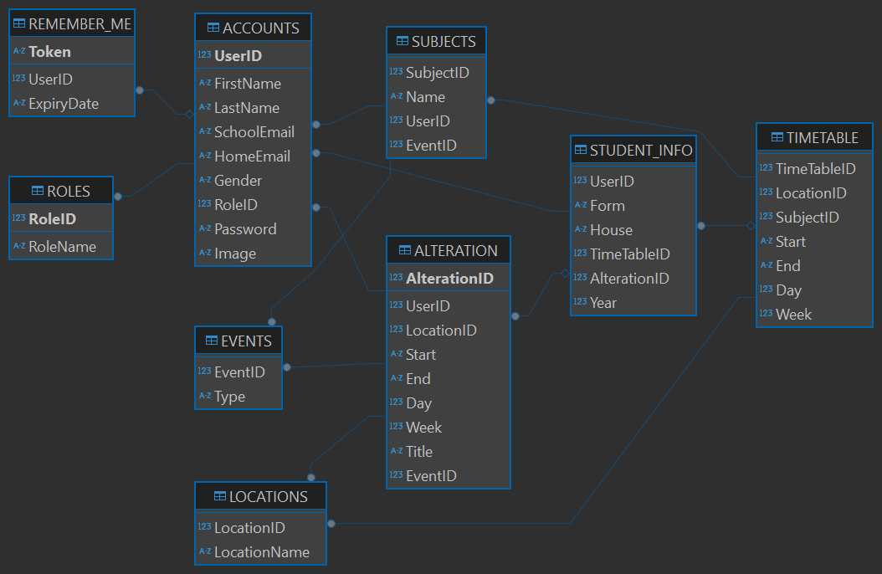

SQL code
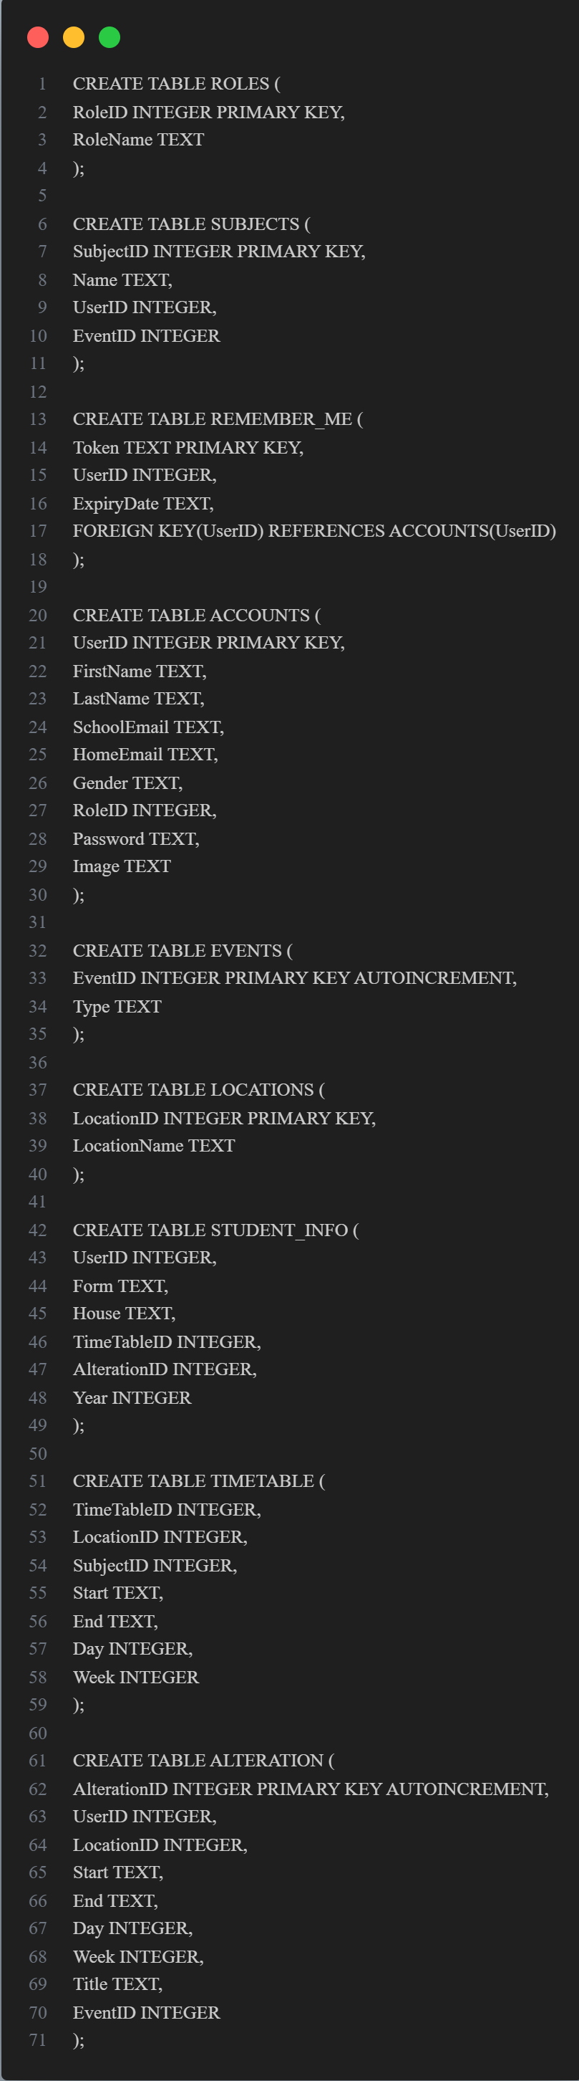

Joining tables (algorithm)
This SQL query gets the data for the student’s timetable. The full timetable display pulls and joins the following information from the database: start and end time, and day and week, as well as lesson information, location, teacher name, and lesson name.
To display teacher initial and last name (for easy reading): To avoid dealing with teachers first and last name, I can manipulate the data (take the first letter of the first name followed by the last name) straight from the database to save time and resources.
In the data base I do not set foreign keys due to with SQLite effecting it will effect that other which I don’t want in all cases. I will deal with this in a way that is in python instead

SELECT // THE COLLUMS WHICH I AM GETTING THE DATA FROM
TIMETABLE.Day,
TIMETABLE.Start,
TIMETABLE.End,
SUBJECTS.Name,
LOCATIONS.LocationName,
TIMETABLE.Week,
substr(ACCOUNTS.FirstName, 1, 1) || '. ' || ACCOUNTS.LastName
FROM // THE TABLE
TIMETABLE
JOIN // JOINING THE PRIMARY KEY(PK) OF SUBJECTS WITH THE FORIN KEY(FK) IN TIMETABLE
SUBJECTS ON TIMETABLE.SubjectID = SUBJECTS.SubjectID
JOIN // LOCATION HAS THE PK TIMETABLE HAS THE FK
LOCATIONS ON TIMETABLE.LocationID = LOCATIONS.LocationID
JOIN // THE TEACHER USERID IS IN SUBJECTS
ACCOUNTS ON SUBJECTS.UserID = ACCOUNTS.UserID
WHERE // ONLY THE ONE PUPILE TIMETABLE
TIMETABLE.TimeTableID = ?
ORDER BY // SORT SO TO BE THE CORRECT ORDER
TIMETABLE.Week, TIMETABLE.Day, TIMETABLE.Start;

Location

Using HTML Geolocation API
“The Geolocation API is accessed via a call to navigator.geolocation. This will cause the browser to ask the user for permission to access their location data. If the user accepts, the browser will search for the best available functionality on the device to access this information (for example GPS).” (HTML Geolocation API, 2025)
It returns a longitude and latitude which I check if it is within the polygon that I can predefine. I am using a library that can check whether the point is inside the boundary.
Using pre-defined zones of each building/area to update the location. Due to the location not normally being that accurate I would need to change the locations from being room specific to building specific.
Mock data would look like {long: 1.2323212, lat: 1.1232233}
I would have another variable called zone which Is a dictionary storing the place name followed by the boundary.

zone = {Home": Polygon([
(-2.2356403, 21.8233035),
(-2.2354203, 21.8229257),
(-2.2344489, 21.8229886),
(-2.2346985, 21.8234195),
(-2.2356323, 21.8233052)])}
I will go through each item in zones and call then “.contains” function on the polygon with the current long and lat. This function returns True for if the point is inside and false if it is outside of the area.

General IP API
There is a public API the returns your ip address. With your ip address you can call another API with the ip as an attribute which returns details like city, region, long, lat. This is an easy way to get a general location but the long and lat is for where the Internet service provider is due to it being the first public ip. This solution will not work due to me needing the accuracy to be within 10-20m(general size of a building) of the real location.

How the Program Will Work
- Assuming an account already exists and has a password.
  - The user (customer or employee) logs in to their account.
  - The user will be placed on the default page then can change the views to the tab that they want (for example a full timetable instead of just todays lessons).
- Email verification and set a password.

How the webpage will function
General layout of web page
- Log in page (home and school email)
  - Pupil account
    - Default timetable view
      - Buttons for different view options
    - Toggle for manual and automatic location update
    - Side menu
      - Log out
      - Change password
      - Change home email
      - Change picture
  - Teacher account
    - Public view (default to hide any sensitive information)
    - Analysis view
    - Class view/register
    - Side menu
      - Log out
      - Change password
      - Change home email
      - Change picture
  - Admin account
    - Global data view
    - SQL commands
      - Common pre-set queries
      - Export data
    - Change student name/image
    - Side menu
      - Log out
      - Change password
      - Change home email
      - Change picture

Figure 1 – Data flow diagram (Initial idea)
initial id of the web page layout
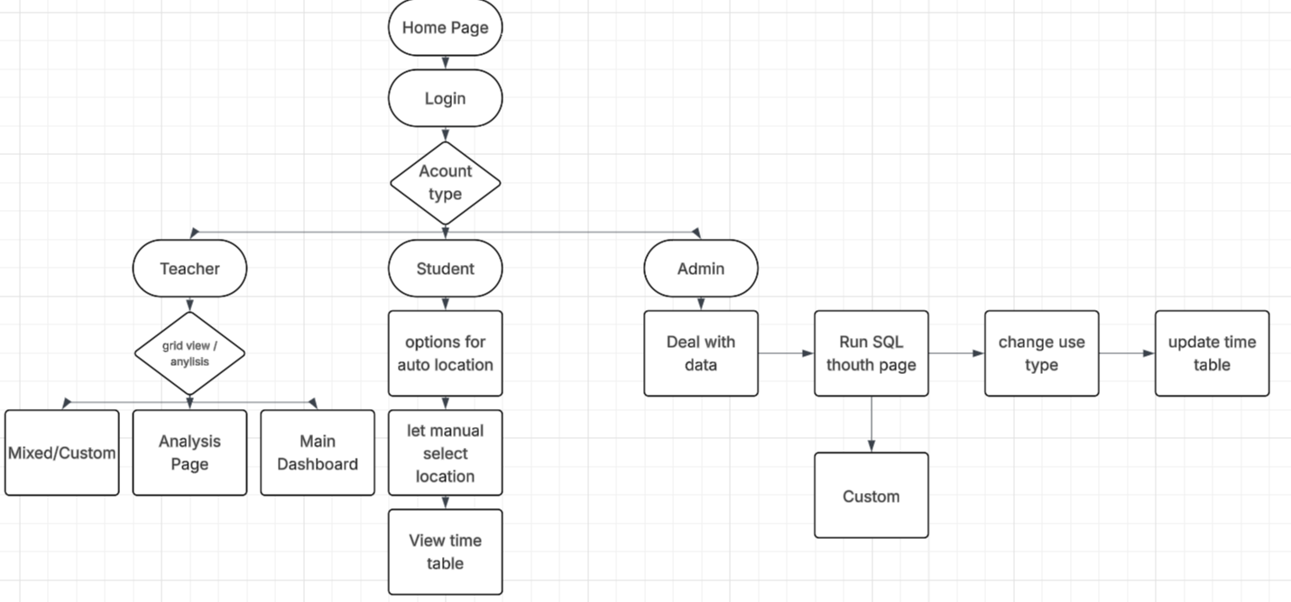

Login
  - this flow chart shows how the login system will work. If the user has already logged in and they selecteded remember me. The session id will retain a cookie with the key to verify the user. Else they will have to enter either there home email or school email with there password.
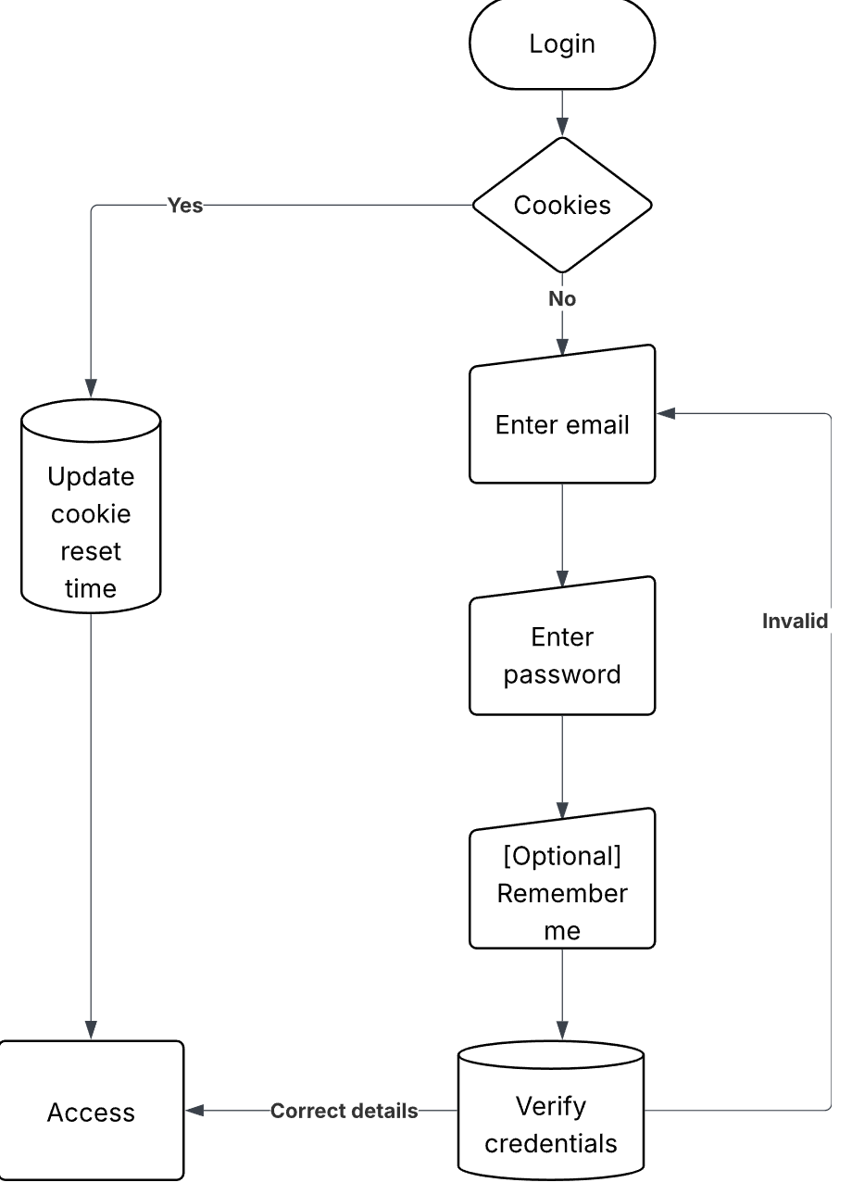

Data Structure
Name | Type | Description | Scope
login | function |  | Global
studentPage | function |  | Global
teacherPage | function |  | Global
adminPage | function |  | Global
teacherTiles | function |  | Global
TeacherList | function |  | Global
adminAddAccount | function |  | Global
adminRemoveAccount | function |  | Global
adminViewAccount | function |  | Global
SQLquery | function |  | Global
add_account | function |  | Global
change_password | function |  | Global
update | function |  | Global
check_location | function |  | Global
update_password | function |  | Global
account_type | function |  | Global
update_current_location | function |  | Global
get_combined_timetable | function |  | Global
get_alteration | function |  | Global
get_time_table | function |  | Global
add_to_remember_me | function |  | Global
check_login | function |  | Global
user_id | int | Stored in the session as private key
emailType | Str | Website request | /login
email | Str | Website request | /login
remember_me | Str | Website request | /login
Enc | str | Encrypted password | /login
Now | Str |  | /studentPage
D | Int |  | /studentPage
T | Str |  | /studentPage
W | Int |  | /studentPage
last | Int |  | /studentPage
next | Int |  | /studentPage
timeTable | array | 2d array. Containing each lesson and its data such as time location and teacher | /studentPage
Limit | Int | Website request | /sub/teacherTiles
search_name | Str | Website request | /sub/teacherTiles
Houses | Int | Website request | /sub/teacherTiles
Form | Str | Website request | /sub/teacherTiles
SQL | Str | Long string contains sql command | /sub/teacherTiles
params | List/tuple | Parameters for sql. List for appending more for dynamic searching but the db needs a tuple for the parameters | /sub/teacherTiles
people | array | 2d array. Each people with relevant data (name, location) | /sub/teacherTiles
response | Bool | verify image upload | /add_account
first_name | Str |  | /add_account
last_name | Str |  | /add_account
Gender | Str |  | /add_account
Email | Str |  | /add_account
Role | Int |  | /add_account
Img | werkzeug.datastructures.file_storage.FileStorage |  | /add_account
File_name | str | Instead of storing the images with the puple name I set the image to be there (encrypted email).png | /add_account
image | (PIL.Image.Image) or (PIL.JpegImagePlugin.JpegImageFile) | During the image manipulation the type changes | /add_account
current_password | Str |  | /change_password
new_password | Str |  | /change_password
confirm_password | str |  | /change_password
location | str |  | /update
data | List |  | /check_location
Lat | Float |  | /check_location
Long | Float |  | /check_location
point | shapely.geometry.point |  | /check_location
zone | dict | List of all the pollygons with there name | global
to_email | str | The school email is fed in but is overridden by my own email for testing | send_email_code
Message | str | Stores the email msg | send_email_code
account_type | int | Student/teacher/admin | account_type
timettable | List | 2d array | get_combined_timetable
alterations | List | 2d array | get_combined_timetable
final_timetable | list | Joint 2d array soreted | get_combined_timetable
entry | tuple | Temp for joining/reformating the table | get_combined_timetable

File Structure
My main webpage folder houses everything except the data base. Main.py is the route python file that you run to start the webpage. Templates house all the html files with the sub folder containing the html file which will be used with iframe to display over the route display. Statics contains all the images for both UI elements and pupil faces. The folder JS contains all the JavaScript files for my program which need to interact with logic. Inside of the route static contains all the CSS files for each page.
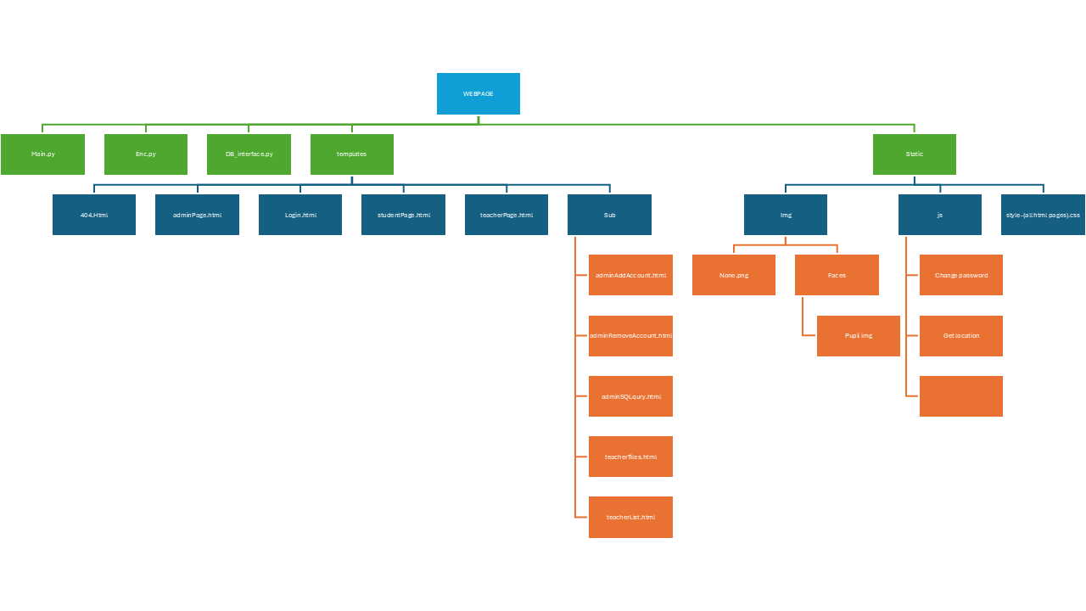

Visuals

Teacher Tiles page
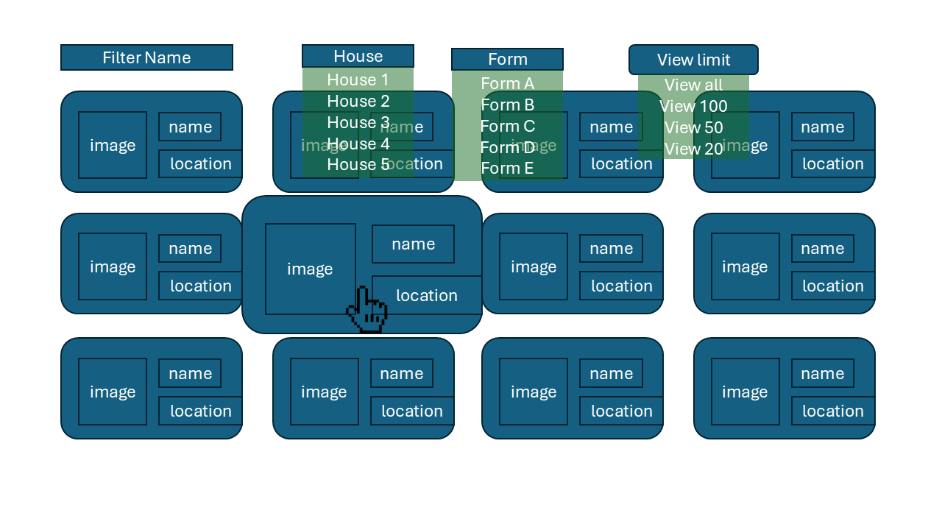

Login Page
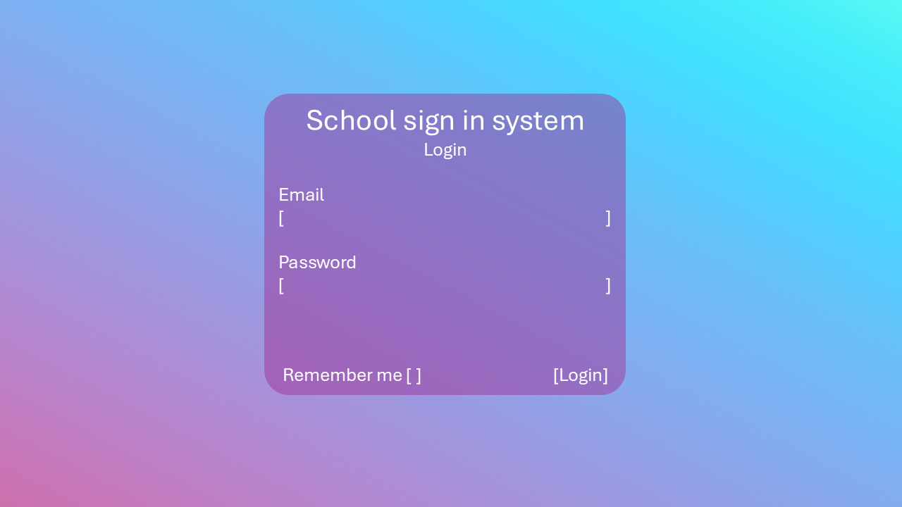

Technical Solution
Main.py
What it douse

Testing

Evaluation

Appendix

Client
I interviewed my client to help create a summary of their objectives:
- House matron
  - What’s your role?
    - I am a matron. I complete registers and admin so I know where every pupil in my house is.
  - How do you currently know where pupils are?
    - Every pupil has to sign in and out when they enter and leave the house to verify when they are in house or where they are going when they leave.
  - Is it important to know where pupils are?
    - Yes, it is extremely important for safety and safeguarding
    - Accurate sign in/out means we can find a pupil when we need them.
  - What do students usually write down on the form?
    - Sign out time; Where they are going; Sign back in time.
  - What are the implications of a student not signing out?
    - If there is an emergency like a fire, we need to know where they are.
    - We have a duty of responsibility to keep pupils safe.
    - We need to contact their parents to verify that they are at home and are safe.
  - What are the current problems with using a pen and paper system?
    - It is not always accurate as sometimes pupils forget to sign in or out.
    - Can be slow to check whether a certain pupil is in, as you need to read all the locations to see where they are and the time they have signed back in.
    - Sometimes it is hard to read pupils handwriting
    - The sign in book is quite heavy and cumbersome to use when you have to move it (like during a fire alarm).
  - Has there been any problems with using the paper system during emergencies (paper + water)?
    - Sometimes pupils forget to sign out, then we do not know where they are.
    - The paper is quite thin so it can tear easily when writing without a clipboard.
  - Is bad handwriting a problem?
    - Yes, most of the younger pupils and some older pupils handwriting is completely eligible, so we need to make a educated guess.
  - Do students ever forget to sign out? How often does that happen?
    - Yes, always. Nearly every day at least a few pupils forget to sign out when they go home.
  - Is there any features you would consider "must haves" or "good to have"?
Must haves | Good to have
- Fast | - Colour coded
- Reliable | - Isams integration
- Easy to use | - Easy filtering
- Compatible/universal | - Permissions. (so tutors can see where there tutees are)
- Secure/safe | - Data analysis. (it would be good to know how long they spend in summer town or the library.
 | - Communication system on it. So we can easily notify them to go back to house.
- Pupil
  - How often do you sign-out?
    - 4 times a day
  - How easy is it to sign-out & in?
    - It can take a while and the pen is sometimes out of ink,
    - Many students forget to sign back in so can now work sometimes.
  - Have you ever gotern in trouble for not signing out?
    - Yes multiple times, I forgot.
  - Would you find it good if the system was online?
    - Yes, it would make it a lot easier.
  - What do you pitcher when I say online sign-in&out sytem?
    - Minimal and seamless + clean and fast(15s>).
  - What would you change about the current system?
    - If you go straight from lessons to town there is now way to let anybody know. So being able to remotely sigh out would help.
  - How would you want to access an online system?
    - Website so you don’t need to download (access on phones and laptop), a phone app could be good.

Bibliography
Dyouri, A., & Walia, A. S. (2025, 6 25). How to Build a Flask Python Web Application from Scratch. Retrieved from digitalOcean: https://www.digitalocean.com/community/tutorials/how-to-make-a-web-application-using-flask-in-python-3
For loop in HTML. (2025, 5 21). Retrieved from Geeks for Geeks: https://www.geeksforgeeks.org/for-loop-django-template-tags/
How TO - Login Form. (2025, 5 19). Retrieved from w3schools: https://www.w3schools.com/howto/howto_css_login_form.asp

