NASDAQ

Cisco Systems, Inc. (CSCO)

I chose Cisco Systems, Inc. (CSCO) from NASDAQ. This analysis focuses on close price and volume. The data was downloaded from [http://finance.yahoo.com/q/hp?s=CSCO+Historical+Prices on](http://finance.yahoo.com/q/hp?s=CSCO+Historical+Prices%C2%A0on) January 31, 2016.

Contents

Data 2

Close Price 4

Stationarity 4

OLS model with Newey-West SE using 2 lags 5

Monday Effect 5

Time Periods 5

Volume 6

Stationarity 6

Autocorrelation Function 7

Partial Autocorrelation Function 7

ARMA(2,2) 8

Change in Trend 8

Regression 9

OLS model with Newey-West SE using 2 lags 9

β coefficient 9

Extra Credit: ARMA(2,2) 10

Autocorrelation Function 10

Partial Autocorrelation Function 11

# Data

|  |  |  |
| --- | --- | --- |
| Date | Close | Volume |
| Min. :1990-03-26 | Min. : 8.60 | Min. : 806400 |
| 1st Qu.:1996-08-31 | 1st Qu.: 19.86 | 1st Qu.: 39292675 |
| Median :2003-02-22 | Median : 25.57 | Median : 53373750 |
| Mean :2003-02-20 | Mean : 37.23 | Mean : 62217983 |
| 3rd Qu.:2009-08-10 | 3rd Qu.: 52.63 | 3rd Qu.: 73021550 |
| Max. :2016-01-29 | Max. :144.38 | Max. :806732800 |

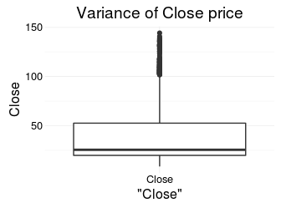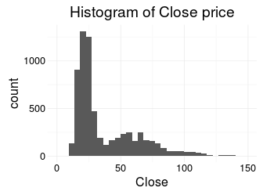

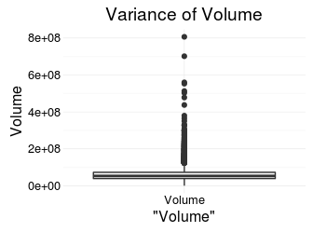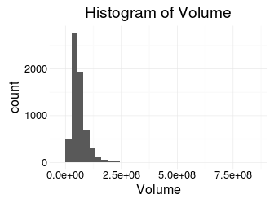

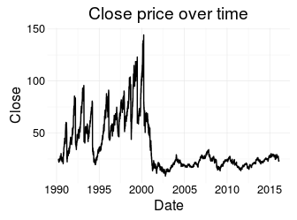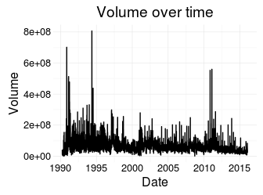

# Close Price

## Stationarity

The "Close price over time" charts seems to show the characteristics of a random walk. But the Phillips-Perron test rejects the hypothesis that it has a unit root with a high confidence.

|  |  |  |
| --- | --- | --- |
| Test statistic | Truncation lag parameter | P value |
| -4.025 | 11 | 0.01 * * |

Phillips-Perron Unit Root Test: **Close price**

Although the original series can be accepted as stationary with high confidence, further improvements can be achieved via transforming the close price: taking the log difference results in a "more" stationary model.

|  |  |  |
| --- | --- | --- |
| Test statistic | Truncation lag parameter | P value |
| -82.09 | 11 | 0.01 * * |

Phillips-Perron Unit Root Test: **Log difference of Close price**

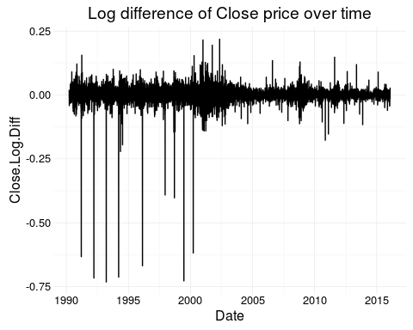

## OLS model with Newey-West SE using 2 lags

Based on OLS with Newey-West SE using 2 lags the returns can not be predicted. It is an evidence of Efficient Market Hypotheses.

|  |  |  |  |
| --- | --- | --- | --- |
|  | (Intercept) | Close.Log.Diff.lag.1 | Close.Log.Diff.lag.2 |
| **Coefficients** | -4.905e-06 | -0.01676 | -0.03996 |
| **Newey-West SE** | 0.0004454 | 0.01348 | 0.01298 |

## Monday Effect

Based on OLS with Newey-West SE using Monday dummy variable there is no evidence for Monday effect when considering the close prices between 1990 and 2016.

|  |  |  |
| --- | --- | --- |
|  | (Intercept) | Weekday.MondayTRUE |
| **Coefficients** | 0.0003848 | -0.00205 |
| **Newey-West SE** | 0.0004366 | 0.00142 |

## Time Periods

Based on the "Close price over time" chart there is a significant difference in close price before and after March, 2000. According to [Market Crashes: The Dotcom Crash](the%20http://www.investopedia.com/features/crashes/crashes8.asp) article, The Nasdaq Composite lost 78% of its value as it fell from 5046.86 to 1114.11.

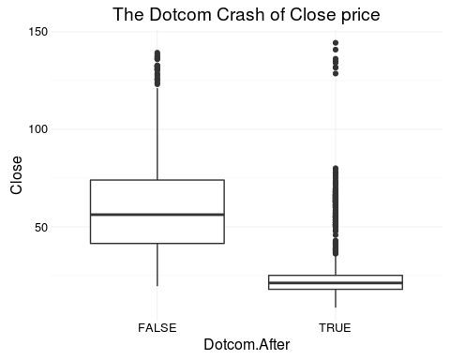

# Volume

## Stationarity

The "Volume over time" charts seems to be stationary. Also, the Phillips-Perron test rejects the hypothesis that it has a unit root with a high confidence.

|  |  |  |
| --- | --- | --- |
| Test statistic | Truncation lag parameter | P value |
| -49.33 | 11 | 0.01 * * |

Phillips-Perron Unit Root Test: **Volume**

Although the original series can be accepted as stationary with high confidence, further improvements can be achieved via transforming the volume: taking the log difference results in a "more" stationary model.

|  |  |  |
| --- | --- | --- |
| Test statistic | Truncation lag parameter | P value |
| -169.7 | 11 | 0.01 * * |

Phillips-Perron Unit Root Test: **Log difference of Volume**

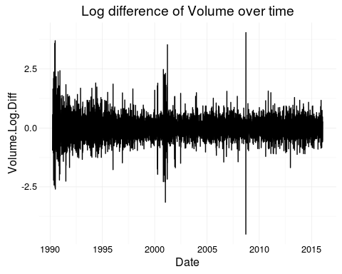

## Autocorrelation Function

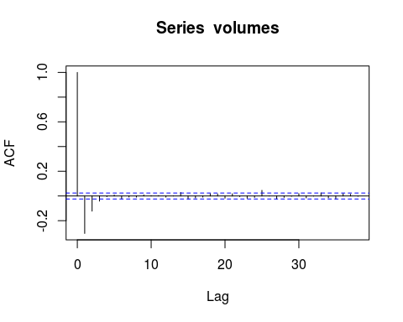

## Partial Autocorrelation Function

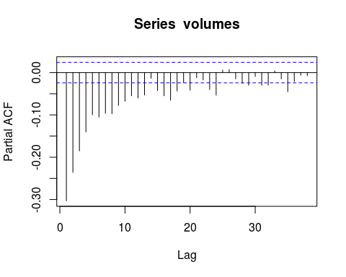

## ARMA(2,2)

Call: arima(x = volumes, order = c(2, 0, 2))

|  |  |  |  |  |  |
| --- | --- | --- | --- | --- | --- |
|  | ar1 | ar2 | ma1 | ma2 | intercept |
|  | 1.14 | -0.2737 | -1.679 | 0.6901 | 0.0001372 |
| **s.e.** | 0.07927 | 0.03856 | 0.07717 | 0.07356 | 0.0003834 |

Coefficients

sigma^2 estimated as 0.145: log likelihood = -2952.83, aic = 5917.66

## Change in Trend

Similarly to the close price, the Dotcom Crash had an effect on daily volumes as well. But this effect is not as significant as on the close price.

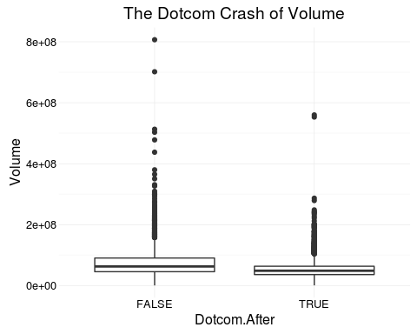

# Regression

$E[lnRS_{t}|lnRI_{t}]=α+β*RI_{t}$

$E[lnRS_{t}|lnRI_{t}]=α+β*RI_{t}+γ*t+sum(O_{i}*s_{i})$

where RS is the return of your stock, RI is the return of nasdaq composite, s are seasonal dummies.

## OLS model with Newey-West SE using 2 lags

|  |  |  |  |  |
| --- | --- | --- | --- | --- |
| var | Coefficients (1) | Newey-West SE (1) | Coefficients (2) | Newey-West SE (2) |
| (Intercept) | -0.0004415 | 0.0003579 | -0.0004028 | 0.002012 |
| Nasdaq.Close.Log.Diff | 1.317 | 0.03824 | 1.316 | 0.03421 |
| Nasdaq.Close.Log.Diff.lag.1 | -0.09071 | 0.03141 | -0.09104 | 0.02989 |
| Nasdaq.Close.Log.Diff.lag.2 | -0.02053 | 0.02015 | -0.02018 | 0.01969 |
| Date | NA | NA | -2.733e-09 | 1.509e-07 |
| Weekday.MondayTRUE | NA | NA | -0.000695 | 0.001293 |
| Weekday.TuesdayTRUE | NA | NA | -0.0002056 | 0.001019 |
| Weekday.WednesdayTRUE | NA | NA | 0.0004278 | 0.0008328 |
| Weekday.ThursdayTRUE | NA | NA | 0.0004005 | 0.0009491 |

## β coefficient

The contemporaneous log difference of NASDAQ composite index has a significant coefficient of 1.317 considering the standard error of 0.03. But the first and second lags are not significant according to the OLS model. Based on to the contemporaneous coefficient, one unit difference in the NASDAQ composite index is expected to result in 1.3 unit difference in the Cisco stock price. It means that whenever the NASDAQ composite index is 10 percentage points higher than the previous day, the Cisco is expected to close with 13 percentage points higher price. The insignificance of the first and second lag is the evidence of Efficient Market Hypotheses. The relative higher proportional increase of price could be explained by the relative strength of the Cisco stock. Cisco can be considered as a Blue-chip company.

# Extra Credit: ARMA(2,2)

The ARMA model is built on the time series of the Cisco stock price. The insignificance of the coefficients is the evidence of Efficient Market Hypotheses.

Call: arima(x = prices, order = c(2, 0, 2))

|  |  |  |  |  |  |
| --- | --- | --- | --- | --- | --- |
|  | ar1 | ar2 | ma1 | ma2 | intercept |
|  | 0.02606 | -0.8597 | -0.03049 | 0.8313 | -2.297e-06 |
| **s.e.** | 0.05862 | 0.06276 | 0.06392 | 0.06817 | 0.0004366 |

Coefficients

sigma^2 estimated as 0.001286: log likelihood = 12434.45, aic = -24856.91

## Autocorrelation Function

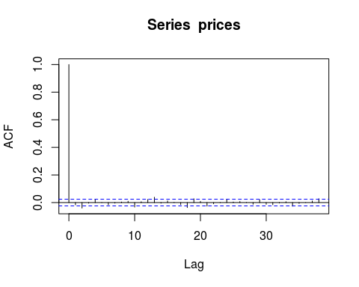

## Partial Autocorrelation Function

