**Question 1.**

15 replications: Mean: 3050, Standard deviation: 7,4833

**Question 2.**

15 replications: Mean: 2953.5, Standard deviation: 17.932

Another place where the space problem may appear is the creation of tubes in P_Creation. If the tubes are sent to cutting and the buffer for cutting is full, the tubes are sent to space instead. As we can see, the throughput has decreased by solving this issue and the standard deviation has more than doubled. This could be explained by the fact that the painting process may be finished before the next cut is finished (if the setup time is needed in the cutting process) and thus the painting process must wait for the next cut to be finished instead of picking a load from space directly. However, this solution is more realistic because due to the limited size of the facilities we cannot put products in a place that does not physically exist.

**Question 3.**

Tried 5 replications, all combinations of buffer size 1, 2 and 3 on the buffer for the three lathes and the painting. Much more combinations than this took unreasonable long time for the computer we used, and the number of factors is constrained by the student version of the software. The best combination was to set all buffer sizes to 3 resulting in an average throughput of 3094.2 products. This indicates that the bigger buffer capacity the better.

**Question 4.**

If tube A always enters cutter 1 and tube B always enter cutter 2, then the average waiting time in the buffers of the cutters was found to be zero, so the buffers are always empty. The “choose minimum” methodology then chooses queue randomly with uniform distribution and injects setup times even though they are not needed. Hence, by changing the routing to avoid this, the setup time has been eliminated and the throughput reached 3017 compared to 2953.5 products.

**Question 5.**

Batch size of two loads resulted in the highest average output (3044.6) and thus it helped compared to painting one single load at a time. See the implementation of painting in batches below the list of questions.

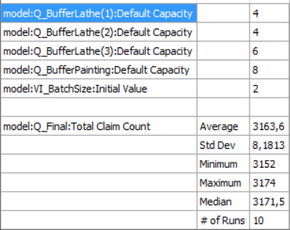**Question 6.**

Due to restrictions in the student license we only evaluated five factors. The best combination is presented to the left. Combinations tried were:

* Q_Buffer_Lathe(1,2,3): 2, 3, 4, 5, 6, 7
* Q_Buffer_Painting: 2, 3, 4, 5, 6, 7, 8, 9
* VI_BatchSize: 2, 3, 4, 5, 6, 7

**Question 7.**

Like other entities, you can define variables from the Process System palette or by using a variable name in the model logic and then defining the variable when saving and quitting the source file.

**The following four procedures were changed in order to introduce batches**

