Code Day Assignment

Oliver Njeru-663565

School of Sciences and Technology, United States International University-Africa

APT3060A: Mobile Programming

Dr. Lawrence Nderu

November 05, 2023

**Code Day Assignment.**

**Image Project**

In this project, our goal is to create an application that displays an image of a butterfly. The first thing I did was to add the butterfly image in the mipmap folder as shown below.

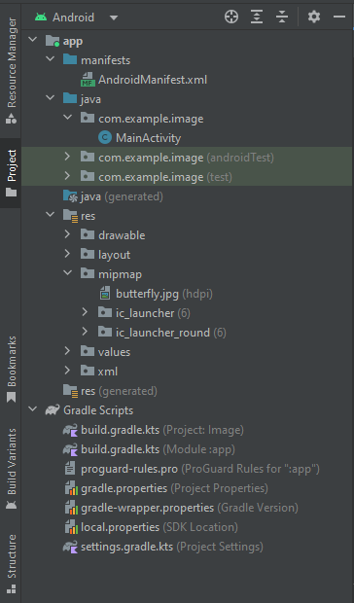

The next thing I did was navigate to the activity_main.xml file and add a LinearLayout tag as well as an ImageView tag that is going to locate the image and display it when the application is run. The code added is shown below.

The next step is to run the application. What the application displays is as shown below.

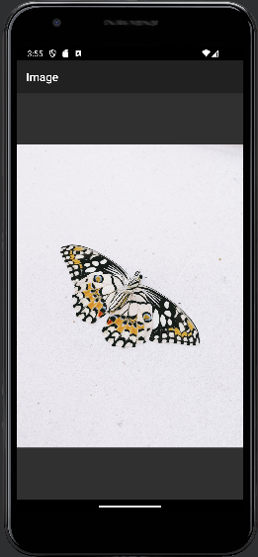

This marks the completion of this project’s goal.

**ImageSwitcher**

This project builds off on top of the previous project. It displays more than one image with a transition in between them.

In the activity_main.xml file, I added a RelativeLayout tag, two Button tags and an ImageSwitcher tag as shown below.

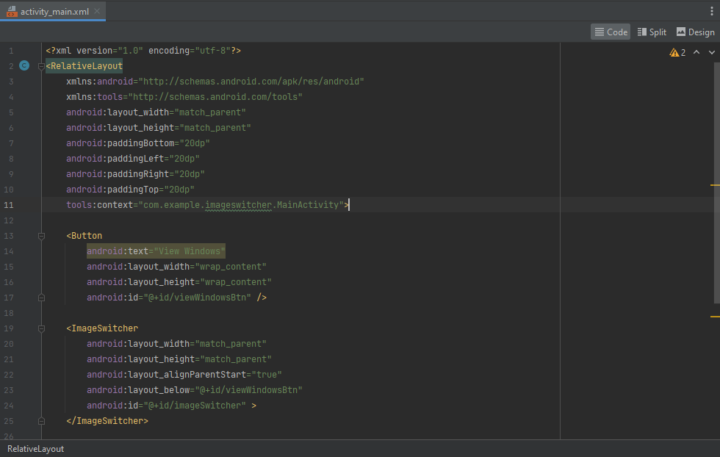

I then added two images in the mipmap folder that I am going to use in this project. The images are shown below.

In MainActivity.java file, I added the following code. Three private variables with an ImageSwitcher type and Button type. Initialize imgSwitcher variable by finding ImageSwitcher widget using its id and casting the result of findViewById to the ImageSwitcher type. I then set the animation for ImageSwitcher transitions using a method to load fade-in and fade-out animations from the android system resources. I initialized the two buttons using their ids. I added a method that makes the image view. I added onClickListener methods for each of the two buttons to set the value for the toast message and view switch the correct image accordingly using the imgSwitcher variable.

When the application is run, the following is seen.

On run:

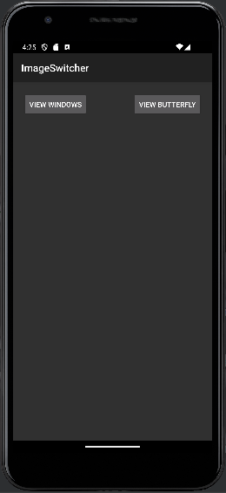

On click of View Windows Button:

On click of View Butterfly button:

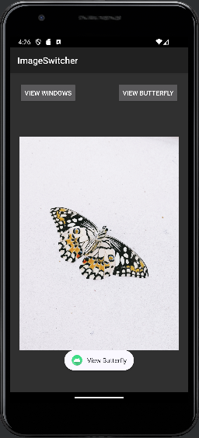

This marks the completion of the objective of this project.

**Grid**

The objective of this project is to display images in a grid view and show a toast message of the image selected and its position.

In the mipmap folder, I added five images, asia, china, circle, santorini and street that are going to be used in this project as shown below.

In the activity_main.xml file, I added a constraint layout and a GridView tag as shown below.

In the MainActivity.java file, I created an array that is going to store the images located and referenced in the mipmap folder. In the onCreate method, I created a gridView variable of type GridView and initialized it to be the gridView widget in the activity_main.xml file by finding its id. I then set an onClickListener to track the position of the image and set the toast message. I created an if statement to check on the convertView value and given it is null, to set the imageView layout, scale type and padding. Else, assign the variable imageView to be convertView casted to type ImageView. Then I set the imageView to the image depending on the position and returned the imageView. The code is as shown below.

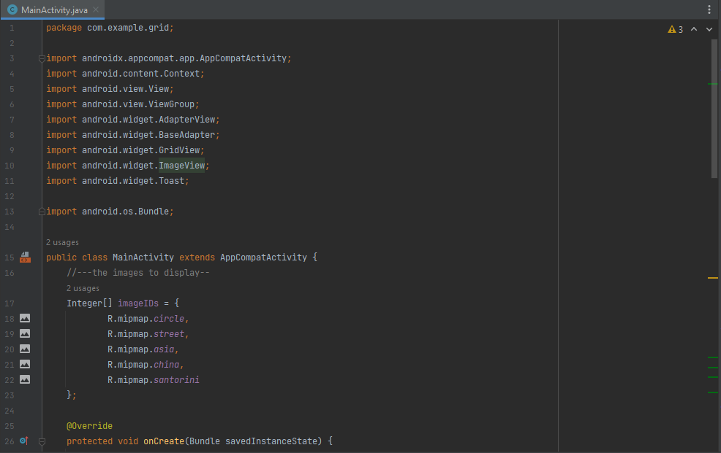

When the application is run, the following screen is displayed:

When I tap on the first image, the toast message is as show:

When I tap on the second image, the toast message is as shown:

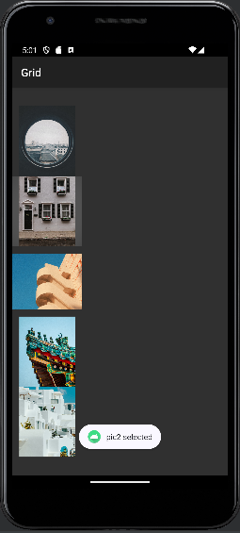

When I tap on the third image, the toast message is as shown:

When I tap on the fourth image, the toast message is as shown:

When I tap on the fifth image, the toast message is as shown:

This shows that we have achieved the project’s objective.

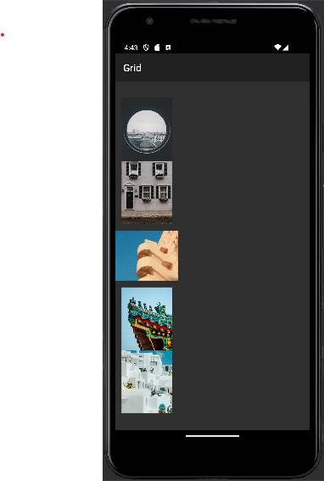

**Menu**

The objective of this project is to create a menu list and have a button display a menu list when a user presses and holds the button. The menu options, when clicked, should display a toast message indicating that the user clicked on an option with its appropriate number.

In activity_main.xml file, I added a constraint layout and a button widget with id button as show below.

In MainActivity.java file, below is the code. I initialized a button variable to be the id of the widget button. I created a void method that creates a contextMenu. I created a Boolean method that creates an options menu and return a true value. I created a Boolean method that returns the menu choice of the item selected. I created a void method that creates a menu with 7 items having the first for with alphabet shortcuts a-d. I created a Boolean method with a switch statement that checks on what was clicked and sets the toast message to display that the user clicked on an option with its number.

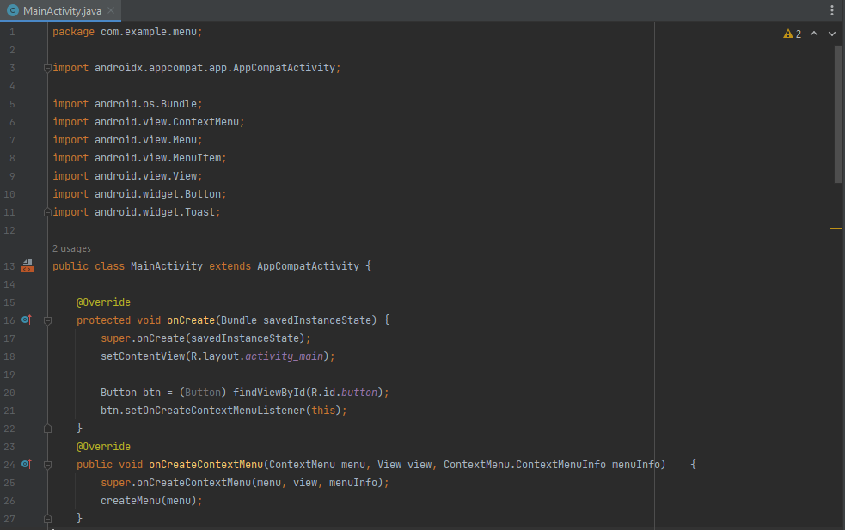

When the app is run, the following is the screen:

When the three dots at the top right of the screen are tapped, the following is displayed:

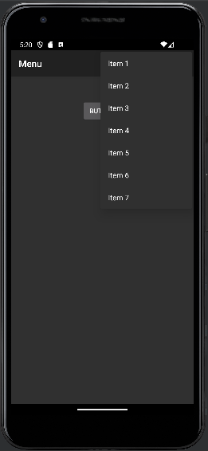

When I tap on Item1, the following toast message is displayed:

When I tap on Item2, the following toast message is displayed:

When I tap on Item3, the following toast message is displayed:

When I tap on Item4, the following toast message is displayed:

When I tap on Item5, the following toast message is displayed:

When I tap on Item6, the following toast message is displayed:

When I tap on Item7, the following toast message is displayed:

When I tap and hold the button at the center of the screen, I see the following:

This shows that the objective of the project has been achieved.

**WebView**

The objective of this project is to create a webview that shows the content of a specified url.

In the activity_main.xml file, I created a constraint layout and added a WebView widget with an id of webView as shown below.

In the MainActivity.java file, I created a variable wv of type WebView and set it to be the webView widget I created earlier in activity_main.xml file. I created variable websettings of type WebSettings and set it to be the getSettings method. I set the websettings built in zoom controls to be of value true. I specified the webview url as shown below.

I gave permission for the project to use the internet in the AndroidManifest.xml file as shown below on line 4.

I created a network_security_config.xml file in the xml folder as shown below.

I configured it to allow access of the application to the internet as shown below.

Back in AndroidManifest.xml file, I set the usesClearTextTraffic value to be true and set the networkSecurityConfig value to look for the file I created previously in line 6 and 7 respectively. This is shown below.

This will allow the application to correctly run.

When I run the application, this is what I see.

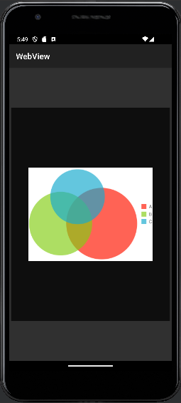

When I drag the screen in the webView section, I see the zoom built in controls as show below:

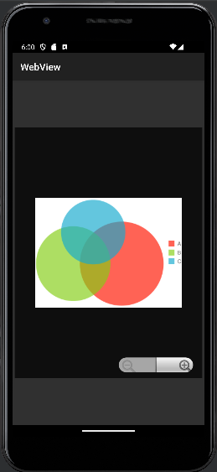

When I tap the zoom in icon twice, it zooms in twice as show below:

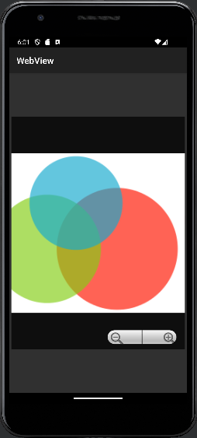

When I tap the zoom out button twice, it zooms out as shown below:

This marks the completion of the project’s objectives.