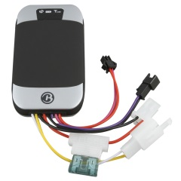GPS303 / TK-303 SMS Commands Cheat Sheet v0.1

Does not cover GRPS commands!

|  |  |
| --- | --- |
| begin+**password** | Resets your device to factory settings (except password!). The standard password of the device is 123456. |
| admin+**password**+space+**cell phone** | Set the administrative cell number for the device. Phone number should be in international format with the + sign leading(e.g. +661231234567) |
| password+**password_old**+space+**password_new** | Change password |
| fix+**interval**+s+**count**+n+**password** | Respond with position details. **Count** is the number of times it should do this and **interval** is the seconds in between samples. The interval cannot be smaller than 20 seconds. If you want continually monitor set the **count** to ***.(Single ping is *fix030s001n123456*) |
| distance+**password**+space+**distance** | Used in conjunction with the above command (fix). When set to *** you can determine at which **distance** in addition to time you want the reporting to be. **Distance** needs to be 4 digit and in meters. (e.g. distance123456 0050) |
| supress+**password** | Drift suppression ON. This should eliminate false movement alerts when standing still. |
| Nosupress+**password** | Drift suppression OFF |
| save+**interval**+s+**count**+n+**password** | Start recording waypoints on internal or microSD storage every **interval**. Usage is analogue to the *fix* command. |
| clear+**password** | To delete all saved waypoints |
| forward+**password**+space+**phone** | Any messages to the SIM phone number will be forwarded to the **phone** number listed. |
| noforward+**password** | Cancel forwarding |
| lowbattery+**password**+space+**on/off** | Alarm that internal Li-Ion battery is running low. ON/OFF |
| extpower+**password**+space+**on/off** | Alarm, that the external power has been cut. ON/OFF |
| gpssignal+**password**+space+**on/off** | GPS blindspot SMS. You will receive the last position that GPS was reachable. |
| help+space+me | Switch off SOS call that is triggered by pressing the SOS button on device (if attached) |
| stockade+**password**+space+**latitude,longitude;latitude,longitude** | Set a geofence top left, bottom right. Will be active after vehicle is stationary 3-10 min. |
| nostockade+**password** | Clear geofence |
| area+**password**+space+**latitude,longitude**+space+**areaname,distance+M/K** | Set one of five multi area settings. Geofence by lat & long + distance (i.e. radius) in **M**eters or **K**ilometers. The **areaname** will be included in the alert. |
| noarea+**password**+space+**areaname** | Clear a geofence area. |
| rename+**password**+space+**old_name;new_name,distance**+**M/K** | Rename an area or/and update radius/**distance**. |
| area+**password**+space+**on/off** | Activate/deactivate multi area geofence. |
| move+**password**+space+**distance** | Movement alarm. Will detect movement after stationary for 3-10min and outside of **distance**/radius in 4 digit meters. Will send SMS every 3min. |
| nomove+**password** | Cancel movement alarm |
| speed+**password**+space+**kmh** | Send SMS when speed is or exceeds the 3 digit **kmh** number. Will send SMS every 3min. Minimum speed is 30km/h. |
| nospeed+**password** | Switch off speed alarm. |
| reset+**password** | Reset GSM and GPS module of tracker. |
| sleep+**password**+space+time | Sent GPS system to sleep 5min after movement has stopped. LEDs will be off. SMS will awake the unit. |
| sleep+**password**+space+shock | Will enter sleep mode if no movement is detected. |
| sleep+**password**+space+off | Cancel any sleep mode. |
| imei+**password** | Will return the 15 digit imei number. |
| check+**password** | Will list the current status’ of the device |
| ***ALARM FUNCTIONS NOT LISTED YET*** |  |

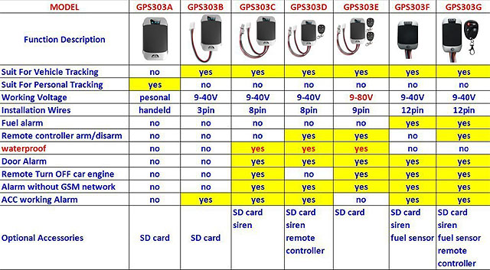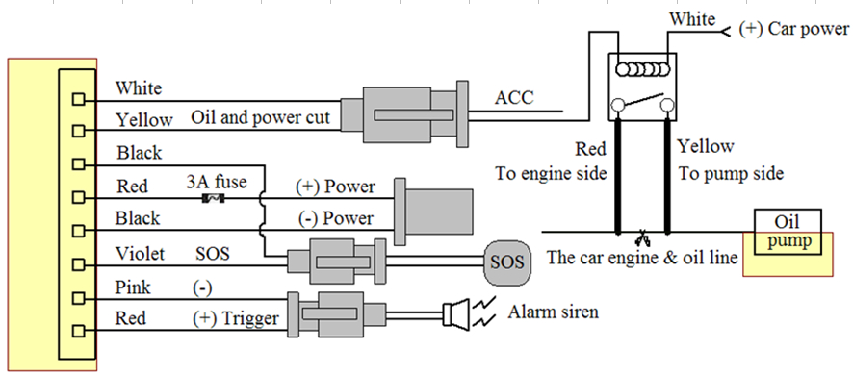

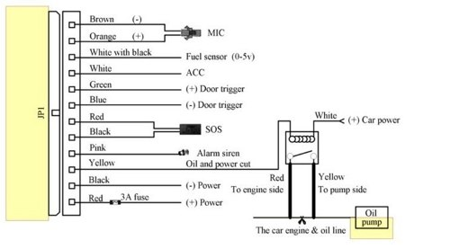

Warnings:

* Do not plug in USB while connected to car battery. Will destroy USB port on computer!
* These devices can suck a motorcycle battery dry in about 2-3 weeks. Car should be a bit longer.

Creative Commons License