FAQ questions

****1. Products****

**1.1 Product introduction: The smart flowerpot was jointly produced by the International Education Institute of Zhengzhou University of Light Industry and the IGP project team of Edinburgh Napier University to help people better take care of plants and avoid plant deaths caused by poor care.**

**1.2 Product advantages: a convenient, small hardware.**

**b Low cost, most hardware is Arduino kit**

**C dual power mode, providing solar panels for power**

**D sleep mode, the device automatically enters sleep mode when not working, saving power.**

**1.3 Usage scenarios: Traveling staff, staff who have been away from home for long periods of time, often forget people who water.**

**1.4 Product features: a. Measuring plant light intensity, moisture, nutrition and other information.**

**b. Automatic watering**

**C. Solar power supply**

**D. WIFI connection**

**E. Sleep mode**

**Revision 1.5 Updated December 2017 Ideas were submitted April 2018 Completed preliminary model May 24, 2018 Completed first edition May 31, 2018 Completed smart pot 1.0**

**2. Purchase guide**

****2.1 Product Price Overview** IGP Hardware budget table**

|  |  |  |  |  |
| --- | --- | --- | --- | --- |
| project  Things | number（个） | unit price（RMB） | total（RMB） | Note |
| 直流3V5V6V小水泵 | 6 | 6 | 46 | Freight 10RMB |
| 18650锂电池3.7V电筒大容量充电平头动力灯 | 6 | 19.23 | 115.4 |  |
| 串口wifi ESP8266-07 | 6 | 15 | 96 | Freight 6 RMB |
| USB转TTL CH340 模块 | 6 | 3.2 | 19.2 |  |
| 8路3.3V-5V 5V-3.3V TTL双向电平转换 弯针 | 6 | 5.40 | 32.4 | Freight 14 RMB |
| 光敏电阻LXD125 | 12 | 2.1 | 48.2 | Freight 23RMB |
| DC直流迷你水泵 | 6 | 2 | 12 |  |
| DC-DC电源模块 | 6 | 3.15 | 18.9 |  |
| 40P杜邦线 | 30 | 1.14 | 34.2 |  |
| SN74HC165N IC集成电路 | 6 | 0.35 | 2.1 |  |
| 铝电解电容器 | 12 | 1.34 | 16.08 |  |
| 2.0-5v 电源模块 | 6 | 4.41 | 26.46 |  |
| 土壤湿度传感器 | 6 | 5.5 | 38 | Freight 5 RMB |
| Micro SD模块 | 6 | 4.9 | 29.4 |  |
| 1路5V继电器模块 | 6 | 3.27 | 19.62 |  |
| TELESKY 元器件收纳盒 | 6 | 2.42 | 14.52 |  |
| CD74HC4067高速CMOS 模拟多路复用器 | 6 | 6.39 | 44.34 | Freight 6 RMB |
| 全金膜电阻 | 8 | 1.98 | 15.84 |  |
| TXS0108E 双向电压转换器 | 6 | 5.54 | 33.24 |  |
| 焊锡丝 | 4 | 9.4 | 37.6 |  |
| 2N3904 三极管 | 1 | 1.48 | 1.48 |  |
| 高电流低电压稳定器 | 2 | 2.27 | 4.54 |  |
| 安规Y电容 250V 电容器 | 6 | 1.38 | 7.28 |  |
| 1N4004 DO-41整流二极管 | 2 | 1.48 | 2.96 |  |
| 金属膜电阻 10k 1/4w | 4 | 1.43 | 5.72 |  |
| 温度传感器芯片 | 6 | 2.57 | 15.42 |  |
| 电池盒 | 4 | 1.78 | 7.12 |  |
| 定时器编程振荡器IC芯片 | 2 | 1.63 | 3.26 |  |
| 面包板电路板 | 12 | 6.36 | 82.32 | Freight 6RMB |
| 温湿度传感器 | 12 | 21.66 | 141.96 | Freight 12RMB |
| 充电电源模块冲电器 | 6 | 1.37 | 8.22 |  |
| 彩色鳄鱼夹测试线导线 | 6 | 3.86 | 23.16 |  |
| 升压电源模块 | 6 | 3.52 | 21.12 |  |
| 面包板电源模块 | 6 | 5.1 | 30.6 |  |
| 水位传感器 | 12 | 1.48 | 17.76 |  |
| 2N3904二极管直插（50个装） | 1 | 1.48 | 1.48 |  |
| 1GB手机内存卡 | 6 | 14 | 91 | Freight 7RMB |
| 单排针 双排针 直针弯针 | 8 | 1.19 | 9.52 |  |
| 电烙铁 | 2 | 49.36 | 98.72 |  |
| 实验板 线路板 | 12 | 4.45 | 53.4 |  |
| wifi模块无线网卡 2.4G | 6 | 3 | 30 | Freight 12 RMB |
| pogopin弹簧顶针天线 | 18 | 4 | 84 | Freight 12RMB |
| 40P杜邦线 | 6 | 1.9 | 11.4 |  |
| UART SPI TTL 弯针 | 6 | 5.4 | 32.4 |  |
| 电解电容器 | 12 | 1.34 | 16.08 |  |

**2.2 Customer Purchase Process**

Select the size of the color of the flowerpot - install the app - confirm if it can be used normally - confirm the purchase

****3. Quick Start****

****3.1 General process**: Put the plant in a smart pot - insert the soil moisture sensor into the pot and put the water pump into the pot - open the mobile app and connect the smart pot - waiting for plant information into the app - - Complete the connection**

****3.2 How to Turn the Smart Pot on and Off:** Work Mode When the connection is completed, the watering is in automatic mode. When the system detects watering, it will automatically water, but if the user wants to do it manually, click the watering button on the screen. can.**

**Dormant system: When the system detects that the flowerpot is not in working condition, it enters into sleep mode and consumes only a small amount of electricity.**

****4. Operation Guide —— Appendix I****

****5. Frequently Asked Questions****1.How to operate when we first take over?

Answer:Check whether the line is connected correctly, whether the device is damaged, and whether the sensor can be used normally.——

Then checking whether the automatic gardener can be successfully connected with the app.——Verify that the various functions on the app interact with the hardware properly.——Put the plant in a pot and check weather it can work.

1. How to connect the software and hardware?

Turn on the power on the flowerpot - open the smart flowerpot application - log on the application - search the flowerpot - connect the flowerpot through certification - carry out related operations

1. How to control the software and achieve automatic watering?

Answer:There are two ways to control the automatic watering of plants. First, when your plant and software are successfully connected, the pot will automatically water according to the state of the plant. Second, if you want to manually water or feel that the watering is not good, you can click the water button in the software interface, so that you can achieve manual watering.

1. How to open or control sensors?

Answer: When the software and the plant are successfully connected, the sensors work automatically.But if the user wants to turn it on manually, there is also a corresponding operation method.

Soil moisture sensor diagram:

**switch**

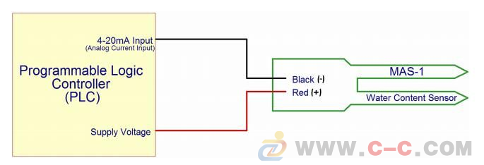

Water level senor: if users want to turn it manually, they can take the sensor out of the water.

Temperature sensor working principle diagram:

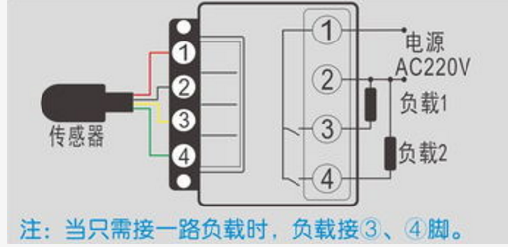

4.How to use solar panels?

Solar panels are reserve power, normally stores electricity when it is not working. When the power supply is exhausted, the solar panel will power the device.

Solar panel working principle:

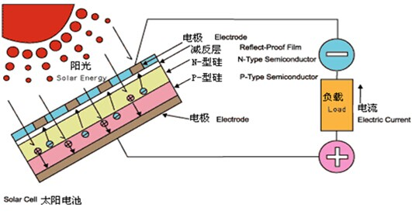

5.How to use pumps?

The water pump is a device that controls the watering. When the system judges that it is watering, the water pump will pressurize the water and send the water to the flower pot.

Pump works: After the pump is turned on, the impeller rotates in a high speed in the pump body (before the pump is opened, the pump body is filled with liquid). The liquid in the pump body rotates with the impeller, and the liquid is pumped by the impeller under the action of the centrifugal force. The liquid that is thrown out and thrown out gradually becomes slower in the diffusion chamber of the pump body. After the liquid is thrown out, a vacuum low pressure area is formed at the center of the impeller. The liquid in the liquid pool flows into the pump through the suction pipe under the action of external atmospheric pressure. The volume of the diffusion chamber of the pump body is constant, and the pressure is gradually increased with the increase of the liquid to be thrown, and finally discharged from the outlet of the pump. The liquid is continuously sucked from the bath and continuously discharged from the water pump outlet.

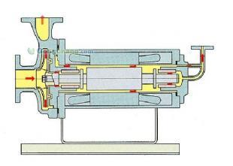

6.How can name the plant?

A.connect your plant and app.

B.Open the switch and open the name interface.

C.Input your plant name.

D.check whether the device can work

Appendix I:

User operation guide: