- Create a new connection driver.
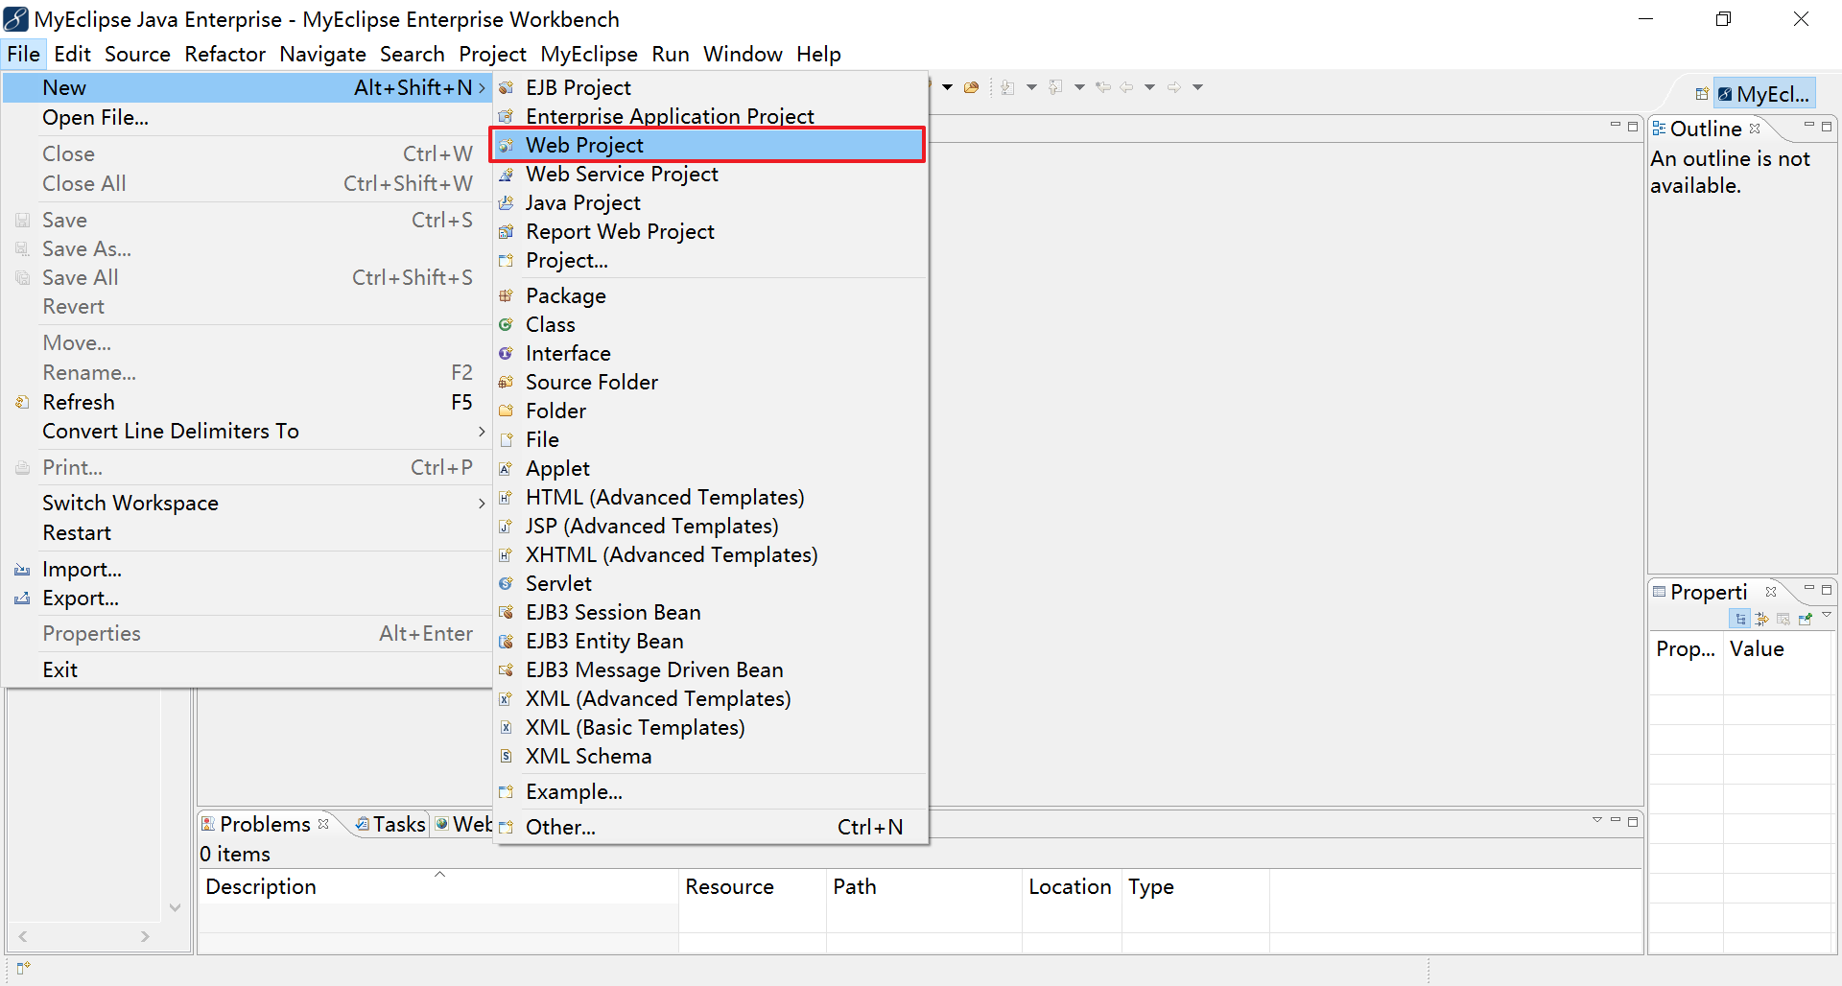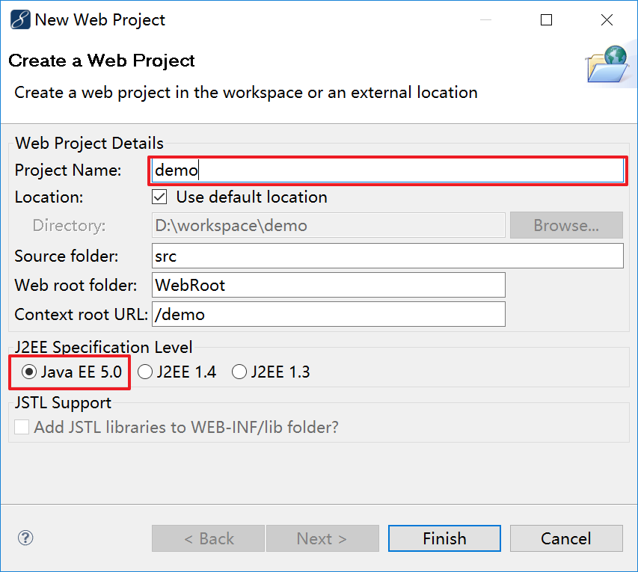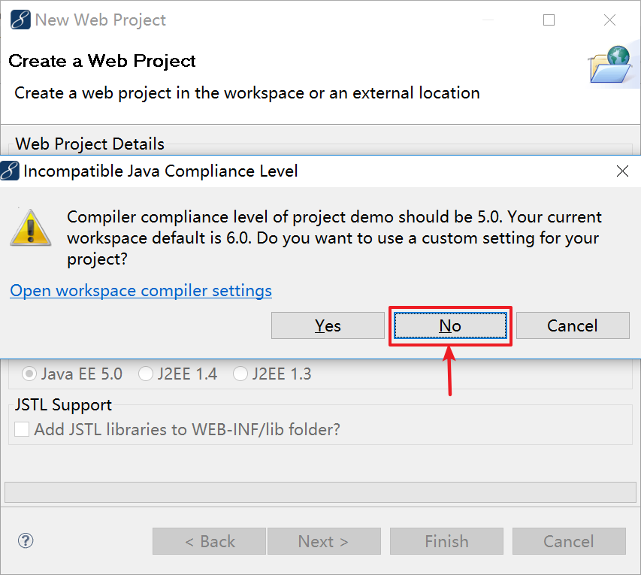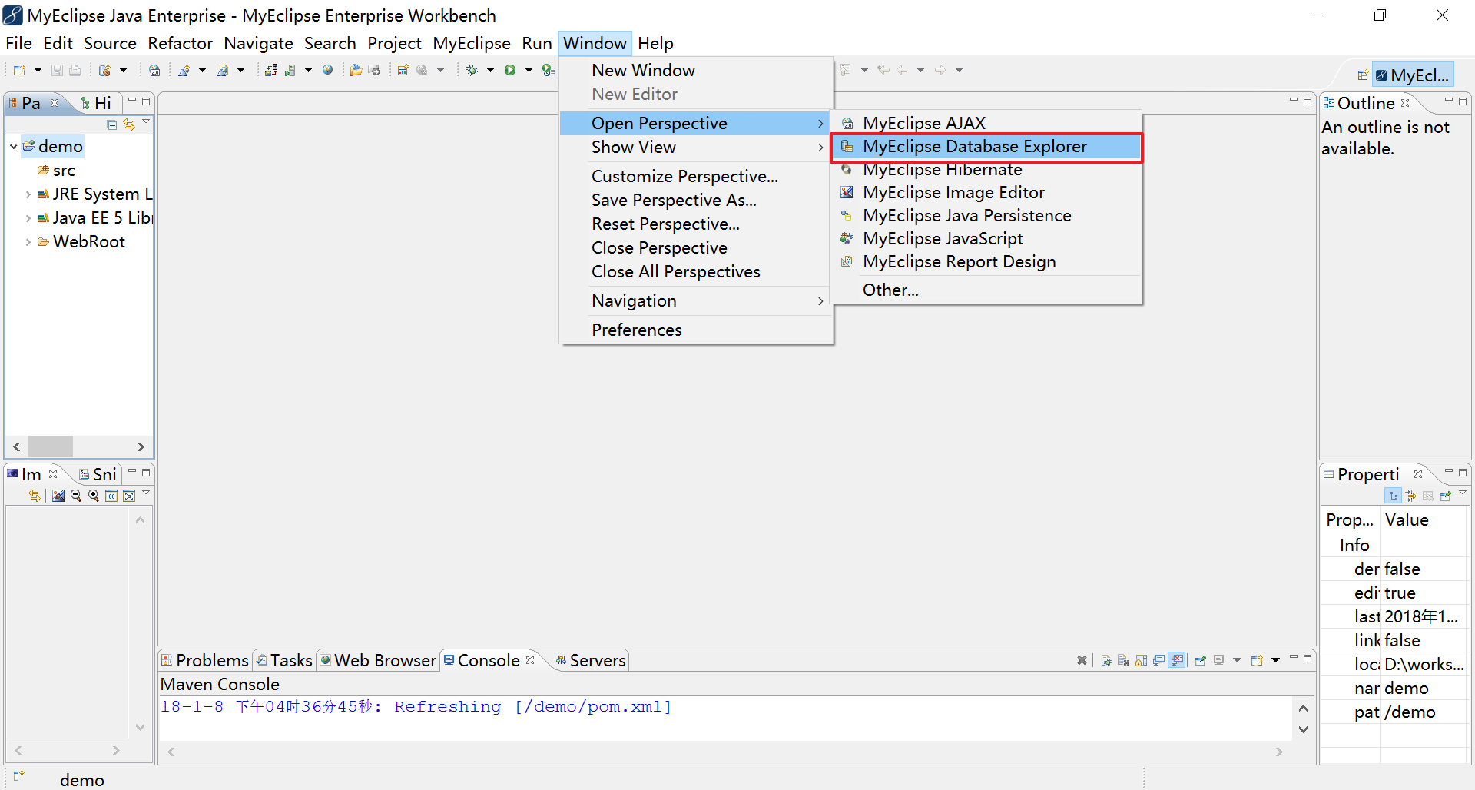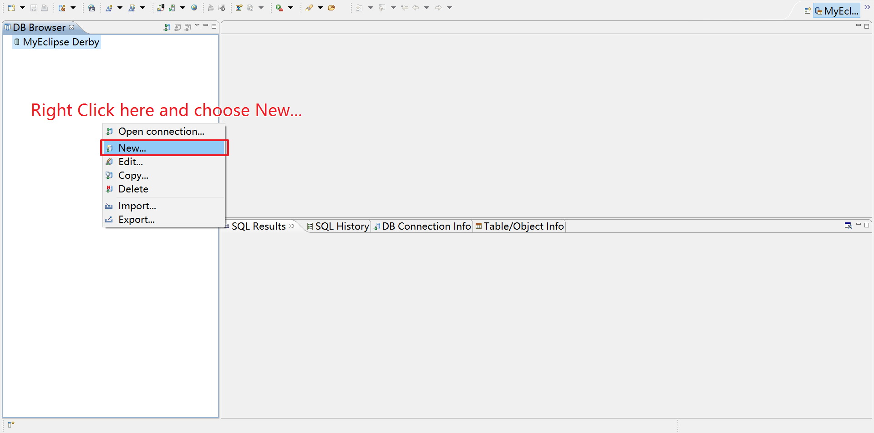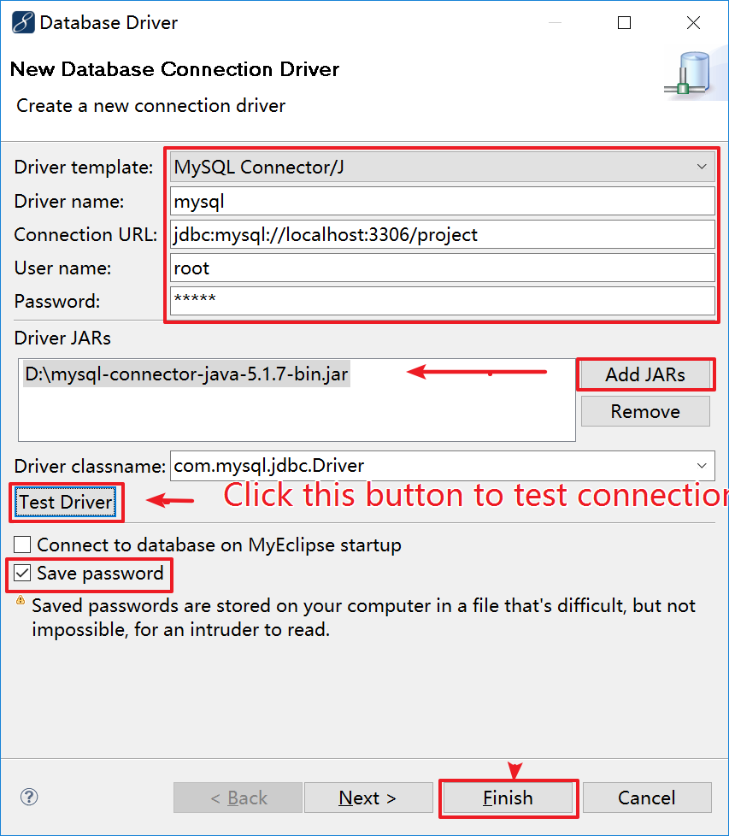

- Add Spring capabilities.
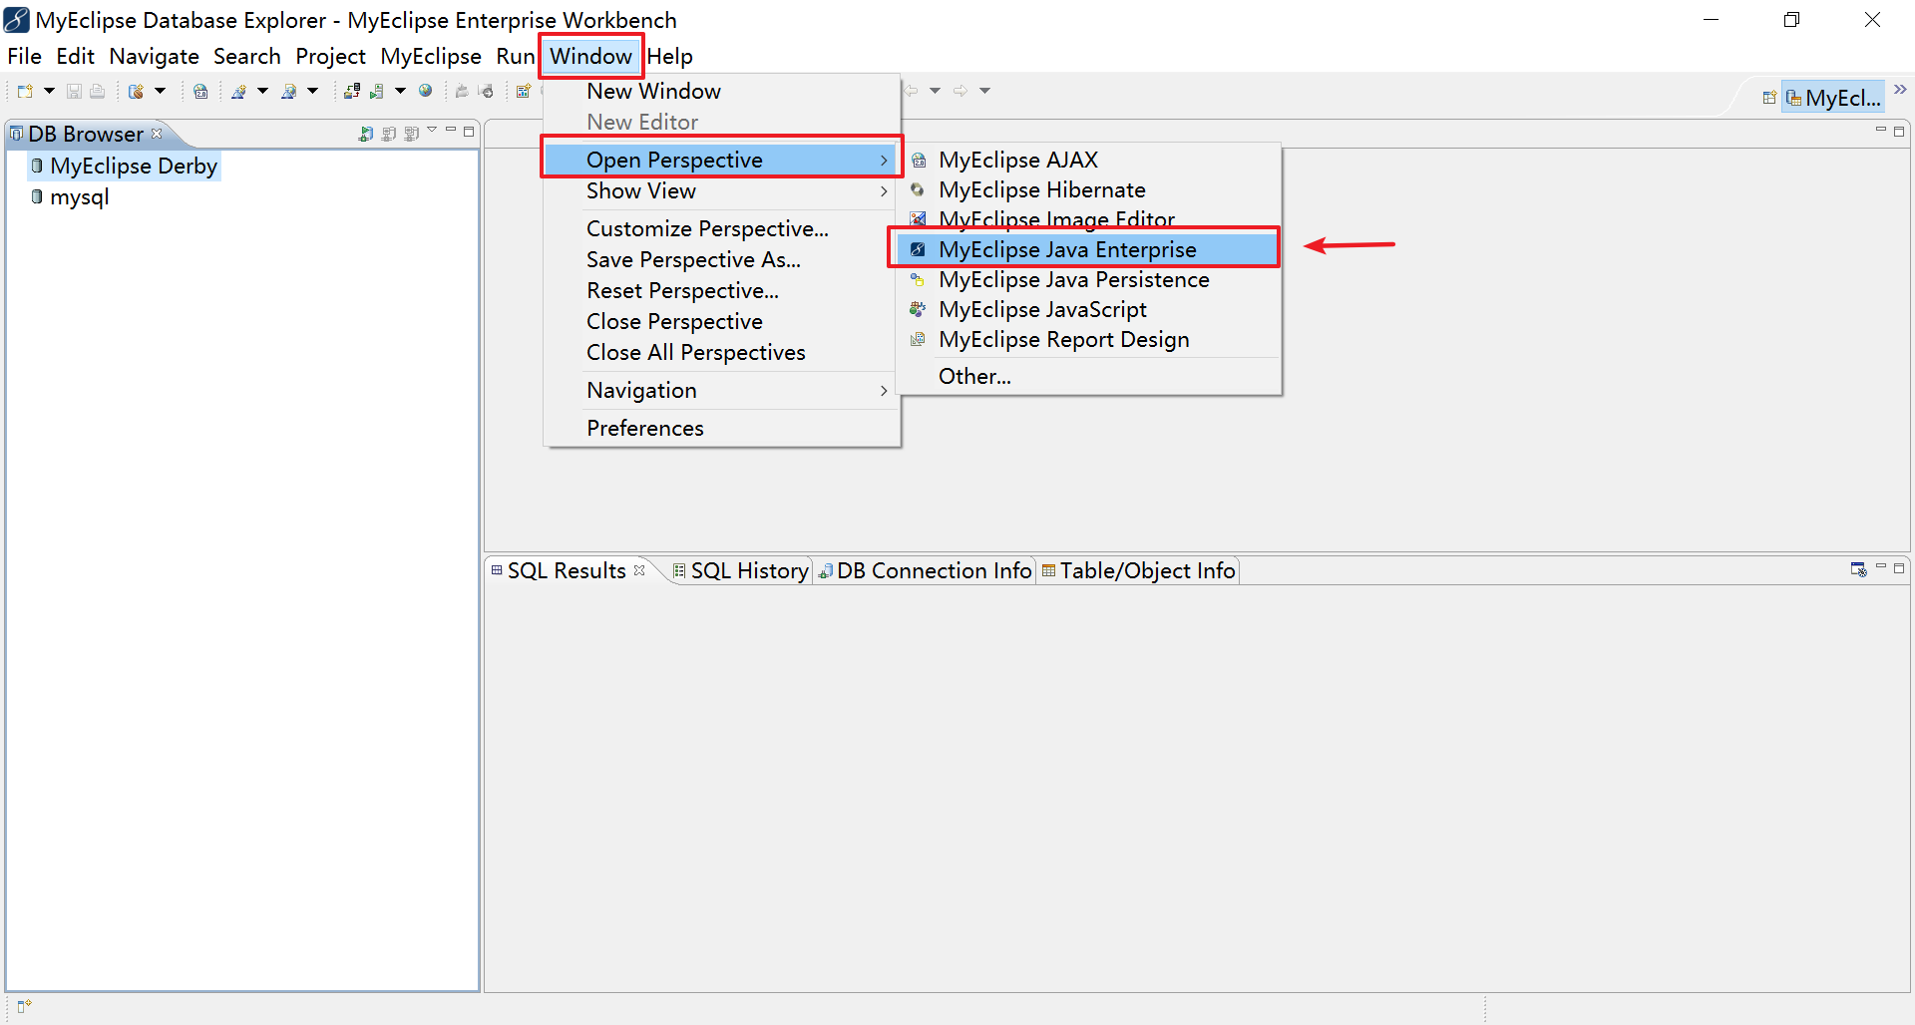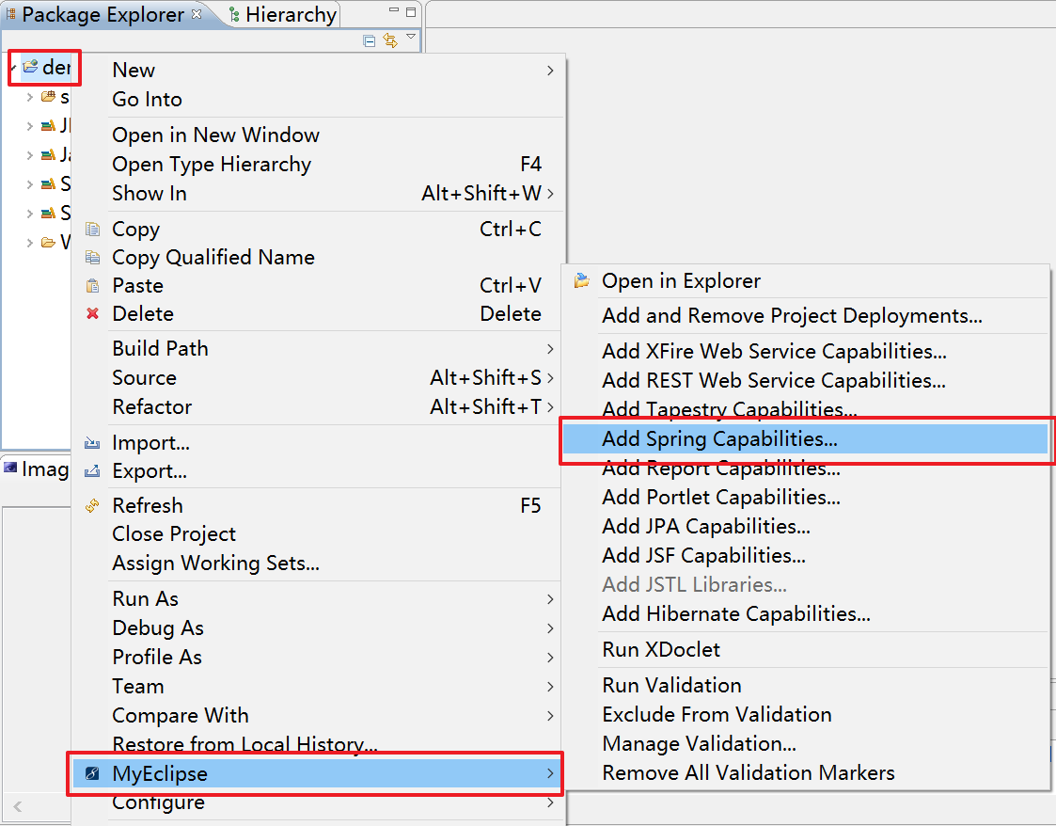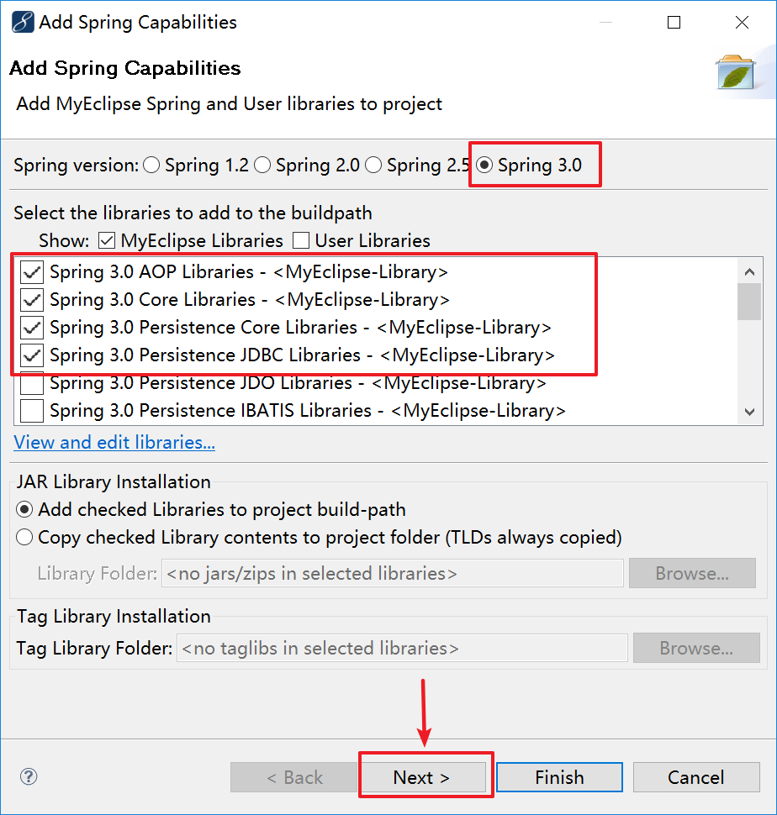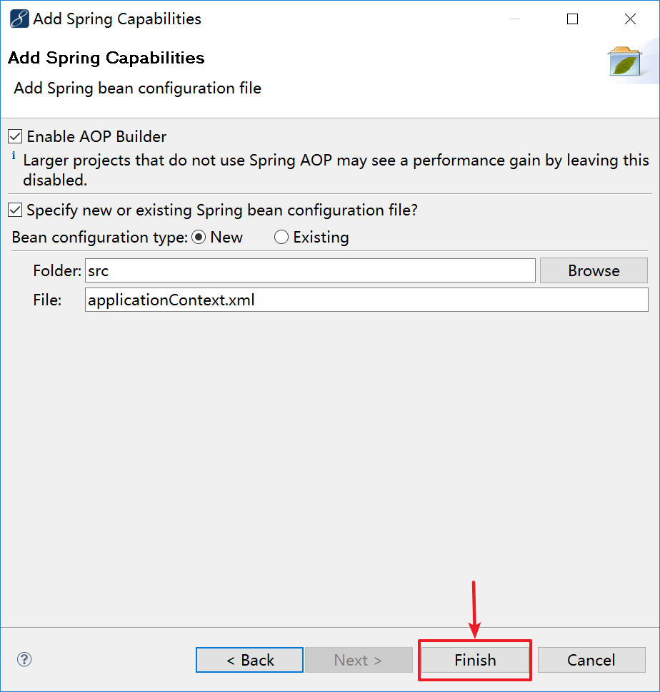

- Add Hibernate 3 capabilities.
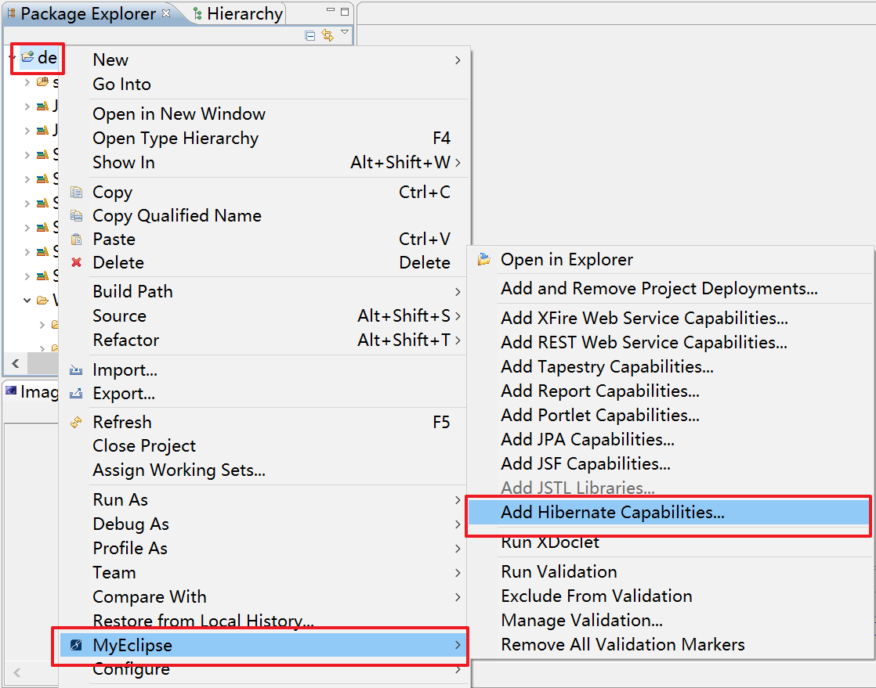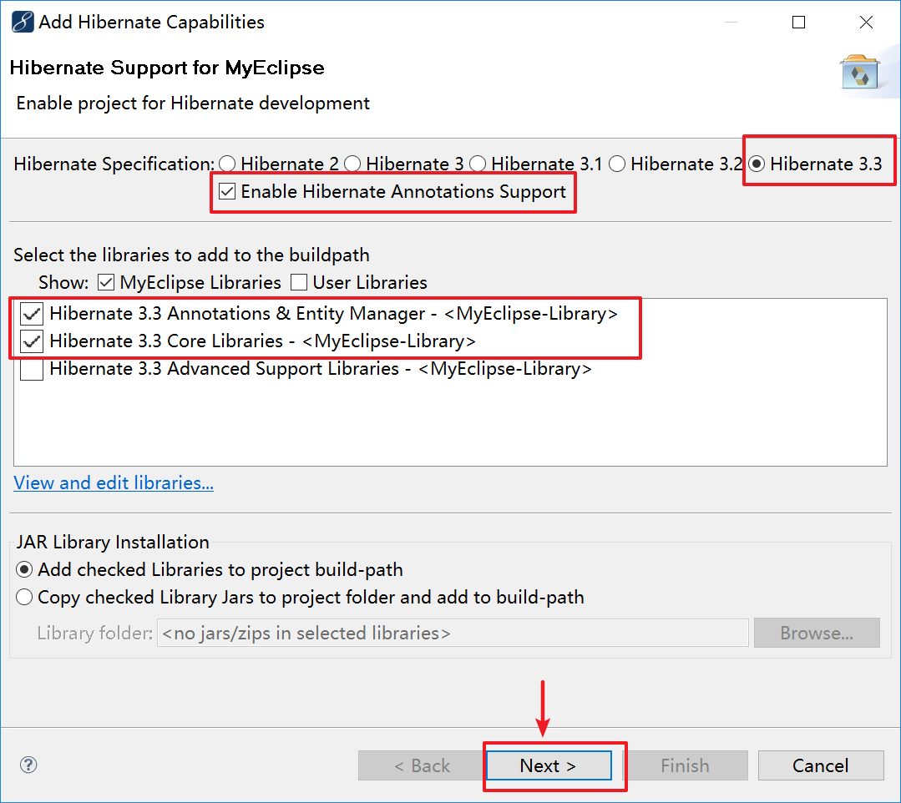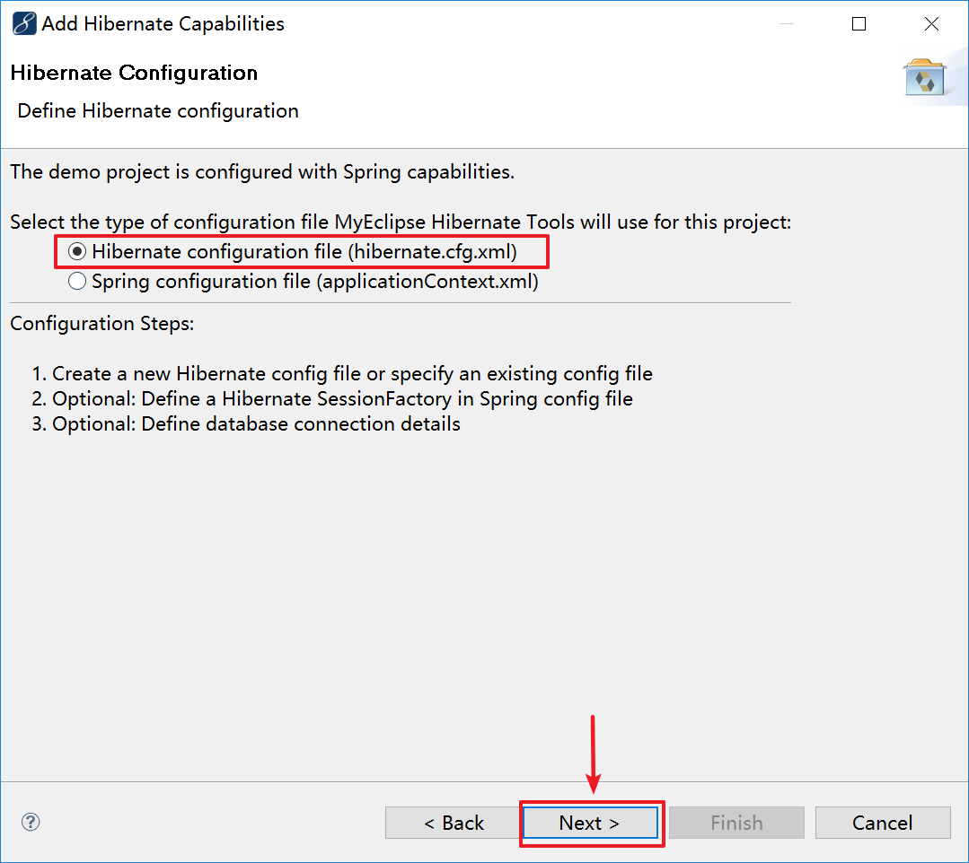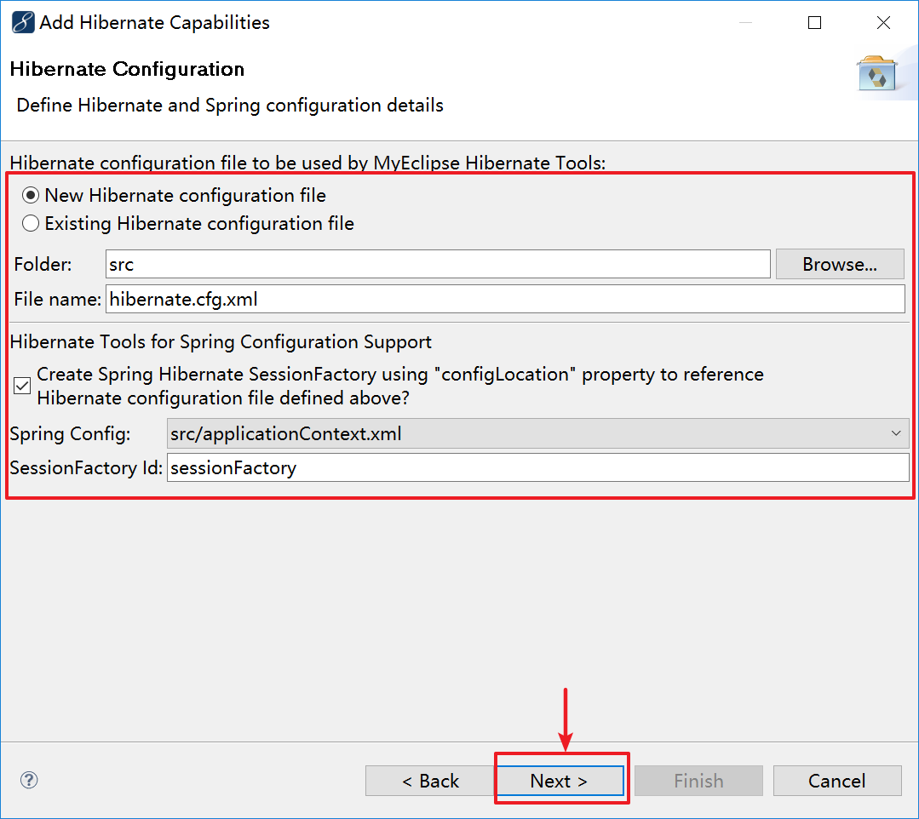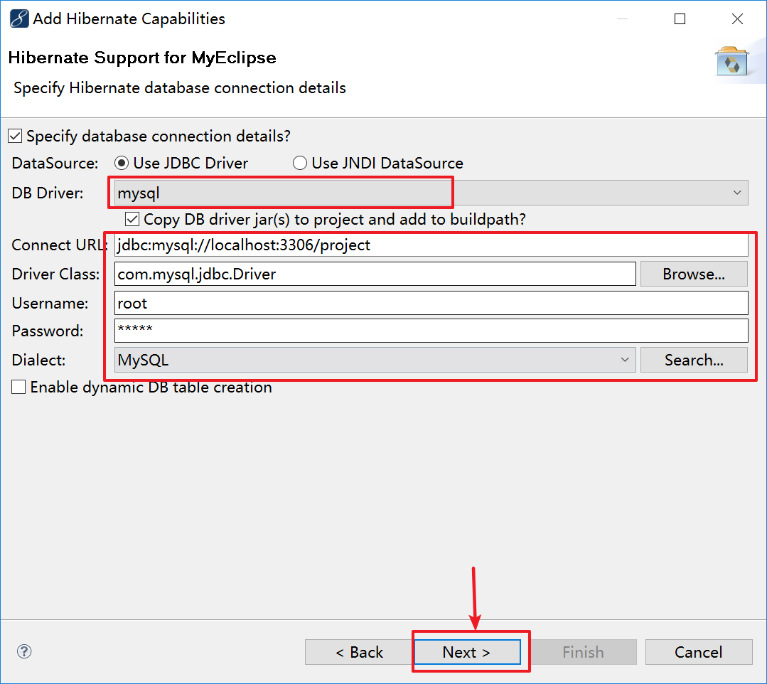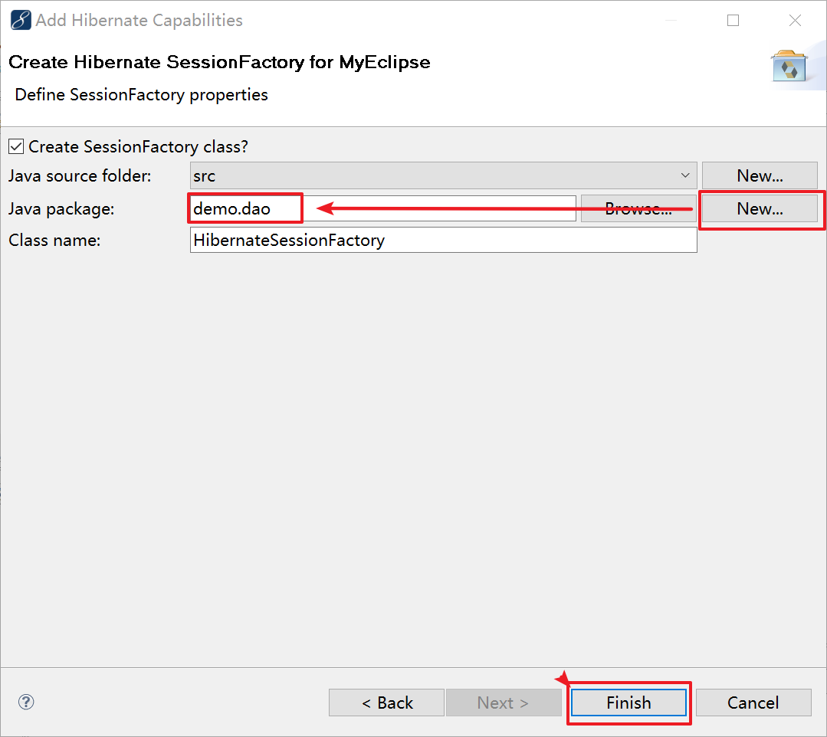

- Hibernate Reverse Engineering
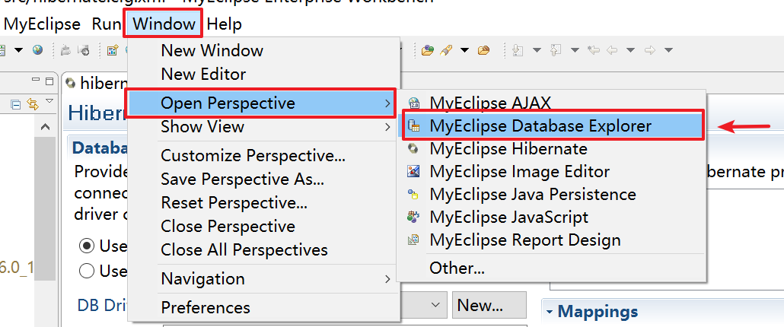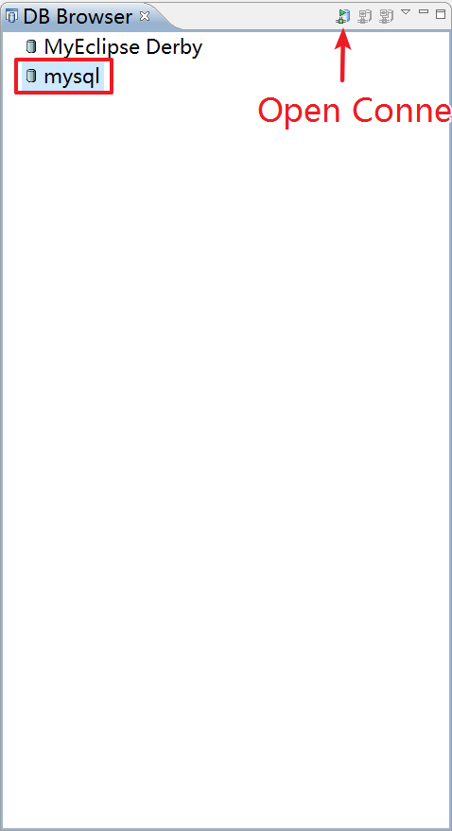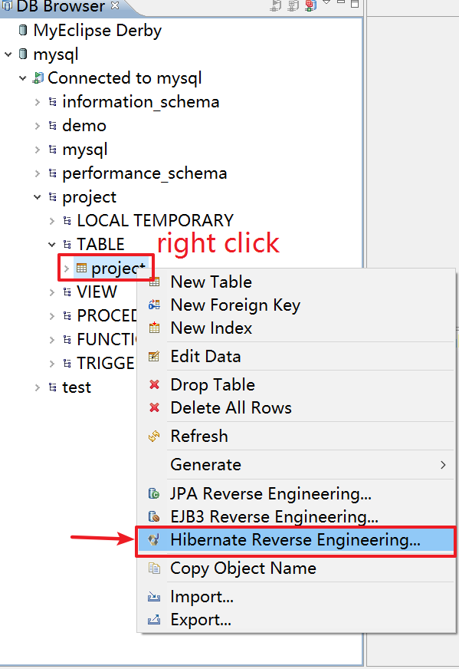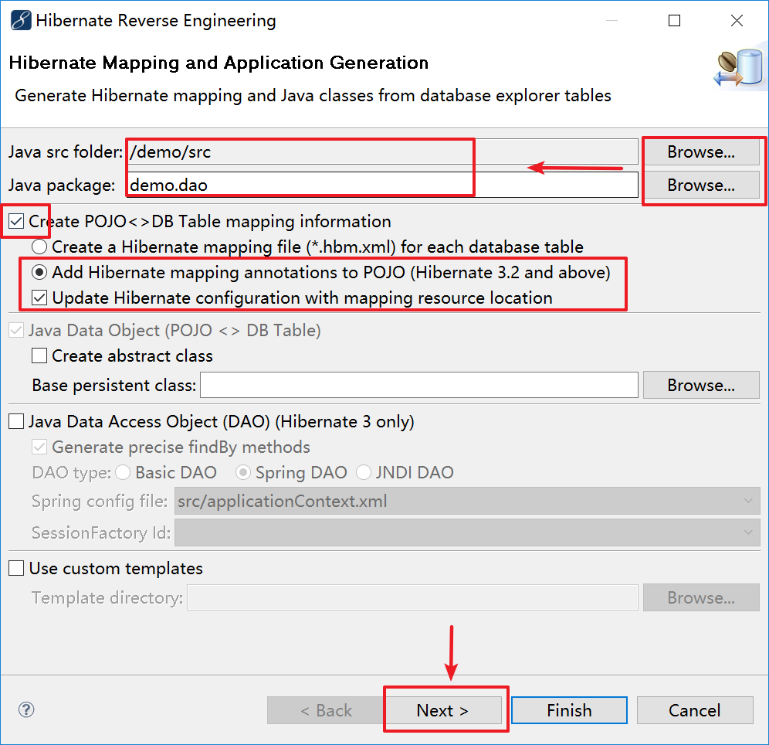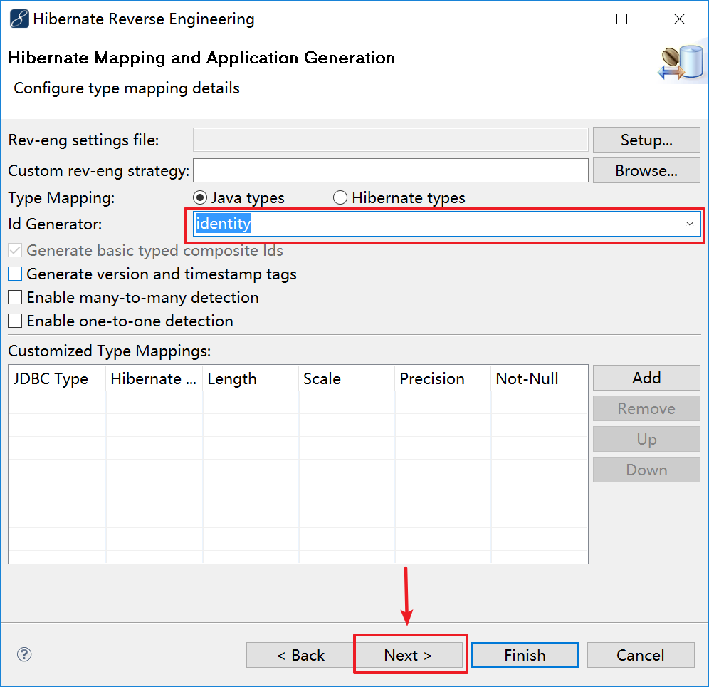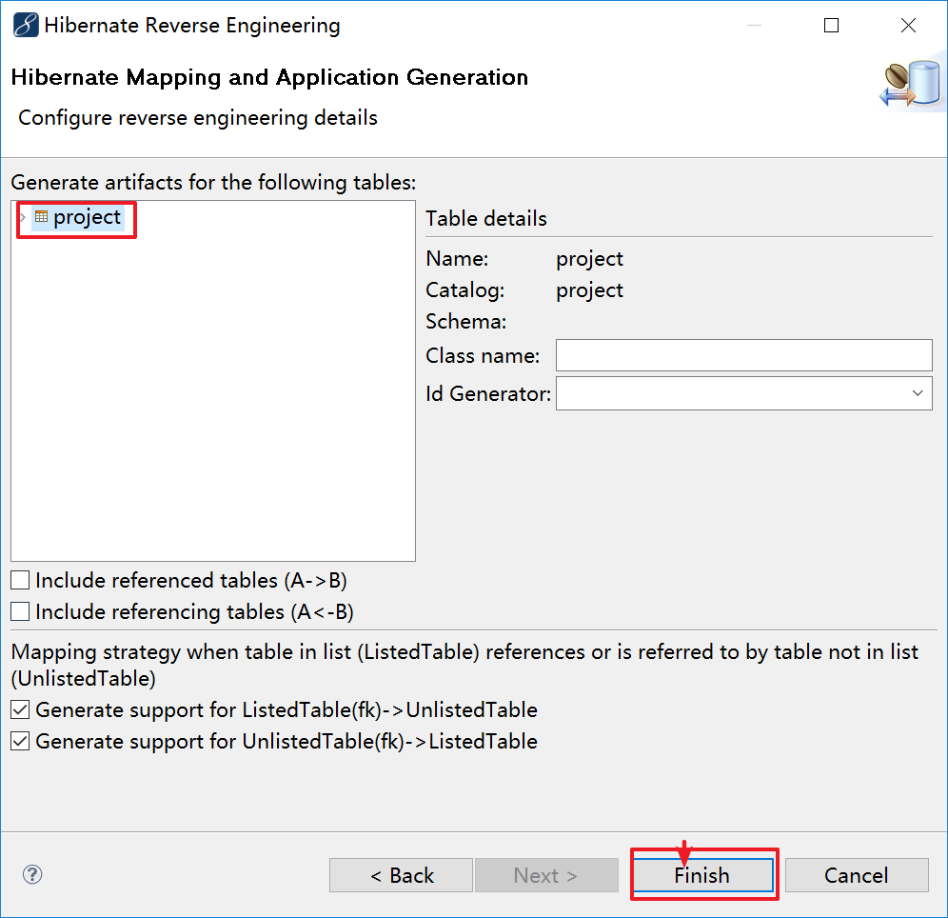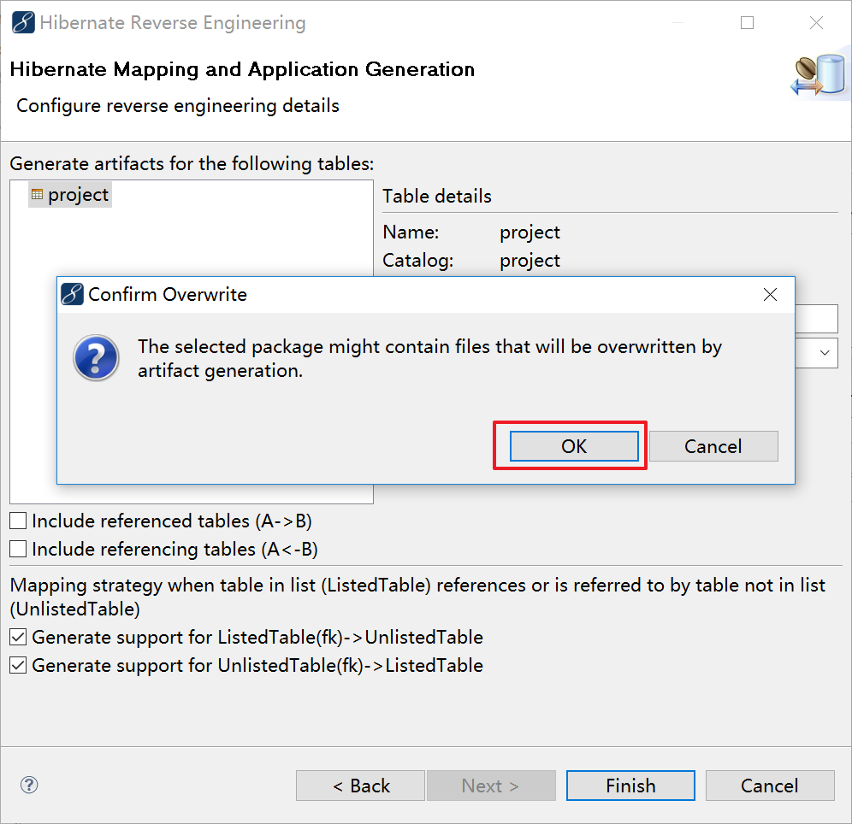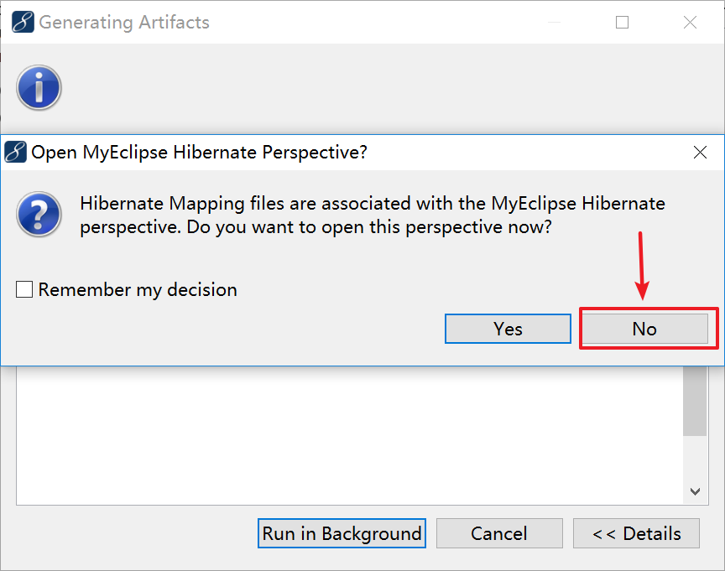

- Test DAO.
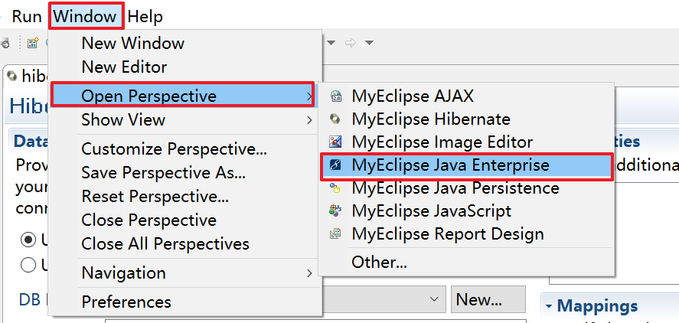

Config hibernate.cfg.xml
<property name="connection.autocommit">true</property>
<property name="hibernate.show_sql">true</property>

Config applicationContext.xml
<bean id="projectDAO" class="demo.dao.ProjectDAO">
<property name="sessionFactory">
<ref bean="sessionFactory"/>
</property>
</bean>

Add ProjectDAO.java in demo.dao package
package demo.dao;

import java.util.List;

import org.springframework.orm.hibernate3.support.HibernateDaoSupport;

public class ProjectDAO extends HibernateDaoSupport {

public void save(Project project)
{
this.getHibernateTemplate().save(project);
}

public List<Project> queryAll()
{
return this.getHibernateTemplate().loadAll(Project.class);
}
}

Add Test.java in demo.dao package and Run Test class
package demo.dao;

import java.util.Date;

import org.springframework.context.ApplicationContext;
import org.springframework.context.support.FileSystemXmlApplicationContext;

public class Test {

/**
* @param args
*/
public static void main(String[] args) {
// TODO Auto-generated method stub
ApplicationContext applicationContext = new FileSystemXmlApplicationContext("src/applicationContext.xml");
ProjectDAO projectDAO = (ProjectDAO) applicationContext.getBean("projectDAO");

Project project = new Project();
project.setProjectName("P1");
project.setPriceRange("100-200");
project.setCount(1);
project.setTechnology("Java");
project.setPublishDate(new Date());

projectDAO.save(project);
}

}

- Add Struts 2 capabilities.
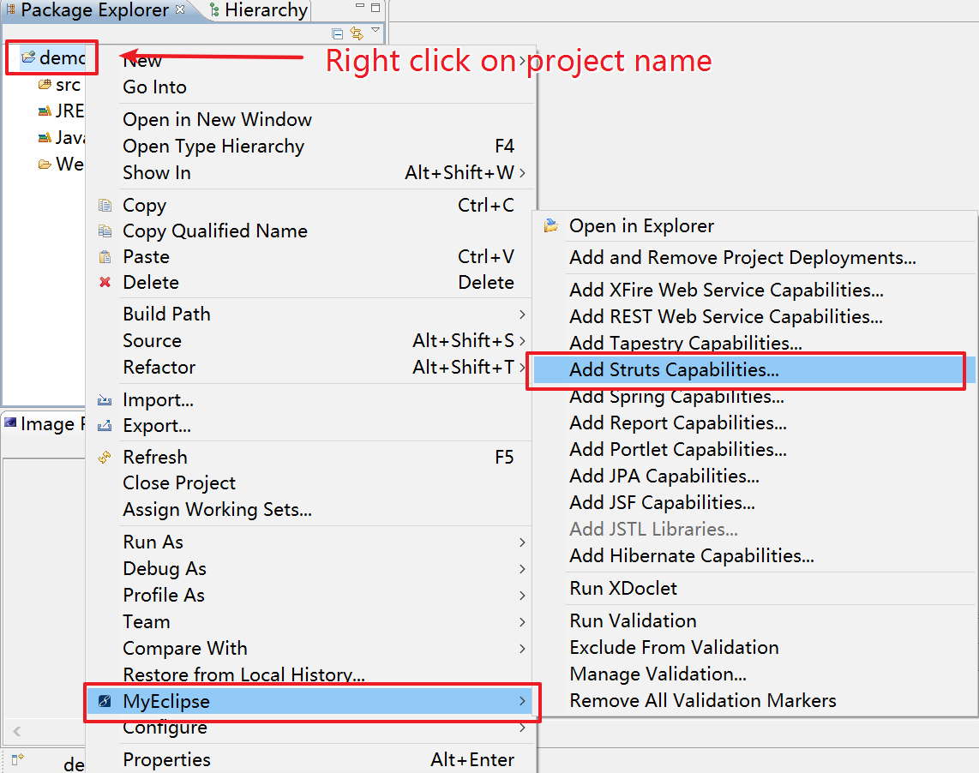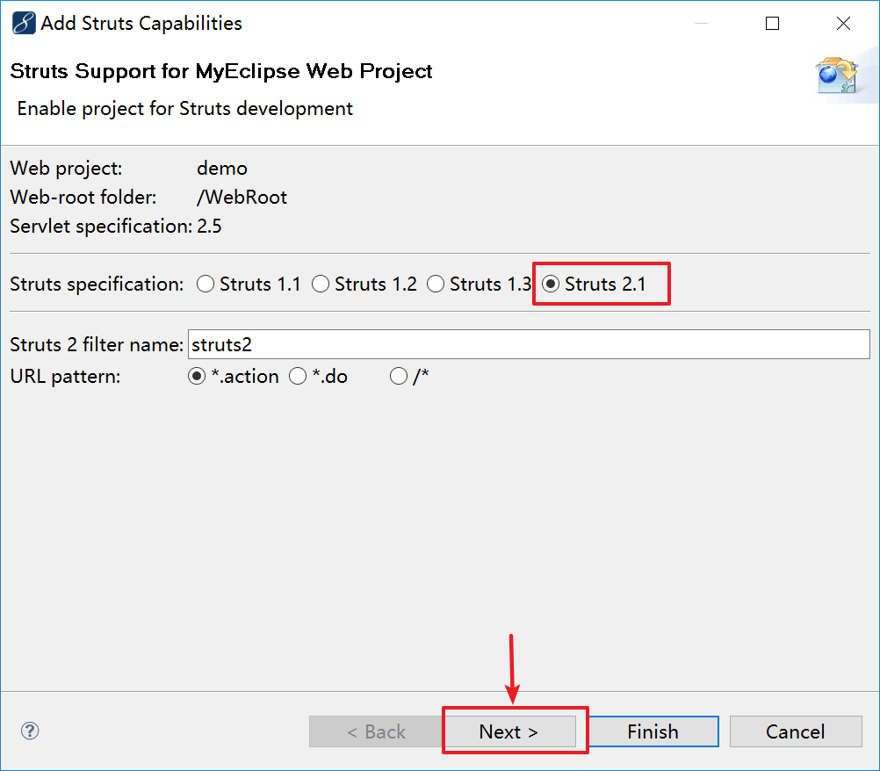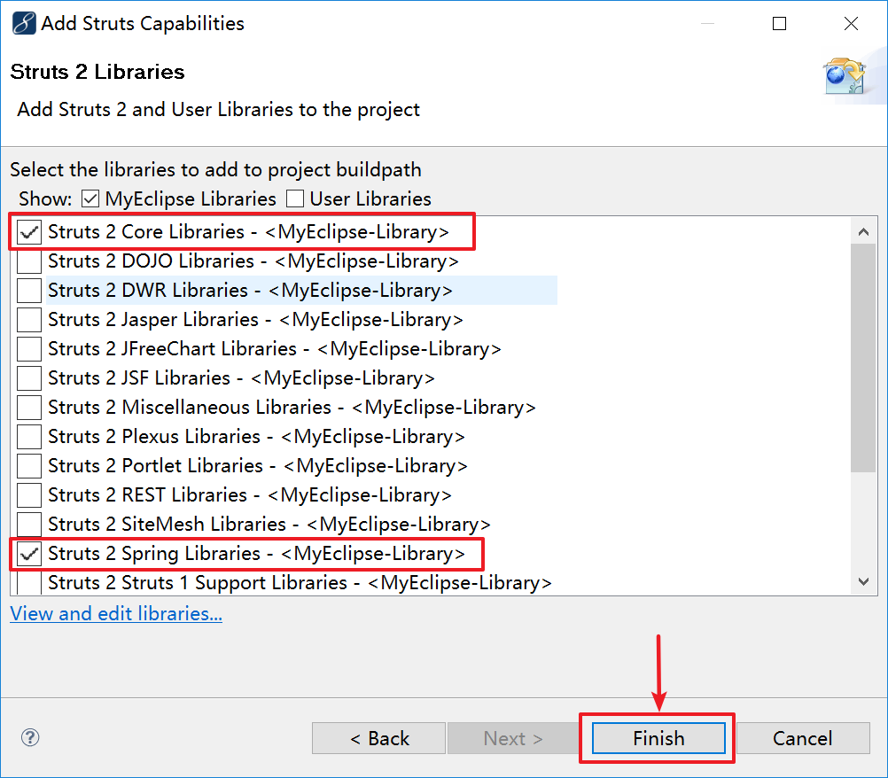

- Add service module and action module.
Config struts.xml & applicationContext.xml

NOTE: See source code for details.
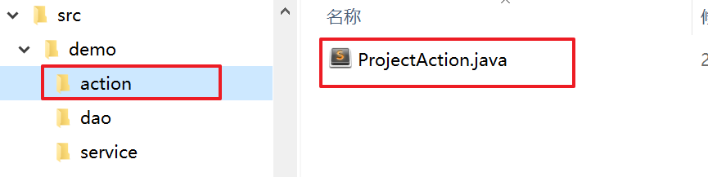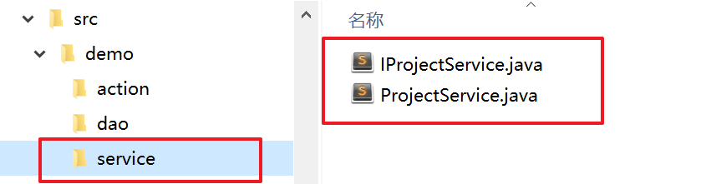

- Integrate UI.
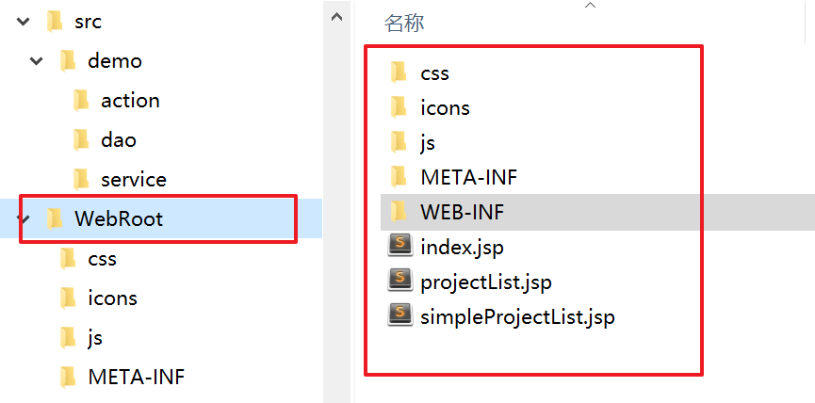

- Config web.xml
<?xml version="1.0" encoding="UTF-8"?>
<web-app version="2.5" xmlns="http://java.sun.com/xml/ns/javaee"
xmlns:xsi="http://www.w3.org/2001/XMLSchema-instance"
xsi:schemaLocation="http://java.sun.com/xml/ns/javaee
http://java.sun.com/xml/ns/javaee/web-app_2_5.xsd">
<welcome-file-list>
<welcome-file>index.jsp</welcome-file>
</welcome-file-list>
<filter>
<filter-name>struts2</filter-name>
<filter-class>
org.apache.struts2.dispatcher.ng.filter.StrutsPrepareAndExecuteFilter</filter-class>
</filter>
<filter-mapping>
<filter-name>struts2</filter-name>
<url-pattern>*.action</url-pattern>
</filter-mapping>

<listener>
<listener-class>org.springframework.web.context.ContextLoaderListener</listener-class>
</listener>
<context-param>
<param-name>contextConfigLocation</param-name>
<param-value>/WEB-INF/classes/applicationContext.xml</param-value>
</context-param>
</web-app>

- Deploy. (DONE)

