Classifying neurons and neuron behavior from cat visual cortex

Oliver Shetler

City University of New York, Hunter College

Department of Mathematics & Statistics

**Introduction**

Scientists often eavesdrop on neurons in a given brain region in order to discern how neural activity relates to stimuli outside of the organism. In this brief paper, I examine neural spike trains from the visual cortex of a partially anesthetized cat, who was exposed to various stimuli. I demonstrate how simple multivariate statistical techniques can be used to infer the stimulus conditions from observed neural activity.

**Description of Data**

The data set has neural spike train recordings of 10 neurons from a poly-electrode implanted in a cat’s visual cortex. The cat was partially anesthetized so that it would stay still during recording sessions. The cat was exposed to three different kinds of stimuli.

 (1) a movie of drifting bars.

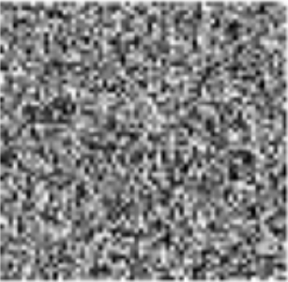 (2) a movie of black-and-white static.

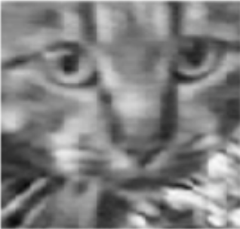 (3) a head-cam movie of another cat moving naturally in its environment.

The drifting bars group has 1 hour and 20 minutes of recorded spike trains with a sampling rate of 10 pico-seconds. The other two experimental groups have 45 minutes of time. Neural spike trains are represented as sequences of timestamps or as binary sequences. Neural activity can vary widely among neurons and across time. Neurons can fire in clustered bursts or more in bursts, as is visible in the example raster plot below.

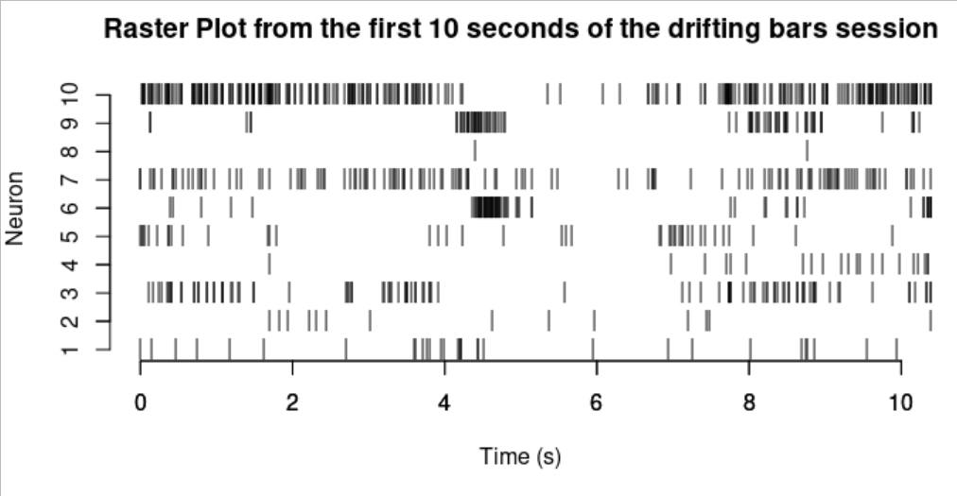

One common way to examine neural spike trains is to disregard the time series and look at the distribution of the inter spike interval (the distance in time between spikes). We can see from the plot below that the distribution can vary in the same neuron across circumstances.

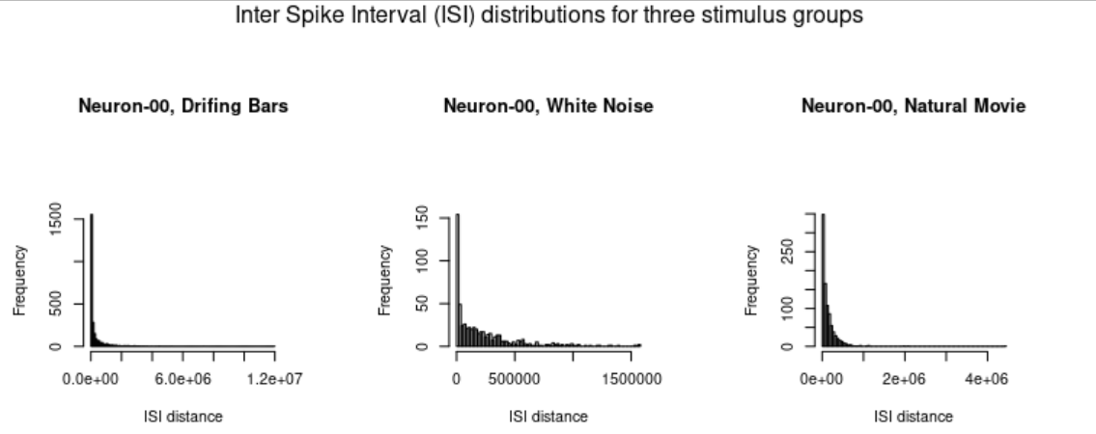 Additionally, these plots reveal that the ISI distributions tend to be highly positively skewed. These plots look like they came from inverse Gaussian type distributions. Another common way to characterize neurons is to look at the frequency of firing rates.

Another way to characterize neural activity is by firing intensity, which can be characterized by model estimates, or by average firing rates over time, depending on the situation.

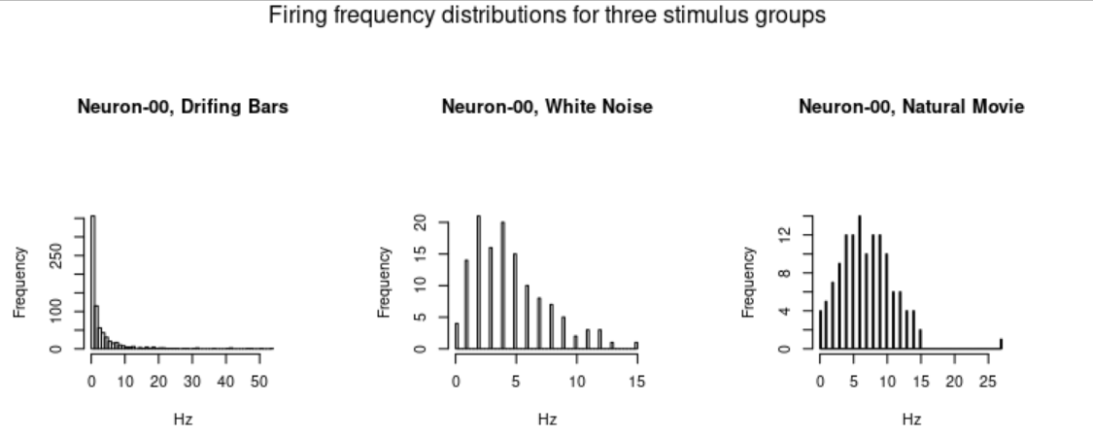

The distribution of average firing rates of one neuron at the 0.01 second time-scale are shown above.

**Method and Results**

Neural firing intensity is usually characterized in one of two ways. First, in experiments with repeated trials, there is usually a natural time-scale of interest, so averages at a given time-scale and across trials can be good estimators for characterizing neural activity profiles under different stimuli. Second, when repeated trials are not available, neural spike trains are often re-scaled so that the spike distributions are poisson (Brown et. al. 2002). Then, a series of regularly spaced time-points are imputed with “rate” values that correspond to the estimated intensity function of the Poisson regression. This method is often used to address the fact that average firing rates vary across time-scales, and therefore do not accurately estimate the instantaneous dispositions of neurons. Unfortunately, it is not easy to extend this method to multivariate data sets (Gerhard et. al. 2011).

The data being presently considered lacks repeated trials and is multivariate. As a consequence, the above methods would each have serious drawbacks. Fortunately, the stimulus exposure times in the experiment under consideration were very long in duration (over an hour each). At larger time-scales, mean firing rates converge to theoretical estimates of firing intensity. That is to say, the average firing rate in a large bucket is the same as the theoretical mean firing intensity over the same interval. As a result, we can cut our long exposure samples into fairly large buckets, from which we can estimate long duration firing rates, without losing too much statistical power. In what follows, I illustrate how this convergence improves model performance as bucket sizes increase, despite drastically reduced sample sizes at the highest time-scale.

**Data Transformation**

In order to make predictions, the frequency of spikes was counted at differing time scales: 1ms, 0.1s, 1s, and 10s. In order to avoid skewing predictive results, the drifting bar group was truncated to be the same size as the other two groups. This yielded 3900000 epochs at the 1ms time scale, 39000 epochs at the 0.1s time scale, 3900 epochs at the 1s time scale and 390 epochs at the 10s time scale.

Several of the models tested assumed normality for the covariates. At the 1ms time scale, all the covariates are Bernoulli, so it was meaningless to even try to normalize these distributions. As a result, only k-means clustering was attempted at this time scale. At the 0.1 second time scale, QQ-plots revealed significant non-normality (see Appendix A). As a result, the covariates x were transformed by log(x + 0.5). This did not fully fix the normality problem, but it reduced it as much as possible. The same adjustment was made for the 1 second time scale in light of similar QQ-plots. Lastly, the QQ-plots of the 10 second time scale were sufficiently normal, so no adjustment was made.

**Modeling Techniques**

Four modeling techniques were used (multinomial regression, LDA, QDA and KNN) at three time scales (0.1s, 1s and 10s). Additionally, KNN was attempted at the 1ms scale, but there were too many ties for the model to produce meaningful output.

**Results**

At the 0.1s time scale, the parametric models did worse than the KNN method, which was 81 percent accurate.

|  |  |  |
| --- | --- | --- |
| Predictive Accuracy of Models at 0.1 seconds time scale | | |
|  | Accuracy | 95% CI |
| Multinomial | 0.63 | (0.61, 0.65) |
| LDA | 0.63 | (0.61, 0.64) |
| QDA | 0.59 | (0.58, 0.61) |
| KNN (1 neighbor) | 0.81 | (0.80, 0.83) |

This was likely due to violations of both normality (even with adjustment) and violation to equality of covariance (Chi-squared(3023) = 8766.6, p < 2E-16).

|  |  |  |
| --- | --- | --- |
| Predictive Accuracy of Models at 1 seconds time scale | | |
|  | Accuracy | 95% CI |
| Multinomial | 0.85 | (0.81, 0.88) |
| LDA | 0.83 | (0.79, 0.86) |
| QDA | 0.59 | (0.58, 0.61) |
| KNN (2 neighbors) | 1.00 | (0.99, 1.00) |

Similarly, at the 10s time scale, performance improved but KNN outdid everything else by a wide margin. Again, the Box M test revealed non-homogeneity of covariances (Chi-squared(110) = 2329, p < 2E-16).

|  |  |  |
| --- | --- | --- |
| Predictive Accuracy of Models at 10 seconds time scale | | |
|  | Accuracy | 95% CI |
| Multinomial | 1.00 | (0.90, 1.00) |
| LDA | 1.00 | (0.90, 1.00) |
| QDA | 1.00 | (0.90, 1.00) |
| KNN (2 neighbors) | 1.00 | (0.90, 1.00) |

**Conclusion**

We discovered that the frequency with which different neurons fire bears a strong relationship to external stimuli. On the other hand, the fleeting activity of spike trains at very short time scales has little information about the sensory data from outside, as it does not reliably estimate the dispositions of neurons. It is clear from the high performance of models at the 1 second, and even 10 second time scales---in spite of the relatively smaller sample sizes---that the most important factor predicting sensory differences is the overall average activity of different neurons, in convex combination. This supports the general view that neural fields, often estimated by Brain Oxygenation Level Dependent (BOLD) activity or electrocorticogram (ECG) measurements, are a sufficient characterization of neural data.

References

Blanche, Tim (2009): Multi-neuron recordings in primary visual cortex. CRCNS.org.  
<http://dx.doi.org/10.6080/K0MW2F2J>

Brown, E. N., Barbieri, R., Ventura, V., Kass, R. E., & Frank, L. M. (2002). The time-rescaling theorem and its application to neural spike train data analysis. *Neural computation*, *14*(2), 325-346.

Gerhard, F., Haslinger, R., & Pipa, G. (2011). Applying the multivariate time-rescaling theorem to neural population models. *Neural computation*, *23*(6), 1452-1483.

**Appendix A**

QQ Plots for 0.01 time scale

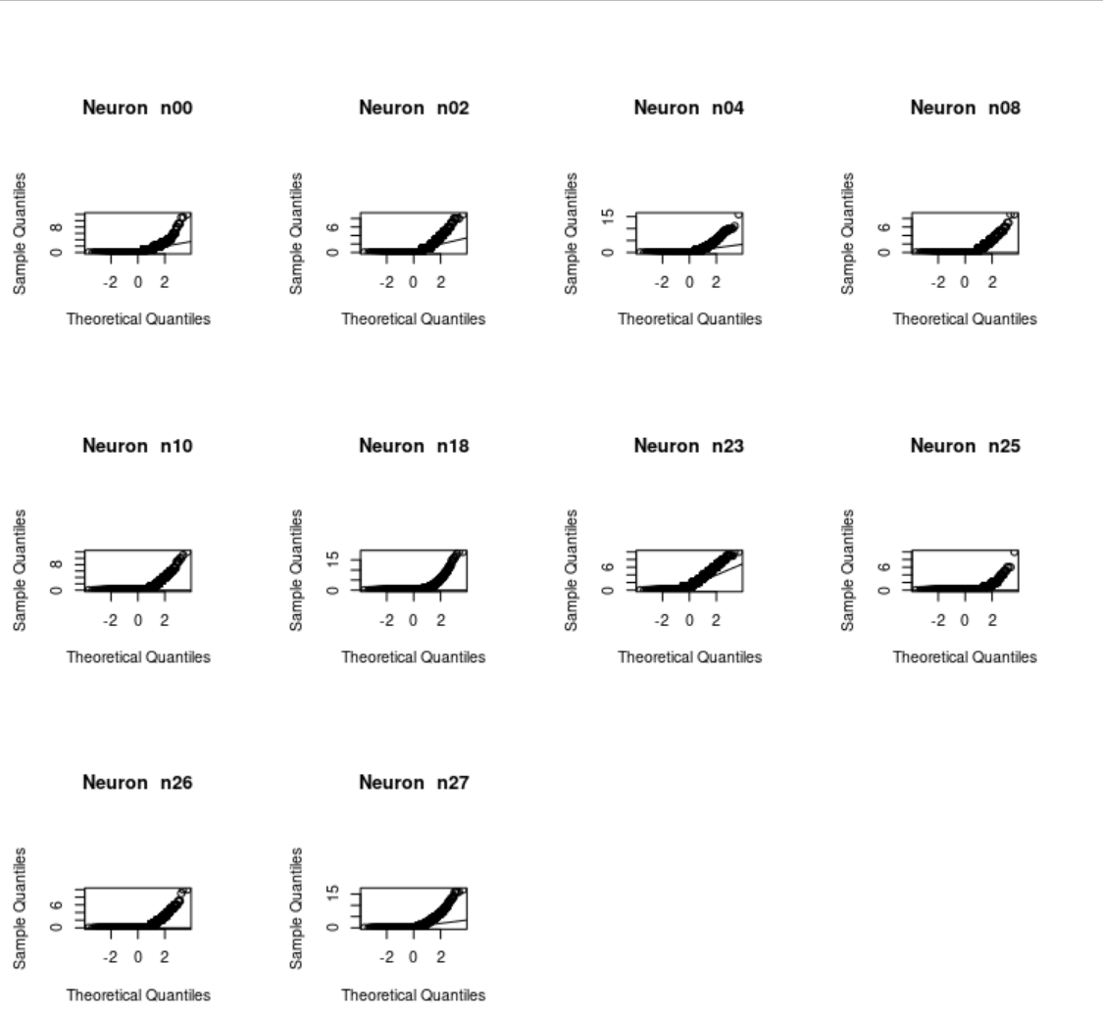

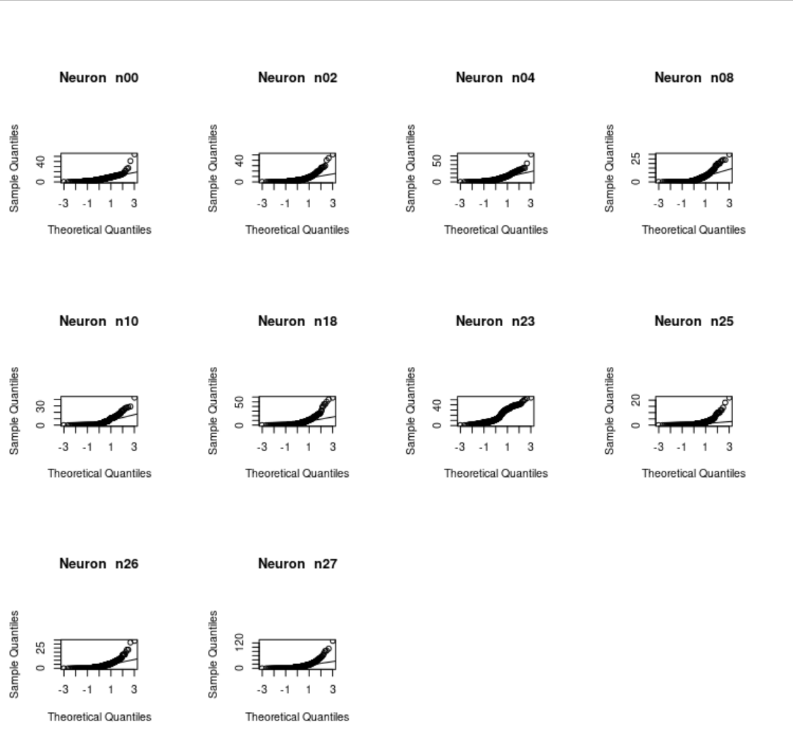QQ Plots for 1 second time scale

QQ plots for 10 second time scale

