Validation: DXI1&2_vollblut_eingefr vs DXI1&2_dir_lysiert

Montag 06. März 2023

### Messdaten

S: sample Number;—x: DXI1&2_dir_lysiert ;—y: DXI1&2_vollblut_eingefr

|  | X | Y |
| --- | --- | --- |
| S1 | 11.44 | 11.05 |
| S2 | 10.68 | 12.22 |
| S3 | 4.86 | 4.71 |
| S4 | 3.85 | 4.28 |
| S5 | 7.67 | 6.77 |
| S6 | 10.60 | 7.69 |
| S7 | 7.49 | 8.12 |
| S8 | 47.78 | 47.10 |
| S9 | 7.43 | 8.16 |
| S10 | 2.59 | 2.69 |
| S11 | 7.85 | 7.26 |
| S12 | 5.05 | 4.62 |
| S13 | 10.78 | 10.41 |
| S14 | 9.41 | 9.82 |
| S15 | 5.89 | 7.42 |
| S16 | 3.56 | 4.32 |
| S17 | 8.80 | 7.97 |
| S18 | 5.91 | 5.52 |
| S19 | 3.17 | 3.36 |
| S20 | 11.61 | 11.78 |
| S21 | 6.94 | 7.17 |
| S22 | 23.88 | 20.16 |
| S23 | 6.73 | 5.14 |
| S24 | 6.36 | 9.10 |
| S25 | 8.81 | 11.35 |
| S26 | 9.49 | 12.03 |
| S27 | 16.91 | 11.95 |
| S28 | 3.09 | 3.22 |
| S29 | 7.32 | 7.48 |
| S30 | 20.23 | 18.31 |
| S31 | 3.60 | 3.11 |
| S32 | 2.38 | 2.61 |
| S33 | 11.40 | 10.81 |
| S34 | 10.91 | 11.70 |
| S35 | 4.92 | 4.44 |
| S36 | 4.19 | 4.38 |
| S37 | 7.85 | 7.25 |
| S38 | 9.56 | 8.02 |
| S39 | 8.32 | 7.64 |
| S40 | 45.51 | 46.19 |
| S41 | 8.20 | 7.94 |
| S42 | 2.64 | 2.90 |
| S43 | 8.47 | 7.46 |
| S44 | 5.59 | 4.99 |
| S45 | 10.83 | 11.24 |
| S46 | 9.60 | 10.30 |
| S47 | 6.05 | 7.66 |
| S48 | 4.21 | 4.80 |
| S49 | 9.98 | 7.97 |
| S50 | 6.14 | 5.60 |
| S51 | 3.50 | 3.46 |
| S52 | 12.24 | 11.74 |
| S53 | 7.48 | 7.42 |
| S54 | 25.20 | 22.17 |
| S55 | 7.01 | 5.48 |
| S56 | 6.42 | 9.92 |
| S57 | 9.37 | 11.90 |
| S58 | 11.00 | 13.60 |
| S59 | 19.87 | 12.67 |
| S60 | 3.28 | 3.35 |
| S61 | 8.16 | 8.51 |
| S62 | 21.60 | 19.32 |
| S63 | 3.84 | 3.53 |
| S64 | 3.03 | 2.90 |

### Korrelation

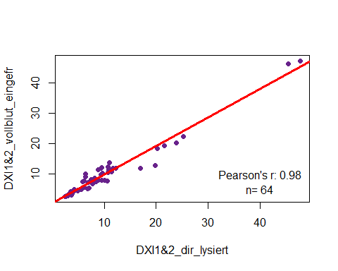

### Passing Bablok

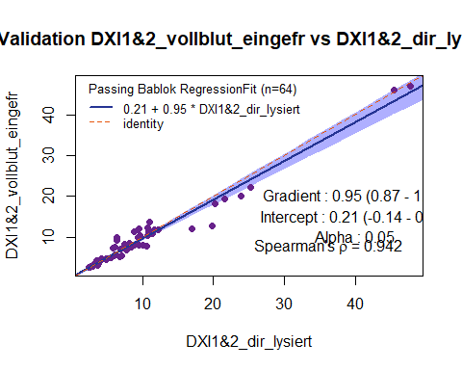

### Bland-Altman

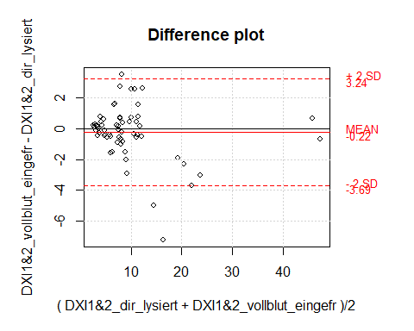

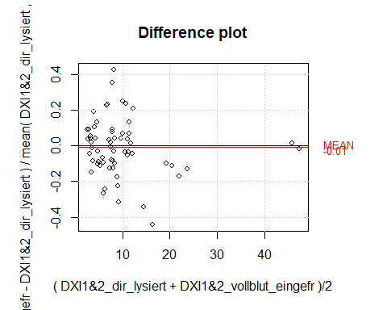

### Schlussfolgerung und Freigabe

Bitte gib hier Deine Beurteilung der vorliegenden Verifikation/Validation ein:  
|  
|  
|  
|  
|  
—

#### Data is processed using R language1 and mcr package2. Rmarkdown3 is used for converting results into Word, PDF and HTML files. This project was inspired by Daniel Holmes (UBC, CA)4 and Burak Bahar (Washington, USA)5.

#### References and packages:

1. R: A language and environment for statistical computing. R Foundation for Statistical Computing, Vienna, Austria. Version: 4.2.2 URL: <https://www.R-project.org>
2. mcr: Method Comparison Regression. Version: 1.3.2 URL: <http://CRAN.R-project.org/package=mcr>
3. rmarkdown: Dynamic Documents for R. Version: 2.20 URL: <http://rmarkdown.rstudio.com>
4. The Lab-R-torian: URL: <https://labrtorian.com/>
5. An interactive website for analytical method comparison and bias estimation: URL: <https://bahar.shinyapps.io/method_compare/>