1. Intro – 閔-翻譯
2. Related studies – 梁SIR ing
3. Calculation -> matlab 0’4 moment
4. Virtual prototype/Solidworks verification
   1. 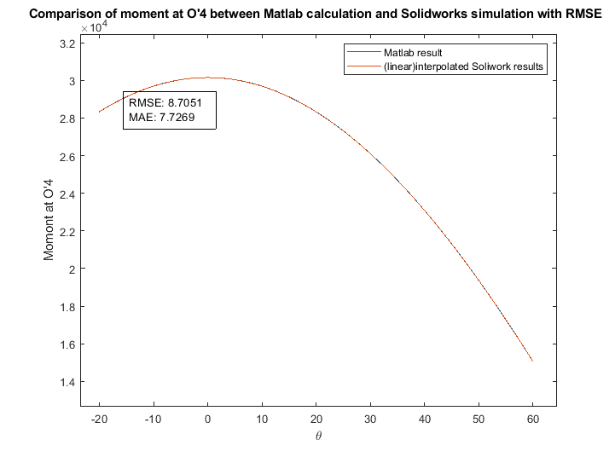
5. Numeric analysis
   1. 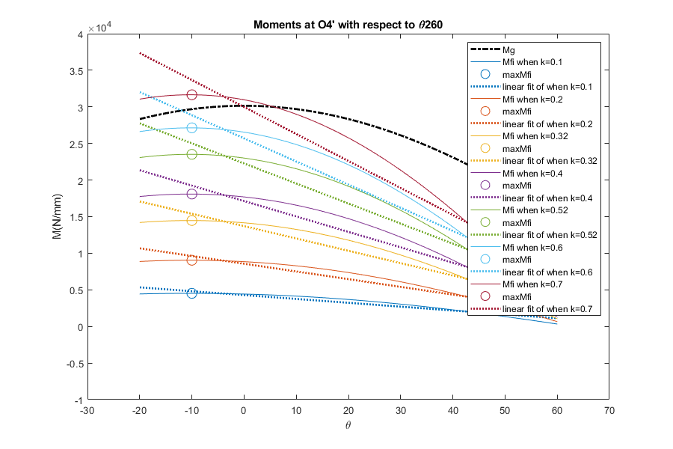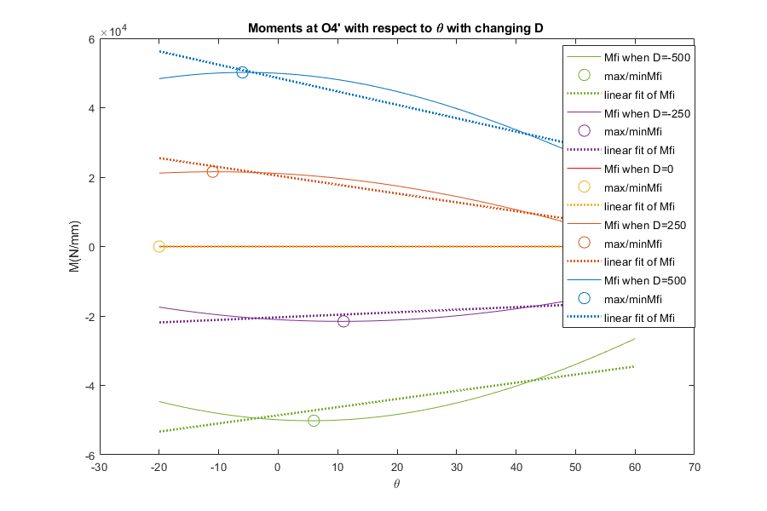
   2. 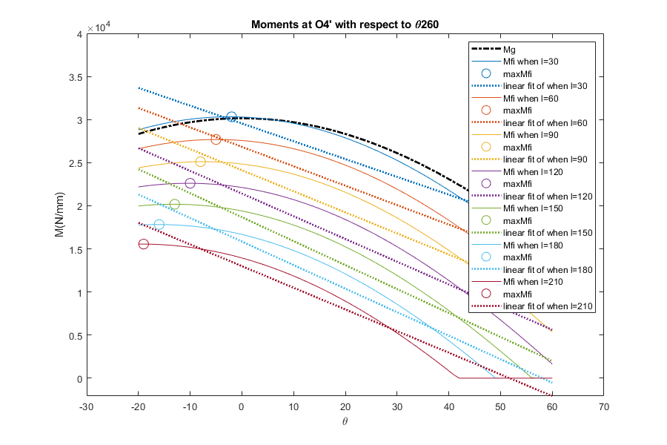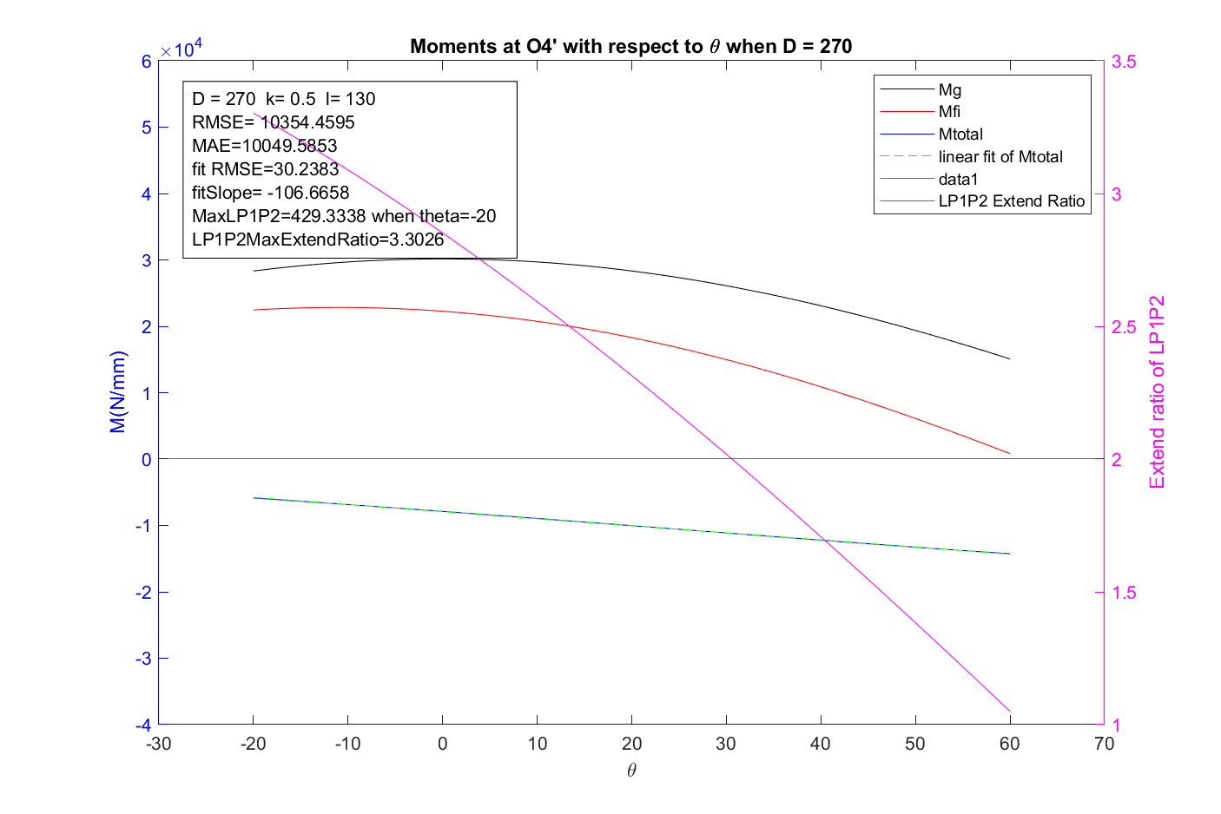
6. result and conclusion
7. future
   1. motion model
   2. dynamics
8. reference