**Assignment 3**

**Oliver Yuan, Ruyi Shi**

**Model Comparison:**

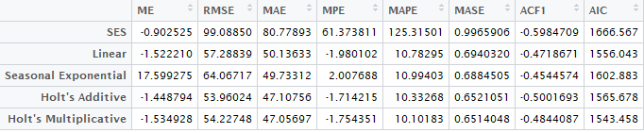

Based on the result above, I will choose Winter’s multiplicative method because **it has the lowest MASE and AIC.**

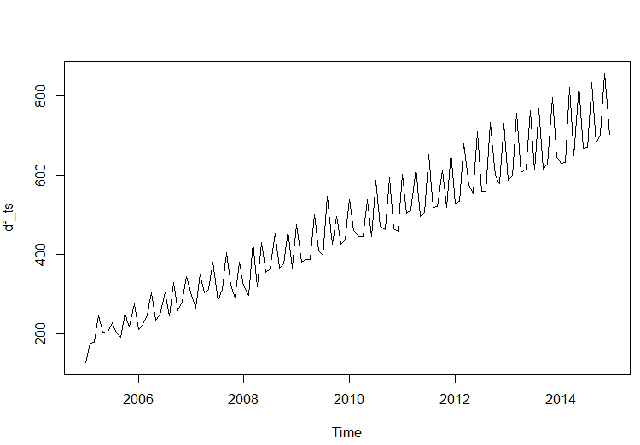

If we plot the series, we can see that this series has a clear trend and seasonality. And that’s why **Winter’s method fits the best because it has trend and seasonality components.**

**Predicted Values:**

