一.基本概念 1
二．代码 7
1.配置文件 7
2. ShortcutDockLayout 8

一.基本概念
onInterceptTouchEvent:
onInterceptTouchEvent是在ViewGroup里面定义的。Android中的layout布局类一般都是继承此类的。onInterceptTouchEvent是用于拦截手势事件的，每个手势事件都会先调用onInterceptTouchEvent。
onTouchEvent:
onTouchEvent同样也是在view中定义的一个方法。处理传递到view 的手势事件。手势事件类型包括ACTION_DOWN,ACTION_MOVE,ACTION_UP,ACTION_CANCEL等事件。
其中Layout里的onInterceptTouchEvent默认返回值是false,这样touch事件会传递到View控件，Layout里的onTouch默认返回值是false, View里的onTouch默认返回值是true,当我们手指点击屏幕时候，先调用ACTION_DOWN事件,当onTouch里返回值是true的时候，onTouch回继续调用ACTION_UP事件，如果onTouch里返回值是false，那么onTouch只会调用ACTION_DOWN而不调用ACTION_UP.
为了让当家更容易理解我写了一个简单的Demo.自定义了Layout与View,Android工程目录如下:
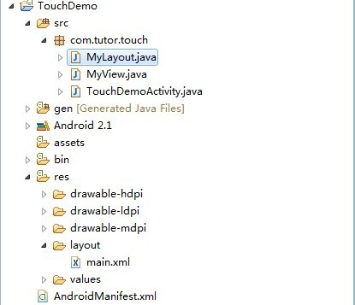
新建一个MyLayout.java代码如下:
package com.tutor.touch;
import android.content.Context;
import android.util.AttributeSet;
import android.util.Log;
import android.view.MotionEvent;
import android.widget.FrameLayout;
public class MyLayout extends FrameLayout {
public MyLayout(Context context){
super(context);
}
public MyLayout(Context context, AttributeSet attrs) {
super(context, attrs);
// TODO Auto-generated constructor stub
}
@Override
public boolean onInterceptTouchEvent(MotionEvent ev) {
Log.e(TouchDemoActivity.TAG, "MyLayout onInterceptTouchEvent.");
Log.e(TouchDemoActivity.TAG,"MyLayout onInterceptTouchEvent default return "
+ super.onInterceptTouchEvent(ev));
return super.onInterceptTouchEvent(ev);
}
@Override
public boolean onTouchEvent(MotionEvent event) {
Log.e(TouchDemoActivity.TAG, "MyLayout onTouchEvent.");
Log.e(TouchDemoActivity.TAG,"MyLayout onTouchEvent default return "
+ super.onTouchEvent(event));
return super.onTouchEvent(event);
}
}
然后新建一个MyView.java代码如下:
package com.tutor.touch;
import android.content.Context;
import android.util.AttributeSet;
import android.util.Log;
import android.view.MotionEvent;
import android.widget.Button;
public class MyView extends Button {
public MyView(Context context){
super(context);
}
public MyView(Context context, AttributeSet attrs) {
super(context, attrs);
}
@Override
public boolean onTouchEvent(MotionEvent event) {
Log.e(TouchDemoActivity.TAG, "MyView onTouchEvent.");
Log.e(TouchDemoActivity.TAG,"MyView onTouchEvent default return "
+ super.onTouchEvent(event));
return super.onTouchEvent(event);
}
}
其中TouchDemoActivity代码如下：
package com.tutor.touch;
import android.app.Activity;
import android.os.Bundle;
public class TouchDemoActivity extends Activity {
public static final String TAG = "TouchDemoActivity";
@Override
public void onCreate(Bundle savedInstanceState) {
super.onCreate(savedInstanceState);
setContentView(R.layout.main);
}
}
上面所有的布局文件main.xml代码如下:
<?xml version="1.0" encoding="utf-8"?>
<com.tutor.touch.MyLayout xmlns:android="http://schemas.android.com/apk/res/android"
android:layout_width="fill_parent"
android:layout_height="fill_parent"
>
<com.tutor.touch.MyView
android:layout_width="fill_parent"
android:layout_height="wrap_content"
android:text="@string/hello" />
</com.tutor.touch.MyLayout>
运行上述Android工程效果如下:
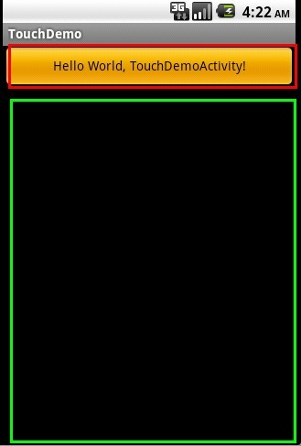
点击红色区域，触发了MyView里的onTouch事件查看logcat,如下图:
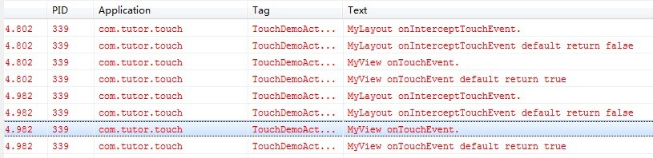
点击绿色区域，则触发了MyLayout里的onTouch事件，查看logcat，如下图:
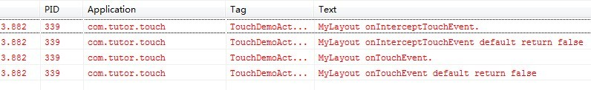
上面俩个截图都是用系统默认值，可以得出结论:onInterceptTouchEvent默认返回值是false,MyLayout里onTouchEvent默认返回值是false，所以只消费了ACTION_DOWN事件，MyView里onTouch默认返回值是true,调用了俩次:ACTION_DOW,ACTION_UP。
下面我们把MyLayout.java里的onInterceptTouchEvent的return值修改为true，代码如下:
@Override
public boolean onInterceptTouchEvent(MotionEvent ev) {
Log.e(TouchDemoActivity.TAG, "MyLayout onInterceptTouchEvent.");
Log.e(TouchDemoActivity.TAG,"MyLayout onInterceptTouchEvent default return "
+ super.onInterceptTouchEvent(ev));
return true;
}

运行工程，继续点击红色区域,查看logcat，发现MyView的onTouch事件没有被调用，也就是被拦截了如下图所示:
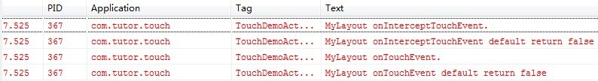
让我们继续实验，让onInterceptTouchEvent的返回值继续为false,将MyView里的onTouchEvent的返回值修改为false,即MyView里的onTouchEvent修改如下:
@Override
public boolean onTouchEvent(MotionEvent event) {
Log.e(TouchDemoActivity.TAG, "MyView onTouchEvent.");
Log.e(TouchDemoActivity.TAG,"MyView onTouchEvent default return "
+ super.onTouchEvent(event));
return false;
}
运行工程，继续点击红色区域，查看logcat，如下图:
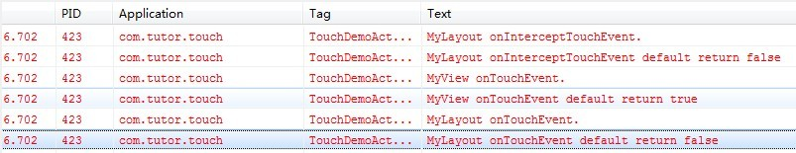
根据上图，我们可以看出MyView里的OnTouchEvent只消费了一次点击事件也就是ACTION_DOWN,还没有执行ACTION_UP,然后跑到MyLayout里又去执行了OnTouchEvent事件。
所以根据上面的内容总结如下:
ViewGroup里的onInterceptTouchEvent默认值是false这样才能把事件传给View里的onTouchEvent.
ViewGroup里的onTouchEvent默认值是false。
View里的onTouchEvent返回默认值是true.这样才能执行多次touch事件。
如果ViewGroup(比如某个layout想要做一系列事件处理)，则需要将onTouchEvent的返回值设置为true，才能做接下来的事件处理

二．代码

1.配置文件
<com.home.dockLayout.ShortcutDockLayout
xmlns:android="http://schemas.android.com/apk/res/android"
android:orientation="horizontal"
android:layout_width="fill_parent"
android:layout_height="fill_parent"
>
<RelativeLayout
android:layout_width="fill_parent"
android:layout_height="fill_parent"
android:clickable="true">
<RelativeLayout
android:layout_width="fill_parent"
android:layout_height="fill_parent">
<TextView android:layout_width="wrap_content"
android:layout_height="wrap_content"
android:id="@+id/ppt_btn_undo"
android:text="1"></TextView>
</RelativeLayout>
</RelativeLayout>

<RelativeLayout
android:layout_width="fill_parent"
android:layout_height="fill_parent"
android:clickable="true">
<TextView android:layout_width="wrap_content"
android:layout_height="wrap_content"
android:id="@+id/ppt_btn_undo"
android:text="2"
></TextView>
</RelativeLayout>
</com.home.dockLayout.ShortcutDockLayout>

2. ShortcutDockLayout

public class ShortcutDockLayout extends LinearLayout {
private static final int INVALID_SCREEN = -1;
private int mScrollingSpeed = 600;
private int mScrollingBounce = 50;
private boolean mFirstLayout = true;
private static final int SNAP_VELOCITY = 300;
private int mCurrentScreen;
private int mNextScreen = INVALID_SCREEN;
private Scroller mScroller;
private VelocityTracker mVelocityTracker;
private float mLastMotionX;
private float mLastMotionY;
private final static int TOUCH_STATE_REST = 0;
private final static int TOUCH_STATE_SCROLLING = 1;
private int mTouchState = TOUCH_STATE_REST;
private int mMaximumVelocity;
private int mTouchSlop;
public boolean isTouchable = true;

public ShortcutDockLayout(Context context, AttributeSet attrs) {
super(context, attrs);
setHapticFeedbackEnabled(false);
initWorkspace();
requestFocus();
}

private void initWorkspace() {
mScroller = new Scroller(getContext());
mCurrentScreen = 1;
final ViewConfiguration configuration = ViewConfiguration.get(getContext());
mTouchSlop = configuration.getScaledTouchSlop();
mMaximumVelocity = configuration.getScaledMaximumFlingVelocity();
}

int getCurrentScreen() {
return mCurrentScreen;
}

protected Parcelable onSaveInstanceState() {
final SavedState state = new SavedState(super.onSaveInstanceState());
state.currentScreen = mCurrentScreen;
return state;
}

@Override
protected void onRestoreInstanceState(Parcelable state) {
SavedState savedState = (SavedState) state;
super.onRestoreInstanceState(savedState.getSuperState());
if (savedState.currentScreen != -1) {
mCurrentScreen = savedState.currentScreen;
}
}

@Override
protected void onMeasure(int widthMeasureSpec, int heightMeasureSpec) {
super.onMeasure(widthMeasureSpec, heightMeasureSpec);

final int width = MeasureSpec.getSize(widthMeasureSpec);
final int widthMode = MeasureSpec.getMode(widthMeasureSpec);
if (widthMode != MeasureSpec.EXACTLY) {
// throw new IllegalStateException(
// "ShortcutDock can only be used in EXACTLY mode.");
}

final int heightMode = MeasureSpec.getMode(heightMeasureSpec);
if (heightMode != MeasureSpec.EXACTLY) {
// throw new IllegalStateException(
// "ShortcutDock can only be used in EXACTLY mode.");
}

final int count = getChildCount();
for (int i = 0; i < count; i++) {
getChildAt(i).measure(widthMeasureSpec, heightMeasureSpec);
}

if (mFirstLayout) {
setHorizontalScrollBarEnabled(false);
scrollTo(mCurrentScreen * width, 0);
mScroller.startScroll(0, 0, 0, 0, 0);
setHorizontalScrollBarEnabled(false);
mFirstLayout = false;
}
}

@Override
protected void onLayout(boolean changed, int left, int top, int right,
int bottom) {
int childLeft = 0;

final int count = getChildCount();
for (int i = 0; i < count; i++) {
final View child = getChildAt(i);
if (child.getVisibility() != View.GONE) {
final int childWidth = child.getMeasuredWidth();
child.layout(childLeft, 0, childLeft + childWidth, child.getMeasuredHeight());
childLeft += childWidth;
}
}
}

@Override
public void computeScroll() {
if (mScroller.computeScrollOffset()) {
scrollTo(mScroller.getCurrX(), mScroller.getCurrY());
postInvalidate();
} else if (mNextScreen != INVALID_SCREEN) {
mCurrentScreen = Math.max(0, Math.min(mNextScreen,getChildCount() - 1));
mNextScreen = INVALID_SCREEN;
}
}

@Override
public boolean onInterceptTouchEvent(MotionEvent ev) {
Log.e("shortcutlayout_mydock","MyLayout onInterceptTouchEvent default return "
+ super.onInterceptTouchEvent(ev));
final int action = ev.getAction();
if ((action == MotionEvent.ACTION_MOVE) && (mTouchState != TOUCH_STATE_REST)) {
return true;
}

final float x = ev.getX();
final float y = ev.getY();

switch (action) {
case MotionEvent.ACTION_MOVE:
final int xDiff = (int) Math.abs(x - mLastMotionX);
final int yDiff = (int) Math.abs(y - mLastMotionY);

final int touchSlop = mTouchSlop;
boolean xMoved = xDiff > touchSlop;
boolean yMoved = yDiff > touchSlop;
if (xMoved || yMoved) {
if (xDiff > yDiff) {
mTouchState = TOUCH_STATE_SCROLLING;
}
}
break;

case MotionEvent.ACTION_DOWN:
mLastMotionX = x;
mLastMotionY = y;

mTouchState = mScroller.isFinished() ? TOUCH_STATE_REST : TOUCH_STATE_SCROLLING;
break;

case MotionEvent.ACTION_CANCEL:
case MotionEvent.ACTION_UP:
mTouchState = TOUCH_STATE_REST;
break;
}
Log.e("shortcutlayout_mydock",
"" + (mTouchState != TOUCH_STATE_REST));
return mTouchState != TOUCH_STATE_REST;
}

@Override
public boolean onTouchEvent(MotionEvent ev) {
Log.e("shortcutlayout","MyLayout onTouchEvent default return "
+ super.onTouchEvent(ev));
if(isTouchable==false) return true;
if (mVelocityTracker == null) {
mVelocityTracker = VelocityTracker.obtain();
}
mVelocityTracker.addMovement(ev);

final int action = ev.getAction();
final float x = ev.getX();

switch (action) {
case MotionEvent.ACTION_DOWN:
if (!mScroller.isFinished()) {
mScroller.abortAnimation();
}
mLastMotionX = x;
break;
case MotionEvent.ACTION_MOVE:
if (mTouchState == TOUCH_STATE_SCROLLING) {
final int deltaX = (int) (mLastMotionX - x);
mLastMotionX = x;
int tScrollX = getScrollX();

if (deltaX < 0) {
if (tScrollX > -mScrollingBounce) {
scrollBy(Math.min(deltaX, mScrollingBounce), 0);
}
} else if (deltaX > 0) {
final int availableToScroll = getChildAt(getChildCount() - 1).getRight() - tScrollX - getWidth() + mScrollingBounce;
if (availableToScroll > 0) {
scrollBy(deltaX, 0);
}
}
}
break;
case MotionEvent.ACTION_UP:
if (mTouchState == TOUCH_STATE_SCROLLING) {
final VelocityTracker velocityTracker = mVelocityTracker;
velocityTracker.computeCurrentVelocity(1000, mMaximumVelocity);
int velocityX = (int) velocityTracker.getXVelocity();

if (velocityX > SNAP_VELOCITY && mCurrentScreen > 0) {
snapToScreen(mCurrentScreen - 1);
} else if (velocityX < -SNAP_VELOCITY && mCurrentScreen < getChildCount() - 1) {
snapToScreen(mCurrentScreen + 1);
} else {
snapToDestination();
}

if (mVelocityTracker != null) {
mVelocityTracker.recycle();
mVelocityTracker = null;
}
}
mTouchState = TOUCH_STATE_REST;
break;
case MotionEvent.ACTION_CANCEL:
mTouchState = TOUCH_STATE_REST;
break;
}
return true;
}

private void snapToDestination() {
final int screenWidth = getWidth();
final int whichScreen = (getScrollX() + (screenWidth / 2)) / screenWidth;

snapToScreen(whichScreen);
}

void snapToScreen(int whichScreen) {
System.out.println("my=" + getChildCount());
whichScreen = Math.max(0, Math.min(whichScreen, getChildCount() - 1));
boolean changingScreens = whichScreen != mCurrentScreen;

mNextScreen = whichScreen;

View focusedChild = getFocusedChild();
if (focusedChild != null && changingScreens && focusedChild == getChildAt(mCurrentScreen)) {
focusedChild.clearFocus();
}

final int screenDelta = Math.abs(whichScreen - mCurrentScreen);
int durationOffset = 1;
if (screenDelta == 0) {
durationOffset = 400;
}
final int duration = mScrollingSpeed + durationOffset;
final int newX = whichScreen * getWidth();
final int delta = newX - getScrollX();

mScroller.startScroll(getScrollX(), 0, delta, 0, duration);
invalidate();
}

public void moveNext(){
mScroller.startScroll(getScrollX(), 0, getWidth(), 0, 600);
invalidate();
}

public void moveBefore(){
mScroller.startScroll(getScrollX(), 0, -getWidth(), 0, 600);
invalidate();
}

public static class SavedState extends BaseSavedState {
int currentScreen = -1;

SavedState(Parcelable superState) {
super(superState);
}

private SavedState(Parcel in) {
super(in);
currentScreen = in.readInt();
}

@Override
public void writeToParcel(Parcel out, int flags) {
super.writeToParcel(out, flags);
out.writeInt(currentScreen);
}

public static final Parcelable.Creator<SavedState> CREATOR = new Parcelable.Creator<SavedState>() {
public SavedState createFromParcel(Parcel in) {
return new SavedState(in);
}

public SavedState[] newArray(int size) {
return new SavedState[size];
}
};
}
}

