Udemy: Technical Writing: How to Write Software Documentation

Exercise 1: Writing Functional Documentation

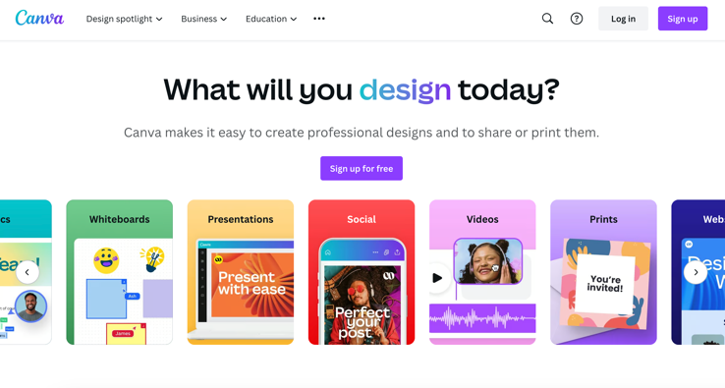Canva

Using your favorite search engine, go to

www.canva.com. Once on the site, click the purple “Sign up for free” button to create an account.

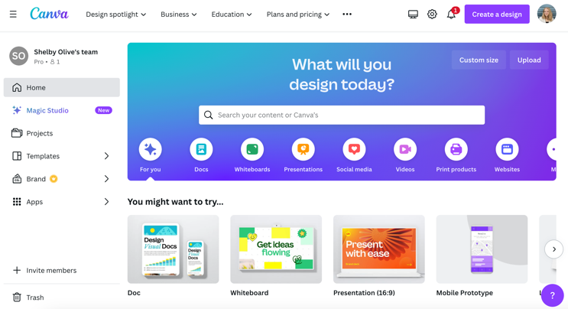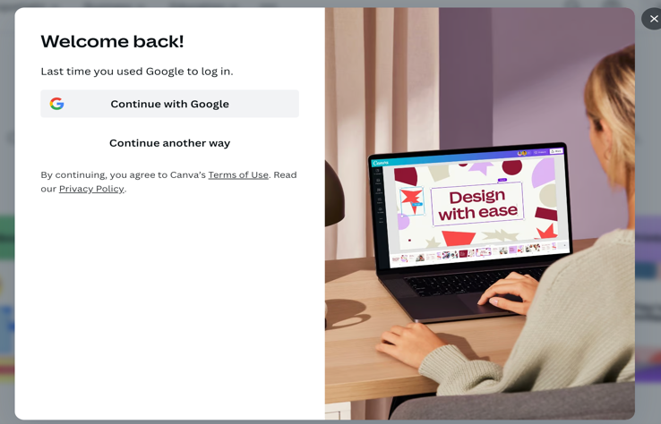If you have a Google account, use “Continue with Google” to easily create a Canva account with your Gmail. Otherwise, click the “continue another way” button to use your email of choice.

Once you have an account, you will have full access to the Canva homepage. From here you can view past projects, add team members, or create new pieces. To design something new, you can either click one of the icons to use a template, click the purple “Create a design” button to add custom dimensions to a blank slate, or type in the search bar for references.

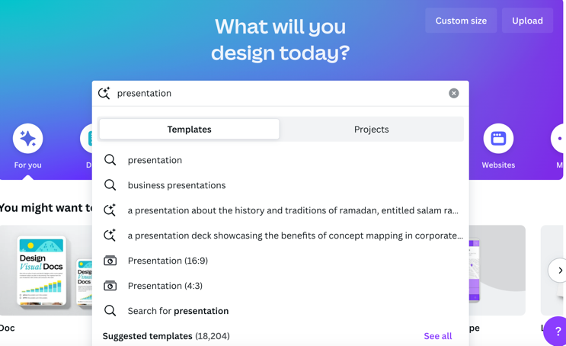

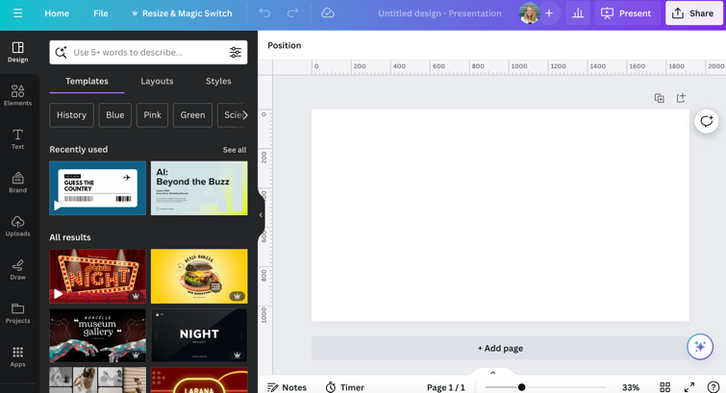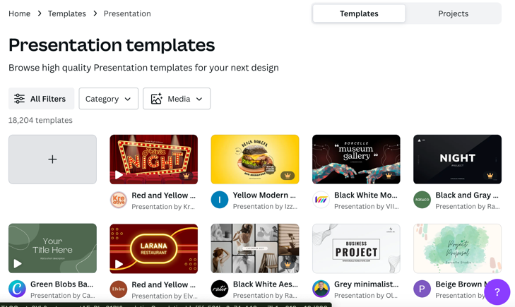Let’s say you want to make a presentation. Typing in the search bar for “presentation”, Canva will show you templates for pre-made designs or offer you a blank option.

While Canva has lots of great choices for pre-made content, let’s assume you want to create a presentation from scratch. For that, you would click the gray “+” square to go to a blank document editor.

In the editor, you can use the channel menu to add templates (design), graphics (elements), text, branded content, uploads, drawn content, merge other projects, or apps for AI generation. Add another slide with the “+ Add page” and give your work a title by clicking “untitled design” and changing the words. Happy Editing!