Udemy: Technical Writing: How to Write Software Documentation

Technical Writing Exercise: Task Oriented Documentation

Notes App

Let’s say that you are planning a trip to your local grocery store. In order to minimize time spent browsing the aisles, you might want to make a list for the items you need. This list can be created in your Notes app.

This tutorial is designed for Macbook users. To find Notes, go to your Finder at the bottom of your screen. Your applications may look different from mine, but Notes, which comes pre-installed on all Apple devices, should be there.



If you don’t see Notes on your Finder, go to the top of your screen and select the magnifying glass icon.



From here, you can manually search for Notes by typing “notes” into the search bar. Click on the yellow and white notebook icon to launch the application.

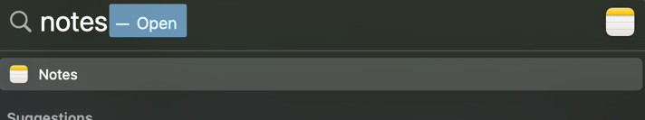

Now that you’re in Notes, let’s create a grocery list.

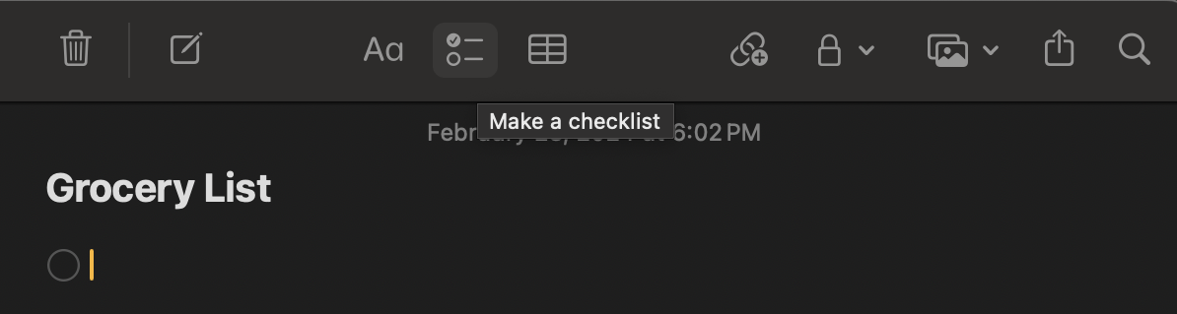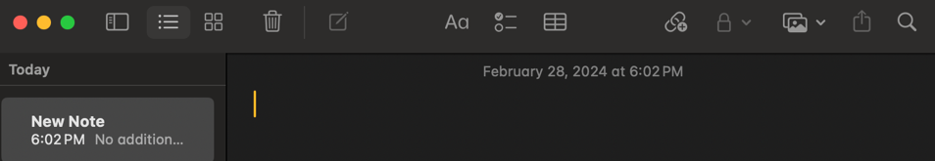First: To create a new note, select the square icon with a pencil in the upper right-hand corner. This will make a blank page.

Second: Give your note a title by typing in the blank space.

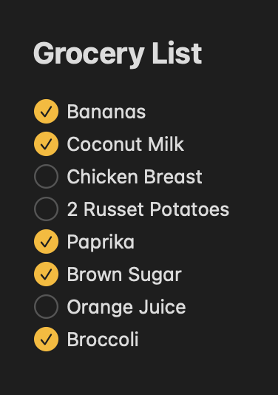Third: Select the checklist icon to add a checklist to your note.

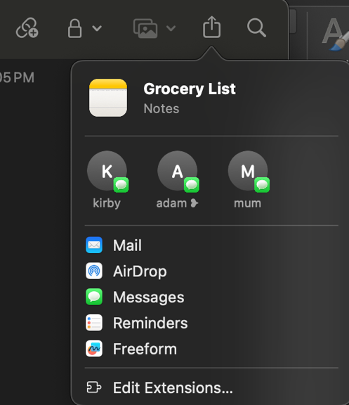

Once your note is finalized, you can send the note to your phone by selecting the share button on your Notes menu bar. You can airdrop it to your phone or text it to your roommate and have them shop for you instead!

With a checklistyour

Grocery

List could

look

like this: