COCA-COLA BEVERAGES PAKISTAN LIMITED
Smart Cooler Monitoring System

Comprehensive Reference Document
Plants | Zones | Distribution | Refrigerator Placement

Prepared for:
Final Year Project — Computer Science Department

Version 1.0 | April 2026

CONFIDENTIAL — FOR ACADEMIC USE ONLY

1. Company Overview
Coca-Cola Beverages Pakistan Limited (CCBPL) is the exclusive bottler and distributor of The Coca-Cola Company's products in Pakistan. Established in 1996, CCBPL is a subsidiary of Coca-Cola İçecek (CCI), a Turkey-based international bottler and the sixth-largest Coca-Cola bottler globally. CCI holds 48% shares of CCBPL with full management control.
Coca-Cola first entered the Pakistani market in 1953, with the inaugural plant established in Karachi. Over the following decades, the bottling operations expanded through independent franchisees before being consolidated under CCBPL. In 2010, CCI acquired CCBPL's shares and management rights, transforming the company into a wholly integrated modern beverage operation.

1.1 Corporate Snapshot
Parameter | Details
Company Name | Coca-Cola Beverages Pakistan Limited (CCBPL)
Parent Company | Coca-Cola İçecek (CCI), Turkey
Founded in Pakistan | 1953 (operations); 1996 (CCBPL incorporated)
Headquarters | Lahore, Punjab, Pakistan
No. of Factories | 7 Bottling Plants across Pakistan
No. of Warehouses | 13+ Regional Warehouses
Retail Outlets Served | 1.2 Million+ Retailers Nationwide
Total Employees | 2,500+ Direct Employees
Market Share | 35–38% of Carbonated Beverage Market
Product Brands | Coca-Cola, Sprite, Fanta, Coke Zero, Sprite Zero, Sprite Lemon Mint, Dasani, Cappy Joosi, Kinley

2. Coca-Cola Bottling Plants in Pakistan
CCBPL currently operates 7 state-of-the-art bottling plants strategically located across Pakistan. These plants collectively serve more than 240 million Pakistanis and produce a wide range of sparkling and still beverages. Each plant is equipped with high-speed production lines, advanced quality control systems, and dedicated warehouse facilities.

2.1 Plant Locations & Profiles
# | Plant Location | Province | Year Est. | Investment (USD) | Capacity (Units/yr) | Key Coverage Area
1 | Karachi | Sindh | 1953 (Original) | ~$80M (refurb.) | High Capacity | Karachi Metro, Lower Sindh, Balochistan Coast
2 | Lahore | Punjab | 1960s | ~$50M (refurb.) | 36,000 units/hr | Central & Urban Punjab, AJK
3 | Multan | Punjab | 2016 (New) | $70 Million | Very High Capacity | South & North Punjab, Upper Sindh
4 | Gujranwala | Punjab | 1980s | ~$40M (refurb.) | Moderate-High | Northern Punjab, Sialkot Belt
5 | Faisalabad | Punjab | 2018 (New) | $45 Million | 100M units/yr | Central Punjab Industrial Belt
6 | Rahimyar Khan | Punjab | 2000s | ~$30M (refurb.) | Moderate | Southern Punjab, Bahawalpur Division
7 | Haripur | KPK | 2022 (New) | $50 Million | High Capacity | KPK, FATA, Islamabad, Northern Areas

Note: Historical plants in Hyderabad, Sialkot, Rawalpindi and Peshawar were operational under earlier franchise arrangements. Capacity figures for older plants represent post-refurbishment estimates. The Multan and Haripur plants are the newest and most technologically advanced facilities.

2.2 Plant-wise Product Portfolio
All seven plants manufacture the core Coca-Cola product range. However, certain plants specialise in specific SKUs (Stock Keeping Units) based on regional demand and production-line configurations:
- Karachi Plant: Full range — PET bottles, glass bottles, cans; Dasani water
- Lahore Plant: Full sparkling range; glass returnable bottles; Cappy Joosi
- Multan Plant: All sparkling beverages; PET focus; large-pack family sizes
- Faisalabad Plant: Sparkling beverages; steel cans manufacturing; 1.5L & 2.25L PET
- Gujranwala Plant: Sprite Lemon Mint; core sparkling SKUs; Coke Zero
- Rahimyar Khan Plant: Core sparkling beverages; regional distribution focus
- Haripur Plant: Full sparkling portfolio; Dasani; northern market specialisation

3. Geographical Zones & Distribution Regions
CCBPL divides Pakistan's market into five major operational zones aligned with administrative provinces and commercial geography. Each zone is managed by a Regional Business Manager (RBM) supported by Area Sales Managers (ASMs), Territory Development Officers (TDOs), and field sales representatives.

3.1 Zone Overview Table
Zone | Provinces Covered | Supplying Plant(s) | Districts | Retail Outlets (Est.) | Key Cities
Zone 1 — Karachi | Sindh (South) | Karachi | 7 | ~300,000 | Karachi, Hyderabad, Thatta, Mirpurkhas
Zone 2 — Lahore | Central Punjab | Lahore, Gujranwala | 12 | ~280,000 | Lahore, Gujranwala, Sialkot, Sheikhupura, Narowal
Zone 3 — Multan | South Punjab | Multan, Rahimyar Khan | 11 | ~240,000 | Multan, Bahawalpur, Rahim Yar Khan, DG Khan, Sahiwal
Zone 4 — Faisalabad | North/Central Punjab | Faisalabad, Lahore | 9 | ~200,000 | Faisalabad, Sargodha, Jhang, Chiniot, Toba Tek Singh
Zone 5 — North | KPK, FATA, Islamabad, AJK, GB | Haripur, Lahore | 15+ | ~180,000 | Islamabad, Rawalpindi, Peshawar, Abbottabad, Haripur, Gilgit, Swat

3.2 Zone 1 — Karachi (South Zone)
Karachi is the largest commercial hub of Pakistan and represents CCBPL's single most important market. The zone is supplied primarily from the Karachi plant, with supplementary stock from Multan during peak seasons.
- Sub-Zones: Central Karachi, East Karachi, West Karachi, North Karachi, District East, District South
- Key Retail Channels: Supermarkets, superstores (Carrefour, Imtiaz, HKB), hotels, restaurants, fast food chains, kiosks
- Total Distributors: ~45 primary distributors, 160+ secondary wholesalers
- Cold Equipment Deployed: ~18,000 branded refrigerators & coolers

3.3 Zone 2 — Lahore (Central Punjab Zone)
Lahore Zone covers the heartland of Pakistan's Punjab province, accounting for a significant share of CCBPL's total revenue. The Lahore plant is the primary supplier, with the Gujranwala plant serving the northern districts.
- Sub-Zones: Lahore City, Lahore East, Lahore West, Gujranwala City, Sialkot Belt, Sheikhupura
- Key Retail Channels: Modern trade, traditional kiryana stores, canteens, educational institutions, petrol stations
- Total Distributors: ~38 primary distributors, 130+ secondary wholesalers
- Cold Equipment Deployed: ~16,000 branded refrigerators & coolers

3.4 Zone 3 — Multan (South Punjab Zone)
The South Punjab Zone spans a vast agricultural and semi-urban region. The recently commissioned Multan plant significantly boosted capacity and delivery speed in this zone. This zone also overlaps into upper Sindh for market coverage.
- Sub-Zones: Multan City, Bahawalpur, DG Khan, Rahim Yar Khan, Sahiwal
- Key Retail Channels: General stores, wholesale markets, truck stops, agricultural markets (mandis)
- Total Distributors: ~30 primary distributors, 90+ secondary wholesalers
- Cold Equipment Deployed: ~13,000 branded refrigerators & coolers

3.5 Zone 4 — Faisalabad (North-Central Punjab Zone)
Faisalabad is Pakistan's industrial capital and hosts a dense population of factory workers, traders and businesses. The newly commissioned Faisalabad plant adds 100 million units per year to this zone's supply chain.
- Sub-Zones: Faisalabad City, Sargodha, Jhang, Chiniot, Toba Tek Singh, Mianwali
- Key Retail Channels: Industrial canteens, street kiosks, markets, transportation hubs
- Total Distributors: ~28 primary distributors, 80+ secondary wholesalers
- Cold Equipment Deployed: ~11,000 branded refrigerators & coolers

3.6 Zone 5 — Northern Zone (KPK, FATA, Islamabad & AJK)
The Northern Zone covers Pakistan's most geographically diverse territory, from Islamabad's modern urban environment to the remote valleys of Gilgit-Baltistan. The Haripur plant (commissioned 2022) is purpose-built to serve this zone's unique logistical challenges.
- Sub-Zones: Islamabad/Rawalpindi, Peshawar, Abbottabad/Hazara, Swat Valley, FATA, AJK, Gilgit-Baltistan
- Key Retail Channels: Hotels, tourist spots, military canteens, government institutions, bazaars
- Total Distributors: ~25 primary distributors, 70+ secondary wholesalers
- Cold Equipment Deployed: ~9,000 branded refrigerators & coolers

4. Distribution Network & Supply Chain
CCBPL operates a multi-tier distribution model designed to ensure product availability at every retail touchpoint across the country — from large supermarkets to small roadside kiosks (panwalas). The distribution system is divided into three tiers: Primary, Secondary, and Tertiary.

4.1 Distribution Tiers

Tier 1 — Plant to Distributor (Primary Distribution)
CCBPL's own fleet of heavy trucks and tankers transports finished goods in bulk from the manufacturing plants to licensed primary distributors. Each distributor holds a territory-exclusive contract. Deliveries typically occur 2–3 times per week per distributor depot.
- Fleet Type: 20-ton container trucks, refrigerated vehicles for sensitive stock
- Route Frequency: Scheduled routes with GPS-tracked vehicles
- Key Performance Indicator: On-Time In-Full (OTIF) delivery rate target: 95%+

Tier 2 — Distributor to Wholesaler / Large Retailer (Secondary Distribution)
Primary distributors dispatch smaller vehicles to reach wholesalers, large grocery chains, restaurants, and fast-food franchises. Distributors maintain their own warehouses and fleet of 5-ton trucks and pick-ups.
- Vehicle Types: Suzuki Ravi pickups, 5-ton mini-trucks, motorbike trolleys
- Order Cycle: Typically 2–4 times per week per retailer depending on sales volume
- Credit Policy: Selective credit extended to high-volume retailers (30-day terms)

Tier 3 — Wholesaler to Retailer (Tertiary Distribution)
For areas with poor road access or very small purchase volumes, CCBPL relies on 77–160 secondary wholesalers per major city who distribute products further into small kiryana stores, panwalas and informal markets.
- Coverage: Slum areas, rural villages, narrow-lane bazaars, temporary markets
- Method: Handcart delivery, motorcycle distribution, local market drop-off
- Role: Bridge the gap between formal distribution and last-mile access

4.2 Distribution Hierarchy — Organizational Structure
Level | Role | Responsibility
National Sales Director | Head of all commercial operations | National strategy, key accounts, P&L oversight
Regional Business Manager (RBM) | 5 RBMs (one per zone) | Zone-level sales targets, distributor management
Area Sales Manager (ASM) | 2–4 per zone (city/district level) | Sub-zone targets, route planning, retailer activation
Territory Development Officer (TDO) | 5–10 per area | Daily market visits, cold equipment monitoring, order taking
Primary Distributor | ~166 nationwide | Receives bulk stock, secondary distribution, warehouse management
Secondary Wholesaler | 500+ nationwide | Last-mile distribution in low-access areas
Retailer / Outlet | 1.2 Million+ nationwide | Point of sale to end consumer

5. Branded Refrigerator Placement & Management
One of CCBPL's most significant capital investments in the retail market is its fleet of branded refrigeration equipment — commonly known as 'Cold Assets' or 'Coolers.' These refrigerators are provided free of charge to qualifying retailers as part of CCBPL's Cold Drink Equipment (CDE) programme, which ensures that Coca-Cola products are always served chilled — a critical driver of impulse purchase behavior.

5.1 Cold Drink Equipment (CDE) Programme
The CDE Programme is governed by a contractual agreement between CCBPL and the retailer. Key terms include:
- Ownership: Refrigerators remain the property of CCBPL at all times
- Placement Condition: The cooler must contain ONLY Coca-Cola branded products (Pure CCBPL outlet = 100% Coke products)
- Maintenance: CCBPL provides free maintenance and technical support through authorised service partners
- Electricity Cost: Borne by the retailer
- Eligibility: Retailers with minimum monthly sales volume of 5 cases per day
- Contract Term: Typically 1–3 years, renewable based on performance

5.2 Refrigerator Types Deployed
Model Type | Capacity | Power (Watts) | Target Outlet | Estimated Units | Temperature Range
Visi-Cooler (Small) | 120–180 Litres | 100–130W | Kiryana / Panwala | ~30,000 | 2°C – 8°C
Visi-Cooler (Medium) | 250–350 Litres | 200–250W | General Store / Canteen | ~22,000 | 2°C – 8°C
Visi-Cooler (Large) | 450–600 Litres | 350–400W | Supermarket / Hotel | ~10,000 | 1°C – 6°C
Island Cooler (Open Top) | 600–900 Litres | 500–700W | Superstore / HoReCa | ~3,500 | 0°C – 5°C
Chest Freezer / Display | 300–500 Litres | 250–350W | High-volume outlets | ~2,000 | -2°C – 4°C

5.3 Zone-wise Cold Equipment Deployment
Zone | Total Coolers | Small Visi | Medium Visi | Large Visi | Island/Chest
Zone 1 — Karachi | ~18,000 | ~8,500 | ~6,000 | ~2,500 | ~1,000
Zone 2 — Lahore | ~16,000 | ~7,500 | ~5,500 | ~2,000 | ~1,000
Zone 3 — Multan | ~13,000 | ~6,500 | ~4,500 | ~1,500 | ~500
Zone 4 — Faisalabad | ~11,000 | ~5,500 | ~3,800 | ~1,200 | ~500
Zone 5 — Northern | ~9,000 | ~4,000 | ~3,200 | ~1,300 | ~500
TOTAL NATIONWIDE | ~67,000 | ~32,000 | ~23,000 | ~8,500 | ~3,500

6. Need for Smart Cooler Monitoring System
With approximately 67,000+ branded refrigerators spread across five zones and 1.2 million retail outlets, manual monitoring of cold assets poses enormous operational, financial and quality challenges for CCBPL.

6.1 Current Challenges
Challenge Area | Current Problem | Business Impact
Temperature Control | No real-time temperature alerts | Product spoilage, consumer complaints
Power Monitoring | Power failures undetected for hours/days | Warm products, lost sales opportunity
Maintenance | Reactive — only fixed after complaint | Extended downtime, high repair costs
Energy Consumption | No energy data per unit | Cannot identify inefficient units
Asset Location | Coolers moved without authorisation | Asset loss, compliance breach
Zone-wise Visibility | No centralised dashboard | Poor management decisions
Competitor Compliance | Cannot verify 100% Coke exclusivity | Brand dilution, contractual breach

6.2 Proposed Smart Monitoring Solution
The Smart Refrigerator Monitoring & Analytics System addresses each challenge by deploying IoT sensors on all branded refrigerators, feeding real-time data to a centralised Node.js/MongoDB backend, and displaying insights through a React.js dashboard accessible to management at all levels.
- Real-time temperature, humidity, power status and energy alerts
- Zone-wise and plant-wise performance dashboards
- Predictive maintenance alerts based on performance trends
- Asset tracking and compliance monitoring
- Historical analytics for operational optimisation

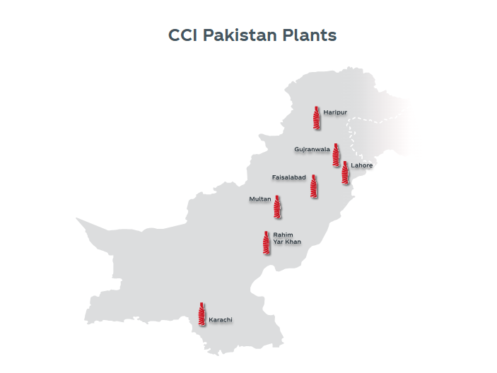
6.3 Coca Cola Distributer Plants in Pakistan

7. Distributor Profiles & Refrigerator Allocation
CCBPL's primary distributors are the backbone of the cold asset management chain. Each distributor is responsible not only for product delivery but also for basic first-level maintenance of cold equipment placed within their territory. Distributors coordinate with CCBPL's Cold Asset Management team for repairs and replacements.

7.1 Typical Distributor Profile
Attribute | Description
Business Type | Private Limited Company or Sole Proprietor
Territory | 1–3 Union Councils or sub-city sectors
Outlets Served | 200 – 2,000 retail outlets
Fleet Size | 2 – 15 vehicles (trucks + pickups)
Warehouse | Minimum 2,000 sq ft CCBPL-approved facility
Refrigerators Managed | 50 – 600 branded coolers per distributor territory
Reporting Frequency | Daily sales reporting via CCBPL's distributor management system
Security Deposit | PKR 500,000 – 5,000,000 (based on territory size)

7.2 Sample Distributor — Zone-wise Mapping
Zone | Sample Distributor Territory | Approximate Outlets | Coolers Placed | Trucks | Pickups
Zone 1 | Gulshan-e-Iqbal, Karachi | 1,200 | 320 | 3 | 8
Zone 1 | SITE Industrial Area, Karachi | 800 | 210 | 2 | 6
Zone 2 | DHA / Gulberg, Lahore | 900 | 280 | 2 | 7
Zone 2 | Gujranwala City North | 600 | 180 | 2 | 5
Zone 3 | Multan Cantt & Shah Rukn-e-Alam | 750 | 200 | 2 | 5
Zone 4 | Faisalabad D-Ground & Ghanta Ghar | 1,000 | 260 | 2 | 7
Zone 5 | G-10 / I-8, Islamabad | 500 | 150 | 1 | 4

8. Smart Monitoring System — Data Reference for MVP
The following data tables provide realistic seeded data for the Smart Cooler Monitoring System's development, testing, and demonstration phases. These values reflect CCBPL's operational context and should be used to populate the MongoDB database during system setup.

8.1 Sample Refrigerator Data (System Seed Data)
Ref ID | Zone | Distributor | Store Type | Temp (°C) | Power Status | Status
REF-KHI-001 | Zone 1 — Karachi | Gulshan Dist. | Supermarket | 4.2°C | ON | Working
REF-KHI-047 | Zone 1 — Karachi | SITE Dist. | Restaurant | 9.8°C | ON | Warning
REF-KHI-093 | Zone 1 — Karachi | Clifton Dist. | Kiryana | N/A | OFF | Faulty
REF-LHR-012 | Zone 2 — Lahore | DHA Dist. | Fast Food | 3.5°C | ON | Working
REF-LHR-078 | Zone 2 — Lahore | Gulberg Dist. | Hotel | 11.2°C | ON | Faulty
REF-MLT-005 | Zone 3 — Multan | Cantt Dist. | General Store | 5.1°C | ON | Working
REF-FSD-022 | Zone 4 — Faisalabad | D-Ground Dist. | Canteen | 6.3°C | ON | Working
REF-ISB-011 | Zone 5 — North | G-10 Dist. | Petrol Station | 4.9°C | ON | Working
REF-ISB-034 | Zone 5 — North | I-8 Dist. | School Canteen | N/A | OFF | Power Off

8.2 Alert Types & Thresholds
Alert Type | Trigger Condition | Severity | Recommended Action
High Temperature | Temp > 10°C for > 15 mins | Critical | Alert TDO immediately; dispatch technician
Warning Temperature | Temp 8°C – 10°C | Medium | Monitor; notify distributor
Power Off | No power signal for > 5 mins | Critical | Notify retailer; check outage zone
High Energy | Consumption > 1.5x monthly average | Low | Schedule preventive maintenance
Door Open | Door open > 10 mins continuously | Low | Notify retailer via SMS/app
Sensor Offline | No data for > 1 hour | Medium | Check connectivity; re-pair sensor

9. UML Diagrams

9.1 System Architecture Diagram

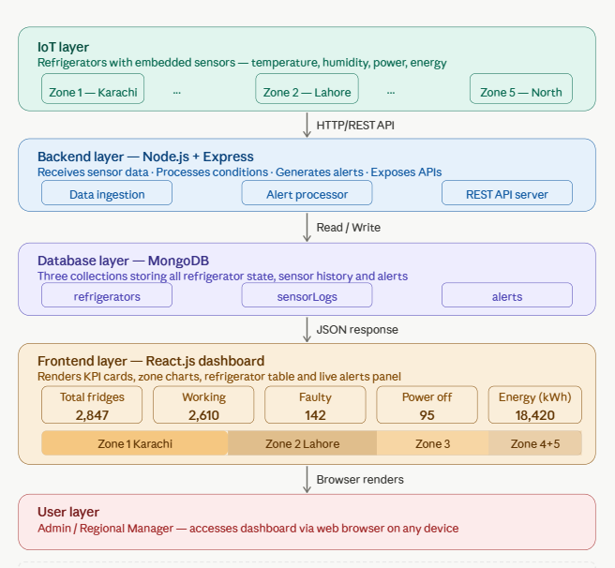

9.2 Data Flow Diagram

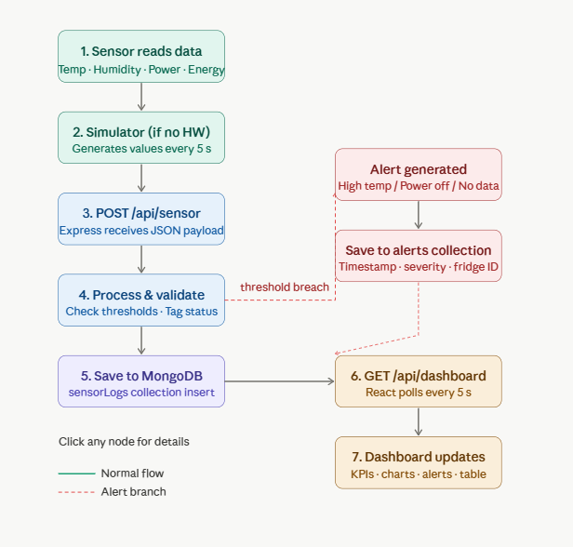

9.3 Use Case Diagram:

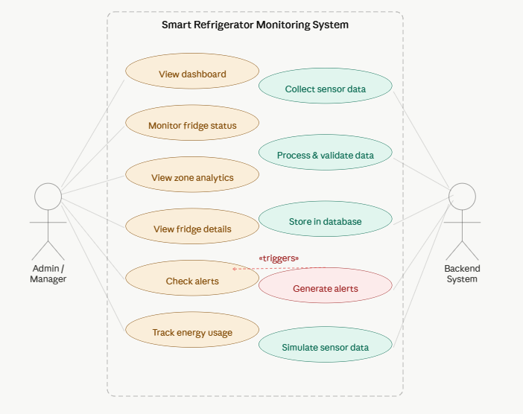

10. Dashboard Features
The Smart Refrigerator Monitoring Dashboard provides centralized monitoring, analytics, and control of all distributed refrigeration units across Pakistan. The system includes the following core features:

1. Global System Overview
- Displays total number of refrigerators
- Shows count of working, faulty, and powered-off units
- Displays total energy consumption of all units

2. Real-Time Sensor Monitoring
- Temperature and humidity readings for each refrigerator
- Power status (ON/OFF) monitoring
- Energy consumption tracking per unit
- Live or near real-time data updates from IoT sensors

3. Zone-wise Analytics
- Categorization of refrigerators by geographical zones
- Zone-level statistics including:
  - Total units
  - Working units
  - Faulty units
  - Power status distribution
  - Energy consumption per zone

4. Data Visualization
- Graphical representation of system data
- Includes:
  - Zone-wise comparison charts
  - Status distribution (working/faulty/off) charts

5. Refrigerator Inventory Management
- List of all refrigerators with detailed information:
  - Unique ID
  - Location and zone
  - Current temperature and humidity
  - Operational status
- Tabular view for easy monitoring

6. Search and Filtering
- Search functionality by refrigerator ID
- Filtering by zone and operational status

7. Alert Management System
- Automated alerts for abnormal conditions such as:
  - High temperature
  - Device malfunction or failure
  - Power disconnection
- Centralized alert history tracking

8. Detailed Refrigerator View
- Individual refrigerator monitoring page
- Displays complete sensor readings and status history

9. Energy Monitoring
- Real-time tracking of energy consumption
- Zone-wise and unit-wise energy usage analysis

10. Real-Time Data Updates
- Continuous data refresh from sensors or simulated data sources
- Ensures up-to-date system monitoring

11. Conclusion
Coca-Cola Beverages Pakistan Limited operates one of the most extensive beverage distribution networks in South Asia. With 7 manufacturing plants, 5 major operational zones, approximately 166+ primary distributors, and over 67,000 branded refrigerators placed across 1.2 million retail outlets, CCBPL's cold chain management requirements are immense.
The implementation of a Smart Cooler Monitoring & Analytics System is not merely a technological upgrade — it is a strategic business necessity. Real-time IoT monitoring will enable CCBPL to reduce product spoilage, cut energy costs, extend equipment lifespan, improve distributor performance, and deliver better consumer experiences at every retail touch point across Pakistan.
This document provides the factual, organizational and operational foundation upon which the proposed final year project system is designed and validated.

References & Data Sources
- Coca-Cola Pakistan Official Website: www.coca-cola.com/pk
- Coca-Cola İçecek (CCI) Corporate Website: www.cci.com.tr
- The Express Tribune — CCBPL Plant Inaugurations (2013, 2016, 2018, 2021)
- Business Recorder — CCI Pakistan KPK Plant Announcement (June 2021)
- Ravi Magazine — Sales Practices at CCBPL (2017)
- CCBPL About Page (Rozee.pk Company Profile)
- Scribd: Coca-Cola Product Line in Pakistan

This document is prepared for academic research and final year project purposes only. All operational figures are estimated based on publicly available information and industry benchmarks.

