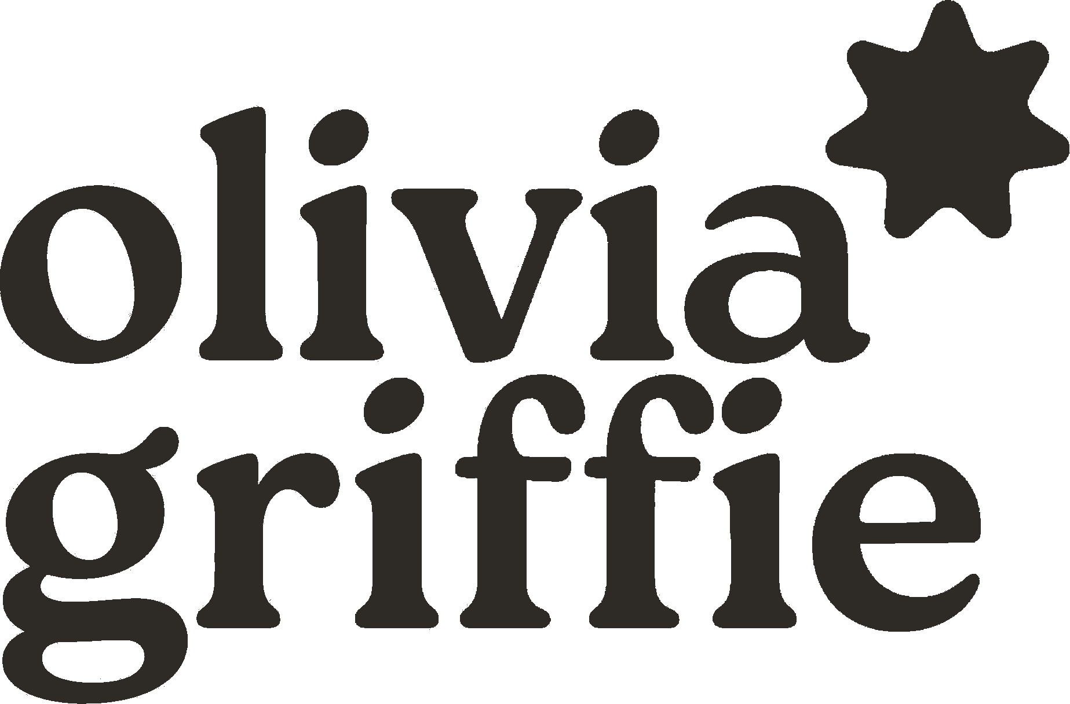  graphic designer · ux & ui designer | 434.610.4833  oewheless@gmail.com  Lynchburg, VA 24502  oliviagriffie.com  dribbble.com/olivia-griffie  linkedin / olivia-griffie  https://github.com/olivia-griffie
about me
Designer with 10+ years of experience in print and UX/UI design with a passion for layout, illustration, and clean function. Deeply versed in marketing, production, website design, corporate identity, product packaging, advertisements, and multimedia design. Seeking a remote role where I can bring versatility, genuine curiosity, and a willingness to grow into any new skill, language, or program the work calls for.
experience
UX & UI Designer · Devia Software, LLC Oct 2023 – Mar 2026
- Designed wireframes for 20+ eCommerce clients, collaborating directly to define UX strategy and visual direction — resulting in faster approvals and fewer revision cycles
- Built and customized variable print forms using Infigo Print Platform (Invent & MegaEdit), improving production efficiency by 30%
- Developed and maintained front-end code using JavaScript, CSHTML, HTML, and CSS for improved site performance, responsiveness, and usability
- Assisted in MIS system integrations that streamlined order processing and reduced manual data entry and errors
- Served as primary point of contact for design communication with 20+ clients, maintaining high satisfaction and repeat business
- Created and managed HubSpot marketing campaigns to improve engagement and tracking accuracy
- Collected and analyzed performance and customer data to support design decisions and marketing optimization
- Provided IT support and troubleshooting across design and production systems, minimizing client downtime
Lead Graphic Designer · Boone Graphics, LLC Mar 2021 – Aug 2023
- Designed logos and brand collateral for 100+ clients across print and digital marketing
- Managed multiple client accounts — overseeing workflows, quoting, and billing — while maintaining on-time delivery for 95%+ of projects
- Created direct mail and publication layouts distributed to 10,000+ recipients
- Supported national/franchise brands including Keller Williams, Duck Donuts, and Planet Fitness under tight deadlines
- Primary driver of reduced production errors through rigorous prepress and proofing for high-volume print jobs
Graphic Designer · Bright Images Media Oct 2019 – Mar 2021
- Collaborated with clients to resolve design needs and maintain strong working relationships
- Produced digital and print proofs ensuring quality and client approval
- Operated, maintained, and repaired large-format printers and bindery equipment
- Used Adobe InDesign, Illustrator, and Photoshop daily for print-ready designs
Graphic Design Intern · Liberty University – Print and Mailing Aug – Oct 2019
- Created and distributed digital proofs ensuring branding and print specifications
- Coordinated with marketing on sizing, bleed, and production requirements
- Prepared files using SmartStream Designer, document imposition, and print uploads
Student Graphic Designer · Liberty University – Beacon of Hope Aug 2017 – Oct 2018
- Designed newsletters, invitations, and donor communications
- Created print-ready layouts using Adobe InDesign
programs & tools
Adobe Suite | Photoshop, Illustrator, InDesign, Acrobat — 10+ yrs
Microsoft Office | Excel, Word, PowerPoint — 10+ yrs
Canva | 5+ years
Figma | 3 years
VS Code | 3 years
Infigo | Invent & MegaEdit — 3 years
HubSpot | 3 years
QuickBooks | 3 years
GitHub / Beanstalk | 3 years
skills
Graphic Design | Desktop publishing — 10+ years
Web Development | CSS, HTML, CSHTML, JavaScript — 3 years
UX / UI Design | 3 years
Web-to-Print | 3 years
Prepress & Proofing | 3 years
eCommerce | Design & administration — 3 years
Attention to Detail | Creativity & precision — 10+ years
education & certifications
B.S. Graphic Design · Liberty University · 2019
Google UX Design Professional Certificate · Google / Coursera
references
Celia Turzai · celiaturzai@devia.com
Gentry Deines · gentrydeines@devia.com

