Table 1. Table with most relevant key terms and the definitions/interpretations used throughout this documentation.
Key Term | Definition
moral agent | an entity that makes a decision, or carries out an action, that influences the outcome in a morally-salient scenario.
moral victim/patient | an entity that is the recipient or target of a moral decision/act/inaction in a morally-salient scenario
moral decision-making | the process where a moral agent makes a decision that influences the outcome in a morally-salient scenario, such as deciding whether to carry out a certain action or not.
moral agency | the capacity for an entity to be a moral agent; to discern right from wrong, make moral decisions, and be held morally judged for these decisions/(in)actions.
moral judgement | an evaluation or assessment, typically by a third-party, of a moral agent's decision or (in)action and its impact on the moral victim(s) in a morally-salient scenario.
moral permissibility | a specific type of moral judgement that assesses whether a moral agent's decision or (in)action in a morally-salient scenario can be considered permissible (or not) within a given moral framework.

Figure 1
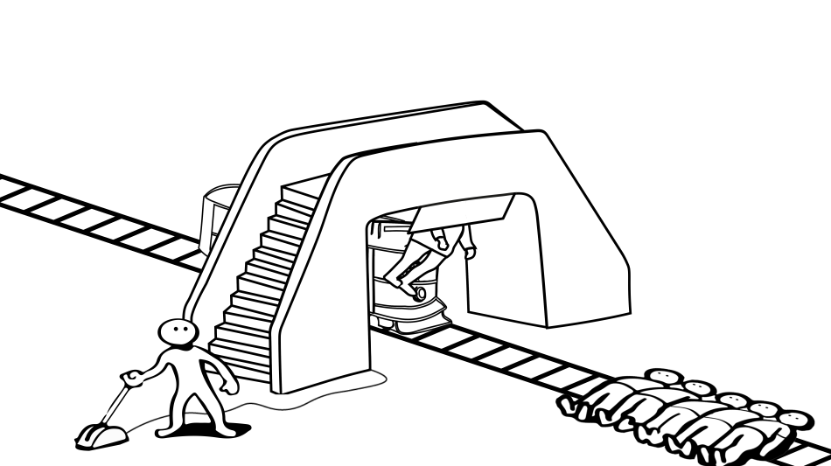
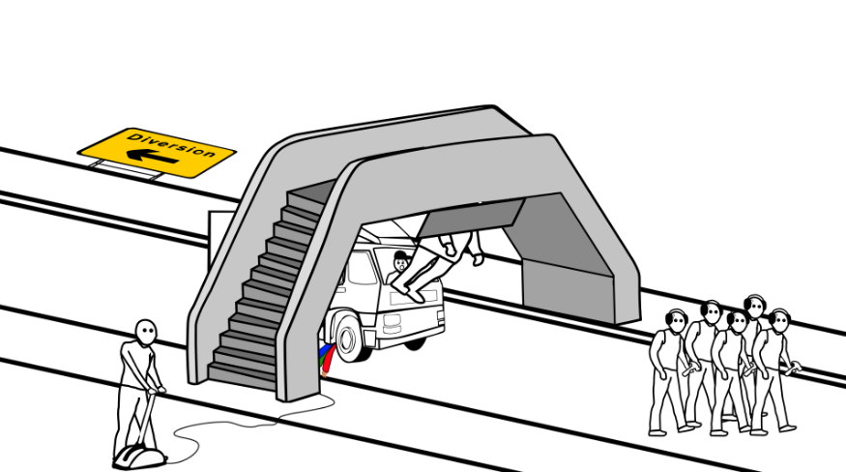
Stills of the Drop Man animative scenarios across all 4-contexts at equivalent time-points

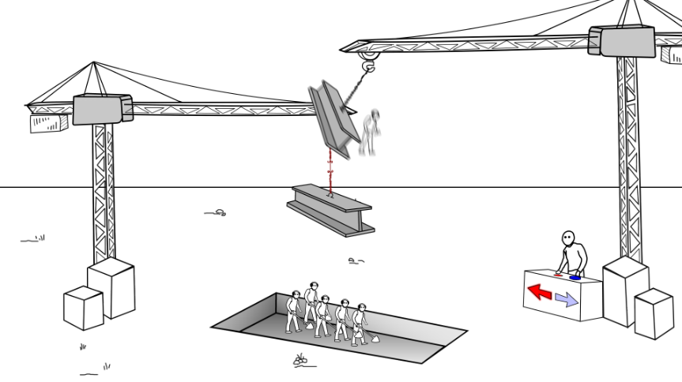
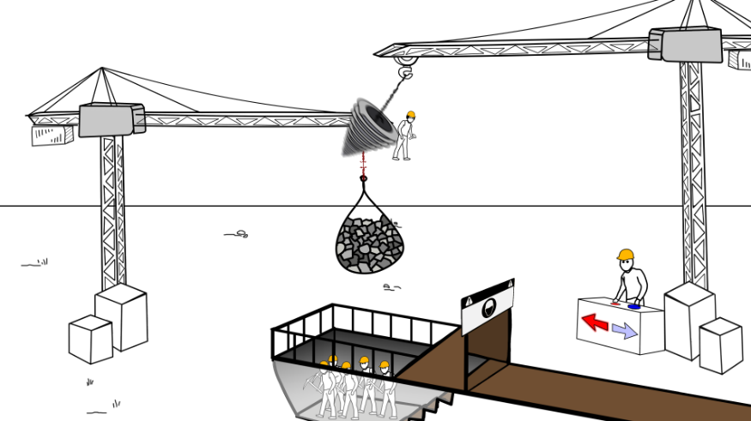
a. Trolley b. Truck

c. Crane d. Mine

Table 2. Table displaying the power simulations output with the parameters described in-text.
Effect Size | Participants N | M Power | Lower CI | Upper CI | Warnings | Error
0.94  0.94  0.94 | 50 | 0.68 | 0.63 | 0.72 | 0 | 0
0.94  0.94  0.94 | 75 | 0.75 | 0.71 | 0.79 | 0 | 0
0.94  0.94  0.94 | 100 | 0.84 | 0.81 | 0.87 | 0 | 0
Note. 500 simulations used.

Table 3. Table displaying the output for the second set of power simulations described in-text.
Effect Size | Participants N | M Power | Lower CI | Upper CI | Warnings | Error
0.94  0.94  0.94 | 80 | 0.79 | 0.75 | 0.83 | 0 | 0
0.94  0.94  0.94 | 100 | 0.81 | 0.77 | 0.84 | 0 | 0
0.94  0.94  0.94 | 110 | 0.82 | 0.78 | 0.85 | 0 | 0
Note. 500 simulations used.

Figure 2

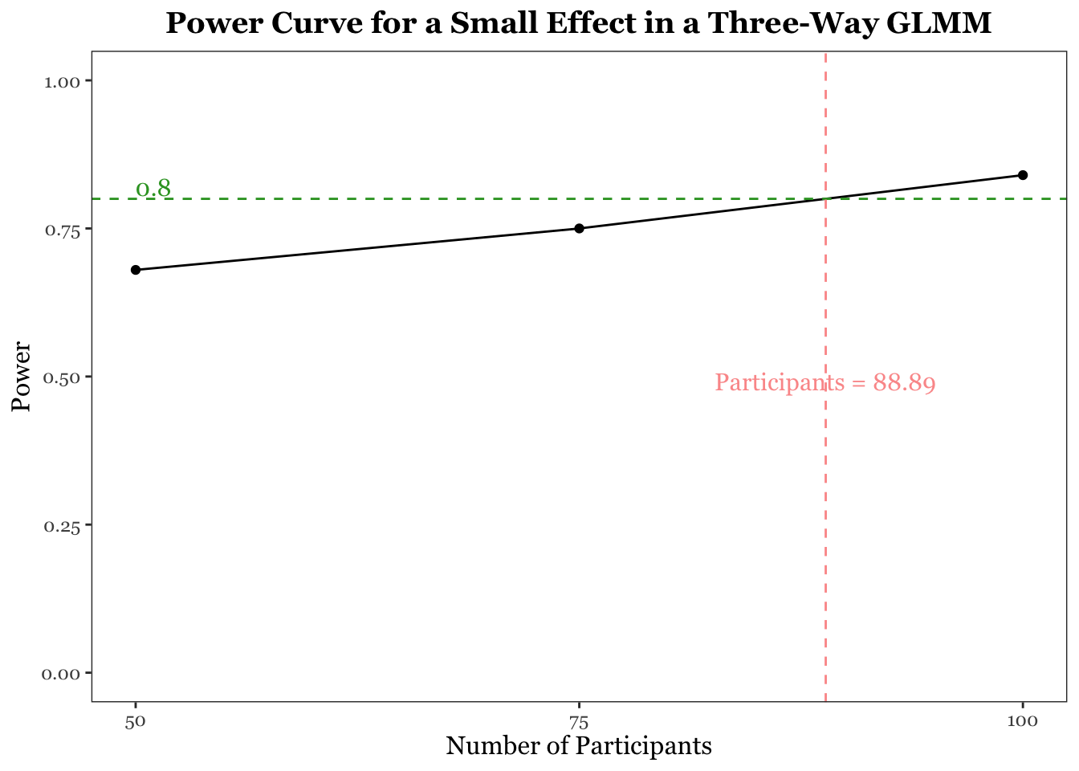

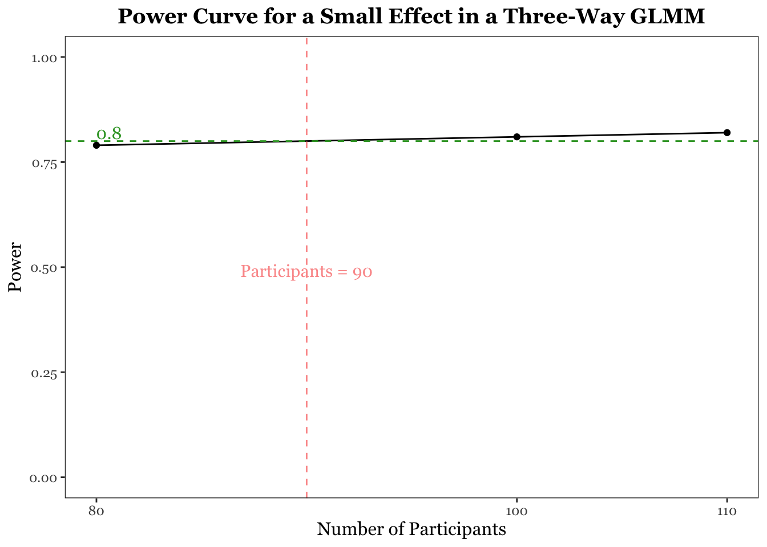
Figure 3

