Sustainable Packaging Solutions

Business Proposal
A Comprehensive Strategy for Market Expansion and Growth


1. Executive Summary and Market Opportunity
Our startup is founded on a clear mission: to deliver sustainable packaging solutions that address the urgent global demand for environmentally responsible alternatives to traditional packaging. As consumer awareness of environmental impacts intensifies and regulatory frameworks become increasingly stringent, businesses across industries are seeking partners who can provide innovative, eco-friendly packaging that aligns with their sustainability commitments and brand values.

1.1 Mission and Value Proposition
Our core mission centers on transforming the packaging industry by offering recyclable, compostable, and bio-based packaging solutions that meet the evolving sustainability expectations of brand owners. We serve key sectors including:
- Food & Beverage industry
- Personal Care and Cosmetics
- E-commerce and Retail
- Healthcare and Pharmaceuticals
Our value proposition is built on three fundamental pillars: environmental responsibility, regulatory compliance, and innovation. We enable our clients to reduce their environmental footprint while maintaining product protection, aesthetic appeal, and cost-effectiveness. By partnering with us, brand owners can confidently meet consumer expectations and navigate the complex landscape of environmental regulations.

1.2 Global Market Size and Growth Projections
The global sustainable packaging market represents a substantial and rapidly expanding opportunity. Current market valuations and future projections demonstrate remarkable growth momentum:

Year | Market Size (USD Billion) | CAGR (%) | Key Notes
2025 | 301.8 - 373.8 | — | Current market valuation range
2025-2030 | — | 5.8 - 8.5 | 5-year growth period
2030 | ~450 - 520 | 6.5 - 7.8 | Mid-term projection
2035 | 530 - 845 | 6.0 - 8.5 | Long-term market potential
Sustainable Packaging Market Size and Growth Forecast

These projections reflect a market valued at USD 301.8 billion to USD 373.8 billion in 2025, with expectations to exceed USD 530 billion to USD 845 billion by 2035. The compound annual growth rate (CAGR) ranging between 5.8% and 8.5% demonstrates sustained, robust demand across all major geographic regions and industry segments.
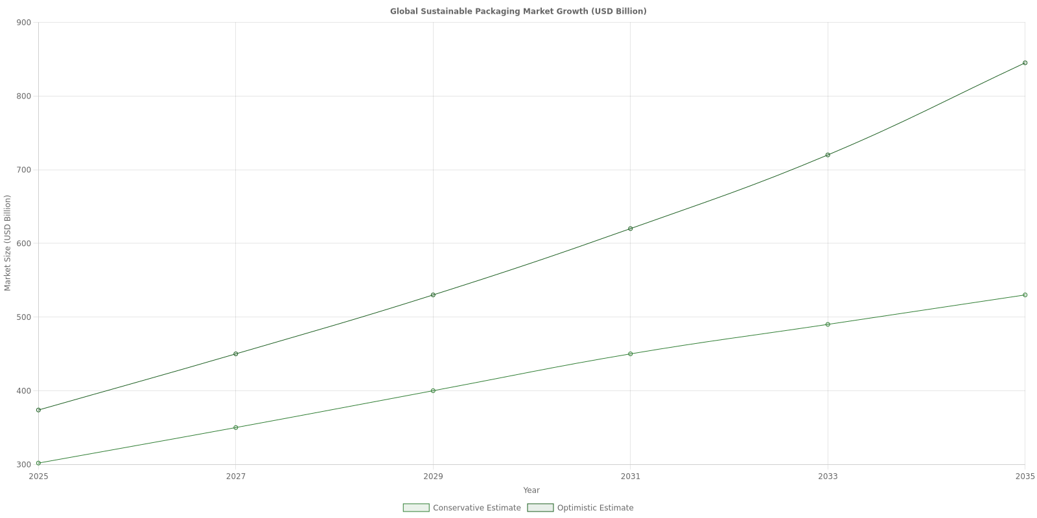

1.3 Key Market Drivers
The sustainable packaging market's impressive growth trajectory is underpinned by several powerful and interconnected drivers that are reshaping the packaging industry landscape:

1.3.1 Consumer Awareness and Environmental Consciousness
Modern consumers are increasingly informed about environmental issues and actively seek brands that demonstrate genuine commitment to sustainability. This heightened consumer awareness translates directly into purchasing decisions, with studies showing that a significant majority of consumers prefer products with eco-friendly packaging and are willing to pay premium prices for sustainable alternatives.

1.3.2 Regulatory Pressures and Legislative Frameworks
Governments worldwide are implementing stringent regulatory measures to combat plastic pollution and promote circular economy principles. Key regulatory drivers include:
- Single-use plastic bans implemented across numerous jurisdictions in Europe, North America, and Asia
- Extended Producer Responsibility (EPR) laws requiring manufacturers to manage end-of-life packaging
- Mandatory recycled content requirements for packaging materials
- Plastic taxes and levies incentivizing alternatives to virgin plastic
- Deposit-return schemes promoting packaging circularity

1.3.3 Corporate ESG Commitments and Procurement Policies
The rise of Environmental, Social, and Governance (ESG) frameworks has fundamentally transformed corporate procurement strategies. Brand owners are increasingly prioritizing sustainable packaging to meet investor expectations, enhance corporate reputation, and achieve ambitious sustainability targets. This shift has created substantial demand for suppliers who can deliver certified sustainable packaging solutions at scale.

1.3.4 Sector-Specific Growth Dynamics
Several industry segments are experiencing particularly strong demand for sustainable packaging:
- Food & Beverage: Driven by direct consumer contact and brand differentiation opportunities
- Minimalist, recyclable packaging formats
- Compostable food service packaging
- Bio-based barrier solutions for extended shelf life
- E-commerce: Rapid growth in online retail necessitating protective yet sustainable shipping solutions
- Right-sized packaging reducing material waste
- Recyclable protective materials
- Plastic-free cushioning alternatives
- Personal Care: Premium positioning aligned with sustainability values
- Refillable packaging systems
- Ocean plastic and recycled content integration
- Minimalist design reducing material usage

1.3.5 Technological Innovation
Advancements in packaging technology are enabling new sustainable solutions that were previously unfeasible. Innovations include smart packaging with enhanced traceability, digital printing reducing waste from shorter runs, advanced bio-based barriers matching conventional plastic performance, and chemical recycling technologies expanding material circularity.

1.4 Regional Market Dynamics
The sustainable packaging opportunity varies significantly by geographic region, with distinct regulatory environments and market maturity levels:

Region | Market Position | Key Characteristics | Growth Outlook
North America | Leading Market | Strong regulatory frameworks, mature consumer awareness, corporate sustainability leadership | Steady growth
Europe | Leading Market | Strictest regulations (EU Plastics Strategy), circular economy leadership, high recycled content mandates | Sustained high growth
Asia Pacific | Fast-Growing | Increasing government initiatives, rapid urbanization, growing middle class, elimination of plastic packaging targets | Highest growth rate
Latin America | Emerging | Growing awareness, regulatory development, urban sustainability initiatives | Moderate growth
Middle East & Africa | Developing | Early stage adoption, increasing awareness, regulatory frameworks emerging | Early-stage growth
Regional Market Characteristics

North America and Europe lead the market with well-established regulatory frameworks and strong consumer demand for sustainable solutions. Asia Pacific is identified as the fastest-growing market, driven by government initiatives to eliminate plastic packaging, rapid economic development, and increasing private-sector commitments to sustainability.

1.5 Material Preferences and Market Segmentation
Material selection represents a critical dimension of the sustainable packaging market, with clear preferences emerging based on environmental performance, functionality, and cost considerations:
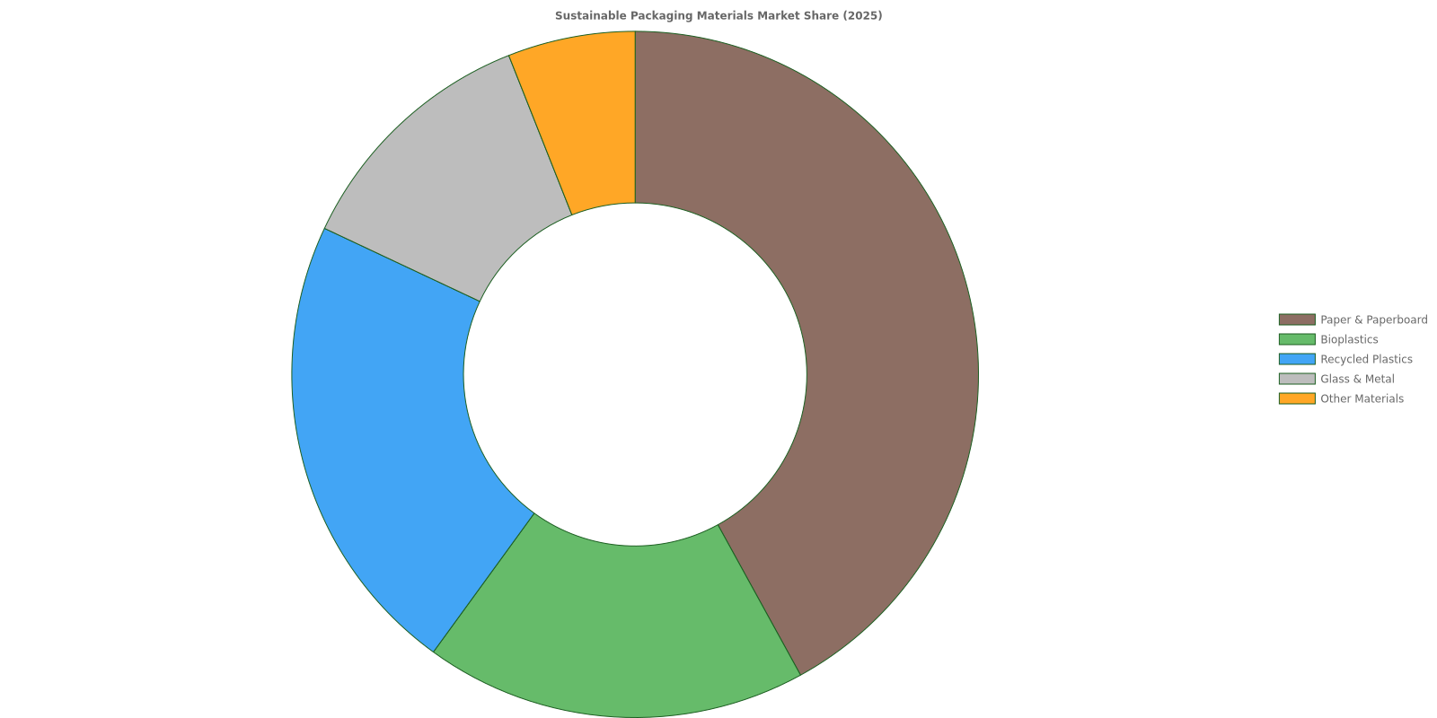
Paper and paperboard materials dominate the sustainable packaging landscape, holding approximately 42% market share in 2025. This leadership position stems from their inherent recyclability, biodegradability, widespread infrastructure for collection and processing, cost-effectiveness relative to many alternatives, and versatility across diverse applications.
Bioplastics and recycled plastics together account for approximately 40% of the market, reflecting the ongoing transition from virgin fossil-based plastics toward renewable and circular alternatives. Glass and metal maintain steady market share in premium and reusable packaging segments.

1.6 Strategic Opportunity Summary
Our startup is strategically positioned to capitalize on a sustainable packaging market characterized by:
- Substantial market size valued at USD 300-375 billion currently, with projections exceeding USD 530-845 billion by 2035
- Robust growth rates of 6-8.5% CAGR sustained over the next decade
- Multiple powerful drivers including consumer demand, regulatory mandates, and corporate ESG commitments working synergistically
- Global opportunity with particular strength in North America, Europe, and rapidly growing Asia Pacific markets
- Material diversity allowing for tailored solutions across client needs and applications
- Sector breadth spanning food & beverage, e-commerce, personal care, and other high-growth industries
This convergence of market size, growth momentum, and structural drivers creates a compelling opportunity to deliver innovative, eco-friendly packaging solutions that align precisely with evolving market demands and regulatory requirements. Our entry into this market is timely, strategic, and positioned for substantial growth as sustainability transitions from competitive advantage to market necessity.

2. Business Description, Target Clients, and Products
This chapter provides a comprehensive overview of the sustainable packaging startup's organizational structure, strategic focus areas, and target market segments. It details the full spectrum of products and services offered, from raw material sourcing to final delivery, demonstrating how the company addresses diverse client needs while maintaining unwavering commitment to environmental responsibility.

2.1 Company Structure and Focus Areas
The sustainable packaging startup operates as a mission-driven enterprise dedicated to offering innovative biodegradable and compostable packaging solutions. The company's core structure emphasizes environmental responsibility while maintaining operational efficiency and profitability. The business can be organized as a sole proprietorship, partnership, or limited liability entity, depending on ownership preferences and investor requirements. Regardless of legal structure, the company maintains a clear commitment to reducing environmental impact through responsible sourcing, lean manufacturing, and sustainable logistics practices.
The startup's strategic focus areas encompass the complete lifecycle of packaging production—from raw material procurement through final product delivery. This holistic approach ensures consistency in environmental standards across all operational phases.

2.1.1 Core Operational Priorities
- Supply Chain Resilience: Establishing partnerships with multiple vetted suppliers to ensure material availability and competitive pricing
- Production Optimization: Implementing lean manufacturing processes that minimize waste generation and energy consumption
- Sustainable Logistics: Utilizing eco-friendly transportation methods to reduce carbon footprints throughout the distribution network
- Innovation Leadership: Continuously investing in research and development of new sustainable materials and production techniques
- Quality Assurance: Maintaining rigorous testing protocols to ensure product reliability and environmental compliance
The company prioritizes innovation in sustainable materials sourcing, ensuring that all suppliers hold relevant certifications such as FSC (Forest Stewardship Council) for paper products or BPI (Biodegradable Products Institute) certification for compostable materials. This certification framework provides clients with transparent verification of environmental claims and regulatory compliance.

2.2 Target Client Segments
The ideal customer base comprises diverse market segments with varying packaging needs and sustainability priorities. Understanding these distinct segments enables the company to tailor solutions that address specific functional requirements while supporting each client's environmental objectives.

2.2.1 Primary Market Segments

Client Segment | Primary Needs | Key Value Drivers
Specialty Food Brands | Freshness preservation, organic certification compatibility | Brand alignment with sustainability values, product protection
E-commerce Retailers | Protective shipping solutions, cost efficiency | Damage prevention, consumer expectations, waste reduction
Beauty & Cosmetic Companies | Aesthetic appeal, premium brand positioning | Customizable designs, sustainability credentials, shelf presence
Small Businesses & Local Markets | Affordable sustainable options, flexible order volumes | Local sourcing preferences, community environmental values
Large Corporations | High-volume production, consistent quality | Scalability, regulatory compliance, corporate sustainability goals
Target Client Segments and Their Packaging Requirements

2.2.2 Detailed Segment Analysis
Specialty Food Brands represent a primary target segment, particularly organic food producers seeking packaging that maintains product freshness while demonstrating environmental commitment. These clients value both functionality and brand alignment with sustainability values, making them ideal partners for long-term collaborative relationships.
E-commerce Retailers constitute another significant market segment, requiring protective packaging solutions that minimize shipping damage while reducing environmental footprint and material costs. These businesses increasingly prioritize sustainable options to meet growing consumer expectations for environmentally responsible fulfillment practices.
Beauty and Cosmetic Product Companies seek sleek, customizable packaging designs that reflect brand positioning while meeting sustainability standards. This segment values aesthetic appeal combined with eco-conscious credentials, often willing to invest premium pricing for differentiated packaging solutions.
Small Businesses and Local Markets including food trucks and organic grocery stores represent an expanding client base. While individual order volumes may be smaller, this segment offers significant aggregate potential and strong community-based brand advocacy opportunities.
Large Corporations across multiple industries present scalability opportunities for established sustainable packaging providers willing to meet bulk production demands and rigorous quality standards. Success in this segment requires demonstrated production capacity, consistent quality control, and comprehensive compliance documentation.

2.3 Product and Service Offerings
The company provides a comprehensive portfolio of products and services spanning the entire packaging value chain. This integrated approach enables clients to consolidate supplier relationships while ensuring consistency in environmental standards and quality benchmarks.

2.3.1 Material Sourcing and Supply Chain Management
The company sources diverse sustainable raw materials designed to replace conventional petroleum-based plastics across various applications. Primary materials include:
- Polylactic Acid (PLA): Plant-based bioplastic derived from fermented sugars, suitable for rigid containers and films
- Polyhydroxyalkanoates (PHA): Biodegradable polyesters produced by bacterial fermentation, offering marine biodegradability
- Starch-based Resins: Cost-effective materials derived from corn, potato, or tapioca starches for flexible packaging applications
- Seaweed-based Biopolymers: Innovative materials that convert seaweed into moldable packaging safe for marine environments
Diversifying supplier relationships prevents production disruptions and ensures competitive material pricing. The company maintains comprehensive supplier vetting processes to confirm ethical sourcing practices, environmental certifications, and capacity reliability. This multi-supplier strategy provides operational resilience while supporting continuous cost optimization.

2.3.2 Packaging Design and Customization Services
Customizable solutions address specific client needs, from keeping organic foods fresh to creating sophisticated designs for beauty products. The design process incorporates sustainability metrics that quantify waste reduction and carbon emission decreases, providing clients with transparent environmental impact data for marketing communications and corporate reporting.
Key design capabilities include:
- Functional Design: Engineering packaging structures optimized for product protection, shelf life extension, and handling efficiency
- Brand Integration: Developing visual designs that reinforce brand identity while communicating sustainability commitments
- Material Selection Consulting: Advising clients on optimal material choices based on product requirements, budget constraints, and environmental priorities
- Prototyping Services: Creating physical samples for testing and stakeholder approval before full production commitment
- Lifecycle Impact Assessment: Quantifying environmental benefits compared to conventional packaging alternatives
Specialized items such as insulated compostable containers for temperature-sensitive products and refillable packaging lines for circular economy applications differentiate offerings from competitors and address emerging market demands.

2.3.3 Prototyping and Innovation Services
The company maintains an active research and development wing focused on continuous product innovation and performance improvement. This innovation capacity demonstrates ongoing commitment to market leadership and technological advancement in sustainable packaging solutions.
Current innovation priorities include:
- Compostable Adhesives Development: Creating bonding solutions that maintain structural integrity while remaining fully biodegradable
- Plant-based adhesive formulations
- Water-resistant bonding technologies
- Temperature-stable applications
- Novel Material Combinations: Exploring hybrid materials that optimize performance characteristics across multiple dimensions
- Barrier property enhancement for moisture and oxygen protection
- Mechanical strength improvements for heavy-duty applications
- Cost reduction through material efficiency innovations
- Refillable Packaging Systems: Developing durable containers designed for multiple-use cycles in circular economy models
- Consumer return and cleaning logistics
- Durability testing for extended lifecycle performance
- Brand customization for retail partnerships

2.3.4 Quality Assurance and Compliance Services
Comprehensive operational procedures ensure consistent product quality and regulatory compliance across all production batches. The company maintains detailed documentation systems that provide full traceability and verification of environmental claims.

Process Area | Key Activities | Documentation Outputs
Material Procurement | Supplier certification verification, material testing, ethical sourcing audits | Procurement checklists, supplier scorecards, certification registries
Production Quality Control | In-process inspections, dimensional verification, performance testing | Quality control guidelines, batch test reports, non-conformance records
Environmental Compliance | Biodegradability testing, compostability certification, emissions monitoring | Sustainability impact verification, compliance certificates, audit reports
Customer Support | Technical assistance, complaint resolution, product improvement feedback | Support tickets, satisfaction surveys, continuous improvement logs
Quality Assurance Framework Components

This comprehensive quality framework assures clients of reliable, environmentally responsible products while supporting continuous operational improvement and regulatory compliance maintenance.

2.3.5 Logistics and Delivery Solutions
Eco-friendly logistics partnerships support sustainable transportation methods that align with the company's overall environmental commitments. This service ensures that the entire customer experience—from order placement through final delivery—reflects sustainability principles and minimizes carbon footprint.
Logistics strategy components include:
- Carbon-neutral Shipping Options: Partnering with carriers offering verified carbon offset programs
- Regional Distribution Centers: Establishing local warehousing to reduce transportation distances and delivery times
- Consolidated Shipments: Optimizing order batching to minimize transportation frequency and fuel consumption
- Returnable Transport Packaging: Using reusable shipping containers for bulk deliveries to reduce single-use packaging waste
- Route Optimization: Implementing logistics software that minimizes delivery miles and fuel consumption
By integrating sustainable logistics practices throughout the supply chain, the company delivers comprehensive environmental performance that extends beyond product attributes to encompass the complete customer relationship lifecycle.

2.4 Competitive Differentiation and Value Proposition
The company's integrated approach to sustainable packaging—combining material innovation, customized design services, rigorous quality assurance, and eco-friendly logistics—creates distinctive competitive advantages in the marketplace. This comprehensive value proposition addresses the full spectrum of client needs while demonstrating measurable environmental impact reductions.
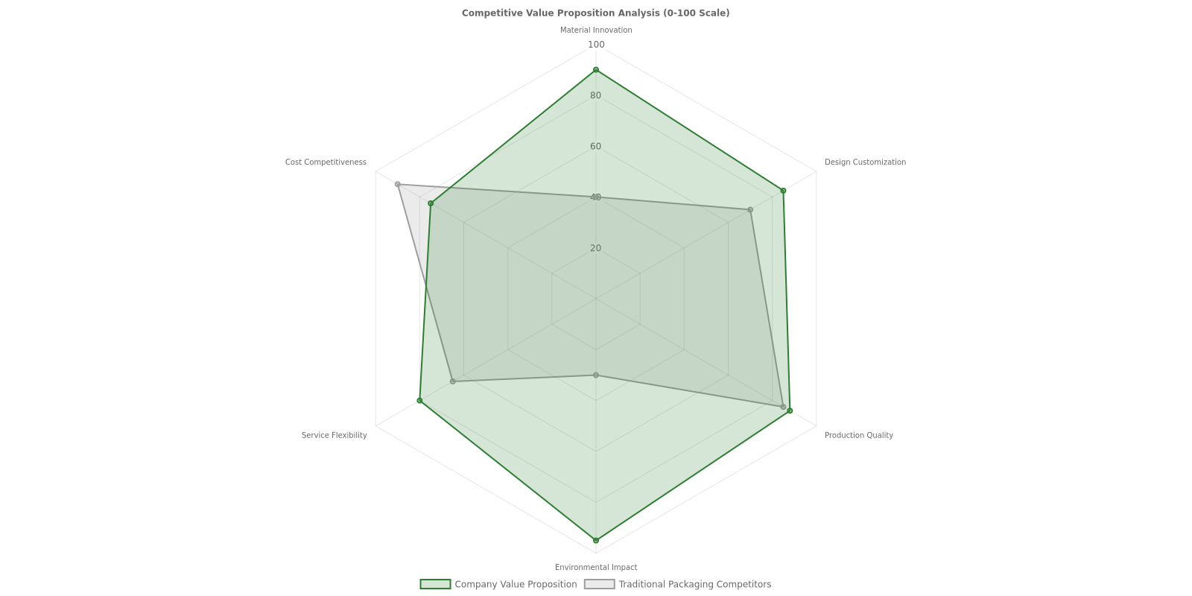
This multidimensional competitive positioning enables the company to serve diverse client segments effectively while building sustainable long-term growth in the expanding sustainable packaging marketplace.

3. Production Process, Sustainability Metrics, and Scaling Strategy
This chapter outlines the comprehensive manufacturing approach, detailing the materials, processes, and metrics that underpin our sustainable packaging solutions. Our strategy integrates lifecycle thinking, operational excellence, and strategic supplier partnerships to deliver environmentally responsible products while maintaining scalability and market competitiveness.

3.1 Eco-Friendly Materials Selection
Our production process prioritizes materials that minimize environmental impact across their entire lifecycle. We utilize a carefully curated portfolio of sustainable raw materials that offer biodegradability, compostability, and significantly reduced carbon footprints compared to conventional packaging materials.

3.1.1 Natural Fiber Materials
Natural fibers form the foundation of many of our packaging solutions, offering renewable alternatives to petroleum-based materials:
- Bamboo: Fast-growing renewable resource with excellent strength-to-weight ratio and natural antimicrobial properties
- Hemp: Durable fiber requiring minimal pesticides and water, with superior tensile strength for structural applications
- Jute: Cost-effective biodegradable option ideal for bulk packaging and protective applications

3.1.2 Bio-Based and Biodegradable Polymers
Advanced polymer materials derived from renewable sources provide necessary barrier properties and flexibility while maintaining end-of-life sustainability. These include polylactic acid (PLA) from fermented plant sugars, polyhydroxyalkanoates (PHA) produced through bacterial fermentation, and starch-based blends. Some formulations require additional treatments to enhance moisture barriers or durability for specific applications.

3.1.3 Recycled Content Integration
Incorporating post-consumer and post-industrial recycled materials reduces virgin resource extraction and supports circular economy principles:
- Recycled paper and cardboard for corrugated solutions and rigid packaging
- Recycled plastics (rPET, rPP, rPE) for flexible packaging applications
- Mixed material streams processed through advanced sorting and cleaning technologies

3.2 Manufacturing Methods and Lifecycle Optimization
Our manufacturing approach integrates energy efficiency, waste minimization, and lifecycle thinking from initial sourcing through production to end-of-life management. Every process decision considers the full environmental impact chain to optimize resource use and minimize emissions.

3.2.1 Energy-Efficient Production Processes
Production facilities employ state-of-the-art equipment and process controls to minimize energy consumption per unit output. Key strategies include heat recovery systems, variable frequency drives on motors, LED lighting throughout facilities, and optimized scheduling to reduce idle equipment time. For bio-based materials requiring fermentation, we actively manage energy-intensive byproducts to reduce Scope 1 and 2 emissions.

3.2.2 Waste Minimization and Circular Design
Designing for circular economy principles enables reuse, recycling, and composting to eliminate the concept of waste. Manufacturing processes incorporate:
- Material optimization algorithms to reduce trim waste and offcuts
- Closed-loop water systems with filtration and reuse capabilities
- Scrap material collection and reintegration into production streams
- Modular packaging designs that facilitate disassembly and material separation

3.2.3 Operational Workflow Efficiency
Efficient packaging line processes reduce bottlenecks and product damages while improving resource utilization. Through continuous improvement methodologies, we achieve line efficiency improvements of up to 30% through incremental optimization. This enhances sustainability by lowering material waste, reducing energy consumption during manufacturing, and increasing throughput without proportional resource increases.

3.3 Sustainability Metrics and Key Performance Indicators
Measurable sustainability KPIs provide transparency and drive continuous improvement across our operations. We track comprehensive metrics across environmental, operational, and supply chain dimensions.

Metric Category | Key Performance Indicator | Measurement Approach | Target Range
Carbon Emissions | Scope 1 & 2 Emissions | Direct facility emissions + purchased energy | 20-30% reduction YoY
Carbon Emissions | Scope 3 Emissions | Supply chain and transportation impacts | 15-25% reduction over 3 years
Material Sustainability | Recycled/Renewable Content % | Weight percentage of sustainable inputs | 60-80% by material type
Energy Efficiency | Energy per Production Unit | kWh per kilogram of output | 10-15% annual improvement
Waste Reduction | Manufacturing Waste Rate | Waste weight vs. total material input | <5% waste to landfill
Lifecycle Impact | Carbon Footprint per Package | Cradle-to-grave CO₂ equivalent | 40-60% lower than conventional
Core Sustainability KPIs and Targets

Continuous material assessments and supply chain collaboration ensure these KPIs remain relevant and ambitious. Regular third-party audits and lifecycle assessment studies validate our environmental claims and identify improvement opportunities.

3.4 Strategic Supplier Partnerships
Sustainable supplier partnerships are critical to achieving our environmental goals and ensuring supply chain resilience. We apply rigorous selection criteria and maintain ongoing collaboration with material suppliers, equipment providers, and logistics partners.

3.4.1 Supplier Selection Criteria
All suppliers undergo evaluation across environmental and social performance dimensions:
- Environmental certifications: FSC, PEFC, Cradle to Cradle, or equivalent standards for responsible resource management
- Carbon disclosure: Transparent reporting of emissions and reduction targets aligned with science-based initiatives
- Local sourcing priority: Preference for regional suppliers to reduce transportation emissions and support local economies
- Social responsibility: Labor practices, community engagement, and ethical business conduct verification

3.4.2 Collaborative Optimization
Regular communication and collaboration with partners optimize resource use, consolidate shipments, and enhance supply chain transparency. Joint initiatives include material innovation projects, shared logistics platforms, demand forecasting alignment, and continuous improvement workshops. This collaborative approach reduces redundancies, minimizes environmental impacts, and strengthens supply chain resilience.

3.5 Scaling Strategy and Growth Roadmap
Our scaling strategy balances aggressive growth targets with unwavering commitment to sustainability principles. The roadmap prioritizes incremental adoption of sustainable materials and equipment while ensuring operational continuity and financial viability.

3.5.1 Phased Capacity Expansion
Capacity expansion follows a structured phase approach to manage capital requirements and operational risk:
- Phase 1 (Year 1-2): Optimize existing production lines and establish baseline KPIs
  - Implement efficiency improvements targeting 30% throughput increase
  - Integrate first-generation bio-based materials into existing equipment
  - Establish supplier partnerships and certification frameworks
- Phase 2 (Year 2-3): Add dedicated sustainable packaging production lines
  - Install specialized equipment for compostable flexible packaging
  - Double production capacity while maintaining sustainability KPIs
  - Expand material portfolio with advanced bio-polymers and composites
- Phase 3 (Year 4-5): Regional expansion and vertical integration
  - Establish secondary production facilities in key markets
  - Develop proprietary material formulations and processing technologies
  - Integrate upstream supply chain elements for enhanced control

3.5.2 Technology and Innovation Integration
Continuous innovation drives competitive advantage and environmental performance improvements. Our scaling strategy incorporates emerging technologies including compostable flexible packaging systems, advanced barrier coatings from renewable sources, digital printing for reduced setup waste, and AI-powered quality control systems for defect reduction.

3.5.3 Market Reach Expansion
Geographic and sector expansion follows demand patterns and regulatory drivers:
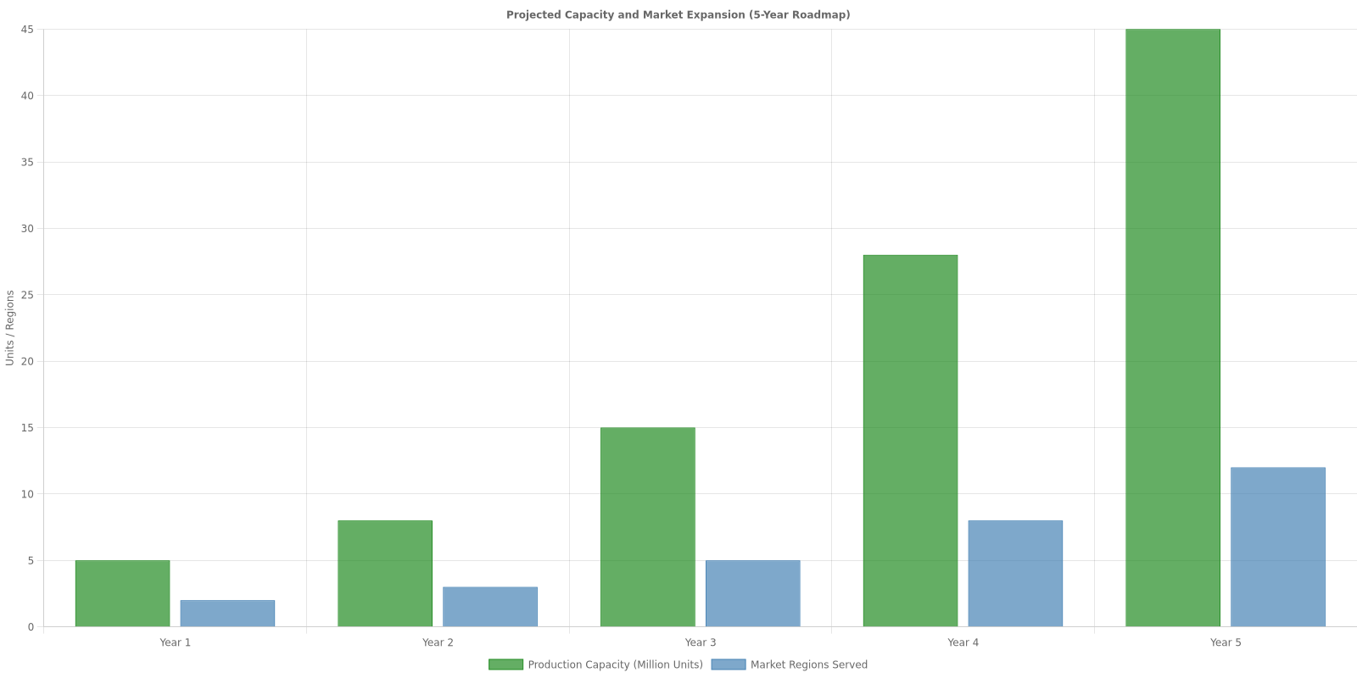

3.5.4 Maintaining Sustainability During Growth
Scaling operations while maintaining or improving sustainability KPIs requires disciplined management and strategic investments. Key commitments include ensuring all new facilities meet or exceed environmental performance of existing operations, maintaining minimum recycled/renewable content percentages regardless of volume, investing in renewable energy for expanded capacity, and implementing real-time monitoring systems for immediate deviation detection and correction.

3.6 Supply Chain Logistics Optimization
Efficient supply chain logistics reduce transportation emissions, minimize inventory waste, and enhance customer satisfaction. Our optimization strategy includes regional distribution centers positioned near customer clusters, consolidated shipments using route optimization algorithms, partnership with carbon-neutral logistics providers, and returnable packaging systems for B2B customers.
By integrating these manufacturing methods, sustainability metrics, supplier partnerships, and scaling strategies, we establish a robust operational foundation capable of meeting growing market demand while advancing environmental stewardship. This comprehensive approach positions the company as a leader in sustainable packaging innovation and demonstrates that profitability and planet-positive practices are mutually reinforcing objectives.

4. Pricing, Financial Outlook, and Industry References
This chapter presents a comprehensive analysis of the financial framework supporting our sustainable packaging startup, including strategic pricing models, detailed cost structures, financial projections, and industry benchmarks that validate our business case in the rapidly evolving sustainable packaging market.

4.1 Strategic Pricing Models
Our pricing strategy departs from traditional cost-plus models, embracing a value-based pricing approach that leverages growing eco-conscious consumer demand and the demonstrated market premium for sustainable solutions. This strategic positioning allows us to capture additional value while maintaining competitive market positioning.

4.1.1 Value-Based Pricing Framework
Research demonstrates that products with sustainability claims achieve approximately 28% higher sales growth compared to conventional alternatives, providing strong justification for premium pricing. Our value-based model considers:
- Environmental impact reduction and measurable sustainability metrics
- Brand value enhancement and consumer loyalty benefits
- Regulatory compliance advantages and future-proofing
- Total cost of ownership including disposal and waste management savings
- Market positioning within the premium sustainable segment
Consumer research indicates that approximately 55% of consumers are willing to pay premium prices for environmentally responsible brands, creating substantial market opportunity for differentiated pricing strategies.

4.1.2 Tiered Pricing Structure
To accommodate diverse client needs while maximizing market penetration, we implement a tiered pricing model that provides flexibility and scalability:

Tier | Volume Range | Features | Target Segment
Starter | 5,000-25,000 units | Standard sustainable materials, basic customization, digital design support | Small businesses, startups
Professional | 25,000-100,000 units | Premium materials, custom design, prototyping, sustainability reporting | Mid-market companies
Enterprise | 100,000+ units | Full material range, dedicated account management, R&D collaboration, comprehensive analytics | Large corporations
Tiered Pricing Model for Sustainable Packaging Solutions

This tiered approach enables clear value communication, increases conversion rates through defined entry points, and maintains flexibility for scaling as client needs evolve.

4.2 Cost Structure and Economic Drivers
Understanding our cost structure is essential for maintaining profitability while scaling operations. Our cost framework encompasses raw materials, production efficiency, and economies of scale that improve as volumes increase.

4.2.1 Raw Material Costs
Sustainable materials represent our primary cost driver, with biopolymers such as PLA (polylactic acid) currently priced between $2,800 and $4,500 per ton. Material selection balances performance requirements, sustainability credentials, and cost optimization:
- Biopolymers (PLA, PHA): $2,800-$4,500 per ton - High sustainability, moderate processing costs
- Recycled materials: $1,800-$3,200 per ton - Lower cost, established supply chains
- Fiber-based alternatives: $1,200-$2,500 per ton - Cost-effective, limited application range
- Advanced composites: $4,000-$6,500 per ton - Premium performance, specialized applications

4.2.2 Production Efficiency and Energy Savings
Our manufacturing processes leverage modern equipment and optimized workflows to achieve significant efficiency gains. Energy consumption analysis demonstrates potential savings of up to 30% compared to traditional packaging production through:
- Lower processing temperatures for biopolymer materials
- Efficient machinery with reduced cycle times
- Waste minimization protocols reducing material loss
- Renewable energy integration where feasible

4.2.3 Economies of Scale
Critical production thresholds significantly impact per-unit costs. Analysis indicates substantial cost reduction beyond production volumes of 50,000 to 100,000 units, with progressive improvements at higher volumes:
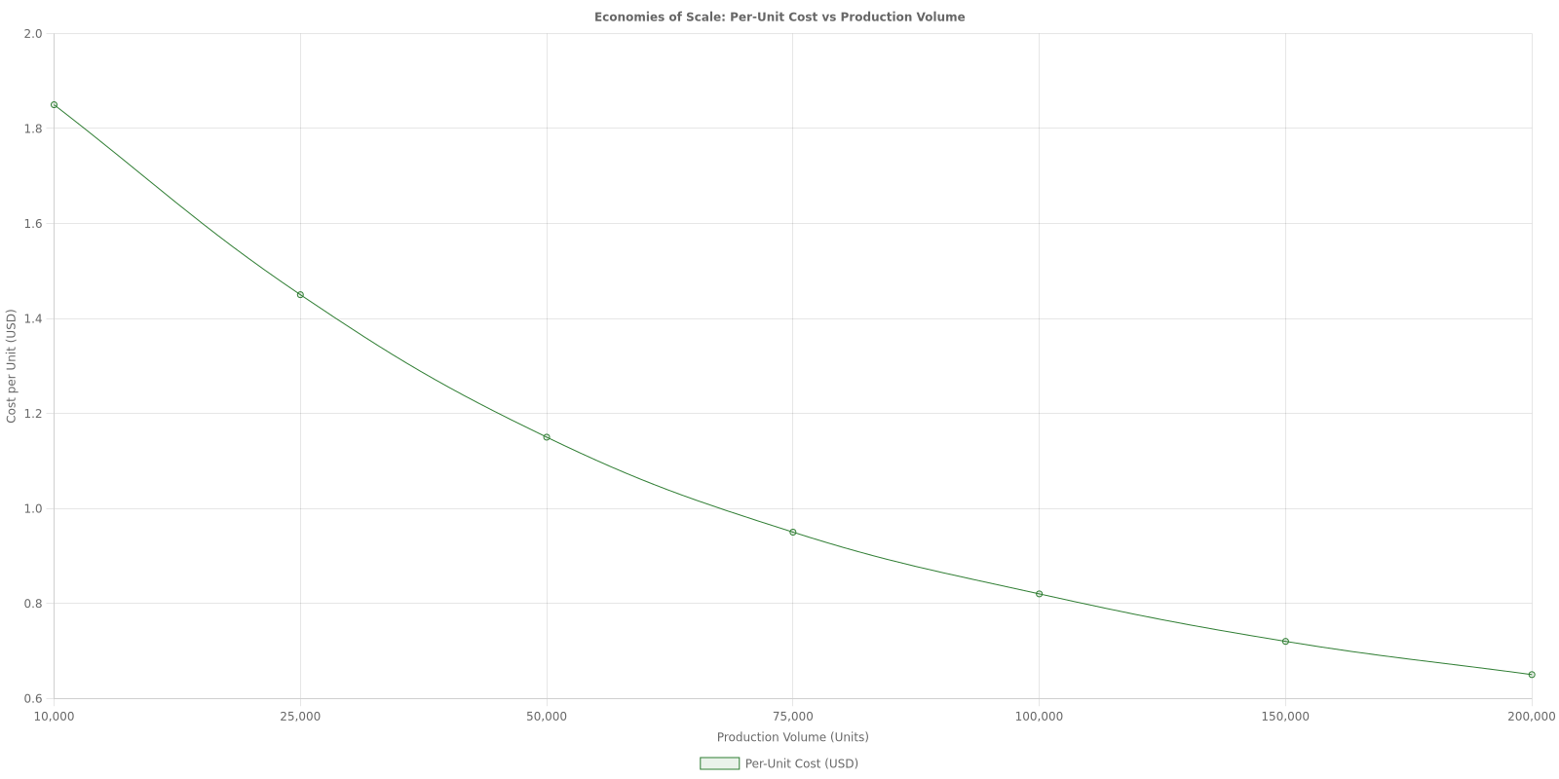

4.2.4 Initial Investment Requirements
Startup costs for biodegradable packaging manufacturing typically range from $100,000 to $300,000, depending on production scale, technology selection, and facility requirements. This investment encompasses:

Category | Investment Range | Percentage of Total
Manufacturing equipment | $40,000 - $120,000 | 35-40%
Facility setup and infrastructure | $25,000 - $75,000 | 20-25%
Initial material inventory | $15,000 - $45,000 | 12-15%
Quality control and testing | $8,000 - $25,000 | 8-10%
Certifications and compliance | $3,000 - $8,000 | 3-5%
Working capital and contingency | $9,000 - $27,000 | 10-15%
Initial Capital Investment Breakdown

4.3 Financial Projections and Long-Term Outlook
While sustainable packaging involves higher upfront investments and navigating supply chain complexities, the long-term financial outlook remains highly favorable due to multiple value drivers and market trends supporting premium positioning.

4.3.1 Revenue Growth Projections
Our financial model projects aggressive but achievable growth based on market expansion, client acquisition, and scaling economies. Conservative projections assume steady market penetration with increasing operational efficiency:

Year | Revenue | Gross Margin | EBITDA Margin | Key Milestones
Year 1 | $450,000 | 32% | -8% | Market entry, initial clients
Year 2 | $1,200,000 | 38% | 5% | Scale production, certification
Year 3 | $2,800,000 | 42% | 12% | Break-even, expand capacity
Year 4 | $5,200,000 | 45% | 18% | Market leadership, R&D investment
Year 5 | $8,500,000 | 47% | 22% | Full-scale operations, diversification
Five-Year Revenue and Profitability Projection

These projections incorporate the demonstrated 28% higher sales growth for sustainable products and assume progressive market penetration aligned with industry growth rates.

4.3.2 Long-Term Cost Savings
Beyond direct revenue, sustainable packaging delivers quantifiable long-term savings and value creation across multiple dimensions:
- Waste disposal fee reduction: Biodegradable materials significantly reduce end-of-life costs for clients
- Regulatory incentives: Access to government programs, tax benefits, and compliance advantages
- Brand value enhancement: Increased customer loyalty and market differentiation worth 15-25% premium
- Supply chain resilience: Diversified material sources reducing dependency on volatile petroleum markets
- Future-proofing: Ahead of regulatory curve as restrictions on conventional packaging increase

4.3.3 Investment and Funding Landscape
The sustainable packaging sector is experiencing significant investment momentum, with investors increasingly funding innovations in this space. Key funding trends include:
- ESG-focused venture capital: Growing allocation to sustainability-focused startups
- Strategic corporate investment: Major brands investing in supply chain innovation
- Government grants and incentives: Public sector support for green technology development
- Impact investment funds: Dedicated capital seeking environmental and financial returns
This favorable funding environment provides multiple pathways for growth capital as we demonstrate market traction and operational milestones.

4.4 Industry Research and Market Trends
Current industry research validates our business model and highlights accelerating trends that strengthen the sustainable packaging business case. Multiple converging factors drive market transformation.

4.4.1 ESG-Driven Consumer Demand
Environmental, Social, and Governance (ESG) considerations increasingly influence purchasing decisions across demographics. Research demonstrates that 55% of consumers are willing to pay premium prices for environmentally responsible brands, with higher percentages among younger demographics:
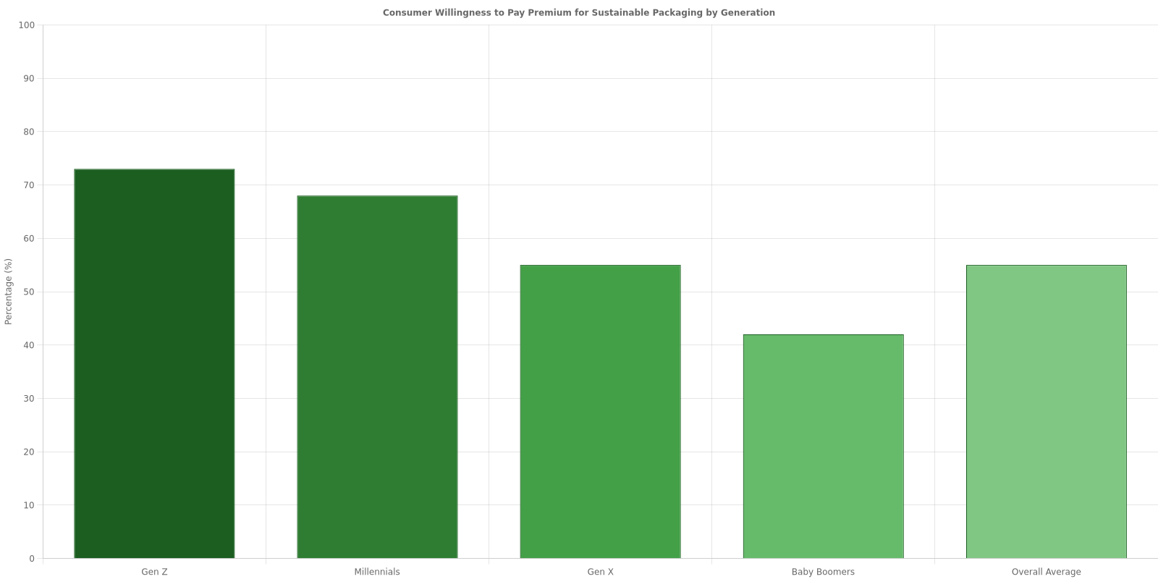

4.4.2 Regulatory Pressure and Compliance Drivers
Governments worldwide are implementing increasingly stringent packaging regulations that favor sustainable alternatives. Major regulatory initiatives include:
- European Union: Single-Use Plastics Directive banning specific conventional packaging by 2025-2030
- United States: State-level extended producer responsibility (EPR) laws expanding rapidly
- Asia-Pacific: China's plastic ban and circular economy initiatives creating massive market shifts
- Global: Over 60 countries implementing plastic bag bans or taxes
These regulatory trends create both compliance requirements and competitive advantages for sustainable packaging providers positioned ahead of the curve.

4.4.3 Technological Innovations and Material Science
Industry innovations focus on minimizing material use, simplifying recycling processes, and leveraging advanced technologies for improved performance and cost-effectiveness:
- AI-assisted material design: Machine learning optimizing material composition for performance and sustainability
- Nanotechnology applications: Enhanced barrier properties enabling thinner, lighter packaging
- Bio-based polymer advances: New generations of PLA and PHA with improved properties and lower costs
- Recycling technology: Chemical recycling enabling closed-loop systems for complex materials
These innovations progressively reduce the cost gap between sustainable and conventional packaging while enhancing performance characteristics.

4.4.4 Industry Collaboration and Consortium Models
Market trends emphasize collaboration through industry consortiums to achieve economies of scale and technical advances that individual startups cannot accomplish alone. Strategic partnerships enable:
- Shared R&D costs reducing innovation barriers
- Collective purchasing power for raw materials
- Standardization efforts improving supply chain efficiency
- Knowledge sharing accelerating best practice adoption

4.5 Sustainability Standards and Certifications
Compliance with recognized sustainability certifications and legal packaging requirements provides essential market credibility and access to premium client segments. While certifications involve initial investment, they deliver substantial returns through enhanced brand positioning and expanded market opportunities.

4.5.1 Key Certification Standards
Our certification strategy targets the most recognized and market-relevant standards that validate our sustainability claims and meet customer requirements:

Certification | Scope | Initial Cost | Strategic Value
ASTM D6400/D6868 | Compostability standards | $2,500-$4,000 | North American market access
EN 13432 | European compostability | $3,000-$5,000 | EU market compliance
FSC/PEFC | Sustainable forestry | $1,500-$3,000 | Fiber-based materials credibility
Cradle to Cradle | Circular economy design | $5,000-$8,000 | Premium brand positioning
ISO 14001 | Environmental management | $3,000-$6,000 | Enterprise client requirement
Priority Sustainability Certifications and Standards

Total initial certification investment ranges from $3,000 to $8,000 depending on scope and priority, with ongoing compliance costs representing 2-3% of annual revenue.

4.5.2 Market Impact of Certifications
Industry data demonstrates that certified sustainable packaging commands significant market premiums and opens access to restricted customer segments:
- 15-25% price premium for certified versus non-certified sustainable packaging
- Enterprise client access: Many large corporations require third-party certification
- Retail placement: Major retailers increasingly mandate sustainability certifications for suppliers
- Brand loyalty: Certified products show 30-40% higher customer retention rates
- Marketing differentiation: Certified claims reduce greenwashing concerns and build trust

4.6 Competitive Financial Positioning
Our financial model positions us competitively within the sustainable packaging landscape while maintaining healthy margins and growth trajectory. Key competitive advantages include:
- Value-based pricing: Capturing premium from demonstrable sustainability benefits rather than competing on cost
- Efficient operations: Technology and process optimization achieving 30% energy savings
- Scalability path: Clear roadmap to volume thresholds (50,000-100,000 units) where unit economics dramatically improve
- Certification portfolio: Comprehensive standards compliance opening premium market segments
- Market timing: Entering during regulatory transition period with first-mover advantages
The intersection of favorable market trends, growing consumer willingness to pay premiums, regulatory support, and improving cost structures creates a compelling financial case for sustainable packaging innovation. Our pricing models, cost management strategies, and market positioning align to capture this opportunity while building a financially sustainable business.

4.6.1 Risk Mitigation and Financial Resilience
Our financial planning incorporates comprehensive risk mitigation strategies to ensure resilience across various market scenarios:
- Material price volatility: Diversified supplier network and strategic inventory management
- Market adoption pace: Tiered product offerings serving multiple market segments simultaneously
- Regulatory changes: Proactive compliance positioning ahead of requirements
- Competition: Continuous innovation and strong customer relationships creating switching costs
- Economic cycles: Focus on necessity goods sectors less sensitive to economic downturns
This comprehensive financial framework, grounded in current industry research and validated by market trends, demonstrates the viability and growth potential of sustainable packaging as both an environmental imperative and a profitable business opportunity.

