Report for Assessment 1:
Log Monitoring Tool Using Aho-Corasick Algorithm

Yoonji Byun (14740664)
University of Technology Sydney
Faculty of Engineering and Information Technology
41052 Advanced Algorithm
27 September 2026
1. What I built
This program is a lightweight, SIEM-inspired log-monitoring tool written in C++. It uses the Aho-Corasick algorithm to detect multiple predefined patterns in text-based server logs. The program can scan an existing log file or monitor a live log file for newly appended entries. Users can enter patterns manually or load them from a text file.
1.1 Algorithm and Design
Aho-Corasick is an efficient string-matching algorithm that constructs a finite-state automaton from a set of patterns to search for keywords in text strings (Aho & Corasick, 1975). The automaton consists of three main components:
- Trie transitions, which determine the next state for each character
- Failure links, which determine the fallback state when no transition exists
- Output lists, which identify the patterns matched at each state
In the implementation, states are represented by integer indices in a vector of $Node$ objects that use a map to store outgoing transitions for that state. The same index is used in the failure and output vectors. For a state $s$, $failure\left[s\right]$ stores one fallback state, whereas $output\left[s\right]$ stores the IDs of all patterns matched at that state. Search results are stored as $Match$ objects containing a pattern ID and match position. For log processing, each $Match$ is stored in a $LogMatch$ together with its line number. Dynamic maps are used for transitions instead of allocating a transition for every possible character.
1.2 Code Structure
The implementation is divided across five source and header files. $main.cpp$ contains the command-line interface, processes user input and coordinates the overall program flow. $aho_corasick.hpp$ and $aho_corasick.cpp$ define and implement the automaton, including pattern insertion, failure link construction, and searching. $log⁡_reader.hpp$ and $log⁡_reader.cpp$ handle log-file input, including scanning existing files and monitoring live files. This separation keeps the matching algorithm independent from the application’s input and file-handling logic.

2. Track B: Log-Monitoring Tool
2.1. How the Tool Works
The tool receives a set of patterns and the path of a log file. Patterns are entered manually or loaded from a text file. Each pattern is inserted into the trie, followed by construction of failure links and output lists to complete the Aho-Corasick automaton.
The Aho-Corasick component performs pattern construction and matching, while the log-reader component obtains lines from the selected file. The automaton is built once from the supplied patterns and reused to search every log line. Both existing-file scanning and live monitoring use the same search operation but differ in how the log reader obtains the lines.
In existing-file mode, the tool processes the complete file and reports all detected matches. In live-monitoring mode, it waits for appended lines and reports matches as they are detected. Each result identifies the matched pattern, its position, and the line number on which it occurred.
2.3 Interface Decisions
A command-line interface was selected because the tool is lightweight and intended to operate directly with text-based server logs. It was designed to provide users with sets of selections to provide flexibility.
First, two pattern-input methods are provided to users. Manual input is convenient for a small number of patterns, while file input supports larger or reusable pattern sets. The program also provides two log-processing modes: scanning an existing file and monitoring a live file.
When live monitoring is selected, the user can begin at the end of the file and process only newly appended lines or begin at the start and process the existing contents before continuing to monitor new entries. These options allow the tool to support both immediate monitoring and examination of earlier log entries.
2.3 Worked Example
For the worked example, $patterns.txt$ contained three patterns, while $security_test_log.txt$ contained five sample log entries (see Table 1). Both files were supplied to the program using existing-file mode. The resulting matches are shown in Figure 1.

Table 1
patterns.txt and security_test_log.txt
“patterns.txt” | “security_test_log.txt”
failed login  /admin  SELECT | failed login from 10.0.0.5  GET /admin HTTP/1.1  normal request  SELECT password FROM users  /admin failed login
Figure 1
Command-line based interface and results
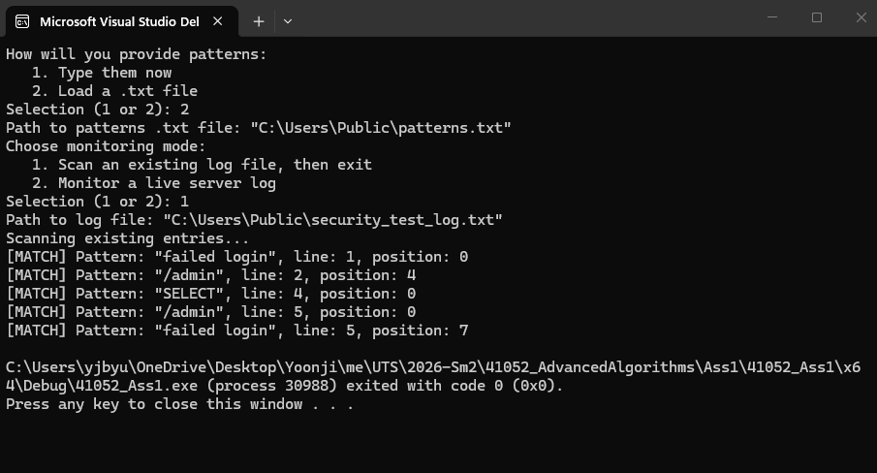
The tool detected “failed login” at position 0 on line 1, “/admin” at position 4 on line 2, and “SELECT” at position 0 on line 4. On line 5, the tool detected both “/admin” at position 0 and “failed login” at position 7. Positions are counted from zero.
This example demonstrates that the automaton can search for all supplied patterns in each log line and report multiple matches from the same line. The same automaton was reused throughout the scan rather than performing a separate scan for each pattern.

3. What I Learned
Before starting this project, I did not realise how many string-matching algorithms there were. I chose Aho-Corasick partly because it is used in cybersecurity, and I initially assumed that meant it was the fastest option. As I was conducting a research for this project, I learned that there were many other string-matching algorithms, and that their usefulness depends on the task. For example, Boyer-Moore can be effective when searching for one pattern in a long text, while Rabin-Karp uses hashes to help find matching passages, which is useful in plagiarism detection. Aho-Corasick is particularly useful when searching for many patterns in the same text, as my log-monitoring tool does. This taught me that there is no single best string-matching algorithm for every situation; choosing one requires understanding what needs to be searched and how.
During implementation, one difficulty I encountered was translating the operations in the pseudocode into C++. For example, $goto\left(state, a\right)=s$ describes a transition from one state to another. but it does not show how to store that transition. At first, I thought I needed a map to hold all three values: the current state, the character, and the next state. I had thought of an index mainly as a way to find a stored value, like a page number in a book. I then realised that the index itself could represent a state. This let me represent the previous pseudo-operation as $nodes\left[state\right].goTo\left[a\right]=s$. I also learned that translating pseudocode does not always mean writing the same condition in C++. the pseudocode can test whether $goto(state, a)$ returns $failure$, but my map contains only characters with existing transitions. In my code, the equivalent condition checks whether the current state’s transition map contains any entry for the character $a$. The key lesson I learned was that I could not translate the pseudocode statement by statement; I had to consider how my data structures represented each operation, then write C++ conditions that produced the same behaviour.
While selecting appropriate data structures, another decision I needed to make was how to store the structures efficiently. For output lists, for example, I thought a map would be more efficient than a vector of vectors because it would avoid storing an empty list for every state without a match. After comparing the two, I realised that a map would save space only if relatively few states had outputs, since each map entry also uses extra memory. A vector, meanwhile, lets me access an output list directly using its state number, whereas lookup in a map takes $O\left(\log{k}\right)$ time. Because the states in my project are numbered consecutively and their number is manageable, I changed my mind and chose a vector. I learned that judging efficiency requires considering both time and space complexity in the context of how the program will be used.
I also encountered a problem with the tool’s interface. The program asks users for a file path so it can read the file, but I had not realised that Windows’ “Copy as path” option may include quotation marks around the path. During testing, I found that entering those quotation marks prevented the program from opening the file. I changed the code to remove them when they appear at both the beginning and end of the input. This taught me to test the program from a user’s point of view, because a step that seems obvious to me as the developer may not be obvious to someone using it.

4. AI Use
4.1 What Tool I Used, and What For
I used ChatGPT from time to time throughout this assessment, including during my study of Aho-Corasick, implementation, testing and report writing. Its use was heavier for the log-reading implementation than for the core matching algorithm.
I initially used ChatGPT to check my understanding and interpretation of the pseudocode from the paper by Aho and Corasick. During implementation of the automaton, I wrote the code by translating the pseudocode myself and used ChatGPT mainly to review my logic, identify possible edge cases, and check whether I was proceeding correctly.
I relied on ChatGPT more when implementing file input and live-log monitoring because I had no experience writing a C++ program that continuously read a changing text file. It especially assisted me with implementing a way to open files and process them line by line. ChatGPT was also used to interpret compiler and runtime errors, propose test cases, and review report drafts against the assessment specification.
4.2 Examples Where AI was Wrong, Unhelpful, or Misleading
One incorrect suggestion occurred while I was implementing the search operation. I wanted to check and compare whether my implementation was correct and efficient, so I asked ChatGPT how it would implement the search operation. However, there were two crucial problems in the suggested code. One was that it proposed code that created an iterator for the transition map before entering the failure-link loop (see Figure 2). When the loop changed the current state, the iterator was not recalculated for the new state. Also, it contained a redundant $else$ branch that assigned $state=0$ (see Figure 2). If that branch was reached, the failure-link loop had already terminated at state 0, so the assignment had no effect. I was able to detect these errors, so I was able to not consume every piece of code, even the wrong ones from ChatGPT, and only use suitable and correct code that I had missed.
Another problem occurred during the implementation of live-log monitoring. The initial AI-assisted version kept the log file open using an input stream. In my Windows testing environment, this prevented PowerShell from opening the same file to append new entries, as shown in Figure 3. I changed the implementation so that it periodically opens the file, resumes from its saved position, processes newly appended lines, and closes the file again. This solution worked during testing, but it does not completely eliminate the possibility of a writer attempting to access the file during the short reading interval. A production implementation would require more robust operating-system-specific handling of file sharing and log rotation.
Figure 2
Code suggestion containing unnecessary lines
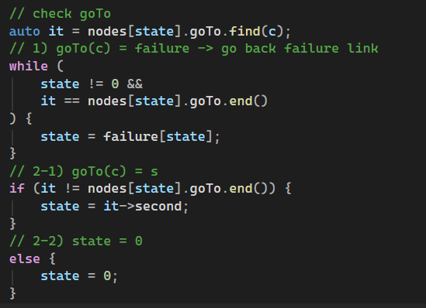
Figure 3
Error when appending new lines to the log
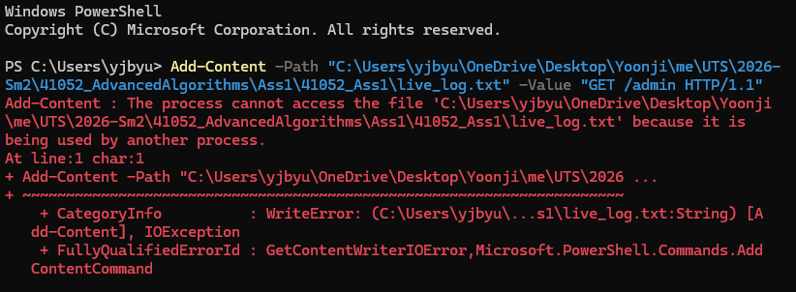
4.3 What I Understood vs. What I Took on Trust
I understood the central Aho-Corasick algorithm, including trie construction, failure-link construction, output computation, and the search process. I implemented these components by interpreting the original pseudocode rather than asking ChatGPT to generate the complete algorithm. When ChatGPT suggested a correction, I examined the relevant states and conditions myself before applying it. I also tested the resulting behaviour using small pattern sets with overlapping and multiple matches.
On the other hand, I had less understanding of the operating system and file stream behaviour involved in live-log monitoring. I relied more on ChatGPT for opening files, preserving the read position and polling for appended entries. I understood the overall control flow, but I took some lower-level details about file access and sharing on trust after testing them in my Windows environment. Passing these tests does not establish that the implementation will behave identically on every operating system or under production workloads.
During this project, I learned that AI output cannot be assumed to be correct simply because it looks technically plausible. Reviewing the proposed control flow and testing it under realistic conditions exposed problems that were not obvious from reading the generated code alone.

5. Reference
Aho, A. V., & Corasick. M. J. (1975). Efficient String Matching: An Aid to Bibliographic Search. Communications of the ACM, 18(6), 333-340. https://doi.org/10.1145/360825.360855

