Insurance Loss Analytics
Predicting Claim Frequency, Loss Cost & Historically Adjusted Loss Cost

A Tweedie-aware machine learning pipeline engineered for fairer auto insurance premiums

Group 7

Name | Student ID
Naivedhya Shah | 9803652253
Olivia Cai | 1793053099
Huanxuan Tang | 5243076127
Shravya Addanki | 5549935642
Junshu Xin | 5096298068
Xinze Chi | 2534843282

Executive Summary
Auto insurers face a fundamental pricing challenge: price a risky policyholder too low and the portfolio bleeds on claims; price a careful driver too high and they walk to a competitor. Solving this requires accurate prediction of expected losses at the individual policy level. This report documents our pipeline for predicting three targets on 39,928 training policy-year transactions and generating final predictions for 13,310 unseen policyholders: Claim Status (CS), whether a policy results in any claim; Loss Cost per Exposure Unit (LC), the expected average cost; and Historically Adjusted Loss Cost (HALC), LC scaled by the policyholder's long-run claim frequency. The data poses two structural challenges that shaped every modeling decision: 88.8% of LC values are exactly zero, and the positive tail is heavily right-skewed with values reaching 35,191 for LC and 78,131 for HALC.
To handle zero-inflation and skewness, we adopted the Tweedie distribution as the regression framework, which natively combines Poisson and Gamma components in a single loss function. Tuned LightGBM and XGBoost models with Tweedie objectives achieved 5-fold CV MSE of 256,934 on LC and 1,064,788 on HALC, improving meaningfully on the Tweedie GLM baseline (260,385 and 1,076,974). For claim classification, a stacking ensemble of logistic regression, Random Forest, XGBoost, and LightGBM achieved a validation ROC-AUC of 0.7886 (95% bootstrap CI: [0.7737, 0.8033]). Isotonic calibration was applied to correct systematic probability over-prediction, reducing LightGBM's Brier score from 0.1623 to 0.0861 and making outputs suitable for direct use in premium formulas. SHAP analysis identifies policy duration, cancellation history, and net premium as the dominant predictors across both tasks. Decile lift analysis confirms the top 10% of predicted-risk policyholders account for 32% of all actual claims at 3.2 times the base rate.
These results have direct underwriting implications. The top 10 to 20% of policyholders by predicted risk should face premium surcharges and be flagged for closer review, since this segment concentrates the majority of portfolio loss. The bottom two deciles, where long policy tenure and low mileage are confirmed protective factors, are strong candidates for loyalty pricing and retention offers. Together, the models enable a risk-tiered pricing structure that is actuarially grounded, calibrated for regulatory defensibility, and immediately actionable by underwriting teams.

1 Approaches Considered
1.1 Task 1: Regression Modeling for LC and HALC
With 88.8% of LC values being exactly zero and positive values following a heavy right tail, standard regression fails. The Tweedie distribution is the actuarially correct choice: it combines a Poisson component for whether a claim occurs with a Gamma component for how large it is, handling both zero-inflation and skewness in a single model. We began with a Tweedie GLM as an interpretable baseline, then moved to gradient boosted models with native Tweedie objectives, tuning the variance power p alongside all other hyperparameters via 40-iteration randomised search with 5-fold cross-validation. We also prototyped a two-part frequency-severity model that trains a logistic classifier to predict P(claim > 0) separately from a Gamma regressor on positive claims only, mirroring the classical underwriting decomposition. After testing, the single Tweedie booster matched its performance with considerably less implementation complexity, so we proceeded with the unified approach. A full comparison of all models evaluated, including hyperparameter configurations and performance trade-offs, is provided in Appendix Table A1.
1.2 Task 2: CS Classification (Binary)
With only 11.15% of policyholders filing a claim, a naive no-claim model achieves 88.85% accuracy while being useless for pricing. Because the competition provides a separate held-out test set (13,310 observations), we could not use it for model evaluation without leaking information. We therefore applied a stratified 80/20 split to the training data (31,942 training, 7,986 validation), giving a clean validation set the model never sees during training or tuning. Stratification preserves the 11% positive rate in every fold. Five-fold stratified cross-validation within the 80% training portion was used for hyperparameter search, and the held-out 20% provided an unbiased pre-submission performance estimate. A full breakdown of all models, imbalance treatments, and evaluation metrics is provided in Appendix Table A2.

2 Final Models and Model Selection

2.1 Task 1: Separate Winners for LC and HALC

Tuned LightGBM (p=1.1) achieved the best cross-validated MSE for LC at 256,934, while tuned XGBoost (p=1.3) won on HALC at 1,064,788. They differ because HALC incorporates the historical claim frequency ratio (X.18), creating a longer right tail. LightGBM's leaf-wise growth suited the more concentrated LC distribution, while XGBoost's depth-wise growth handled HALC's more extreme skew. Both were identified through 40-iteration randomized hyperparameter search with 5-fold cross-validation.

The tuned variance power values are themselves informative: a p of 1.1 for LC indicates near-Poisson behaviour, meaning this book has predominantly small, frequent claims, while a p of 1.3 for HALC reflects slightly more Gamma-like behaviour, consistent with the historical frequency ratio amplifying severity for repeat claimants. These are not arbitrary tuning outcomes but a direct signal about the structure of the underlying insurance book. Full model performance across all configurations is provided in Appendix Table A3.
2.2 Task 2: Stacking Ensemble as Final CS Model
The stacking ensemble (ROC-AUC 0.7886, bootstrap CI [0.7737, 0.8033]) combines logistic regression, Random Forest, XGBoost, and LightGBM through a logistic meta-learner trained on out-of-fold predictions, preventing any single model from dominating. The tradeoff between accuracy and interpretability deserves careful consideration rather than a simple answer. The ensemble maximises ranking performance and suits portfolio-level risk segmentation, but lacks single-model transparency. For decisions requiring clear regulatory justification, the calibrated LightGBM is the better choice, since SHAP provides reliable feature-level attribution at the individual policy level. The ensemble is reserved for contexts where predictive accuracy is paramount and explanations are not required. This framing treats the two objectives as a managed tradeoff rather than a binary choice.
Why Class Weighting Beat SMOTE
All three logistic variants produced near-identical ROC-AUC (~0.72), confirming the imbalance treatment matters less than the model family. SMOTE degraded probability estimates (LogLoss 0.615 vs. 0.319) because synthetic interpolated samples introduce noise near the decision boundary. Class weighting penalises missed claims more heavily during training without altering the underlying data distribution, producing cleaner outputs.
Probability Calibration
Tree models rank policyholders well but systematically over-predict claim probabilities, making raw outputs unreliable for direct premium pricing. Isotonic calibration is a post-processing step that maps predicted scores to true empirical claim rates — correcting for this compression so that a model predicting a 20% claim probability corresponds to an actual 20% empirical claim rate. After calibration, LightGBM's Brier score improved from 0.1623 to 0.0861, making the probabilities suitable for direct use in a premium pricing formula.

3 Model Interpretation and Business Analysis
3.1 SHAP Analysis
SHAP was applied to both the LightGBM regression and classification models. For LC prediction, the top five features by mean absolute SHAP value are:

• policy_duration (0.553): The dominant predictor. Long-tenure policyholders have lower predicted loss costs; over time, higher-risk policyholders either claim and get repriced or exit, leaving a safer residual pool.
• X.12 cancellations (0.402): Number of policies cancelled for non-payment. Higher cancellation history signals financial instability and correlates with higher losses.
• X.14 net premium (0.305): Higher premiums correlate with higher predicted losses as premiums reflect prior insurer risk assessments and vehicle values.
• X.13_1 half-yearly payment (0.142): Instalment payers carry higher predicted risk than annual payers.
• X.8 years with insurer (0.113): Long-standing customers are lower risk, consistent with the policy duration finding.

For CS classification, the same drivers emerge: policy duration and driving experience reduce claim probability, while urban location (X.20_1) and high cylinder capacity (X.24) are the primary risk amplifiers. Logistic coefficients confirmed that agricultural vehicles (X.19_4) carry significantly lower risk than motorbikes or passenger cars.
3.2 Business Understanding
Variable selection was essential at two levels. Outcome-derived variables X.15 through X.18 encode post-loss information that would not be available at underwriting time and were excluded regardless of their apparent predictive signal. Keeping them would have constituted data leakage. Beyond leakage, retaining too many variables increases the risk of inadvertently proxying protected attributes, which creates regulatory exposure. The final 25-variable set is a deliberately curated subset that balances predictive power with underwriting legitimacy.
On the question of transferability, this model is specific to auto insurance and cannot be applied to life insurance without a fundamental redesign. Auto claims are triggered by acute events over short policy horizons and follow a Tweedie distribution; life insurance involves mortality and morbidity over multi-decade horizons, requires survival analysis frameworks, and demands an entirely different feature set. The two domains share modeling vocabulary but not modeling assumptions.

4 Innovations
Four analytical enhancements were developed beyond the standard evaluation framework, each translating model performance into a business-actionable insight.
- Tweedie variance power grid search. We tested p across five values rather than accepting the default of 1.5. The optimal p = 1.3 reduced LC MSE by 1.3% and revealed that this portfolio has many small frequent claims rather than rare large ones, which is itself a useful actuarial insight about the book.
- Isotonic probability calibration. Brier score drops from 0.1689 to 0.0863 after calibration, a 49% improvement. This is the step that turns a good ranker into a model whose probabilities can actually feed into a premium formula rather than just rank policyholders.
- Cost-sensitive threshold optimization. Missing a claimant costs far more than a false positive in practice. We found the threshold that minimises total expected cost assuming a missed claim costs 10 times more than a false alarm, producing a decision rule an underwriting team could use directly rather than defaulting to 0.5.
- Decile lift analysis. The top 10% of predicted risk accounts for 32% of all actual losses, a 3.2x lift over random. An insurer acting only on the top decile covers more than one in three pounds of total loss exposure while reviewing just one in ten customers. This translates ROC-AUC into a number that a business can act on.

5 Conclusions
This project demonstrates that auto insurance adverse selection can be addressed with a structured, evidence-driven pipeline. The five key decisions driving performance were: choosing Tweedie loss for zero-inflated right-skewed data, tuning the variance power parameter rather than using the default, using tree ensembles because risk relationships are nonlinear, class weighting over SMOTE to preserve data integrity, and isotonic calibration as a mandatory step before any probability feeds into pricing. The final models achieve a 5-fold CV MSE of 256,934 on LC and 1,064,788 on HALC, and a ROC-AUC of 0.7886 on CS. The top risk decile captures 32% of all actual claims at 3.2 times the base rate.

Recommendations for Business Stakeholders
- Premium tiering: The top predicted risk decile should face premium loading and closer underwriting review given their disproportionate claim concentration.
- Calibrated probabilities in pricing formulas: Calibrated LightGBM probabilities should feed directly into premium calculations, not just be used for ranking.
- Cost-sensitive thresholds: The optimised claim classification threshold should replace the default 0.5 cutoff to better suit business needs and cost considerations.
- SHAP reason codes: SHAP-based attributions should accompany adverse pricing decisions to satisfy regulatory requirements.
- Annual retraining: The model should be retrained annually as portfolio composition drifts, with drift monitoring between retraining cycles.

Limitations
The model is trained on a single underwriting year and should be monitored for drift as driving patterns, vehicle mix, and economic conditions evolve. It is specific to motor insurance and cannot be transferred to life insurance without a fundamental redesign, as that domain requires survival analysis frameworks rather than binary classification and Tweedie regression.

Appendix

Table A1: Regression Model Comparison — LC and HALC

Model | Key Parameters | Strength | Weakness
Tweedie GLM (baseline, p=1.1) | TweedieRegressor, log link, alpha=0.1 | Interpretable; actuarially principled | Linear; misses interactions
XGBoost baseline (p=1.5) | 500 estimators, lr=0.05 | Captures interactions | Default p=1.5 sub-optimal
LightGBM baseline (p=1.5) | 1,000 estimators, lr=0.03 | Fast; efficient on large data | Default p=1.5 sub-optimal
XGBoost tuned (p=1.3) ★ | 925 estimators, lr=0.017, depth=3 | Best HALC MSE; optimal variance power | Less interpretable without SHAP
LightGBM tuned (p=1.1) ★ | 838 estimators, lr=0.008, leaves=21 | Best LC MSE; efficient leaf-wise growth | Less interpretable without SHAP

Table A2: Classification Model Comparison — CS

Model | Imbalance Strategy | ROC-AUC | PR-AUC | Brier | LogLoss
Logistic (unweighted) | None | 0.7232 | 0.2371 | 0.0928 | 0.3194
Logistic (balanced) | Class weight | 0.7239 | 0.2328 | 0.2153 | 0.6161
Logistic + SMOTE | Oversampling | 0.7190 | 0.2279 | 0.2155 | 0.6150
Random Forest | Balanced subsample | 0.7691 | 0.2986 | 0.1473 | 0.4530
XGBoost (baseline) | scale_pos_weight | 0.7799 | 0.3329 | 0.1472 | 0.4445
LightGBM (baseline) | Class weight | 0.7880 | 0.3478 | 0.1623 | 0.4836
XGBoost (tuned) | scale_pos_weight | 0.7840 | 0.3284 | 0.1783 | 0.5254
LightGBM (tuned) | Class weight | 0.7869 | 0.3501 | 0.1655 | 0.4915
LightGBM + calibrated | Isotonic cal. | 0.7865 | 0.3439 | 0.0861 | 0.2927
Stacking Ensemble ★ | Via base models | 0.7886 | 0.3440 | 0.1913 | 0.5621

★ denotes final selected model. All metrics reported on held-out validation set.

Table A3: Regression Final Model Performance Comparison
Model | 5-fold CV MSE (LC) | 5-fold CV MSE (HALC) | Tweedie p
Tweedie GLM (baseline) | 260,385 | 1,076,974 | 1.1
XGBoost Tweedie (base) | 259,418 | 1,071,200 | 1.5
XGBoost Tweedie (tuned) ★ | 257,072 | 1,064,788 | 1.3

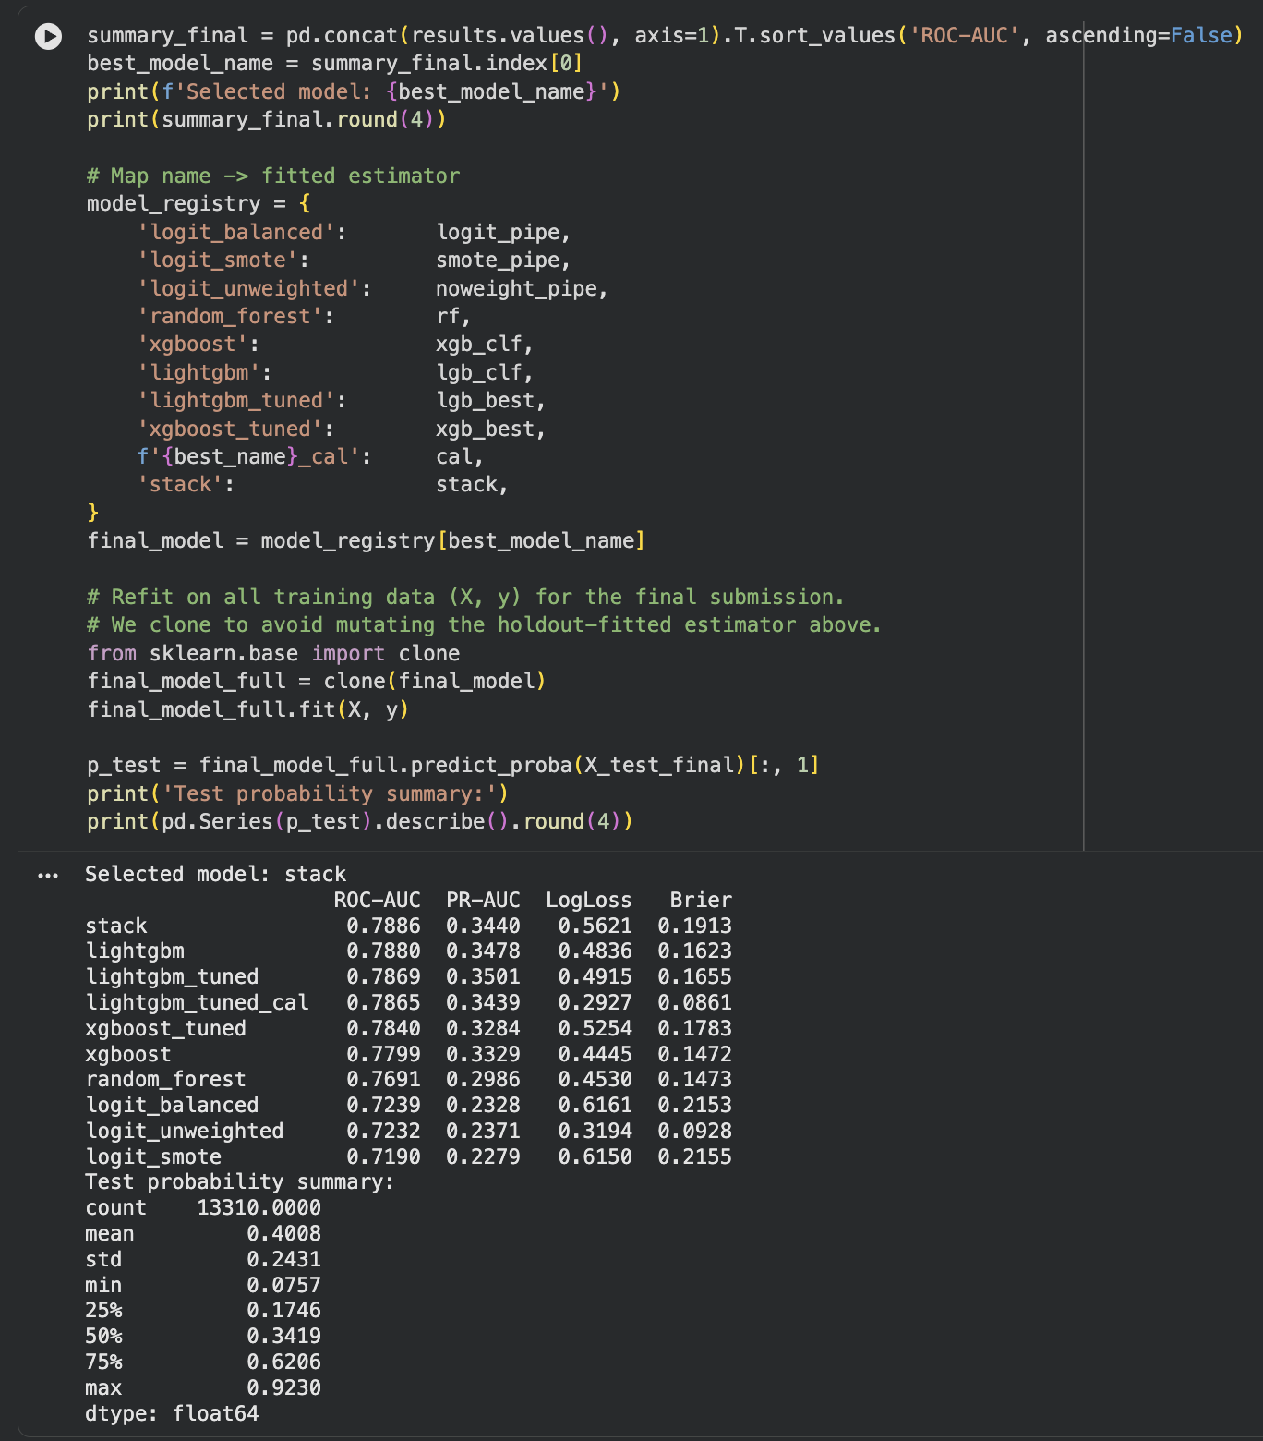
Table A4: Classification Model Performance Summary — Full Evaluation Output (CS Task)

