**Planning**

**Decomposing the program:**

The full functioning program needs to have a list of movies that the user can cycle through and rate. At any time the user can search for movies with a specific rating, and will be taken to a summary screen which lists all of the movies with a specific rating. Then they can search again or return to the rating screen.

1. Get the rating frame to work
   1. Set up the frame and get the rating to work for ONE movie
   2. Set up the next button to cycle through the movies
   3. Set up the previous button so the user can go backwards as well
2. Set up the search frame
3. Combine the search and rating frame into the first screen.
4. Get search functionality to work
   1. Pressing go button will hide rating frame and show summary frame
   2. Get summary frame to show the movies
   3. Get back button to hide summary and show rating frame.­­­

**Test Plan**

|  |  |
| --- | --- |
| **Test** | **Expected Result** |
| Rating (One movie) | |
| Rate a movie 1 | It will show up for searches of 1 |
| Rate a movie 2 | It will show up for searches of 2 |
| Rate a movie 3 | It will show up for searches of 3 |
| Rate a movie 4 | It will show up for searches of 4 |
| Rate a movie 5 | It will show up for searches of 5 |
| Rating multiple movies | |
| Rate two or more movies the same thing  (e.g. try rating multiple 3 or multiple 5) | All movies with that rating should show in the scrolled text for that option. If there are more than it can fit, there should be a scroll bar option. |
| Don’t rate any | All movies should show up in the no rating search option |
| Search after rating only one or two movies  (e.g. rate the first movie 1 and then no others) | The movies that have been rated should show up in their respective searches – in this case, 1. The others should all be in the no rating search option. |
| Next and Previous buttons | |
| Press the next button until you reach the last movie in the list | The next button should disable |
| Press the back button from the last movie in the list | The next button should re-enable |
| Press the back button until you reach the first movie in the list | The back button should disable |
| Press the next button from the first movie in the list | The back button should re-enable |
| Searching | |
| RB1 + go | Will search for all movies with rating 1 |
| RB2 + go | Will search for all movies with rating 2 |
| RB3 + go | Will search for all movies with rating 3 |
| RB4 + go | Will search for all movies with rating 4 |
| RB5 + go | Will search for all movies with rating 5 |
| No radio button, just press go | Go button should be disabled unless radio button pressed, so it should not work. |
| Summary Menu | |
| Searching (see searching tests above) | Should work the same as with the search frame on the rating screen |
| Press back to rating button | Should take you back to the rating screen, at the position you were on before you searched, with the right rating selected if the movie has been rated. |

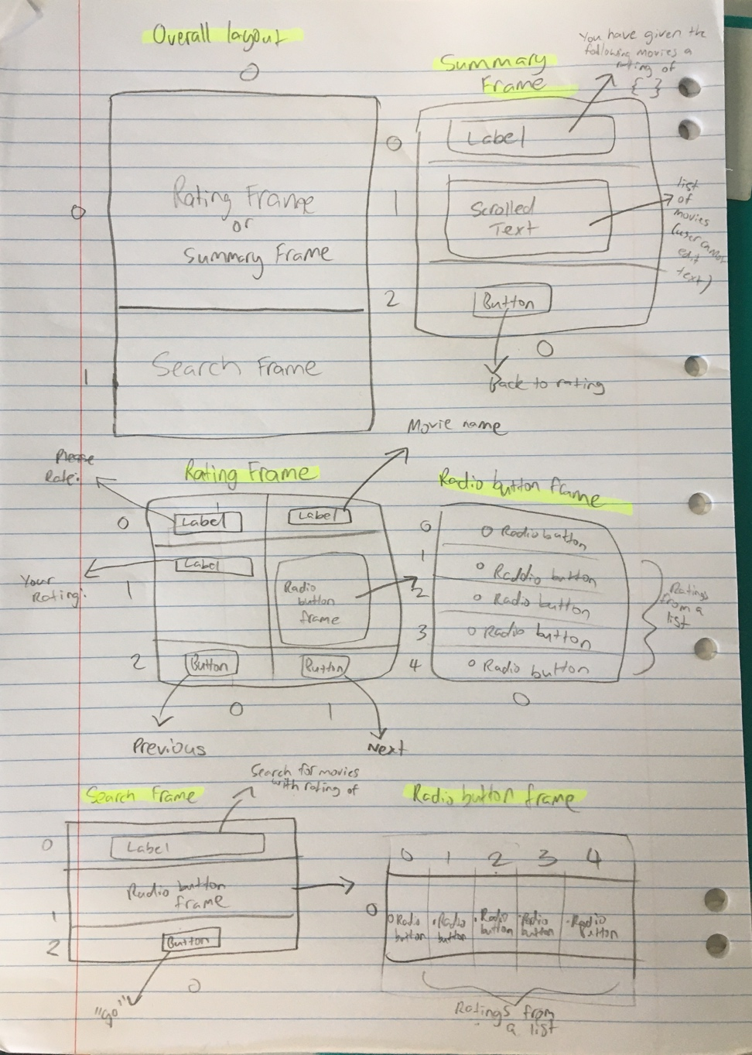

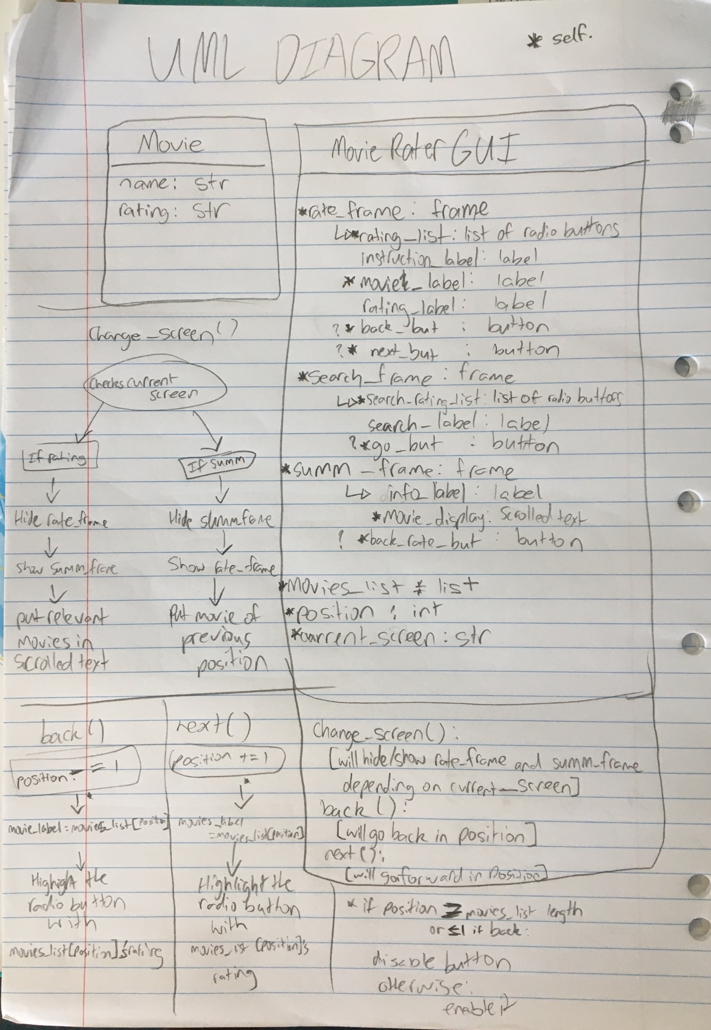

**Movies to use in the program:**

* The Hobbit
* The Titanic
* Jurassic Park
* Spirited Away
* Mary Poppins
* The Lion King
* The Wizard of Oz
* E.T. the Extra Terrestrial