Using the Storytelling Playlist App

The playlist app is a storytelling template that organizes point data sets, usually from a CSV file embedded in a web map, into an organized interactive list. Your audience can explore the points from the map itself or they can click on a corresponding item in a list.

# The Project

The project we chose was a story map version of the most visited US National Parks. The list of the most visited parks is published online as a [PDF](http://www.nps.gov/news/upload/NPS-Visitation-historic-and-top-10-2012.pdf) by the National Park Service. We used the statistics from that report, and also used photos and text from the websites of the top ten parks.

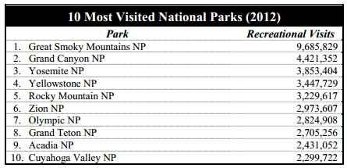

# The Steps

To create a playlist tour follow a few simple steps, outlined below. To successfully publish your story map using this template you’ll need to be able to host the application and the photos you will use on a publicly accessible server and you’ll also need an ArcGIS Online account (public or subscription) to author and save the map used in the playlist.

### Step 1 ­– Set up a testing directory

Extract all the contents of the *deploy* folder into a folder in your inetpub \wwwroot folder or local web server. Later, to complete our story map, we’ll be editing the index.html file that is within the deploy folder.

## Step 2 – Make you thumbnails

For each location on your map you’ll need a photo or graphic to use as the thumbnail in the list. The size of the thumbnail is 70 x 70 pixels, larger thumbnails will be resized automatically to fit. To optimize your story map keep the file size to a minimum, and keep a square format to avoid distortion. Shown below is what the thumbnails will look like in the playlist story map:

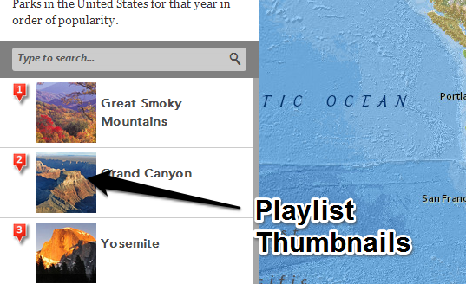

For our National Parks playlist we also wanted to include a photo in the pop-up for each location. This isn’t a requirement to use the playlist template, but we thought it would make a nice addition.

The optimal size for pop-up photos is 200 x 150 pixels. To save time, and avoid having to save two images for each location, we used a single image of 150 x 150 px for both the thumbnail and pop-up. We chose a square 150 px image for both, since it would avoid thumbnail distortion when resized, and still fit nicely in our pop-up. Here are both as they appear in our final story map:

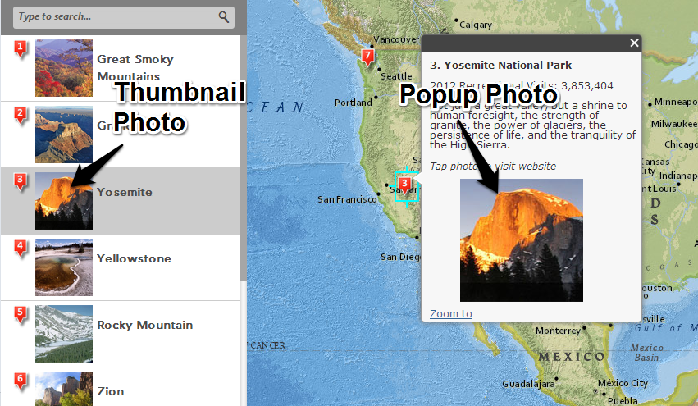

Once you’ve named and edited your photos, upload them to your web location so they can be referenced in the application via their URL. For example, below is the URL to one of the photos used in our application:

<http://downloads.esri.com/agol/pub/npstop102012/graphics/zion.jpg>

## Step 3 – Create a CSV for your locations and other information

You can use a comma-separated value (CSV) file to add your playlist locations to your web map, and store other information used by the template and the pop-up. You can use Notepad or any other text editor to create one, but it’s often easiest if you use Excel.

There are several required fields:

* **Order** – the order that the locations in the CSV will appear in the application list, and also the number that will appear on the map icon. This is optional, and only needed if overwriting the default order (e.g., you want the 5th item to be numbered 2), but it’s a good idea to use this field even if not changing the order, just keep things easily to understand and neat in your CSV.
* **Name** – the title for the playlist item in the side panel. If the field “Name” is not found, the application will use the first text attribute.
* **Color** – use if two icon colors are desired. Using “b” will display a blue icon, otherwise red will be used. If the field is not present all icons will be red.
* **Thumb_URL** – URL location of the image used as the side panel thumbnail. If not present, the app will look for the first attribute that has a string with an image type as a file extension (.gif, .jpg, .png, etc.).
* **Filter** – the filter attribute is an optional field that can be added to your data to extent the built in search capabilities. If the data has a filter field, the app will add a new filter option for each unique value in this field.

Because all of our playlist points are from a common category, we will not include a filter field.

In addition to the fields above, for the NPS top 10 we also used other fields in our CSV for the location and other information that we wanted to display in the pop-up, as follows:

* **Latitude, Longitude** – location of each park.
* **Description** – a text string with a brief description of each park used in the pop-up window.
* **Website_URL** – the park website to open when the photo in the pop-up is clicked.
* **Visits** – the number of visitors in 2012 that the park received, also used in the pop-up.

Shown below is the spreadsheet used for our NPS playlist. You can download the spreadsheet from ArcGIS Online.

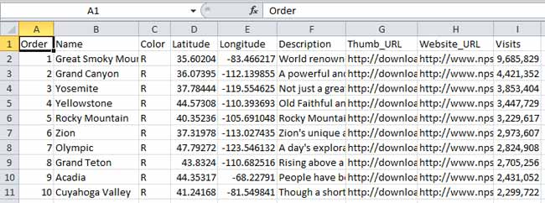

## Step 4 – Author and configure the web map

Open a new map and drag and drop the completed CSV file onto the map, or click Add, then Add Layer from File to add the CSV. Change the basemap and add additional layers as desired.

Symbols used in your web map will be ignored by the playlist template; a red, blue, green, or purple icon with the order number will automatically be substituted. But since the map can be publicly discovered outside the context of the playlist application, it’s a good idea to follow best practices and author a complete and well-documented map.

Configure the pop-up for each location. For our project we wanted to include the number of visitors in 2012, a short description, and a photo the user can click that links to the park website.

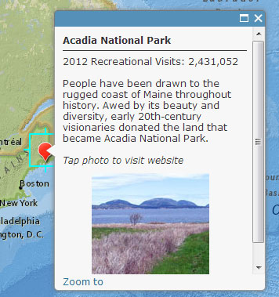

Zoom to where you would like your initial map extent to be, and save your map.

By default, the title of your map item will be used as title of the application, the item summary will become the subtitle, and the map item description will appear in the top left panel. These can be overridden by editing the index.html, see Step 5 below.

Be sure to share your map publicly when finished. The map used in this example can be found here:

<http://www.arcgis.com/home/item.html?id=17898ee9d0794193815c32b468bb5037>

## Step 5 – Configure your playlist index.html

Using any text editor, edit the playlist index.html (see Step 1) to insert your saved web map ID and other variables. Scroll most of the way to the bottom and you will find the configuration section; it will start with *var configOptions*.

Now you will want to replace the current web map ID with the ID of the new web map you just created.

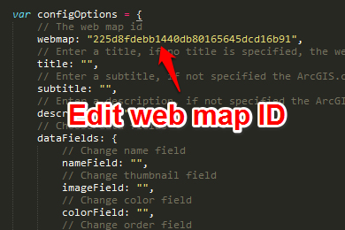

Additionally, you will want to modify the following options as needed:

* **title/subtitle/description** - optionally add text to override the web map's title/subtitle/description that was saved on ArcGIS Online.
* **dataFields** - if any of the field names in your point layer do not match those list in Step 3, add the new name to its corresponding option.
* **layerTitle** - add a name for your playlist point layer to be used in the legend.
* **visible** - choose to display your playlist point layer in the legend (true or false).
* **items** - for each item, choose to display the item in the legend with the visible option (true or false) and the name used in the legend with the name option.

## Step 6 – Upload your application

Once you’ve completed the steps above, copy the entire template folder to a publicly accessible server and you’re finished, and ready to share your story map.

Here’s our completed [NPS Top 10](http://esri.github.io/playlist-storytelling-template-js/deploy/) playlist application.

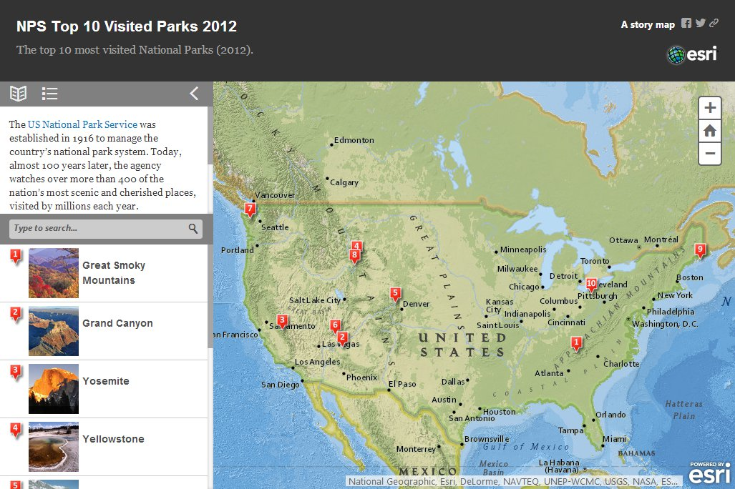

## Step 6 – Add a ‘web mapping application’ entry on ArcGIS Online to represent your playlist

Now you've deployed your playlist, we recommend that you add a 'web mapping application' entry, [like this one](http://www.arcgis.com/home/item.html?id=96ea4a0f4af541129a29a63b4aa2e256) to represent your application in ArcGIS Online. You've already got an entry in ArcGIS Online for the web map you are using in your playlist, but you don't have an entry in ArcGIS Online for the application itself. Although you aren't required to add a 'web mapping application' entry into ArcGIS Online for your app, it is highly recommended because it enables people who search in ArcGIS Online to discover and launch your application, including Esri staff who are looking for cool new examples. Without one of these entries, people can find your web map but won't be able to find your app. It also enables your app to be added into ArcGIS Online galleries.

To add a 'web mapping application' entry, go to My Content in ArcGIS Online, and click the Add Item button, and then in the dialog that appears choose 'The item is an application', enter the URL of your playlist and other information, including tags. Be sure to include 'story map' and 'playlist' in the tags you add so that your entry can be found easily when people search for examples using those keywords. You should also include tags such as the name of the city, state or province, and country the playlist covers, plus additional Tags to reflect the theme or content of the playlist.

After you've added the entry, you should edit it directly in ArcGIS Online to give it a nice looking thumbnail image, like a little screenshot of the app, and specify additional credits, etc. The thumbnail image is important because if your app is added into a gallery, it is represented in the gallery with its thumbnail.

Finally, be sure to share your web mapping application entry publicly.

## Additional resources:

* [About authoring web maps](http://resources.arcgis.com/en/help/arcgisonline/010q/010q0000009p000000.htm)
* [About CSV files](http://resources.arcgis.com/en/help/arcgisonline/010q/010q0000008v000000.htm)
* [Configuring popups](http://resources.arcgis.com/en/help/arcgisonline/010q/010q0000004m000000.htm)
* [Story maps forum](http://forums.arcgis.com/forums/264-Story-Maps)