Windows 10 IoT Core on Raspberry Pi 2 – Prerequisites

# 1. Download Windows 10 and Install Visual Studio 2015

To setup your Windows 10 IoT Core development PC, you first need to install the following:

1. **Make sure you are running the public release of Windows 10 (version 10.0.10240) or better**. You can upgrade from [here](http://www.microsoft.com/en-us/software-download/windows10). If you are already running Windows 10, you can find your current build number by clicking the start button, typing “winver”, and hitting enter.
2. **Install Visual Studio 2015**
   1. We recommend [Visual Studio Community Edition](http://go.microsoft.com/fwlink/?LinkID=534599), but Visual Studio Professional 2015 and Visual Studio Enterprise 2015 will work as well (available [here](https://www.visualstudio.com/vs-2015-product-editions)).
   2. If you have to install Visual Studio, make sure to do a **Custom** install and select the checkbox **Universal Windows App Development Tools** -> **Tools and Windows SDK** and **Common Tools -> GitHub Extension for Visual Studio**.
   3. **Validate your Visual Studio installation** by selecting Help > About Microsoft Visual Studio. The required version of **Visual Studio** is 14.0.23107.0 D14Rel. The required version of **Visual Studio Tools for Universal Windows Apps** is 14.0.23121.00 D14OOB.
3. **Install Windows IoT Core Project Templates** from [here](https://visualstudiogallery.msdn.microsoft.com/06507e74-41cf-47b2-b7fe-8a2624202d36). Alternatively, the templates can be found by searching for Windows IoT Core Project Templates in the [Visual Studio Gallery](https://visualstudiogallery.msdn.microsoft.com/) or directly from Visual Studio in the Extension and Updates dialog (Tools > Extensions and Updates > Online).
4. **Enable developer mode** on your Windows 10 device by following [these instructions](https://msdn.microsoft.com/library/windows/apps/xaml/dn706236.aspx). The relevant portion of the linked instructions is the “Windows 10 Desktops/tablets” section, as you should be attempting setup with one of these devices.

# 2. Download and Install the Windows 10 IoT Core tools

The IoTCoreWatcher tool displays all the Windows 10 IoT Core devices on your network. Click [here](http://go.microsoft.com/fwlink/?LinkId=616847) to download it, and follow the instructions to install it. It should launch once it’s finished installing.

1. [Download](http://go.microsoft.com/fwlink/?LinkId=616847) the ISO for the Raspberry Pi 2 from the Microsoft Download Center.
2. **Save the ISO** to a local folder

http://ms-iot.github.io/content/images/SetupRPI/Iso.PNG

1. Double click on the ISO (IoT Core RPi.iso). It will automatically mount itself as a virtual drive so you can access the contents.

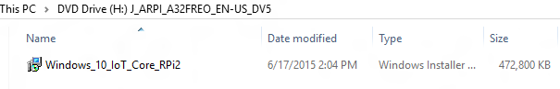

1. Install **Windows_10_IoT_Core_RPi2.msi**. When installation is complete, flash.ffu will be located at **C:\Program Files (x86)\Microsoft IoT\FFU\RaspberryPi2**

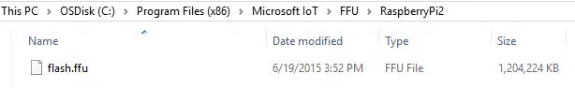

1. Eject the Virtual CD when done

# 3. [Optional] Install GitHub Desktop for Windows

1. Download [GitHub Desktop for Windows](https://desktop.github.com/).
2. Set up an account on [GitHub](https://github.com/).
3. Sign into GitHub Desktop with your GitHub account.