Windows 10 IoT Core on Raspberry Pi 2 –Listen to the Cloud

In order to confirm that your text messages are being sent to the Event Hub on Microsoft Azure, we can create a piece of code that simply reads new messages from the Event Hub back down to a console application on your device, in real time. As the LED turns on and off every 2 seconds, the console application shows the message and date in real time of the light turning on and off.

# File New Project

Open a new window in Visual Studio 2015 and choose File -> New -> Project

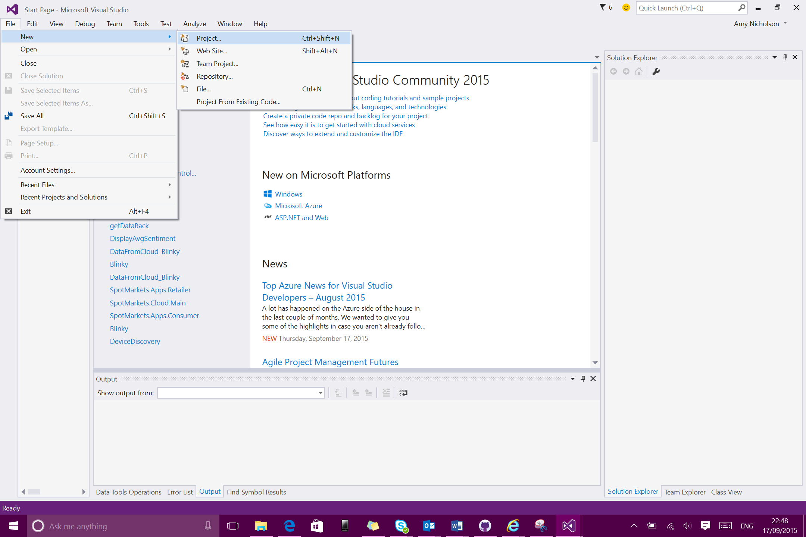

Then choose a new Visual C# Console Application and provide it with a name. Then click OK

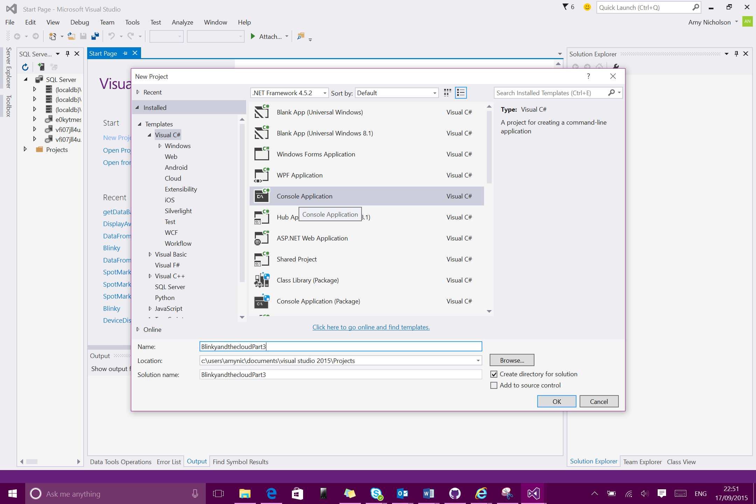

# Create Code for Event Hub Calls

Enter the Main method in Program.cs and enter the code below. Remember to substitute in the values for your Event Hub.

string ehname = "<eventhubname>";

string connection = "Endpoint=sb://<eventhubnamespace>.servicebus.windows.net/;SharedAccessKeyName=<policy>;SharedAccessKey=<key>;TransportType=Amqp";

MessagingFactory factory = MessagingFactory.CreateFromConnectionString(connection);

EventHubClient ehub = factory.CreateEventHubClient(ehname);

EventHubConsumerGroup group = ehub.GetDefaultConsumerGroup();

EventHubReceiver reciever = group.CreateReceiver("0");

while (true)

{

EventData data = reciever.Receive();

if (data != null)

{

try

{

string message = Encoding.UTF8.GetString(data.GetBytes());

Console.WriteLine(message + " " + DateTime.Now);

Console.WriteLine();

}

catch (Exception ex)

{

Console.WriteLine(ex.ToString());

}

}

}

This code sets up a programmatic connection to your event hub. It then looks for the next piece of data in the event hub and converts it to a string message and writes it to the console application along with the Date/Time.

# Build and Run the Solution

Now, in the solution explorer, right click on the solution and Build it

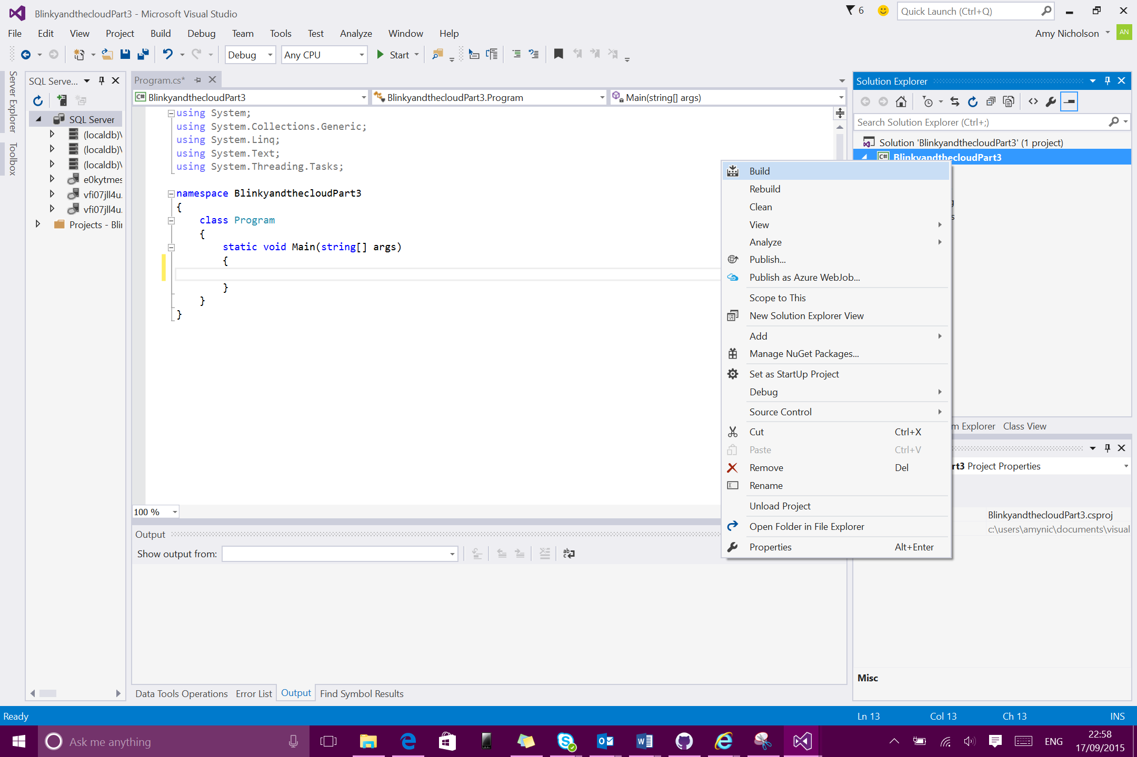

Now the code is ready to run, so start debugging by pressing ‘Start’ or F5

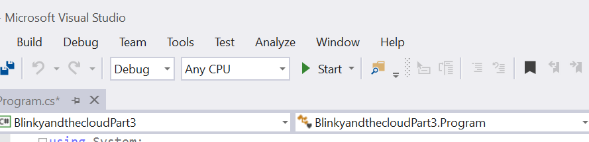

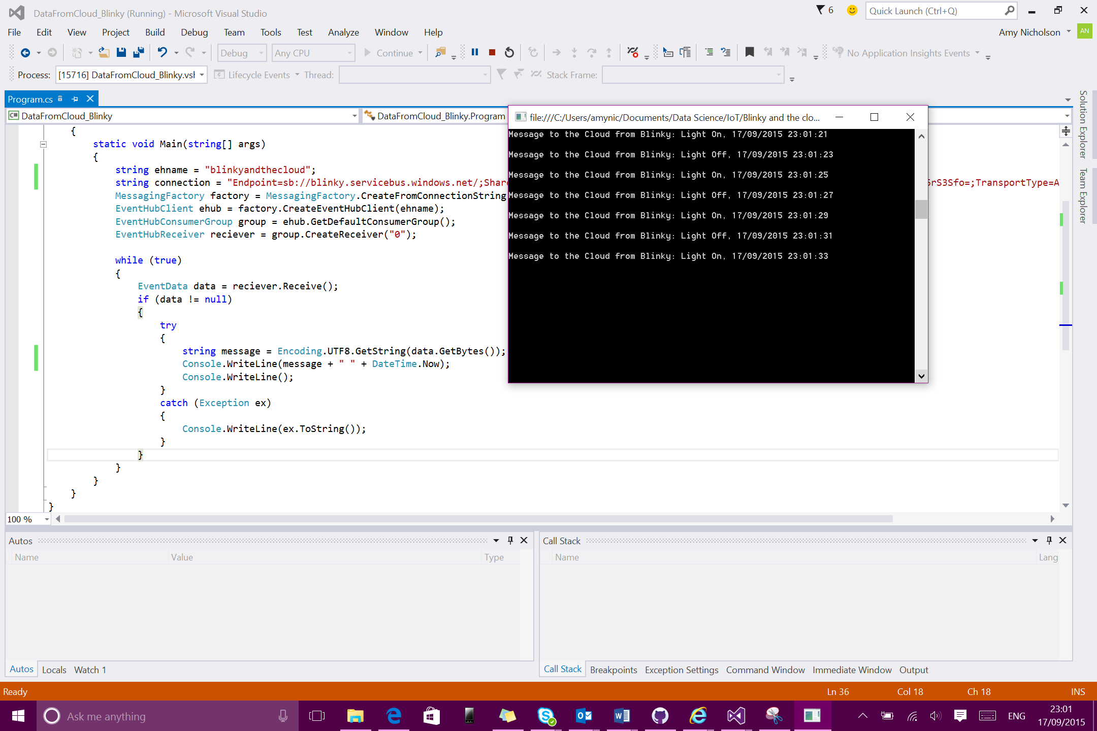When the Blinky solution is running and writing to the cloud, as well as the console application running, you should start to see the messages that are written to the cloud appearing in the console in real time, like below:

# Blinky and the Cloud – Review the Complete Solution

Within this 3-part tutorial, you have created a Universal Windows 10 app and deployed this to a RPI2 running Windows 10 IoT Core. You also controlled an LED light within the Universal Windows App.

In the 2nd part you started to connect your device to the Cloud, using Event Hubs – a data ingestion service. Each time the LED changes state, a message is written to the event hub in Microsoft Azure.

In the final part of this tutorial, you were able to confirm the device was writing data to the cloud by programmatically calling the event hub using a simple C# console application for each message in real time.

This is a small and simple scenario, however all the concepts and architecture explained here would be true in a real-life project.