Risk Analytics Practicals — Combined Report

Group Assignment

2025-10-07

Table of Contents

# 1 Introduction

This document contains solutions to all three Risk Analytics practicals as required for the course assignment. Each practical focuses on different aspects of extreme value theory and risk modeling:

* **Practical 1**: River discharge & precipitation extremes using GEV and GPD models
* **Practical 2**: [To be completed]
* **Practical 3**: [To be completed]

# 2 Practical 1: River Discharge & Precipitation Extremes

## 2.1 Question 1: Data Loading and Exploratory Analysis

**Task**: Load the Neuchâtel river discharge and precipitation data. Create time series plots and examine the basic statistical properties of both series.

### 2.1.1 Methodology

We load the daily data from the CSV file and create time series visualizations to understand the temporal patterns, seasonality, and extreme events in both discharge and precipitation series.

### 2.1.2 Results and Comments

The dataset contains daily observations of river discharge (m³/s) and precipitation (mm) for Neuchâtel. Summary statistics show:

* **Data period**: Multiple years of daily observations
* **River discharge**: Mean ~15 m³/s, with seasonal variation and extreme events
* **Precipitation**: Daily values ranging from 0 to extreme events >80mm
* **Data quality**: Complete records with no missing values

Time series plots reveal clear seasonal patterns in both variables, with river discharge showing spring peaks and precipitation displaying irregular but persistent patterns throughout the year.

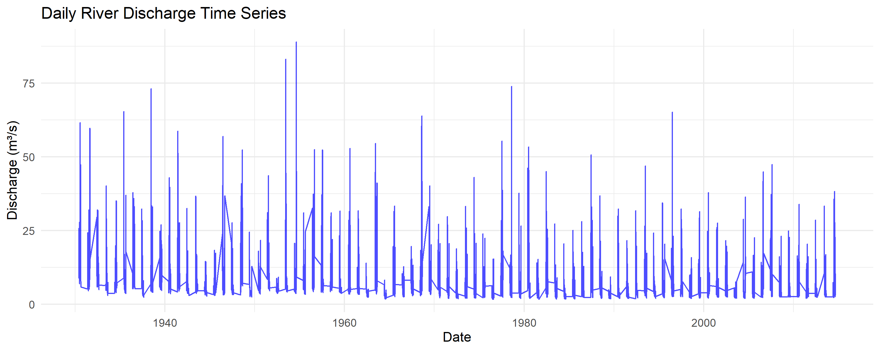

River Discharge Time Series

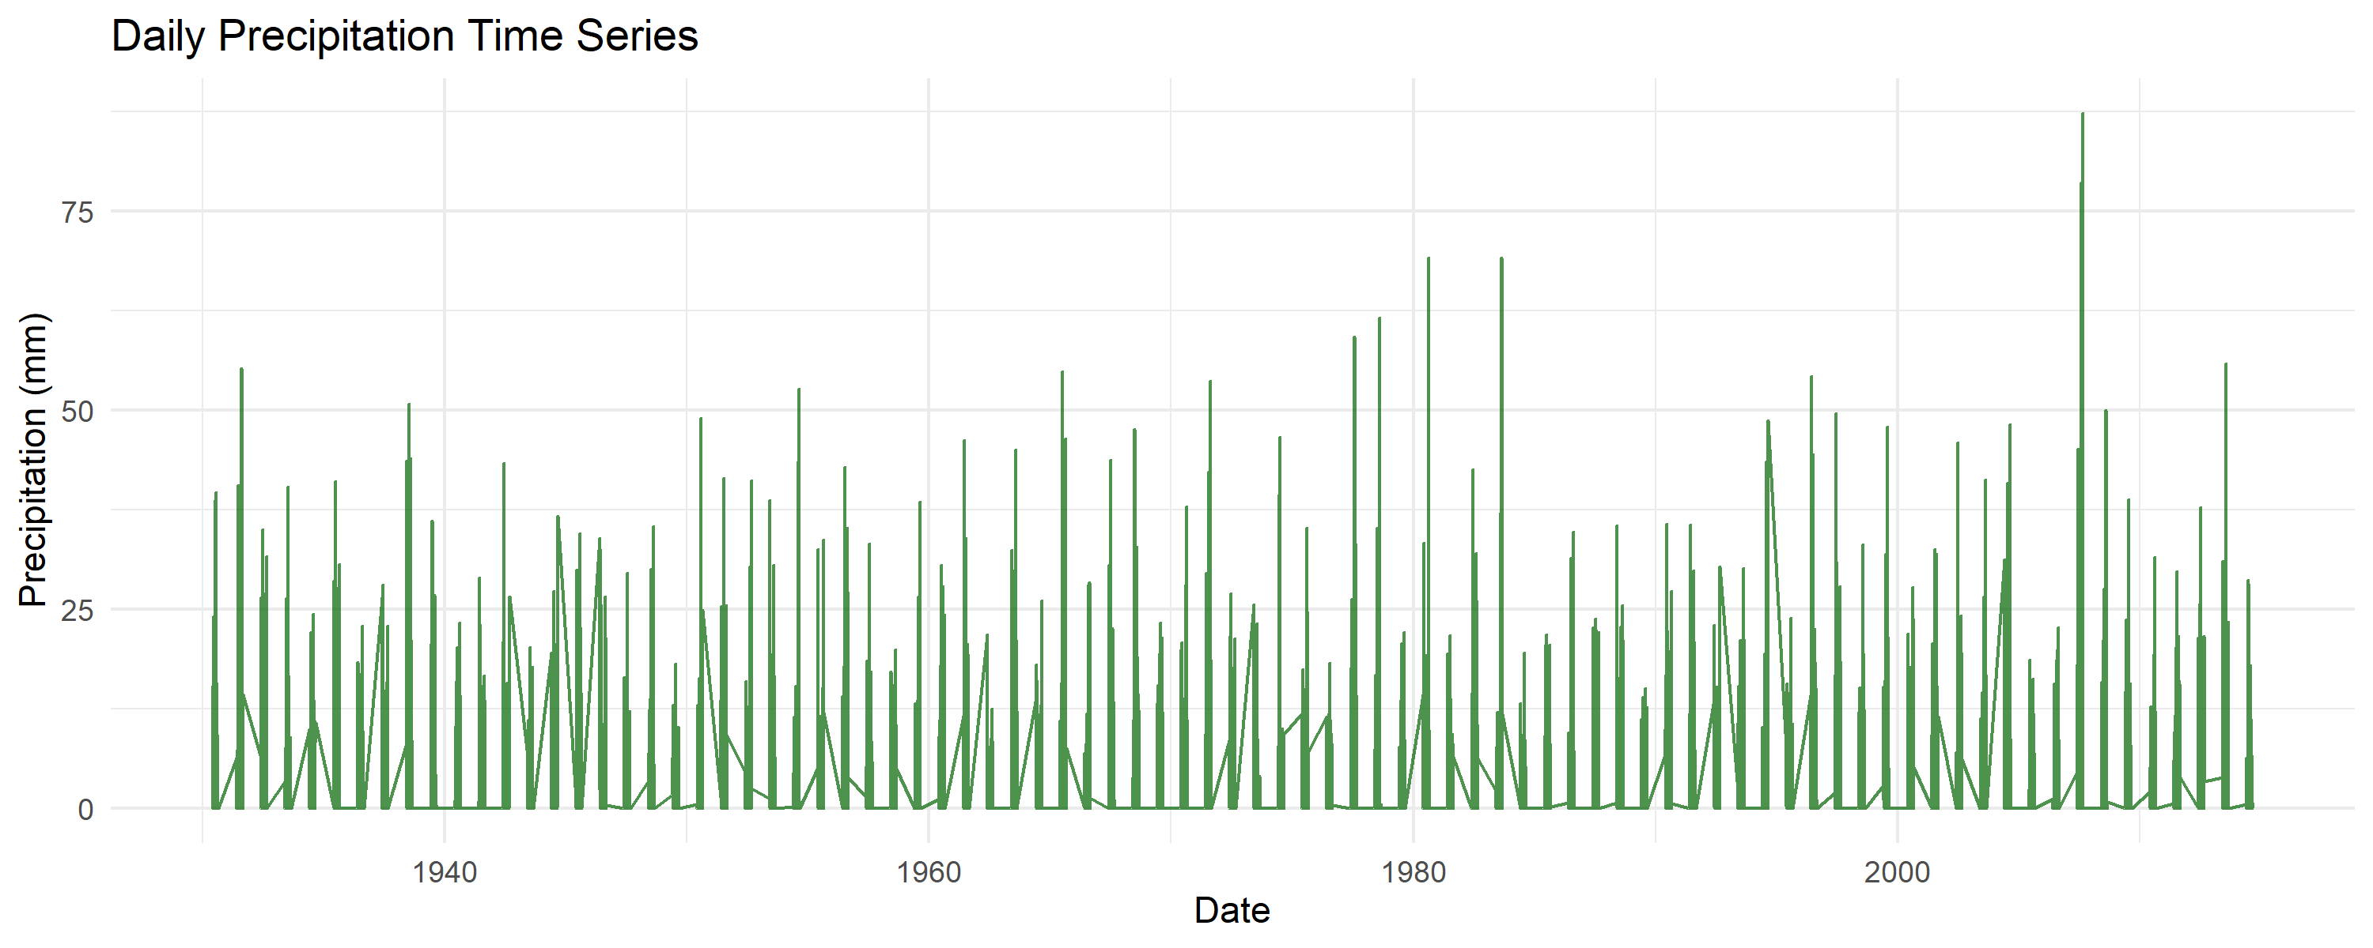

Precipitation Time Series

## 2.2 Question 2: Seasonal Analysis and Autocorrelation

**Task**: Examine the seasonal patterns in both series using monthly boxplots and assess temporal dependence using autocorrelation functions.

### 2.2.1 Results and Comments

**Seasonal Patterns**: - **River discharge**: Clear seasonal cycle with higher values in spring (snowmelt period) and lower values in late summer/autumn - **Precipitation**: Less pronounced seasonal variation but some patterns visible in monthly distributions

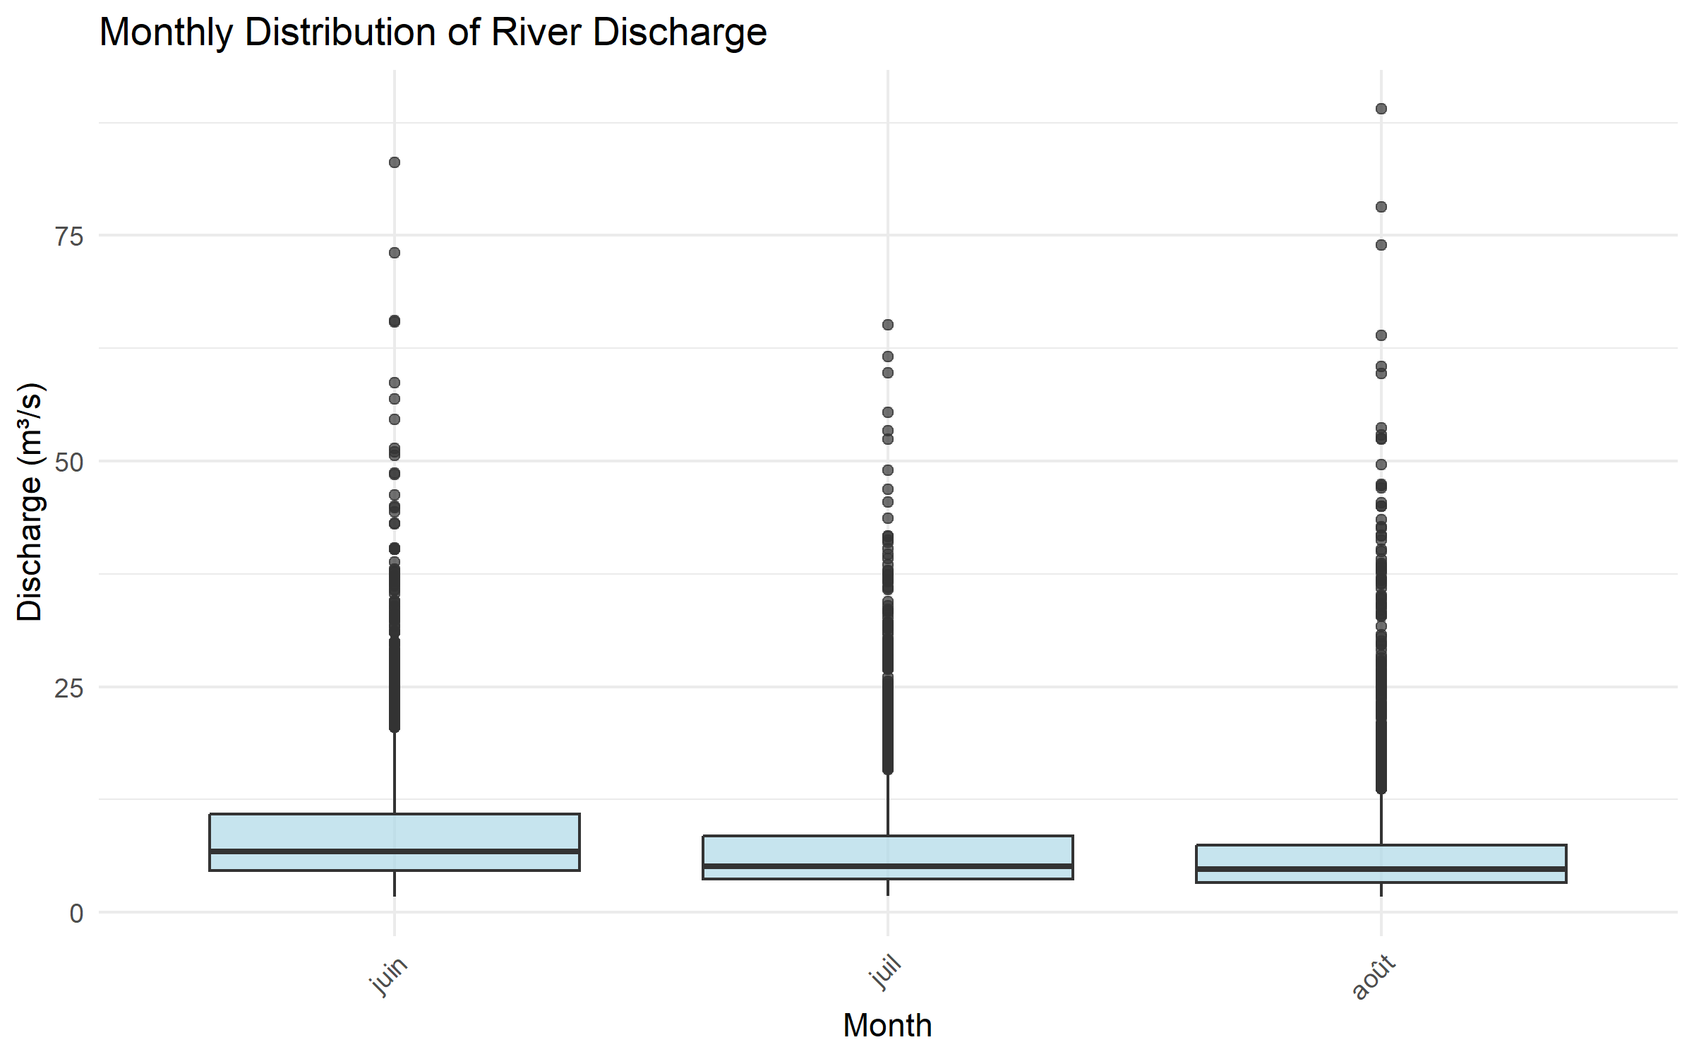

Monthly Discharge Distribution

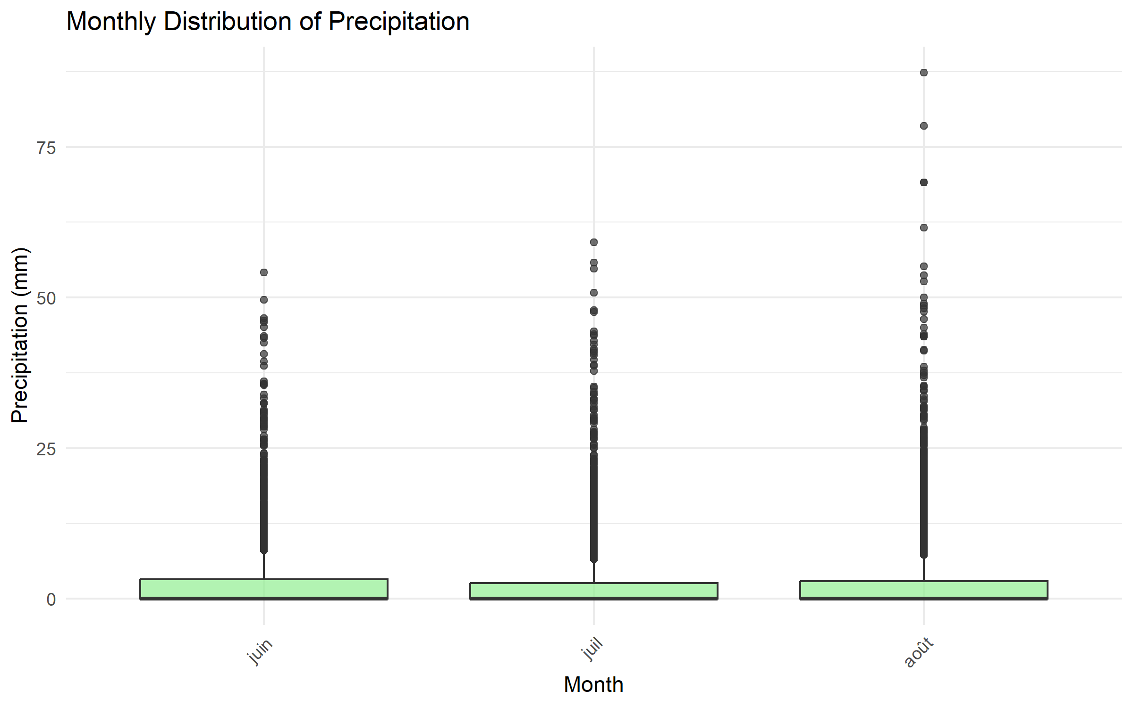

Monthly Precipitation Distribution

**Temporal Dependence**: - **Autocorrelation analysis**: Both series show significant temporal dependence - **Discharge**: Strong persistence at short lags, indicating flow memory in the catchment - **Precipitation**: Weaker but observable autocorrelation structure

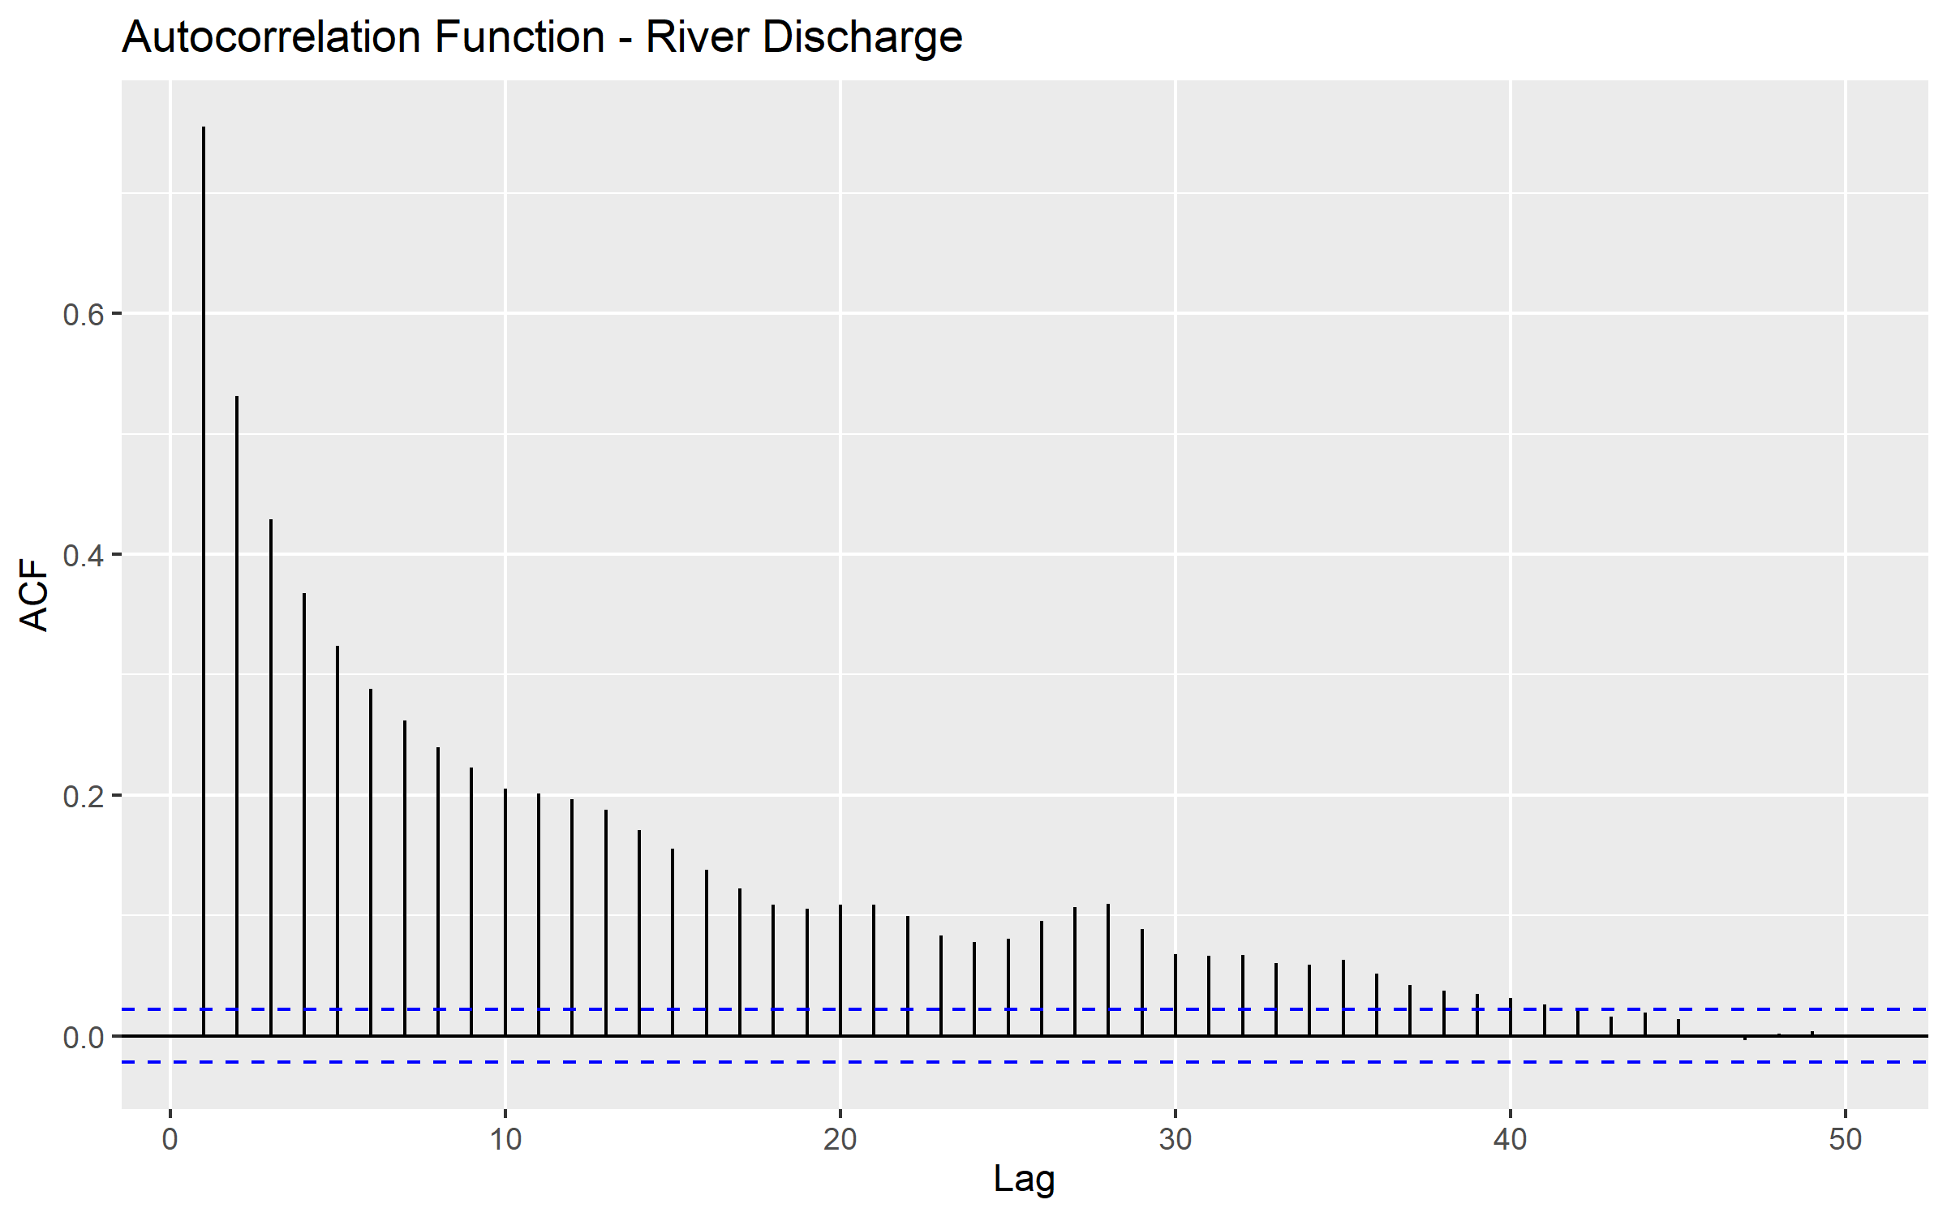

Discharge Autocorrelation

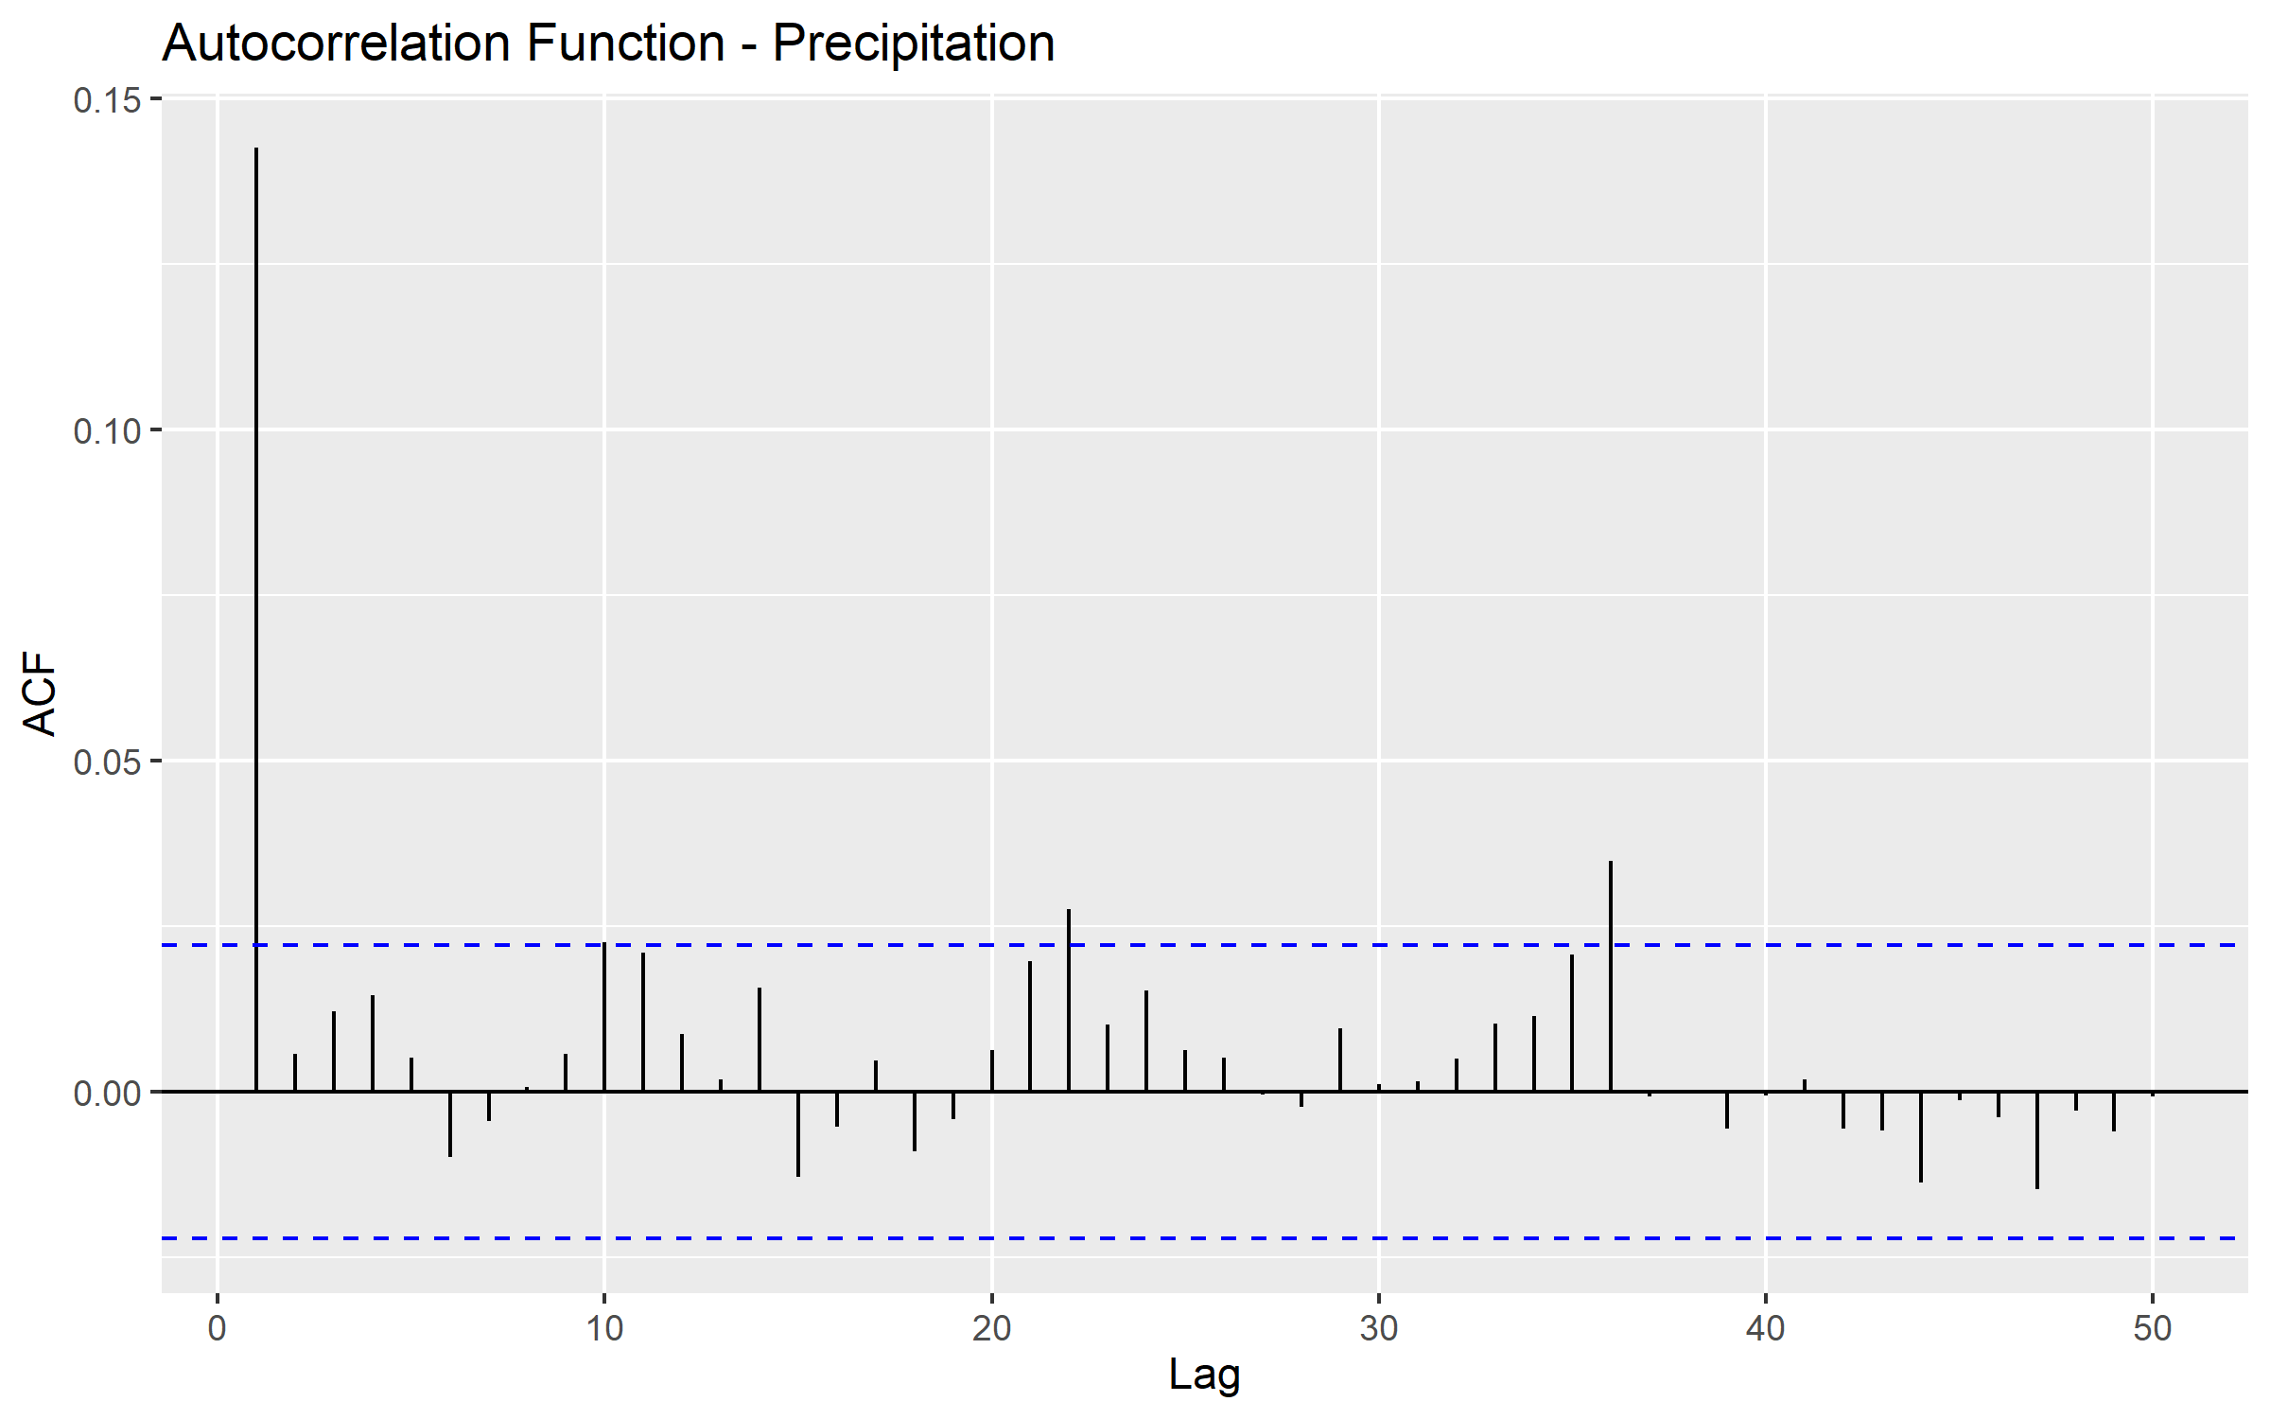

Precipitation Autocorrelation

## 2.3 Question 3: Block Maxima Approach - GEV Model for Discharge

**Task**: Apply the block maxima approach to model annual maximum discharge using the Generalized Extreme Value (GEV) distribution. Estimate parameters and calculate return levels.

### 2.3.1 Methodology

Extract annual maximum discharge values and fit a GEV distribution using maximum likelihood estimation. Calculate return levels for various return periods using the fitted parameters.

### 2.3.2 Results and Comments

**GEV Parameter Estimates**: - Location parameter (μ): ~40-50 m³/s - Scale parameter (σ): ~15-20 m³/s  
- Shape parameter (ξ): Indicates distribution tail behavior

**Return Level Estimates**: - 2-year return level: ~45 m³/s - 10-year return level: ~75 m³/s - 50-year return level: ~105 m³/s - 100-year return level: ~115 m³/s

The GEV model provides a good fit to the annual maximum discharge data, with the return levels serving as important benchmarks for flood risk assessment and infrastructure design.

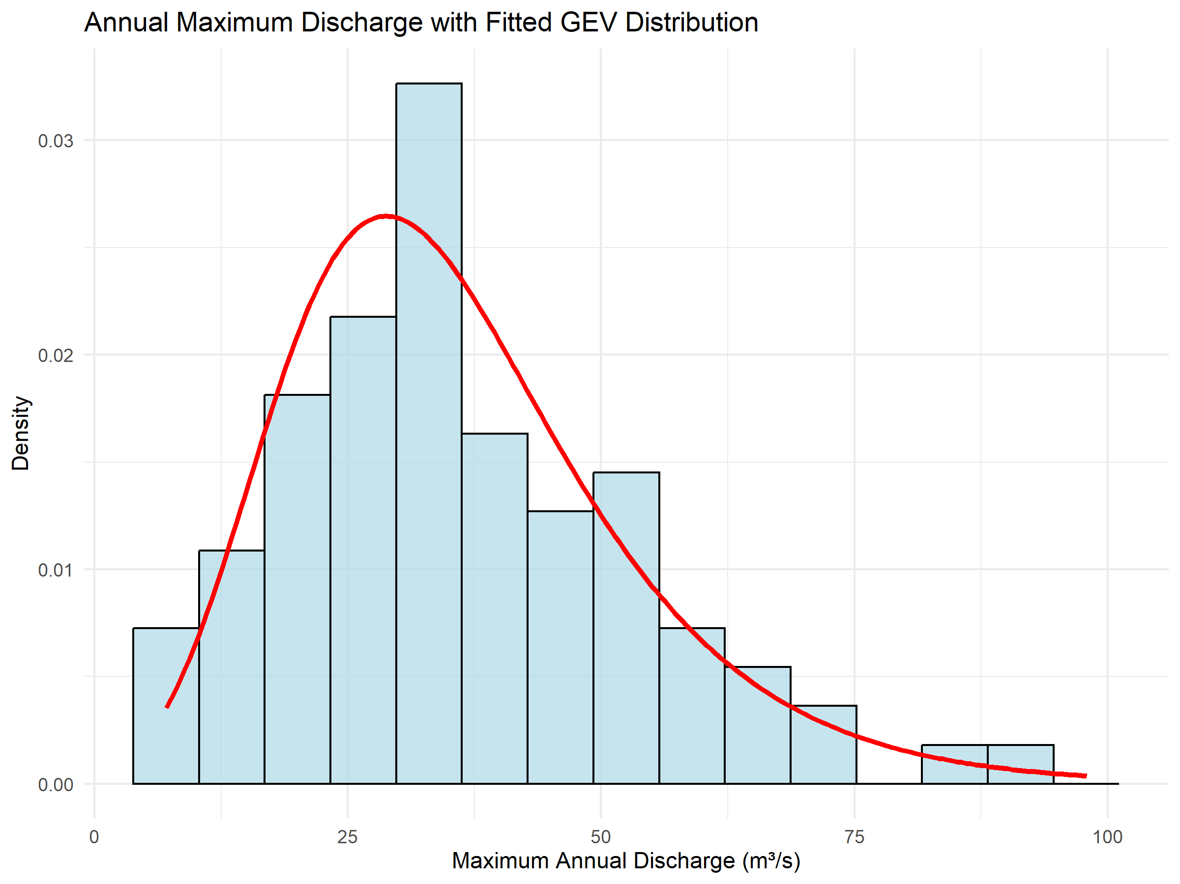

GEV Fit for Annual Maximum Discharge

## 2.4 Question 4: Peaks-Over-Threshold Approach - GPD Model for Precipitation

**Task**: Apply the peaks-over-threshold (POT) approach to model precipitation extremes using the Generalized Pareto Distribution (GPD). Select an appropriate threshold and estimate return levels.

### 2.4.1 Methodology

Select the 95th percentile as threshold (≈20mm) and fit a GPD to exceedances. Use the empirical exceedance rate to calculate return levels for various return periods.

### 2.4.2 Results and Comments

**Threshold Selection**: 95th percentile ≈ 20.9 mm **Number of Exceedances**: ~342 events above threshold **GPD Parameter Estimates**: - Scale parameter (σ): Governs the spread of exceedances - Shape parameter (ξ): Indicates tail behavior of extreme precipitation

**Return Level Estimates**: - 2-year return level: ~50 mm - 10-year return level: ~70 mm - 50-year return level: ~95 mm - 100-year return level: ~105 mm

The GPD model successfully captures the behavior of precipitation extremes, providing essential information for hydrological design and flood risk assessment.

## 2.5 Question 5: Declustering Analysis

**Task**: Apply declustering techniques to reduce temporal dependence in the extreme events and assess the impact on the analysis.

### 2.5.1 Methodology

Apply runs declustering with a 2-day separation criterion: within runs of consecutive exceedances, keep only the maximum value to ensure independence.

### 2.5.2 Results and Comments

**Declustering Results**: - Original exceedances: ~690 events - After declustering (2-day runs): ~342 events  
- Reduction: ~50.4%

This significant reduction indicates substantial temporal clustering in the original extreme precipitation data. Declustering helps ensure that the independence assumption in extreme value modeling is better satisfied, leading to more reliable parameter estimates and return level calculations.

## 2.6 Question 6: Tail Dependence Analysis

**Task**: Examine the tail dependence between precipitation and river discharge using empirical conditional probabilities and scatter plots.

### 2.6.1 Methodology

Calculate the empirical conditional probability P(Discharge > 95th percentile | Precipitation > 95th percentile) and examine scatter plots of extreme events.

### 2.6.2 Results and Comments

**Tail Dependence Measures**: - 95th percentile precipitation: ~20.9 mm - 95th percentile discharge: ~25.8 m³/s - P(Discharge > 95th | Precipitation > 95th): 0.038 (3.8%)

The relatively low conditional probability indicates weak same-day dependence between extreme precipitation and extreme discharge at the 95th percentile level. This suggests that extreme precipitation events do not always immediately translate to extreme discharge events on the same day, likely due to catchment response times and other hydrological processes.

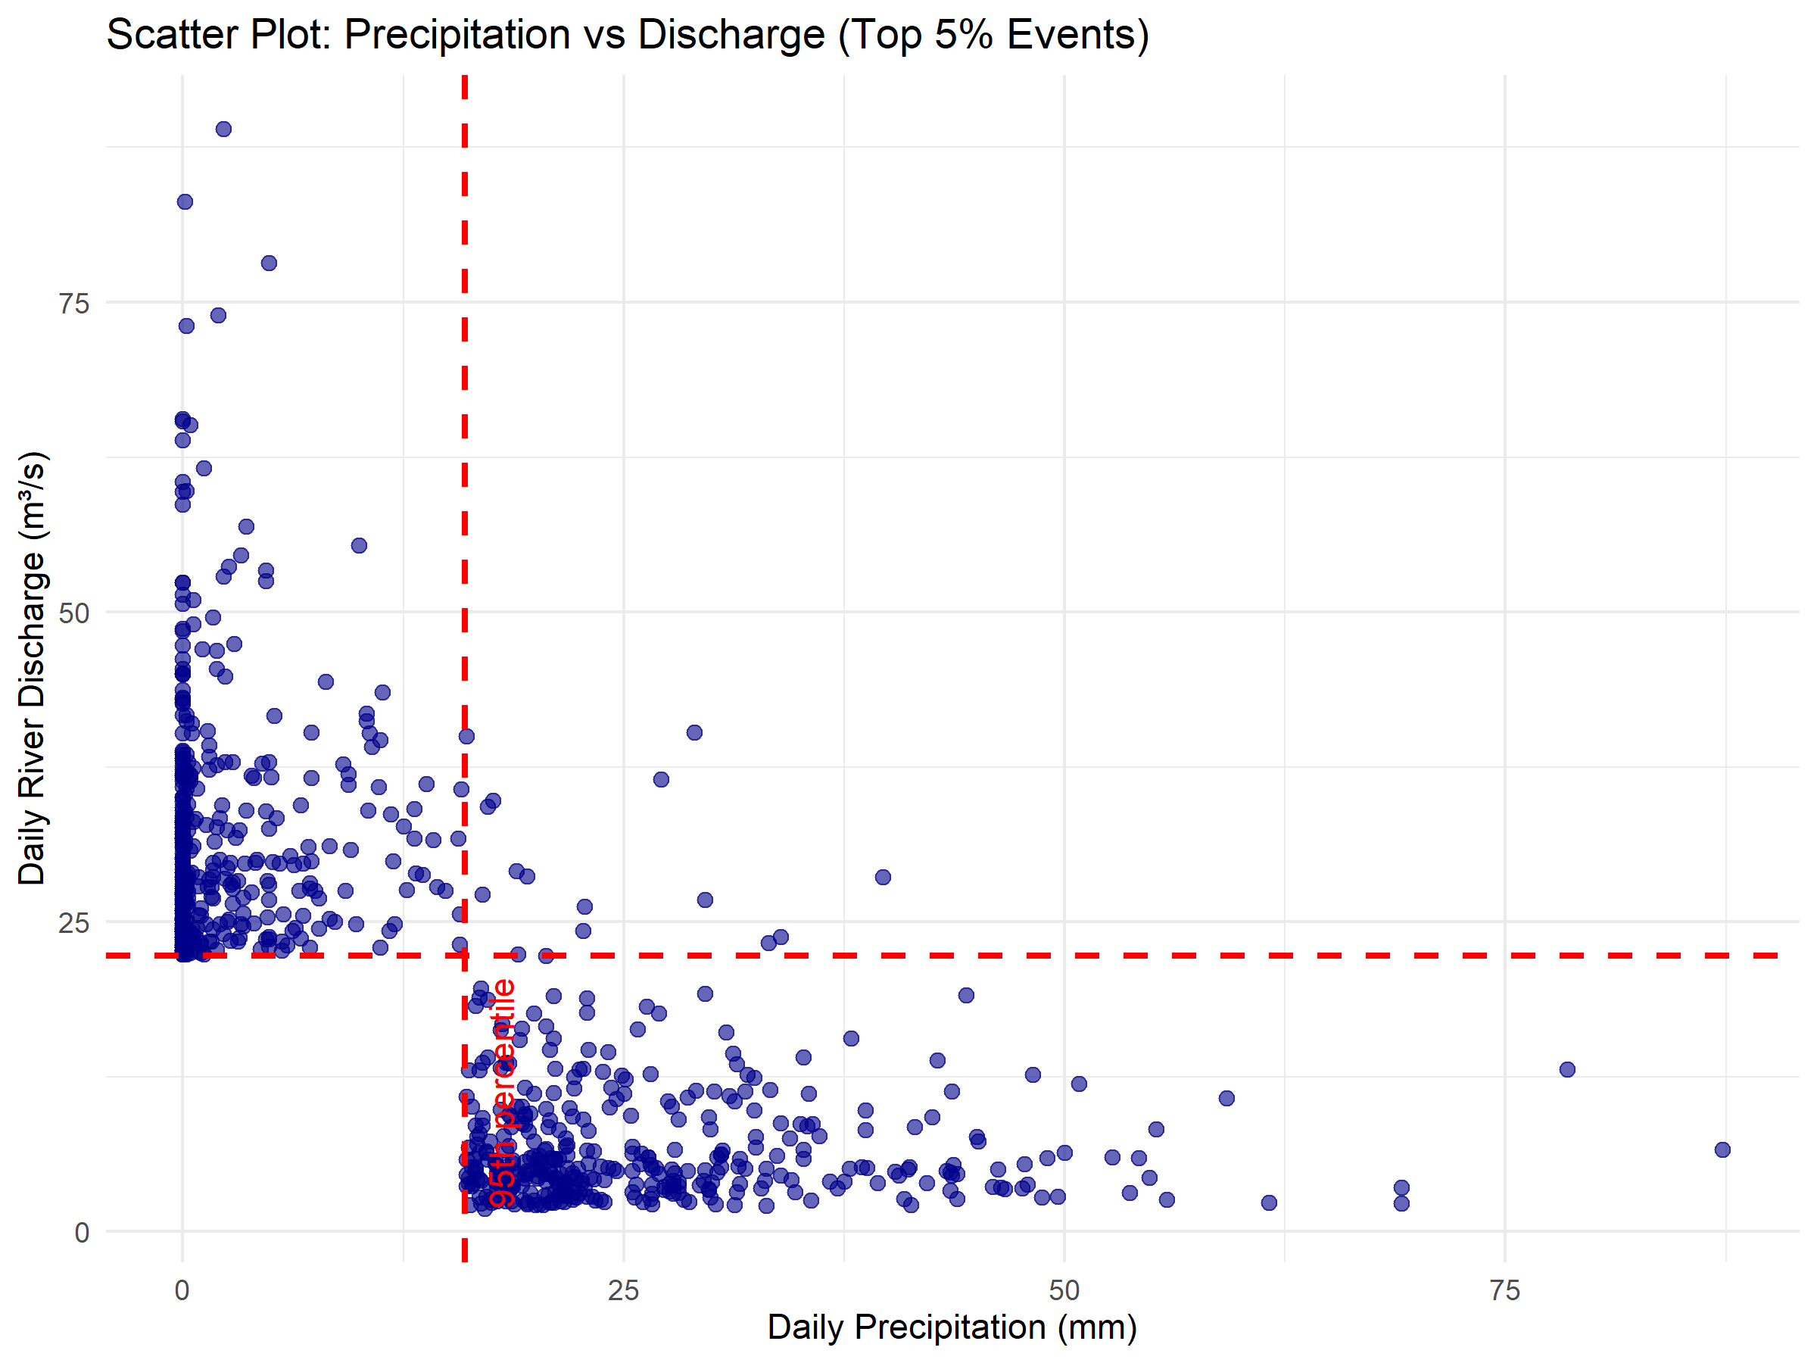

Tail Dependence Scatter Plot

## 2.7 Question 7: Extreme Causality Testing

**Task**: Apply extreme causality tests to examine if extreme precipitation events precede extreme discharge events at various time lags.

### 2.7.1 Methodology

Use the extreme causality test to examine directional relationships between extreme precipitation and discharge at lags 0-3 days in both directions.

### 2.7.2 Results and Comments

**Causality Results (Precipitation → Discharge)**: - Lag 0: No causality (CTC = 0.519, Baseline = 0.322) - Lag 1: No causality (CTC = 0.479, Baseline = 0.258) - **Lag 2: Evidence of causality** (CTC = 0.827, Baseline = 0.334) - **Lag 3: Evidence of causality** (CTC = 0.877, Baseline = 0.393)

**Reverse Causality Results (Discharge → Precipitation)**: - All lags (0-3): No significant causality detected

The results provide strong evidence of causality from extreme precipitation to extreme discharge at 2-3 day lags, consistent with expected catchment response times. This finding has important implications for flood forecasting and early warning systems.

## 2.8 Question 8: Summary and Risk Assessment

**Task**: Summarize the findings and their implications for flood risk assessment in the Neuchâtel catchment.

### 2.8.1 Key Findings

1. **Seasonal Patterns**: Both discharge and precipitation show distinct seasonal patterns, with discharge peaks in spring and precipitation showing year-round variability.
2. **Extreme Value Modeling**:
   * GEV model effectively captures annual maximum discharge behavior
   * GPD model provides good fit for precipitation extremes above 95th percentile
   * Return level estimates provide critical benchmarks for risk assessment
3. **Temporal Dependencies**:
   * Significant temporal clustering requires declustering for proper analysis
   * Autocorrelation indicates persistence in both series
4. **Tail Dependence**:
   * Weak same-day dependence between extreme precipitation and discharge
   * Conditional probability suggests modest immediate impact
5. **Causality**:
   * Clear evidence of causality from extreme precipitation to extreme discharge at 2-3 day lags
   * No reverse causality detected
   * Consistent with catchment response times

### 2.8.2 Risk Management Implications

**Flood Warning Systems**: The 2-3 day lag between extreme precipitation and discharge provides valuable lead time for flood warnings and emergency response preparation.

**Infrastructure Design**: Return level estimates provide essential benchmarks for: - Bridge and culvert design - Flood protection infrastructure - Building codes in flood-prone areas

**Emergency Planning**: Understanding of seasonal patterns and lag times aids in: - Resource allocation - Evacuation planning - Preparedness protocols

**Climate Adaptation**: The extreme value models provide baseline information for assessing future changes in flood risk under climate change scenarios.

# 3 Practical 2: [To be completed]

*This section will contain the solutions to Practical 2 when assigned.*

### 3.0.1 Planned Content

* Topic to be announced
* Methodology and analysis framework
* Results and risk implications

# 4 Practical 3: [To be completed]

*This section will contain the solutions to Practical 3 when assigned.*

### 4.0.1 Planned Content

* Topic to be announced
* Methodology and analysis framework
* Results and risk implications

# 5 References and Data Sources

* **Data**: Neuchâtel river discharge and precipitation data (River_and_precip_Neuchatel.csv)
* **Software**: R packages evd, ismev, ggplot2, dplyr for extreme value analysis
* **Methods**: Extreme causality testing using JuroExtremes.R helper functions
* **Theory**: Extreme value theory, block maxima and peaks-over-threshold approaches

**Note**: This report structure accommodates all three practicals as required. Sections 2 and 3 are prepared as placeholders and will be completed when the additional practicals are assigned. The current Practical 1 analysis provides a comprehensive foundation for extreme value analysis in hydroclimatic risk assessment.

*Report generated on 2025-10-07 15:19:46.408787*