Olivia Miller

Water Resources Planning

2/26/16

Progress Report

Current Problems, Stakeholder Objectives, and Proposed Management Alternative

For this project, our group selected Salt Lake City Department of Public Utilities as a stakeholder in the Jordan River basin. Their goal is to maintain an adequate supply of high quality drinking water to citizens. Maintaining high water quality requires environmental protections, management, and restoration. We are assessing the effects of the proposed Argenta Dam on flows in Big Cottonwood Creek and water supply for Salt Lake City.

Big Cottonwood Canyon contains 50 square miles of drainage area (Bear West, 1999). The upper basin creeks of the canyon and two reservoirs (Lake Mary and Twin Lakes) form the headwaters of Big Cottonwood Creek. Big Cottonwood Canyon is a popular recreation area with two ski resorts, cross country skiing facilities, back country skiing and hiking trails, camping and picnicking, and full and part time residencies. The US Forest Service manages a majority of the land in Big Cottonwood Canyon (78%), followed by private parties (20%), Salt Lake City (1%) and Salt Lake County (<1%) (Bear West, 1999).

Salt Lake City Department of Public Utilities “provides culinary water to over 326,000 residential customers, and serves nearly 92,000 connections within Salt Lake City, Cottonwood Heights, Holladay, Millcreek Township, and portions of Murray, Midvale, and south Salt Lake, a service area of 135 square miles. Included in our customer base are an international airport, two universities, numerous hospitals, public schools, and over 1400 acres of irrigated public parks and golf courses” (SLC Public Utility, 2009). Salt Lake City is considering several potential new water sources including new well development, additional surface water development, wastewater reuse, and Utah Lake system water (Bowen, Collins & Associates, 2007). Development of the Argenta Dam could be part of additional surface water development plans.

The City is also concerned with water quality, and maintains a goal of achieving excellent to superior water quality (Bear West, 1999). The City prioritizes water quality over multiple uses of the watershed (Bear West, 1999). The Public Utilities Water Rights and Watershed Purchase Fund, established in 1989, is used to purchase land to protect the watershed (Bear West, 1999). The Fund is supported by a $0.25 customer surcharge on monthly water bills, and generates approximately $250,000 annually (Bear West, 1999).

Additional concerns include impacts of global climate change on water supply (SLC Public Utilities, 2009). The 2014 SLC Water Conservation Master Plan describes one hypothetical climate change scenario, and we plan to expand on this to see how warming may impact stream flow (Figure 1).

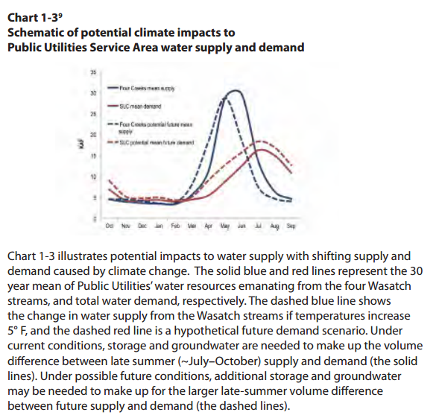

Figure 1. SLC Public Utilities, 2009.

The City sources water from surface water, groundwater, and water rights through the MWDSLS (Salt Lake City Department of Public Utilities, 2009). To meet future demand, the City plans to develop new wells, additional surface water sources, wastewater reuse, and Utah Lake system water (Salt Lake City Department of Public Utilities, 2009). To expand surface water supplies, the City is investigating development of water treatment facilities to treat water from Mill Creek Canyon or other surface water sources, which are estimated to provide an additional 3,300 ac-ft during dry years and 3,967 ac-ft during average water years (Salt Lake City Department of Public Utilities, 2009).

The Argenta Dam, recommended by the 1928 Water Advisory Board to develop a firm stored water supply for Salt Lake City, was proposed to store 12,000 ac-ft of water (Hooton, 1999). The reservoir would have been located about 11 miles up from the mouth of Big Cottonwood Canyon, and would store water from 26 square miles of watershed ranging from 7,200 to 11,500 ft. At the time, the dam was estimated to cost $191/ac-ft of water. The City estimated that the dam would provide water for an additional 80,000 people. The proposed dam would have stood 220 ft above the creek bed and 67 feet below the creek bed. The dam would have been 67 ft thick at the base, 47 ft thick at the creek bed, and 8 ft thick at the top. The resulting reservoir would have stretched 1.5 miles up Big Cottonwood Canyon, causing relocation of the road (Hooton, 1999).

Current Water Use

The average was use per capita in Utah is about 270 gallons/day (Bear West, 1999). The most significant use is outdoor irrigation. In Salt Lake City, 49% of water use goes to lawn watering (Bear West, 1999). Residential water use is the largest single category, followed by commercial and industrial, institutional, and city accounts (Figure 2).

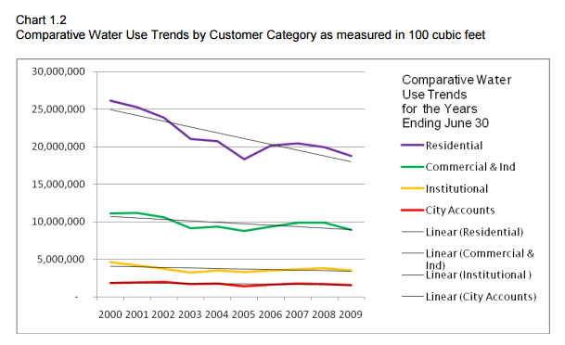

Figure 2. Comparison of water use trends in Salt Lake City. Salt Lake City Department of Public Utilities, 2009.

Institutional Analysis

Salt Lake City Public Utilities has partnerships with surrounding local, state, and federal land and water management agencies. They take a broad perspective in maintain water quantity and quality. The City considers watershed protection as a significant component of maintaining high water quality. There are also multiple efforts to promote water conservation through education. To increase water supply, the City must balance multiple methods including conservation, and developing new supplies. One opportunity to further promote water conservation could be revising water use rates. The Argenta Dam is one option for new surface water supply, however it should be compared to other methods of increasing water supply.

The Argenta Dam may provide additional water for a growing population. However, concerns about environmental degradation, impact on transportation and recreation in Big Cottonwood Canyon, and and cost need to be considered. Additionally, expansion of the Big Cottonwood Water Treatment Plan and associated costs may need to be considered.

Data on stakeholder water demands in the basin

Salt Lake City Department of Public Utilities presents the following water use data and demand projections in the 2009 Water Conservation Master Plan (Table 1):

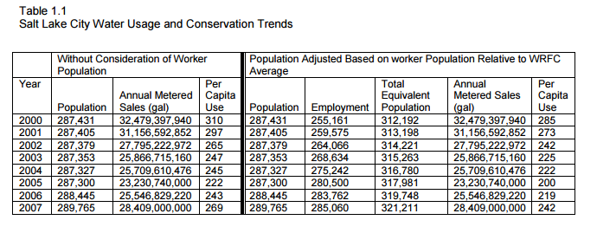

Table 1. Salt Lake City Department of Public Utilities, 2009.

Salt Lake City has a conservation goal of reducing per capita water use by 25% from use in 2000 by 2050. The 2014 Salt Lake City Water Conservation Plan presents demand projections developed for the Major Conveyance Study with and without water conservation efforts (Table 2):

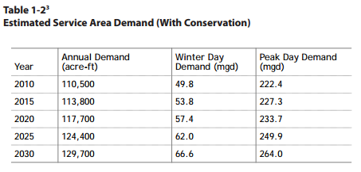

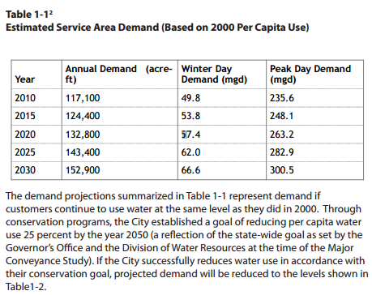

Table 2. Salt Lake City Department of Public Utilities, 2009.

Quantitative metrics to evaluate the extent to which the Argenta Dam meets the stakeholder’s objectives

For this project, we will evaluate how construction of the Argenta Dam will affect the reliability, resiliency, and vulnerability of the Salt Lake water supply, as well as the cost to benefit ratio. We will look at reliability, resiliency, and vulnerability for peak day demand compared to winter day demand as well. Reliability, resilience, and vulnerability can be calculated using the methods of Loucks and van Beek, 2005. The projected average yield (based on historic flow records, available storage, and available treatment capacity) of the Big Cottonwood Water Treatment Plant is 26,050 ac-ft/year, and in a dry year it is 18,182 ac/ft (Bowen, Collins & Associates, 2007). Big Cottonwood Creek has an annual water yield of 51,238 ac-ft, the highest of the seven major Wasatch Mountain Creeks from City Creek south through Little Cottonwood Creek (Bear West, 1999). We will investigate if the Argenta Dam would meaningfully increase yield to water supplies. We will also evaluate these metrics in response to different climate change impacts on precipitation and streamflow. The cost to benefit ratio will be based on dam construction costs and water supply increases, and will be compared to water conservation costs and benefits.

Major Findings and Future Steps

We have historical monthly stream flow data from the USGS Utah Water Science Center (2016).

At this point, we have adequate stream data and our next big step is to build the WEAP model. To do the cost to benefit ratio analysis, we need to collect data on costs of dam construction. We will also need to develop some reservoir operation rules. Once our model is calibrated (stream flows are matched for different historical water inputs) we will add the Argenta Dam and see how our quantitative metrics change. Then we will use climate change factors that increase and decrease stream flow to see how the quantitative metric are affected.

References

Bear West, 1999.Salt Lake City Watershed Management Plan. <http://www.townofalta.com/pdf/SLC_Watershed_Management_Plan.pdf>

Bowen, Collins & Associates, 2007. Salt Lake County Demand and Supply Study. http://utahwater.net/wp-content/uploads/2008/02/1-salt-lake-city-projected-average-2010-production-existing-151172-acre-feet-with-future-source-168994-acre-feet-73760-af-of-preferred-right-in-mwdsl.pdf

Loucks, D.P., van Beek, E., 2005. Water Resources Systems Planning and Management: An Introduction to Methods, Models, and Applications, UNESCO Publishing.

Hooton, LeRoy, W. 1999. Argenta: The Dam That Wasn’t. http://www.slcdocs.com/utilities/NewsEvents/news1999/news091399.htm

Salt Lake City Department of Public Utilities, 2009. Water Conservation Master Plan. http://www.slcdocs.com/utilities/PDF%20Files/2009%20Water%20Conservation%20Master%20Plan%20-%2011-03-2009.pdf

Salt Lake City Department of Public Utilities, 2014. Water Conservation Master Plan. http://www.slcdocs.com/utilities/PDF%20Files/2014%20SLC%20Water%20Conservation%20Master%20Plan.pdf

USGS Utah Water Science Center, 2016, http://waterdata.usgs.gov/nwis/inventory?agency_code=USGS&site_no=10168499